GATITU MIXED SECONDARY SCHOOL
FORM 3 BIOLOGY
END-TERM 2015
1. What components of blood are absent in the tissue fluid. (2marks)

2(a) State the kingdom to which chamydomonus belong. (1mark)

(b) An organism has the following characteristics
- Four pairs of wings
- cephalothorax and abdomen
- Absence of antennae
- Presence of a pair of chelicerae.
Name the phylum and class that the organism belongs to? (2marks)
Phylum __________________________________________
Class_____________________________________________
3. (a)Name the association between leguminous plant and rhizobium bacteria (1mark)

(b)(i) State the population estimation method of grasshoppers in your school compound. (1mark)

(ii) Suggest the name of the formula used to calculate population of the grasshoppers.

4 (a) Identify the process through which water is absorbed by plant roots. (1mark)

(b) State one role of active transport in plants. (1mark)

6. A certain solution was boiled in a clean test tube containing five drops of Benedict’s solution for three minutes. The color turned orange. Suggest the food material likely to be present. (1mark)

7. State any three theories that explain the mechanism of opening and closing of stomata. (3mks)

10. (a) State functions of the following organelles
(i) Centrioles (2mark)

(ii) Golgi bodies (2mark)

11. The following is an equation representing a type of respiration
C₆H₁₂O₆ 2 C₃H₆0₃ + Energy
(a) Identify the type of respiration. (1mak)
(b) Suggest two examples of industrial application of the process named in part (a) above. (2maks)

12. (a) Identify the apparatus drawn below. (1mark)

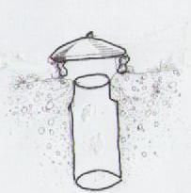
(b) Of what use is the apparatus (1mark)

15. Suggest three characteristics of gaseous exchange organs in frogs. (3marks)

- The diagram below shows a seed of a certain plant.
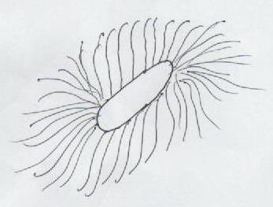
(a) Name the likely agent of dispersal . (1mark)
(b) Give a reason for your answer. (1mark)
18. (a) Name the source of hydrochloric acid in the mammalian stomach. (1mark)
(b) The diagram below represents internal structure of a mammalian tooth.
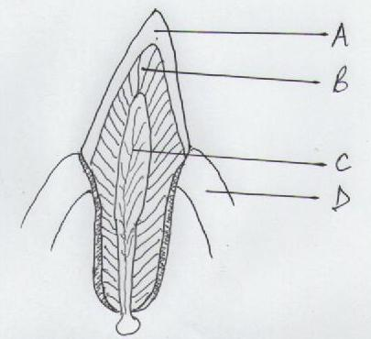
(c) Label the parts labeled B and D (2marks)
20. Give two reasons why blood pressure is greater in arteries than in the veins of mammals. (2marks)

22. Differentiate between intracellular and extracellular enzymes. (2marks)

23. How does the mammalian liver regulate excess proteins in the diet. (4marks)
24. The diagram below represents a common laboratory equipment.
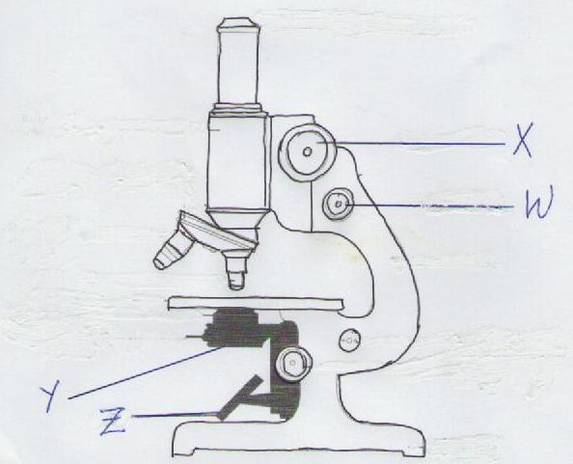
(i) Label the parts labeled X and Y. (2marks)
(ii) Using arrows show how the object is illuminated. (2 marks)
25. (a)Name secretion from sebaceous gland of mammals (1mark)

(b) State two functions of the secretion named above. (2marks)

26. The scientific name of organism that causes malaria is PLASMODIUM VIVAX. How would a form one student write the name in her exercise book correctly? (2marks)

27. What is the main function of vascular bundles? (2marks)

28. (a) Name the part in the chloroplast where light stage take place. (1mark)
(b) State the differences between photosynthesis and chemosynthesis. (2marks)

29. The diagram below represents a mature embryo sac. Study it and answer the questions below
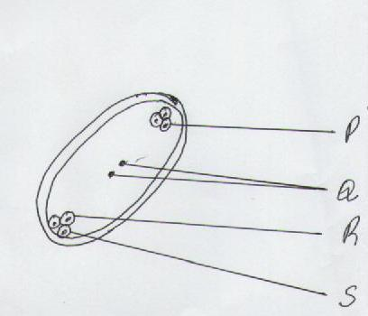

(a) On the diagram name part P, R and S (3marks)
(b) What is the name given to the type of fertilization in flowers? (1mark)
(c) What is an entomorphillus flower? (1mark)

31. The diagram below represents a longitudinal section of a dicotyledonous root.
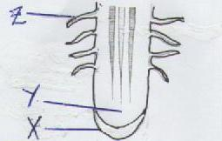
(a) Name the parts labeled X (1mark)
(b) Identify the cells found at part labeled Y. (1mark)
(c) In which zone of growth are structure labeled Z found . (1mark)

32. Explain the role of the skin in thermo regulation. (10 marks)

MARKING SCHEME(70 mks)
1. Blood cells; (2 marks)
- Accept correct examples RBC;
WBC;
- (Plasma) Proteins;
2. (a) Protoctista; (1 mark)
(b) Phylum –Arthropoda Rj Arthropods, (2 marks)
Class Archinida Rj Arachinids
3 (a) Symbiosis; (1 mark)
(b)(i) Capture, Release – Recapture(method) / Capture – Recapture (method);(1mark)
(ii) Lincoln’s (formula);
4. (a) Osmosis; (1 mark)
(b) Mineral salt absorption; (1 mark)
6. Reducing sugars/simple sugars; (1 mark)
Accept correct examples.
7. - Photosynthetic theory; (3 marks)
- Starch sugar interconversion (theory);
- Potassium ion pumps (theory);

8
10. (a) (i) Centrioless; (1 mark)

- Formation of spindle fibres (in animal cells);
- Formation of flagella; (mark any one correct;
- Formation of cilia;
(ii) Golgi bodies; (1 mark)
- Production of lysosomes;
- Secretion of enzymes; Acc. Correct example lyptic;
10 (a) (ii) - Packaging and transport of secretions . Acc. Glycoproteins;

11. (a) Anaerobic respiration in animal ; ( 1mark)
Rj Anaerobic respiration alone;
(b) - Beer brewing; (2 marks)
- Bread baking/leavening of bread.;
- Processing of dairy products; Acc correct examples;
- Biogas production;
- Sewage treatment;
- Manufacture of wines and spirit;
- Production of organic acid;
Mark the first two
12. (a) Pitfall trap; (1 mark)
(b) Taps crawling insects; (1 mark)
15. - They are moist;
- Highly vascularised/suppled by blood capillaries;
15. - Have a thin epithelium R thin walls; (3 marks)
- Have large surface area;
Any 3 correct marks
16. (a) Wind (dispersal ); (1 mark)
(b) Presence of hairs; (1mark)
18. (a) Parietal cells; (1 mark)
Oxyntic cells;
(b) Dentine ; (2 marks)
Gum;
20. Arteries Veins (2 marks)
Has narrower lumen ; Has wider lumen /size;
Receiving blood directly from
the heart;
Has thick muscular walls Has thin muscular walls
22. Intracellular Extracellulaar (2 marks)
Enzymes produced by a cell Enzymes produced by a cell but digestion outside and digestion in same cell ; that cell;
23. - Excess proteins are deaminated /removal of amino- group; (4 marks)
- To form ammonia; that reacts with carbon (iv) oxide( Rj carbon dioxide) to form ;
- Urea; through ornithine cycle.;
- Urea is excreted through kidney;
24. (i) X - Coarse Adjustmat knob; (2 marks)
Y - Diaphign ;
(ii) On the diagram (2 marks)
25. (a) Sebum ; (1 mark)
( Rj) - Oily substances;
(b) - Antiseptic / kill pathogens ; R; germs; (2 marks)
- hair/fur flexible and skin /supple/prevent skin from cracking;
- Water proof;
26. Plasmodium vivax; (2 marks)
Observe principal of binomial nomenclature i.e Genus name- start with capital letter and other letters small;
Underline separately;
27. Xylem - Transport water; mineral salts Rj, Mineral salone ;( 2marks)
- Support ( lignifications);
27. Phloem - Translocation of manufactured food; (2 marks)
- Transport of plants hormone;
Acc. The correct examples;
For each one correct answer.
28. (a) Granum / Grana; (1 mark)
(b) Photosynthesis – Manufacture of food by green plants using (sun) light energy;
Chemosynthesis – food manufacture by (non-green ) bacteria using chemical energy; ( 2 marks)
29. (a) Antipodal cells ; (2 marks)
Synergrids;
(b) Double fertilization ; (1 mark)
(c) Insect pollinated; (1 mark)
31. (a) Root cap; (1 mark)
(b) Apical ; meristematic; (1 mark)
(c) Zone of cell division; ( 1 mark)

32. (a) Hair shaft ; (10 Marks)
- Connected to erector pili muscles;
- Temperature Elector pili muscle contract raising hair shaft erect;
- Hair traps air which insulates /poor conductor of heat.;
- Hair reflects away heat;
Low temperature
- Erector pili muscle relax and extends;
- Hair shaft lies on the skin;
- Little or no air is trapped;
- Skin loses heat through convection /conduction /radiation ;
Blood vessels
- High temperature they vasodilatae;
- More blood flows near skin surface;
- Heat is lost through conduction /convection/ radiation;
Low temperature
- Vasoconstriction ;
- Little blood flows deeper in the muscles;
- Less heat or ho heat lost through conduction/convection/ radiation;
Sweat gland
- High temperature;
- Sweat occurs and ( evaporates);
- Carries latent heat of vaporization; body cools;
7. Low temperature
- No sweat;
- Shivering; to generate heat ;
- Goose pimples closing sweat pores;
- Shunting of blood vessels ;
- ;
Subcutaneous fatty layer /Adipose tissue libber;
Insulation ;

