GATITU MIXED SECONDARY SCHOOL
GROWTH AND DEVELOPMENT
AUGUST HOME HOLIDAY ASSIGNMENT (FORM 3)
INSTRUCTIONS: All questions and answers should be written at the back of the exercise book. (No question should be left unanswered)
- Explain why several auxiliary buds sprout when a terminal bud in a young tree is removed.
- Account for loss in dry weight of cotyledons in a germinating bean seed.
- What is the effect of gibberellins on shoots of plants?
- A student set up an experiment as shown in the diagram below
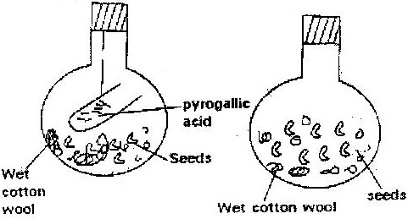

The set up was left at room temperature for a week
- What was the aim of the experiment?
- What would be the expected results at the end of the experiment?
- State two advantages of metamorphosis to the life of insects
- During germination and early growth, the dry weight of endosperm decreases while that of the embryo increases. Explain
- In an experiment, a group of student set up four glass jars as shown in the diagram below jar A, B and C were maintained at 25⁰C for 7 days. While Jar D was maintained at 0⁰ c for the same period of time.
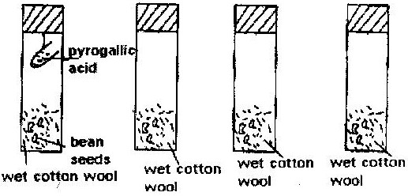

- What was this set up supposed to investigate?
- Why was pyrogallic acid included in glass jar A?
- Explain why glass jar C and D were included in the experiment
- What result would you expect in glass jar A and B at the end of the experiment?
- State two artificial ways of breaking seed dormancy
- Removal of the apical bud from the shrub is a practice that results in the development of the lateral buds which later from the branches.
- Give reasons for the development of the lateral braches after the removal of the apical bud
- Suggest one application of this practice
- What is the importance of this practice?
- In an experiment some germination seeds were placed in large airtight flask and left for four days
- Suggest the expected changes in the composition of gases in the flask on the fifth day
- Give four reasons for your answer in (a) above
- Name two factors that cause dormancy in seeds
- (a) Distinguish between epigeal and hypogeal germination ( 1 mark)
(b) Why is oxygen necessary in the germination of seeds? ( 2 marks)
- An experiment was carried out to investigate the effect of hormones on growth of lateral buds of three pea plants
The shoots were treated as follows:
Shoot A- Apical bud was removed
Shoot B – Apical bud was removed and gibberellic acid placed on the cut shoot
Shoot C- Apical bud was left intact.
The length of the branches developing from the lateral buds were determines at regular intervals
The results obtained are as shown in the table below
Time (days) | Length of branches in mm
 | Shoot A | Shoot B | Shoot C
0 | 3 | 3 | 3
2 | 10 | 12 | 3
4 | 28 | 48 | 8
6 | 50 | 90 | 14
8 | 80 | 120 | 20
10 | 118 | 152 | 26
- Using the same axes, draw graphs to show the length of branches against time
( 8 marks)
- (i) What was the length of the branch in shoot B on the 7th day? ( 1 mark)
(ii) What would be the expected length of the branch developing from shoot A on the 11th day? ( 1 mark)
- Account for the results obtained in the experiment ( 6 marks)
- Why was shoot C included in the experiment? ( 1 mark)
- What is the importance of gibberallic acid in agriculture? ( 1 mark)
- State two physiological processes that are brought about by the application of gibberellic acid on plants. ( 2 marks)
12. (a) State tow environmental conditions that can cause seed dormancy
(b) Name the part of a bean seed that elongates to bring about epigeal germination
( 1 mark)
13. (a) “True growth is not simply an increase in size” State four different ways in which true may be defined.
(b) State two external factors, which influence growth in plants and describe one effect of each.
(c) Fill in the spaces in the following table, which refers to hormones involved in growth processes.

Name hormone | Site of hormone production | Effect
 | Thyroid gland
 |  | Maturation of Graafin follicles
Auxins
Gibberellins

14. Seedling from 100g of maize seed was grown in the dark for 10 days. The seedlings were then analyzed and compared with 100g of ingeminated maize. The following results were obtained.

 | Dry mass of ingeminated seeds | Dry mass of seedling after 10 days
Cellulose  Starch  Other organic  Material Ash | 2g  63g  13g  2g | 5g  9g  27g  4g
Total dry mass | 80g | 45g

- Why is dry mass used for comparison?
- How would one ensure that the drying process had been completed
- Account for the decrease in the total dry mass of the seedlings
- Why did the seedling contain more cellulose than the underminated seeds?
- What is the most likely source of the carbon used to form this new cellulose?

