NAME:……………………………………………………………ADM NO:…………….CLASS:………
KAHUHO UHURU HIGH SCHOOL
FORM 3 TERM 3
BIOLOGY PAPER 2
TUNE UP EXAM 2014
TIME: 1 ½ HRS

INSTRUCTIONS
- The paper has TWO sections A and B
- Answer all questions in this section A, and follow instructions for Section B.

SECTION A (30 MARKS)
- (a) what is meant by the term biological control ( 1 mark)

(i) Give two examples of biological control (2 marks)

(b) (i) What is eutrophication? ( 2 marks)

(ii) What are the effects of eutrophication ( 2 marks)

(c) Name two substances responsible for acid rain ( 2 marks)

- The chart below shows the number of chromosomes before and after cell division and fertilization in a mammal.

2n 2n
z z
n n n n

2n

n n

(a) What type of cell division takes place at Z? (1mark)

(b) Where in the body of a female does process Z occur? (1mark)

(c) On the chart indicate the position of parent and gametes (2marks)

(d) What is the significance of meiosis? (2 marks)

- The diagram below represents a stage during cell division
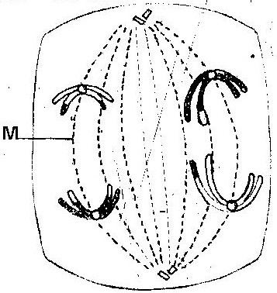

(a) (i) Identify the stage of cell division (1mark)

(ii) Give two reasons for your answer (a) (i) above (2marks)

(b) Name the structure labeled M (1mark)

- (a) What is meant by the following terms?
(i) Protandry (1mark)

(ii) Self- sterility ( 1 mark)

(b) The diagram below shows a stage during fertilization in plant
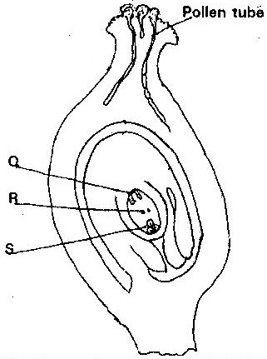

(i) Name the parts labeled ( 3 marks)

Q …………………………………………
R …………………………………………
S………………………………………….
(ii) State the function of the pollen tube ( 1 marks)

- On the diagram, label the micropyle ( 1 mark)

- A flower was found to have the following characteristics
  - Inconspicuous petals
  - Long feathery stigma
  - Small light pollen grains
- What is the likely agent of pollination of the flower? ( 1 mark)

- What is the significance of the long feathery stigma in the flower ( 1 mark)

- Name the part of a flower that developed into:
- Seed ( 1 mark)

- Fruit ( 1 mark)

Section B (20marks)
Answer question 6 (compulsory) and any other between 7 and 8 in the spaces provided

- The numbers of different types of animals supported by a square kilometer in two terrestrial ecosystems are shown in the table below

Type of ecosystem | Type of animal | Number of animals supported per sq. km
Acacia savannah | Domestic animals  Cattle  Goat  Sheep | 7  30  10
Bush land | Wild games  Thomsons’s gazelles  Eland  Wildebeest  Domestic animals  Cattle  Goats  Sheep  Wild game  Thomson’s gazelles  Eland  Wildebeest | 450  20  60  2  15  5  200  12  10

- (i) Which domestic animal is better adapted to both ecosystems? (1 mark)

(ii) Give a reason why the animal named in (a) (i) above is better adapted to the two ecosystems.

(1 mark)
- Why are cattle and sheep fewer in the bush land than in the savannah? (1 mark)

- (i) Name suitable methods that were used to estimate the population of:
Domestic animals (1 mark)

Wild animals (1 mark)

(ii) Give a reason why the method named for wild animals in (c) (i) above is suitable (1 mark)

- Name two biotic factors that could have regulated the animal population in both ecosystems
(2 mark)

- State two human activities that affect population of animals in game parks (2 mark)

- Explain how a flower is modified to insect pollination (10 marks)
- Explain how the various activities of man have caused pollution of air. (10 marks)

