SUPPLEMENTARY EXAM
FORM 3
BIO PAPER
Extracted from old KUHS past papers
NAME……………………………………………………………………………….

- Suggest and an explanation to each of the following

(a) The kidneys of desert animals have very long loop of Henle (2 marks)

…………………………………………………………………………………………………………………………………………………………………………………………………………………………………………………………
(b) Fresh water fish excrete ammonia but land animals excrete urea (2 marks)
…………………………………………………………………………………………………………………………………………………………………………………………………………………………………………………………
2. In an accident a victim suffered damage of his internal organs, consequently he started having excess glucose in his blood.
(a) Which organ was damaged? (1mk)
……………………………………………………………………………………………………………….
(b) Give a reason for your answer. (1mk)
……………………………………………………………………………………………………………….
3. Identify three plant waste products and state their economical importance to man (6 marks)

4. The diagram below represents a mammalian nephron
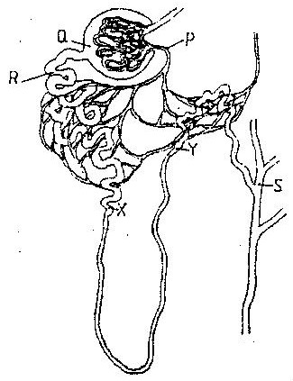

(a) Name the
(i) Structure labeled P (1mark)

(ii) Portion of the nephron between point X and Y (1mark)

(b) Name the process that takes place at point Q (1mark)

5. Describe the homeostatic function of the body to glucose regulation (5marks)

