KAHUHO UHURU HIGH SCHOOL
BIOLOGY DEPARTMENT

NAME……………………………………..……………..……..ADM NO…….…….……..CLASS……….…

FORM 3 BIOLOGY
TERM 1 2012 TUNE UP EXAM
PAPER 1
TIME: 1½ HOURS
INSTRUCTIONS
Answer all questions in the spaces provided in the paper.

QUESTIONS (50 MARKS)

1.Explain why red blood cells burst when placed in distilled water while plant cells remain intact. (2mks)
…………………………………………………………………………………………………………………………………………………………………………………………………………………………………………
2. A solution of sugarcane was boiled with hydrochloric acid; sodium carbonate was heated with Benedict’s solution. An orange precipitate was formed.
a) Why was the solution boiled with hydrochloric acid? (1mk)
…………………………………………………………………………………………………………………………………………………………………………………………………………………………………………
b) To which class of carbohydrates does sugarcane belong? (1mk)
…………………………………………………………………………………………………………………………………………………………………………………………………………………………………………
c) Name the type of reaction that takes place when:
i) Simple sugars combine to form complex sugar. (1mk)
…………………………………………………………………………………………………………………………………………………………………………………………………………………………………………
ii) A complex sugar is broken into simple sugar. (1mk)
…………………………………………………………………………………………………………………………………………………………………………………………………………………………………………
3. Explain the role of the following organs in the digestion of food in a mammal. (2mks)
a) Salivary glands
…………………………………………………………………………………………………………………………………………………………………………………………………………………………………………
b) Liver
…………………………………………………………………………………………………………………………………………………………………………………………………………………………………………
4. The diagram below represents the pathway of water from soil into the plant.
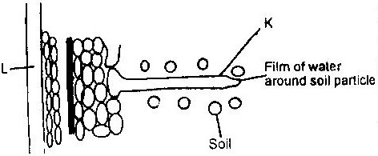

Name the structures labeled K and L (2mks)

K……………………………………….

L……………………………………….
5. a) i) Name the blood vessels that link arterioles with venules. (1mk)
…………………………………………………………………………………………………………………………………………………………………………………………………………………………………………
ii) State two ways in which the vessels you named in (a) above are suited to carrying out their functions. (2mks)
…………………………………………………………………………………………………………………………………………………………………………………………………………………………………………
……………………………………………………………………………………………………………………
b) State two ways in which the composition of blood in the pulmonary arterioles differ from that in the pulmonary venules. (2mks)
…………………………………………………………………………………………………………………………………………………………………………………………………………………………………………
……………………………………………………………………………………………………………………
6. a) Name the process by which the human body naturally stops bleeding. (1mk)
…………………………………………………………………………………………………………………………………………………………………………………………………………………………………………
b) How can low blood volume be brought back to normal? (2mks)
…………………………………………………………………………………………………………………………………………………………………………………………………………………………………………
……………………………………………………………………………………………………………………
7Name the substance which accumulates in muscles when respiration occurs with insufficient oxygen. (1mk)
…………………………………………………………………………………………………………………………………………………………………………………………………………………………………………
- a) A dog weighing 15.2kg requires 216kJ while a mouse weighing 50g requires 2736KJ per day. Explain. (2mks)
…………………………………………………………………………………………………………………………………………………………………………………………………………………………………………
……………………………………………………………………………………………………………………
- Below is a diagram of an organelle that is involved in aerobic respiration.
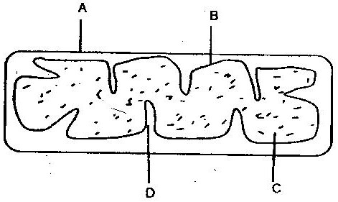

a) Name the organelle (1mk)

………………………………………………………………
b) Name the parts labeled B, and C. (2mks)

B………………………………………………………………
C………………………………………………………………
c) What is the purpose of the folding labeled D? (1mk)
…………………………………………………………………………………………………………………………………………………………………………………………………………………………………………
d) Give the chemical compound which is formed in the organelle and
forms the immediate source of energy. ( 1 mk)

……………………………………………………………………………
10. The diagram below illustrates a physiological process that occurs in
the alimentary canal of man.

Q
Fat
Molecule

Fat droplets

a) Name the process Q above (1mk) ………………………………………………………………
b) Explain the biological importance of the above process (1mk)
………………………………………………………………………………………………………………………………………………………………………………………………………………………………………..
c) Name the substance that helps the process named in (a) above (1mk)
………………………………………………………………………………………………………………………………………………………………………………………………………………………………………
- The diagram below represents an organ from a bony fish, study the diagram and answer the questions that follow.
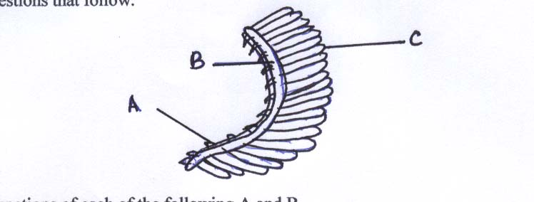

(a) State the functions of each of the following A and B (2 mark)

A…………………………………………………………………………………………………………B……………………………………………………………………………………………………………
(b) How is the structure labeled C adapted to its function? (1mark)
………………………………………………………………………………………………………………………………………………………………………………………………………………………………………
11. In plants food is manufactured in the leaves
(a) Name any two mechanisms by which food is Trans located in plants. (2 marks)
………………………………………………………………………………………………………………………………………………………………………………………………………………………………………
……………………………………………………………………………………………………………………
(b) Name the tissue concerned with translocation of food in plants (1 mark)
………………………………………………………………………………………………………………………………………………………………………………………………………………………………………
12. The table below shows the composition of the cell sap of Netella clavata.
(fresh water algae)collected from pond water.

Ions cout(
(milli equivalent per litre)
 | K | Na+ | Ca+ | Mg2+ | Cl- | SO42-
Cell sap | 50.8 | 56.2 | 11.7 | 12.1 | 105.5 | 11.0
Pond water | 0.51 | 1.2 | 1.3 | 3.0 | 1.0 | 0.67

- State with a reason the mechanism by which the ions are taken up by the fresh water algae from the pond water
Mechanism (1 mark)

…………………………………………………………
Reason (1 mark)
………………………………………………………………………………………………………………………………………………………………………………………………………………………………………
- State and explain one factor that affect the uptake of the ions by the mechanism you have named above (2 marks)
………………………………………………………………………………………………………………………………………………………………………………………………………………………………
………………………………………………………………………………………………………………
13. Distinguish between haemaglutination and blood clotting. (2 marks)
………………………………………………………………………………………………………………………………………………………………………………………………………………………………………
14. What characteristics do gills and the mouth cavity of a frog have in common that enable them to be efficient in gaseous exchange? (3 marks)
………………………………………………………………………………………………………………………………………………………………………………………………………………………………………
………………………………………………………………………………………………………………………………………………………………………………………………………………………………………
15. Name the substance which accumulates in muscle tissues when respiration occurs with Insufficient oxygen…………………………………………………………………………………………… (1 mark)
16Name the polysaccharides found in the following structures:
(a) Exoskeleton: (1 mark)
………………………………………………………………………
(b) xylem vessels: (1 mark)
………………………………………………………………………
17. The diagram below shows an alveolus and the blood vessels close to it.

- Name the type of blood vessel C. (1mark)

………………………………………………………………
- Name the gases A and B. (2 marks)
A:……………………………………………………………
B: ………………………………………………………….

