KAHUHO UHURU HIGH SCHOOL
BIOLOGY DEPARTMENT

NAME……………………………………………..……..ADM NO………….……..CLASS……….…

FORM 3 BIOLOGY
TERM 3 TUNE UP EXAM
PAPER 1
TIME: 1½ HOURS

INSTRUCTIONS
Answer all questions in the spaces provided in the paper.

QUESTIONS (50 MARKS)

1.Explain why red blood cells burst when placed in distilled water while plant cells remain intact. (2mks)
…………………………………………………………………………………………………………………………………………………………………………………………………………………………………………
2. A solution of sugarcane was boiled with hydrochloric acid; sodium carbonate was heated with Benedict’s solution. An orange precipitate was formed.
a) Why was the solution boiled with hydrochloric acid? (1mk)
…………………………………………………………………………………………………………………………………………………………………………………………………………………………………………
b) To which class of carbohydrates does sugarcane belong? (1mk)
…………………………………………………………………………………………………………………………………………………………………………………………………………………………………………
c) Name the type of reaction that takes place when:
i) Simple sugars combine to form complex sugar. (1mk)
…………………………………………………………………………………………………………………………………………………………………………………………………………………………………………
ii) A complex sugar is broken into simple sugar. (1mk)
…………………………………………………………………………………………………………………………………………………………………………………………………………………………………………
3. Explain the role of the following organs in the digestion of food in a mammal. (2mks)
a) Salivary glands
…………………………………………………………………………………………………………………………………………………………………………………………………………………………………………
b) Liver
…………………………………………………………………………………………………………………………………………………………………………………………………………………………………………

4. The diagram below represents the pathway of water from soil into the plant.
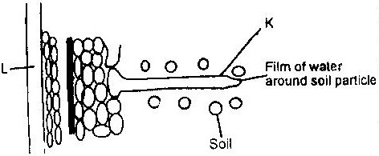

Name the structures labeled K and L (2mks)

K……………………………………….

L……………………………………….

5. a) Give an example of a phylum where all members have (2mks)
i) Open circulatory system

……………………………………….
ii) Closed circulatory system

……………………………………….
6. a) i) Name the blood vessels that link arterioles with venules. (1mk)
ii) State two ways in which the vessels you named in (a) above are suited to carrying out their functions. (2mks)
…………………………………………………………………………………………………………………………………………………………………………………………………………………………………………
……………………………………………………………………………………………………………………

b) State two ways in which the composition of blood in the pulmonary arterioles differ from that in the pulmonary venules. (2mks)
…………………………………………………………………………………………………………………………………………………………………………………………………………………………………………
……………………………………………………………………………………………………………………
7. a) Name the process by which the human body naturally stops bleeding. (1mk)
…………………………………………………………………………………………………………………………………………………………………………………………………………………………………………
b) How can low blood volume be brought back to normal? (2mks)
…………………………………………………………………………………………………………………………………………………………………………………………………………………………………………
……………………………………………………………………………………………………………………
- Name the substance which accumulates in muscles when respiration occurs with insufficient oxygen. (1mk)
…………………………………………………………………………………………………………………………………………………………………………………………………………………………………………
- a) A dog weighing 15.2kg requires 216kJ while a mouse weighing 50g requires 2736KJ per day. Explain. (2mks)
…………………………………………………………………………………………………………………………………………………………………………………………………………………………………………
……………………………………………………………………………………………………………………
- Below is a diagram of an organelle that is involved in aerobic respiration.
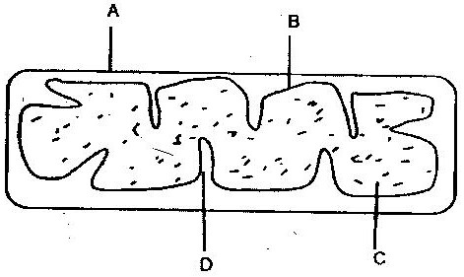

a) Name the organelle (1mk)
…………………………………………………………………………………………………………………………………………………………………………………………………………………………………………
b) Name the parts labeled B, and C. (2mks)
…………………………………………………………………………………………………………………………………………………………………………………………………………………………………………
……………………………………………………………………………………………………………………
c) What is the purpose of the folding labeled D? (1mk)
…………………………………………………………………………………………………………………………………………………………………………………………………………………………………………
d) Give the chemical compound which is formed in the organelle and
forms the immediate source of energy. ( 1 mk)
………………………………………………………………………………………………………………………………………………………………………………………………………………………………………
- How would one find out from a sample of urine whether a person is suffering from diabetes mellitus? (2 marks)
…………………………………………………………………………………………………………………………………………………………………………………………………………………………………………
……………………………………………………………………………………………………………………
- Explain the term negative feedback (2mks)
…………………………………………………………………………………………………………………………………………………………………………………………………………………………………………
……………………………………………………………………………………………………………………

- Beside the abdomen, name the other body part of members of arachnida ( 1 mark)
…………………………………………………………………………………………………………………………………………………………………………………………………………………………………………
- Below is a list of organisms, which belong to classes insecta, myriapoda and arachnida. Tick, centipede, praying mantis, tsetse fly. Millipede and spider. Place the organisms in their respective classes in the table below. Give reasons in each case. (3mks)
Class | Organisms | Reasons
Insecta
Myriapoda
Arachnida

- To estimate the population size of crabs in a certain lagoon, traps were laid at random. 400 crabs were caught, marked and released back into the lagoon. Four days later, traps were laid again and 374 crabs were caught. Out of the 374 crabs, 80 were found to have been marked.
- Calculate the population size of the crabs in the lagoon using the formula below ( 2 marks)
N = n x M
M
Where
N= Total population of crabs in the lagoon
n= Total number of crabs in the second catch
M= Number marked crabs during the first catch
M= Number of marked crabs in the second catch.

(b) State two assumptions that were made during the investigation ( 2 marks)
…………………………………………………………………………………………………………………………………………………………………………………………………………………………………………
……………………………………………………………………………………………………………………
- What is the name given to this method of estimating the population size? ( 1 mark)
…………………………………………………………………………………………………………………………………………………………………………………………………………………………………………
- A flower was found to have the following characteristics
  - Inconspicuous petals
  - Long feathery stigma
  - Small light pollen grains
- What is the likely agent of pollination of the flower? ( 1 mark)
…………………………………………………………………………………………………………………………………………………………………………………………………………………………………………
(b) Explain how the following prevents self- pollination:
(i) Protoandry ( 1 mark)
…………………………………………………………………………………………………………………………………………………………………………………………………………………………………………
(ii) Self- sterility ( 1 mark)
…………………………………………………………………………………………………………………………………………………………………………………………………………………………………………

- The diagram below represents a human foetus in a uterus
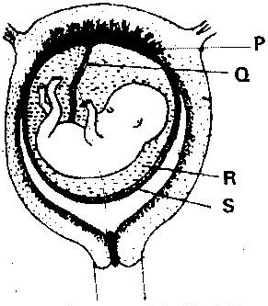

(a) Name the part labeled S ( 1 mark)
…………………………………………………………………………………………………………………………………………………………………………………………………………………………………………
(b) Name the types of blood vessels found in the structure labeled Q ( 2 marks)
…………………………………………………………………………………………………………………………………………………………………………………………………………………………………………
……………………………………………………………………………………………………………………
(c) State the role of the part labeled R ( 1 mark)
…………………………………………………………………………………………………………………………………………………………………………………………………………………………………………

- What part does the placenta play in the
- Nutrition of the embryo (1mk)
…………………………………………………………………………………………………………………………………………………………………………………………………………………………………………
(ii) Protection of the embryo ( 1 mk)
…………………………………………………………………………………………………………………………………………………………………………………………………………………………………………

