NAME:……………………………………………………………ADM NO:…………….CLASS:………

**KAHUHO UHURU HIGH SCHOOL**

**FORM 3**

**BIOLOGY PAPER 2**

**TERM 2 TUNE UP SUPPLEMENTARY EXAM**

**TIME: 1 HOUR**

## INSTRUCTIONS

* ***The paper has TWO sections A and B***
* ***Answer all questions in this section A, and follow instructions for Section B.***

**SECTION A (30 MARKS)**

1. (a) what is meant by the term biological control ( 1 mk)

(i) Give an example of biological control ( 1 mk)

(b) (i) What is eutrophication? ( 2 mks)

(ii) What are the effects of eutrophication ( 2 mks)

(c) Name a substance that is responsible for acid rain ( 1 mk)

1. The diagram below represents the lower jaw of a mammal

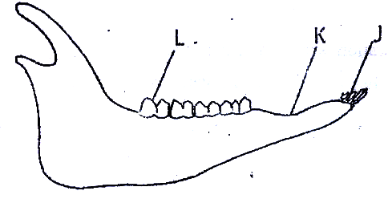

(a) Name the mode of nutrition of the mammal whose jaw is shown (1 mk)

(b) State one structural and one functional difference between the teeth labeled J and L Structural ( 1 mk)

Functional ( 1 mk)

(c) Name the toothless gap labeled K. (1 mk)

(d) Name the substance that is responsible for hardening of teeth (1 mk)

1. A freshly obtained dandelion stem measuring 5 cm long was split lengthwise to obtain two similar pieces.The pieces were placed in solutions of different concentrations in Petri dishes for 20 minutes.The appearance after 20 minutes is as shown

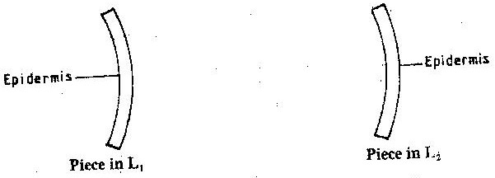

1. Account for the appearance of the pieces in solutions L1 and L2 ( 4 mks)

1. State the significance of the biological process involved in the experiment ( 2 mks)

1. State four characteristics that distinguishes arthropoda from the other phyla of the animal kingdom

(4marks)

1. The diagram below represents a traverse section through a plant organ



a). From which plant organ was the section obtained? (1 mk)

b). Give two reasons for your answer in (a) above. (2mks)

c). Name the parts labeled J,K and L. (3mks)

J

………………………………………………….

K

………………………………………………….

L

………………………………………………….

D. State two functions of the part labeled M. (2mks)

**Section B (20marks)**

Answer question 6 (compulsory) and any other between 7 and 8 in the spaces provided

1. The numbers of different types of animals supported by a square kilometer in two terrestrial ecosystems are shown in the table below

|  |  |  |
| --- | --- | --- |
| Type of ecosystem | Type of animal | Number of animals supported per sq. km |
| Acacia savannah | **Domestic animals**  Cattle  Goat  Sheep | 7  30  10 |
| Bush land | **Wild games**  Thomsons’s gazelles  Eland  Wildebeest  **Domestic animals**  Cattle  Goats  Sheep  **Wild game**  Thomson’s gazelles  Eland  Wildebeest | 450  20  60  2  15  5  200  12  10 |

1. (i) Which domestic animal is better adapted to both ecosystems? (1 mark)

(ii) Give a reason why the animal named in (a) (i) above is better adapted to the two ecosystems.

(1 mark)

1. Why are cattle and sheep fewer in the bush land than in the savannah? (1 mark)

1. (i) Name suitable methods that were used to estimate the population of:

Domestic animals (1 mark)

Wild animals (1 mark)

(ii) Give a reason why the method named for wild animals in (c) (i) above is suitable (1 mark)

1. Name four biotic factors that could have regulated the animal population in both ecosystems

(2 mark)

1. State four human activities that affect population of animals in game parks (2 mark)

1. Explain how xerophytes are suited to reduction of water loss (10 marks)
2. Explain how the various activities of man have caused pollution of air. (10 marks)