**KAHUHO UHURU HIGH SCHOOL**

**FORM 3**  MARKING SCHEME.

**BIOLOGY PAPER 2**

**MID TERM 2 EXAM 2011**

**TIME: 2 HOURS**

## INSTRUCTIONS

* ***The paper has TWO sections A and B***
* ***Answer all questions in this section A, and follow instructions for Section B.***

**SECTION A (30 MARKS**

1. (i) Using a living organism to regulate/control/ reduce/ check the population of another organism

(ii) Lady bird (beetle) used to control Aphids in coffee

- Cats used to control rats in the store/ snakes

- Wasps used to control coffee mealy bugs

(b) enrichment of water bodies with nitrates/ phosphates/ sulphates

Acc. NO-3 (aq) NH4+; due to discharge of sewage/ domestic effluent kitchen water containing water detergents/ run off water fertilizer; leading rapid growth of aquatic plants/ phytoplankton’s *( accept: nutrients phosphates)*

(ii) ( Proliferation of plants) block light from reaching plants underneath which will not

photosynthesize the plants die and decompose leading to lack/ depletion of O2; animals

also die/ suffocate.

(c) Nitrogen IV oxide/ sulphur iv oxide. Accept nitrogen dioxide sulphur dioxide

1. The diagram below represents the lower jaw of a mammal

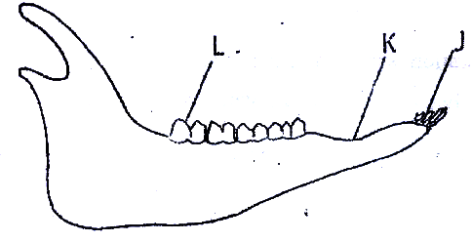

(a) Herbivorous Rej Herbivore Acc Herbivory

(b) Tooth J is narrow/ sharp/ chisel like while tooth L is broad/ ridged

Accept: J has one root while L has 2/3/4 roots

**Functional**

Tooth J is used for cutting while tooth L is used for grinding

(Acc cutting for biting)

(c)

(i) Diastema

(ii) For manipulation of blood by tongue

(d) Calcium phosphate; Rj calcium/ phosphorous/ phosphate

1. A freshly obtained dandelion stem measuring 5 cm long was split lengthwise to obtain two similar pieces.The pieces were placed in solutions of different concentrations in Petri dishes for 20 minutes.The appearance after 20 minutes is as shown

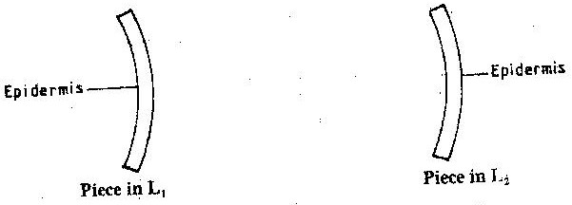

(a) L1

Inner cells gained water by Osmosis; hence increased in length; epidermal cells did not gain water because they are covered by a water proof cuticle leading to currature.

L2

Inner cells lost water by osmosis; leading to (flaccidity) decrease in length; epidermal cells did not lose water due to waterproof leading to curvature

(b)

Support in (herbaceous) plants

Absorption of water

Opening and closing of stomata

Movement of water from cell to cell

Leading in infectious plants

Folding of leaves in the Mimosa

1. The diagram below represents a stage during cell division

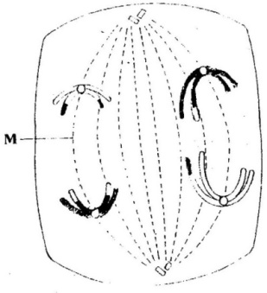

1. (i) Anaphase 1

(ii)-Homologous chromosomes separate at the equator

-Chromosomes start migrating to opposite poles

-Sister chromatids attached at the centromere

(b) Spindle fibres

1. The diagram below represents a traverse section through a plant organ



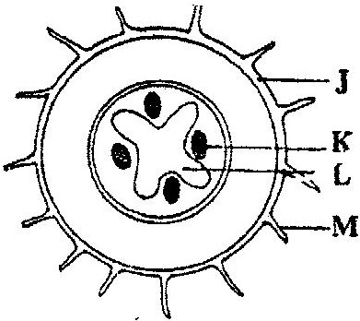

(a) Root

(b) Presence of root hairs

Presence of endodermis

Xylem star shaped at centre

Phloem at arms of the xylem

(c) J- Epidermis

K- Phloem

L – Xylem

(d) - Absorption of water

- Absorption of minerals salts

**Section B (20marks)**

Answer question 6 (compulsory) and any other between 7 and 8 in the spaces provided

1. The numbers of different types of animals supported by a square kilometer in two terrestrial ecosystems are shown in the table below

|  |  |  |
| --- | --- | --- |
| Type of ecosystem | Type of animal | Number of animals supported per sq. km |
| Acacia savannah | **Domestic animals**  Cattle  Goat  Sheep | 7  30  10 |
| Bush land | **Wild games**  Thomsons’s gazelles  Eland  Wildebeest  **Domestic animals**  Cattle  Goats  Sheep  **Wild game**  Thomson’s gazelles  Eland  Wildebeest | 450  20  60  2  15  5  200  12  10 |

1. *(a) (i) Goat*

*(ii) It is a grazer and a browser*

*(b) Insufficient grass in bush/ aren’t adapted to eating twigs/ not browsers/ are grazers*

*(c) (i) Domestic animals - total counts*

*Wild animals – total counts; aerial counts/ quadrat/ Belt transect/ capture/ recapture*

*(ii) Analyzing gut counts, studying dentition/ breaks/ claws/ parts*

*(d) Irrigation*

*Competition; diseases*

*Predation; human activity/ man accept any correct*

*Parasitism*

1. *Poaching, cropping/ culling/ licensed spot hunting*

*OWTTE*

1. Explain how xerophytes are suited to reduction of water loss (10 marks)

Reduced leaf surface/Thorny Leaves; reduce surface area thusreduce water loss

Sunken stomata; reduces exposure of water to factors of transpiration

Deep roots; to absorb water to replace any lost through transpiration(by transpiration pull

Succulent stems; to store water thus use it when needed

Small number of stomata; to reduce chances of loosing water

Stomata may be found on the lower side of the leaves; to reduce exposure to factors that increase transpiration

1. Explain how the various activities of man have caused pollution of air. (10 marks)

Sulphur based chemicals e.g. sulphure dioxide gas H2S Cl2 HCl2 produced by (food preventing) industries /sewages matter, Affect gaseous exchange/makes acid rain /damages plants leaves.

Acc. Pesticides, Herbicides, Insecticides, Acaricides, paint sprays,

Aerosols

CFCs sprayed to control (plant) disease and pests, also affect respiratory organs of animals; the chemicals are residuals and persistent (not easily) broken down deplete.

Ozone layers; smoke/fumes produced in areas with (heavy) industries and (high density of motor vehicles / fire which burn fuel/oils wood coal; These visibility; fumes also settle on leaves and stop photosynthesis (excessive) production of carbon dioxide causes the green house effect/Temp. inversion as a result of heating in lower layers of atmosphere; sound /noise produced incessantly b machines/ heavy vehicles/aircraft; affects hearing in animals; Dust, industrial production of (cement) generates dust; which finally settles on plants leaves limiting photosynthesis; removal of vegetation/cutting of trees; interferes with.

The carbon cycle; radioactive emissions; from nuclear reactors/mines/ x-rays machines bombs cause mutation/cancer/death.