NAME: --------------------------------------------------------------------- ADM.No:--------------- CLASS: --------------
KAHUHO UHURU HIGH SCHOOL
FORM 3: BIOLOGY
MID TERM EXAMINATION
TERM 2 2016
TIME: 1 ½ HOURS
INSTRUCTION
Answer ALL questions in this paper in the spaces provided

- The photographs below represent different types of animals. Study them carefully and answer the questions that follow.

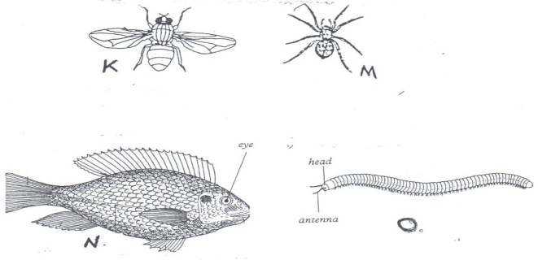

      - State two observable differences between K and M. (2mks)

      - Classify specimen M into the following taxa giving reasons for each case.
- Phylum (1mk)

Reasons (3mks)

- Class (1mk)

- Reasons (3mks)

      - (i) Name the class to which the specimen N belongs. (1mk)

    - Give three reasons for your answer in (d) (i) above. (3mks)

- (a) Define the following terms. (2marks)
- Population

- Community

(b) Name a method that could be used to estimate the population size of the following organisms.
- Fish in a pond. (1mark)

- Black jack in a garden. (1mark)

- State three differences between Chilopoda and Diplopoda. (3marks)

- The diagram below represents a member of the kingdom Animalia.
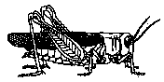
- Name the phylum to which the organism belongs. (1mark)

- Using observable features in the diagram, give three reasons for the answer in (i) above. (3marks)

1. Below is a diagram of nitrogen cycle. Study it and answer the questions that follows.
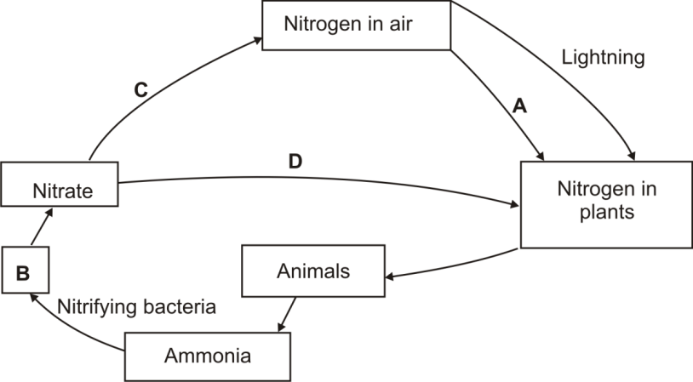

- Name the processes represented by: A and B ( 2marks)

- Name the compound represented by B (1mk)

- Name the group of organisms represented by C (1mk)

(d) (i) Identify the class of the plants to which the above cycle takes place (1mk)

(iii)Name the part of the plant where process A takes place (1mk)

6. A certain experiment was performed to demonstrate the effect of sweating on human body temperature. Boiling tubes A and B were filled each with water their initial temperatures recorded. This was repeated after every 5 minutes. The surface of Tube A was continuously wiped with a piece of cotton wool which had been soaked in methylated spirit. The results are as shown below.
Time (Min) Temperature O^{C} in tubes

A B
0 80 80
5 54 67
10 40 59
15 29 52
20 21 47
25 18 46

- On the same axis, plot graphs of water temperature against time (min) (8mks)
- Find the rate of cooling in test tube A (1mk)

- Why was tube B included in the set up? (1mk)

- Name two ways through which heat is lost in tube B (2mks)

- State the expected results if tube A was insulated (1mk)

- Name the structures in the following organisms that would insulate heat loss
- Birds (1mk)

- Mammals (1mk)

- Name any two receptor cells on the skin of man (2mks)
- Describe the response of hair on the skin during cold weather (3mks)

