NAME……………………………………………..…….. ADM NO…………..CLASS…….. ROLL NO……

KAHUHO UHURU HIGH SCHOOL

BIOLOGY DEPARTMENT
FORM III END OF TERM EXAM
TERM 3 2014
Time 1 Hr.30min.

Attempt all the questions in the space provide.

QUESTIONS (50 marks)

- Suggest the importance of each of the following in living organisms
- Nutrition. (2mks)
……………………………………………………………………………………………………………………………………
……………………………………………………………………………………………………………………………………
- Excretion
……………………………………………………………………………………………………………………………………
……………………………………………………………………………………………………………………………………
- The diagram below illustrates a growing pollen tube.

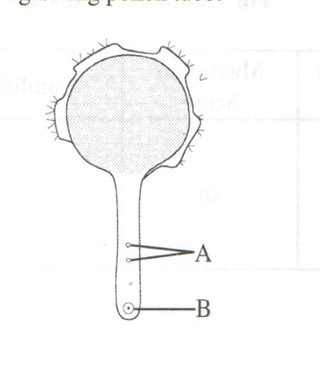
- Name the part labelled B (1mk)

………………………………………………………………………………………………………………………………………………
- Explain the role of the parts labelled A (2mks)
………………………………………………………………………………………………………………………………………………
………………………………………………………………………………………………………………………………………………
- A student drew a 6cm long diagram of a plant flower.If the actual lengh of the flower was 12cm, calculate the magnification of the drawing made by the student?Show your working. (2mks)

………………………………………………………………………………………………………………………………………………
………………………………………………………………………………………………………………………………………………
- a) Explain two roles of diffusion in human beings? (4mks)

………………………………………………………………………………………………………………………………………………

………………………………………………………………………………………………………………………………………………
………………………………………………………………………………………………………………………………………………
………………………………………………………………………………………………………………………………………………
………………………………………………………………………………………………………………………………………………
b)What is meant by each of the following terms?
i) Crenated cell. (1mk)
…………………………………………………………………………………………………………………………………………..….
…………………………………………………………………………………………………………………………………………..….
ii) flaccid cell (1mk)
…………………………………………………………………………………………………………………………………………..….
…………………………………………………………………………………………………………………………………………..….
- The diagram below shows a set up for an experiment to demonstrate a certain physiological process
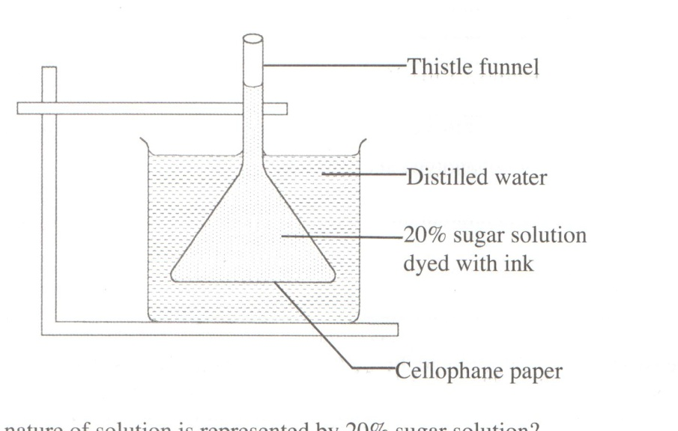

a)what nature of solution is represented by 20% sugar solution? (1mk)

……………………………………………………………………………………………………………………………………

b) Explain the observation made on the setup after one hour (2mks)
……………………………………………………………………………………………………………………………………………………………………………………………………………………………………………………………………………………………..
…………………………………………………………………………………………………………………………………………..….
- The diagram below represents a model used to demonstrate breathing in mammals
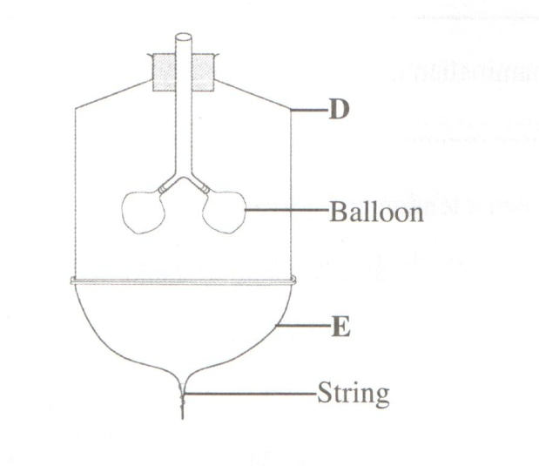

- Name the mammalian structure represented by the parts labelled D and E
- D……………………………………………………………………………. (1mk)
- E……………………………………………………………………………..
- State the observation made when the string is pulled downwards (1mk)
…………………………………………………………………………………………………………………………………………..….………………………………………………………………………………………………………………………………
- Explain the observation in (b) above. (2mks)
…………………………………………………………………………………………………………………………………………..….………………………………………………………………………………………………………………………………
- Explain why
- Mammalian testes are located to hang outside the body (2mks)
…………………………………………………………………………………………………………………………………………..….…………………………………………………………………………………………………………………………
- Four months after fertilization, ovaries can be removed from a human female, without terminating pregnancy (2mks)
…………………………………………………………………………………………………………………………………………..….…………………………………………………………………………………………………………………………
- Why is a burning charcoal stove in a poorly ventilated room likely to cause death of inhabitants (3mks)
…………………………………………………………………………………………………………………………………………..….…………………………………………………………………………………………………………………………
…………………………………………………………………………………………………………………………………………..….…………………………………………………………………………………………………………………………
- State one function of each of the following cell organelles
- Golgi bodies (1mk)
…………………………………………………………………………………………………………………………………………..….…………………………………………………………………………………………………………………………
- Lysosomes (1mk)
…………………………………………………………………………………………………………………………………………..….…………………………………………………………………………………………………………………………
- Below is an illustration of a cross section of a plant root showing the transportation of substances in the plant
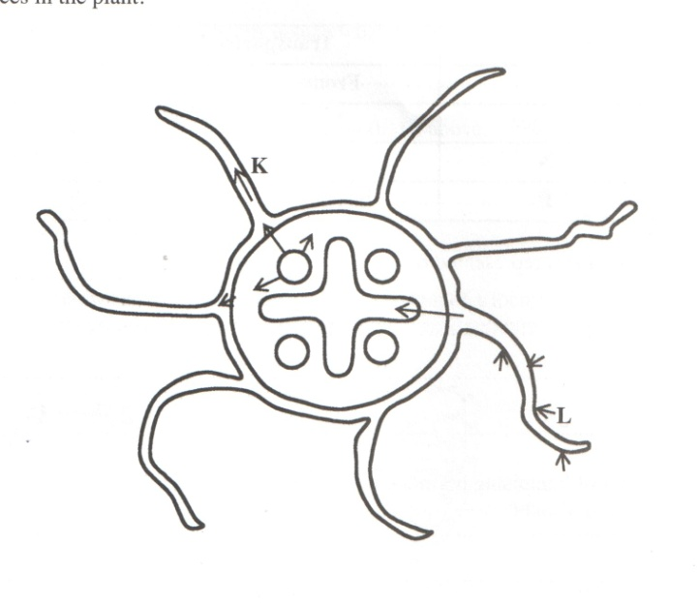
- Name the substances transported along the paths labelled K and L
K…………………………………………………………………………….. (1mk)
L…………………………………………………………………………….. (1mk)
- Give a reason for your answer in L above (1mk)
…………………………………………………………………………………………………………………………………………..….
…………………………………………………………………………………………………………………………………………..….

- The table provided shows the transportation of substances in the human body

Substance | Transported by
 | From | To
Oxygen | M | Whole body
N | Liver | Kidneys
P | Intestines | Whole body

Name the substances represented by
M …………………………………………………………………………… (1mk)
N …………………………………………………………………………… (1mk)
P …………………………………………………………………………… (1mk)

- State two role of Luteinising hormone in human reproduction (2mks)

…………………………………………………………………………………………………………………………………………..….………………………………………………………………………………………………………………………………
……………………………………………………………………………………………………………………………………..

- The table provided shows the concentration of sodium and iodine in sea water and cell sap of a plant

 | Sodium Concentration | Iodide ion Concentration
Sea water | 250 | 35
Cell Sap | 100 | 550

- i) Name the process through which the plant cells take up sodium ions (1mk)

…………………………………………………………………………………………………………………………………………..….………………………………………………………………………………………………………………………………

ii)Give a reason for your answer (1mk)
…………………………………………………………………………………………………………………………………………..….………………………………………………………………………………………………………………………………

- If the plant was sprayed with a chemical that inhibits respiration:
- Which of the two ions uptake will be affected? (1mk)
…………………………………………………………………………………………………………………………………………..….…………………………………………………………………………………………………………………………
- Give a reason for your answer in (b) (i) above. (1mk)
…………………………………………………………………………………………………………………………………………..….……………………………………………………………………………………………………………………

- The diagram below shows the gaseous the gaseous exchange system of a locust

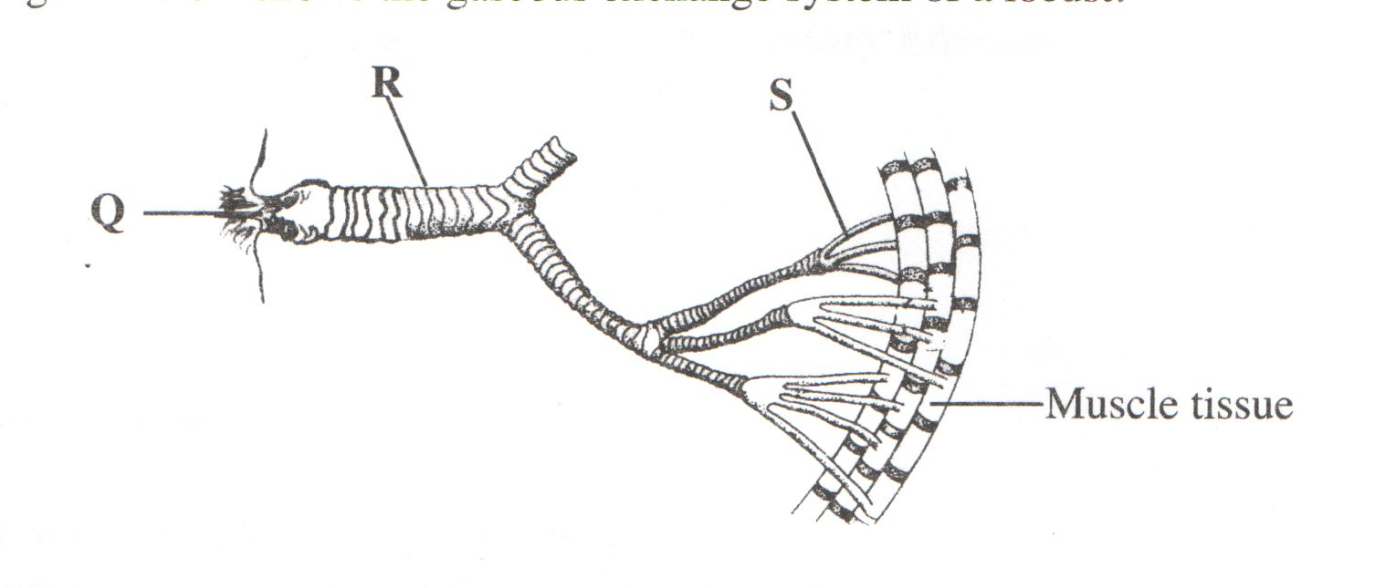
- Name the structure labelled Q (1mk)
…………………………………………………………………………………………………………………………………………..….…………………………………………………………………………………………………………………………

- State the function of the part labelled R (1mk)
…………………………………………………………………………………………………………………………………………..….…………………………………………………………………………………………………………………………
- How is the part labelled S structurally adapted to its function? (2mks)
…………………………………………………………………………………………………………………………………………..….…………………………………………………………………………………………………………………………

- a) State four characteristics of fruits dispersed by animals (4mks)
…………………………………………………………………………………………………………………………………………..….…………………………………………………………………………………………………………………………
…………………………………………………………………………………………………………………………………………..….……………………………………………………………………………………………………………………………………………………………………………………………………………………………………………………………………..….…………………………………………………………………………………………………………………………
b)Explain the role of calcium ions in blood clotting (1mk)
…………………………………………………………………………………………………………………………………………..….………………………………………………………………………………………………………………………………
…………………………………………………………………………………………………………………………………………..….………………………………………………………………………………………………………………………………

Merry Christmass

