NAME: ……………………………………..…… DATE: ……………………………………….............
ADM NO: .…………….……….……..…..…….. CANDIDATE’S SIGNATURE: …………..………..

231/1
BIOLOGY PAPER 1 (THEORY)
TERM TWO
TIME: 2 HOURS
FORM THREE

Kenya certificate of Secondary school Education (KCSE)

INSTRUCTIONS TO CANDIDATES

- Write your name and Admission number in the spaces provided above.
- Sign and write the date of examination in the space provided above.
- Answer ALL questions in the space provided.
- Candidates should check the question paper to ascertain that all the pages are printed.

FOR EXAMINER’S USE ONLY

QUESTION | MAXIMUM SCORE | CANDIDATES SCORE
1 - 23 | 80

DIGITAL PROVE INVESTMENT CO.
BOX 7877-00200 NRB
TEL :0716052864

- Using definition only differentiate between growth and development (2 mks)
……………………………………………………………………………………………………………..
……………………………………………………………………………………………………………..
……………………………………………………………………………………………………………..
……………………………………………………………………………………………………………..
- Name two cell structures that synthesize the following cell organelles (2 mks)
- Ribosomes
………………………………………………………………………………………………………….
- Nucleolus
………………………………………………………………………………………………………….

- Give four different between plants and animals (4 mks)
……………………………………………………………………………………………………………..
……………………………………………………………………………………………………………..
……………………………………………………………………………………………………………..
……………………………………………………………………………………………………………..

- Give the functions of the following parts of a microscope (4 mks)
- Condenser
………………………………………………………………………………………………………….

- Objective lens
………………………………………………………………………………………………………….

- Body tube
………………………………………………………………………………………………………….

- Diaphragm
………………………………………………………………………………………………………….
………………………………………………………………………………………………………….

- Study the reaction below and answer the questions that follow.
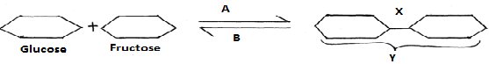
- What biological processes are represented by A and B? (2 mk)
………………………………………………………………………………………………………….
………………………………………………………………………………………………………….

- Identify the product Y. (1 mk)
………………………………………………………………………………………………………….

- State the bond represented by X. (1 mk)
………………………………………………………………………………………………………….
- In an experiment to investigate an aspect of digestion, two tubes A and B were set up as shown in the diagram below.
Starch + saliva
Starch + boiled saliva
Water bath at 37ºC
A
B

The test tubes were left in the water bath for 30 minutes. The content of each tube was then tested for starch using iodine solution.
- What was the aim of the experiment? (1 mk)
………………………………………………………………………………………………………….

- Explain the expected in the tube. (4 mks)
………………………………………………………………………………………………………….
………………………………………………………………………………………………………….
………………………………………………………………………………………………………….
………………………………………………………………………………………………………….
- Explain the events of the light stage of photosynthesis. (3 mk)
……………………………………………………………………………………………………………..
……………………………………………………………………………………………………………..
……………………………………………………………………………………………………………..
- State two adaptations of red blood cells to their functions (4 mks)
……………………………………………………………………………………………………………..
……………………………………………………………………………………………………………..
- Explain how the following adaptation reduce transpiration in xerophytes
- Sunken stomata (2 mks)
………………………………………………………………………………………………………….
………………………………………………………………………………………………………….
- Thick waxy cuticle (2 mks)
………………………………………………………………………………………………………….
………………………………………………………………………………………………………….
- Name the:
- Material that strengthens xylem tissue (1 mk)
………………………………………………………………………………………………………….

- Tissue that is removed when the bark of a dicotyledonous plant is ringed (1 mk)
………………………………………………………………………………………………………….

- Conducts water in a plant (1 mk)
………………………………………………………………………………………………………….
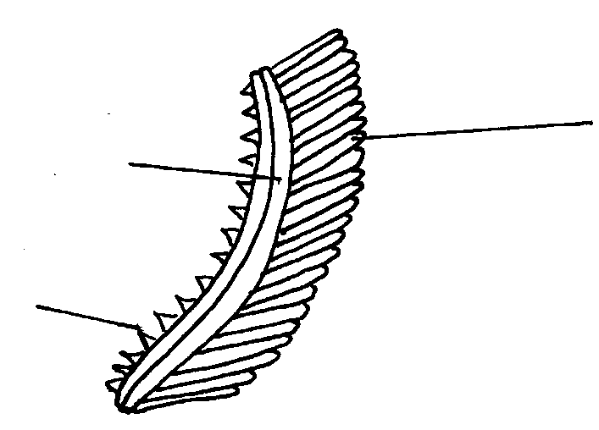
- The diagram below represents an organ from a bony fish. Study the diagram and answer the questions that follow:
B
C
A

- State the functions of each of the following: (3 mks)
A…………………………………………………………………………………………………………………………………………………………………………………………………………………
B………………………………………………………………………………………………………
C………………………………………………………………………………………………………
- How is the structure labeled C adapted to its function (4 mks)
………………………………………………………………………………………………………….
………………………………………………………………………………………………………….
………………………………………………………………………………………………………….
………………………………………………………………………………………………………….
- Name one part of the mammal that the above organ represents in function (1 mk)
……………………………………………………………………………………………………………..

- Give two phases of aerobic respiration (2 mks)
………………………………………………………………………………………………………….
………………………………………………………………………………………………………….
- Give two end products anaerobic respiration (2 mks)
………………………………………………………………………………………………………….
………………………………………………………………………………………………………….
- Name three plant leaf excretory products (3 mks)
……………………………………………………………………………………………………………..
……………………………………………………………………………………………………………..
……………………………………………………………………………………………………………..
- A student mixed a sample of urine from a person with Benedict’s solution and heated, the colour changed to orange.
- What was present in the urine sample (1 mk)
………………………………………………………………………………………………………….

- What did the student conclude on the health status of the person (2 mks)
………………………………………………………………………………………………………….
………………………………………………………………………………………………………….
- Which organ in the person may not be functioning properly (1 mk)
………………………………………………………………………………………………………….
- Name three diseases that affect the kidney (3 mks)
……………………………………………………………………………………………………………..
……………………………………………………………………………………………………………..

- What is meant by the term taxonomy (1 mk)
………………………………………………………………………………………………………….
………………………………………………………………………………………………………….

- The scientific name of a rat is Rattus norvegicus
- Write the name correctly (1 mk)
……………………………………………………………………………………………………..

- Identify the genus and species names (2 mks)
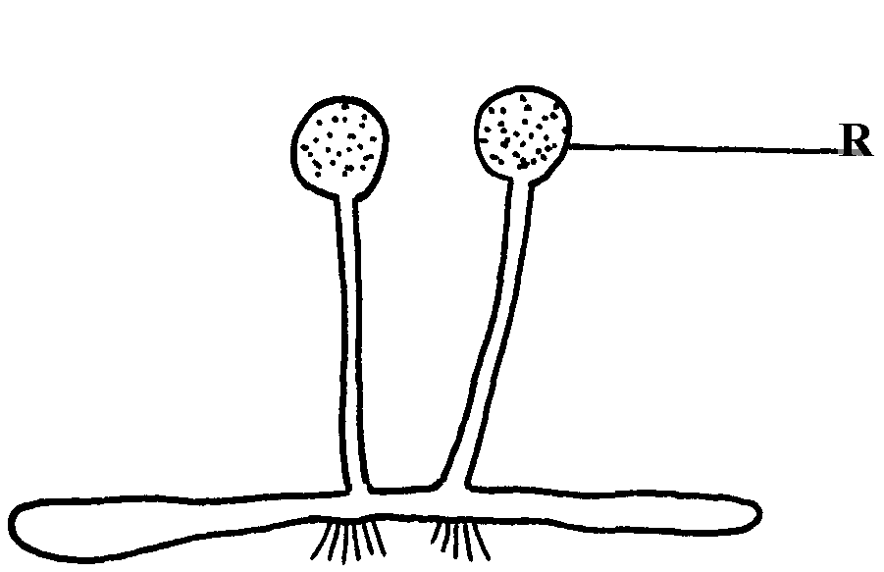
…………………………………………………………………………………………………….
The diagram below represents a bread mould:-

- Identify the kingdom to which the organism belongs (1 mk)
………………………………………………………………………………………………………….
- Name the part marked R (1 mk)
………………………………………………………………………………………………………….
- Identify three types of leaf phylotaxy (3 mks)
………………………………………………………………………………………………………….
………………………………………………………………………………………………………….
………………………………………………………………………………………………………….
- What is the significance of the following in the ecosystem:
- Decomposers (2 mks)
………………………………………………………………………………………………………….

- Predators (2 mks)
………………………………………………………………………………………………………….

- Birds feed on grasshoppers that feed on grass.
- Draw a possible food chain from the above information (2 mks)
………………………………………………………………………………………………………….
………………………………………………………………………………………………………….

- Explain why the biomass of organisms decreases at each preceding trophic level. (2 mks)
………………………………………………………………………………………………………….
………………………………………………………………………………………………………….

- Name the causative agent of the following diseases;
- Cholera (1 mk)
………………………………………………………………………………………………………….

- Typhoid (1 mk)
………………………………………………………………………………………………………….

- Identify three ways of estimating population size in a population (3 mks)
……………………………………………………………………………………………………………..
……………………………………………………………………………………………………………..
……………………………………………………………………………………………………………..

- Name two part of an ovule that develops into each of the following parts of a seed after fertilization
(2 mks)
- Testa
………………………………………………………………………………………………………….

- Endosperm
………………………………………………………………………………………………………….

©2015 DIGITAL PROVE INVESTMENT CO.
NAIROBI KENYA.
PO BOX 7877-00200
CELL 0716052864 / 0770636455
END

