NAME: ……………………………………..…… DATE: ……………………………………….....

ADM NO: .…………….……….……..…..…….. CANDIDATE’S SIGNATURE: …………..…

231/2
BIOLOGY PAPER 2
(THEORY)
TIME: 2 HOURS
TERM TWO
FORM THREE

INSTRUCTIONS TO CANDIDATES

- Write your name and Admission number in the spaces provided above.
- Sign and write the date of examination in the space provided above.
- The paper consists of Sections A and B.
- Answer ALL questions in Section A in the space provided.
- In Section B answer question 6 (compulsory) and either 7 or 8 in the space provided.
- Candidates should check the question paper to ascertain that all the pages are printed as indicated and no question is missing.

FOR EXAMINERS USE ONLY
SECTION | QUESTION | MAXIMUM SCORE | CANDIDATES SCORE
A | 1 | 08
 | 2 | 08
 | 3 | 08
 | 4 | 08
 | 5 | 08
B | 6 | 20
 | 7 | 20
 | 8 | 20
 | TOTAL | 80

DIGITAL PROVE INVESTMENT CO. TEL. 0716052864

SECTION A
- The diagram below represents a process in a given organism.
a) (i) Name the organism (1 mk)
…………………………………………………………………………………………………………
(ii) Identify the process that is shown to be taking place. (1 mk)
…………………………………………………………………………………………………………
(iii) State the economic importance of organisms found in the kingdom which the organisms shown above belong (2 mks)
…………………………………………………………………………………………………………
…………………………………………………………………………………………………………
b) (i) Define the term species (2 mks)
…………………………………………………………………………………………………………
…………………………………………………………………………………………………………
(ii) State two principles of binomial nomenclature (2 mks)
…………………………………………………………………………………………………………
…………………………………………………………………………………………………………
- The information given below was obtained in a certain ecosystem

Organism Biomass
Green plants 95
Lizards 15
Praying Mantis 7
Predatory birds 14
Moths 20
Grass hoppers 30
Herbivorous bugs 18

a) Construct a labeled pyramid of biomass (2 mks)

b) (i) Construct four step food chains (2 mks)
………………………………………………………………………………………………………………
………………………………………………………………………………………………………………
………………………………………………………………………………………………………………
………………………………………………………………………………………………………………
(ii) State two ways in which energy is lost in an ecosystem (2 mks)
………………………………………………………………………………………………………………
………………………………………………………………………………………………………………
………………………………………………………………………………………………………………
……………………………………………………………………………………………………………………………………………………………………………………………………………………………………
(iii) From the data given above state two groups of animals competing for the same resource (2 mks)
………………………………………………………………………………………………………………
………………………………………………………………………………………………………………
…………………………………………………………………………………………………………………..
…………………………………………………………………………………………………………………..

- Proteins are present in a balanced diet. They are broken down into amino acid, the body cannot store amino acids, and so any excess amino acids are metabolized as shown below.
Excess amino acids

Process S

Non-nitrogen organic compound Urea

Process T

Carbon (IV) oxide + water + energy Removal from the body

- Names the process S and T, stating the organ in which each occurs. (4 mks)
Process | Name | Organ
S
T

- Describe how urea is transported to the site of removal from the body. (2 mks)
…………………………………………………………………………………………………………
…………………………………………………………………………………………………………
…………………………………………………………………………………………………………
…………………………………………………………………………………………………………
- State the type of respiration shown, giving a reason to explain your answer (2 mks)
…………………………………………………………………………………………………………
…………………………………………………………………………………………………………
- 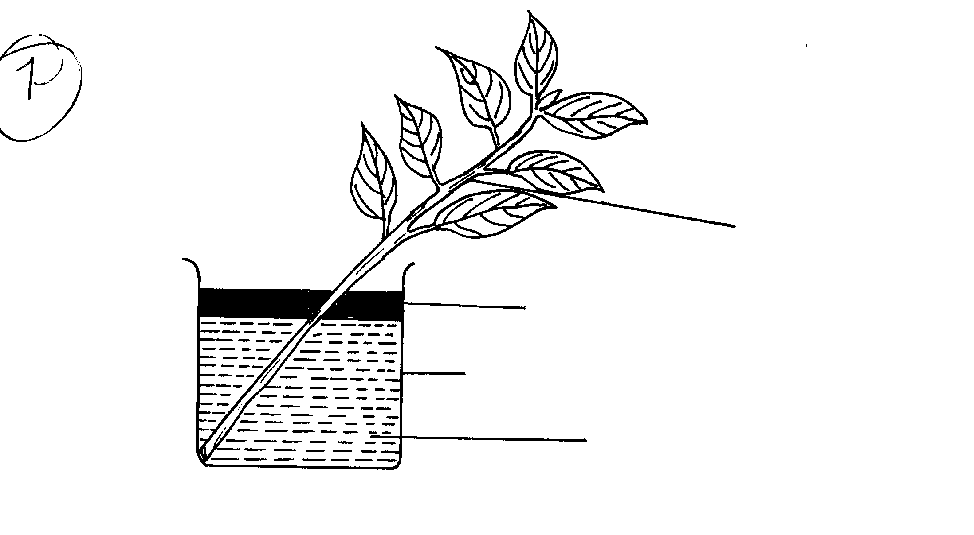An experiment shown below was set-up to investigate a certain physiological process in plants:
Leafy Shoot
Oil
Beaker
Water

- What process was being investigated (1 mk)
…………………………………………………………………………………………………………

- Give the role of the oil layer in this experiment (1 mk)
…………………………………………………………………………………………………………

- (i) What observation did the students make after leaving the set-up in bright sunlight for two hours
(1 mk)
……………………………………………………………………………………………………..
……………………………………………………………………………………………………..
(ii) Explain the observation in (c) (i) above (1 mk)
……………………………………………………………………………………………………..
……………………………………………………………………………………………………..
d) What effect will the following have on the observation made:-
i) Fanning the shoot (1 mk)
……………………………………………………………………………………………………….
ii) Removing all the leaves from the shoot (1 mk)
………………………………………………………………………………………………………..
iii) Placing the set-up in the dark (1 mk)
………………………………………………………………………………………………………..
e) Suggest a suitable control for this experiment (1 mk)
…………………………………………………………………………………………………………
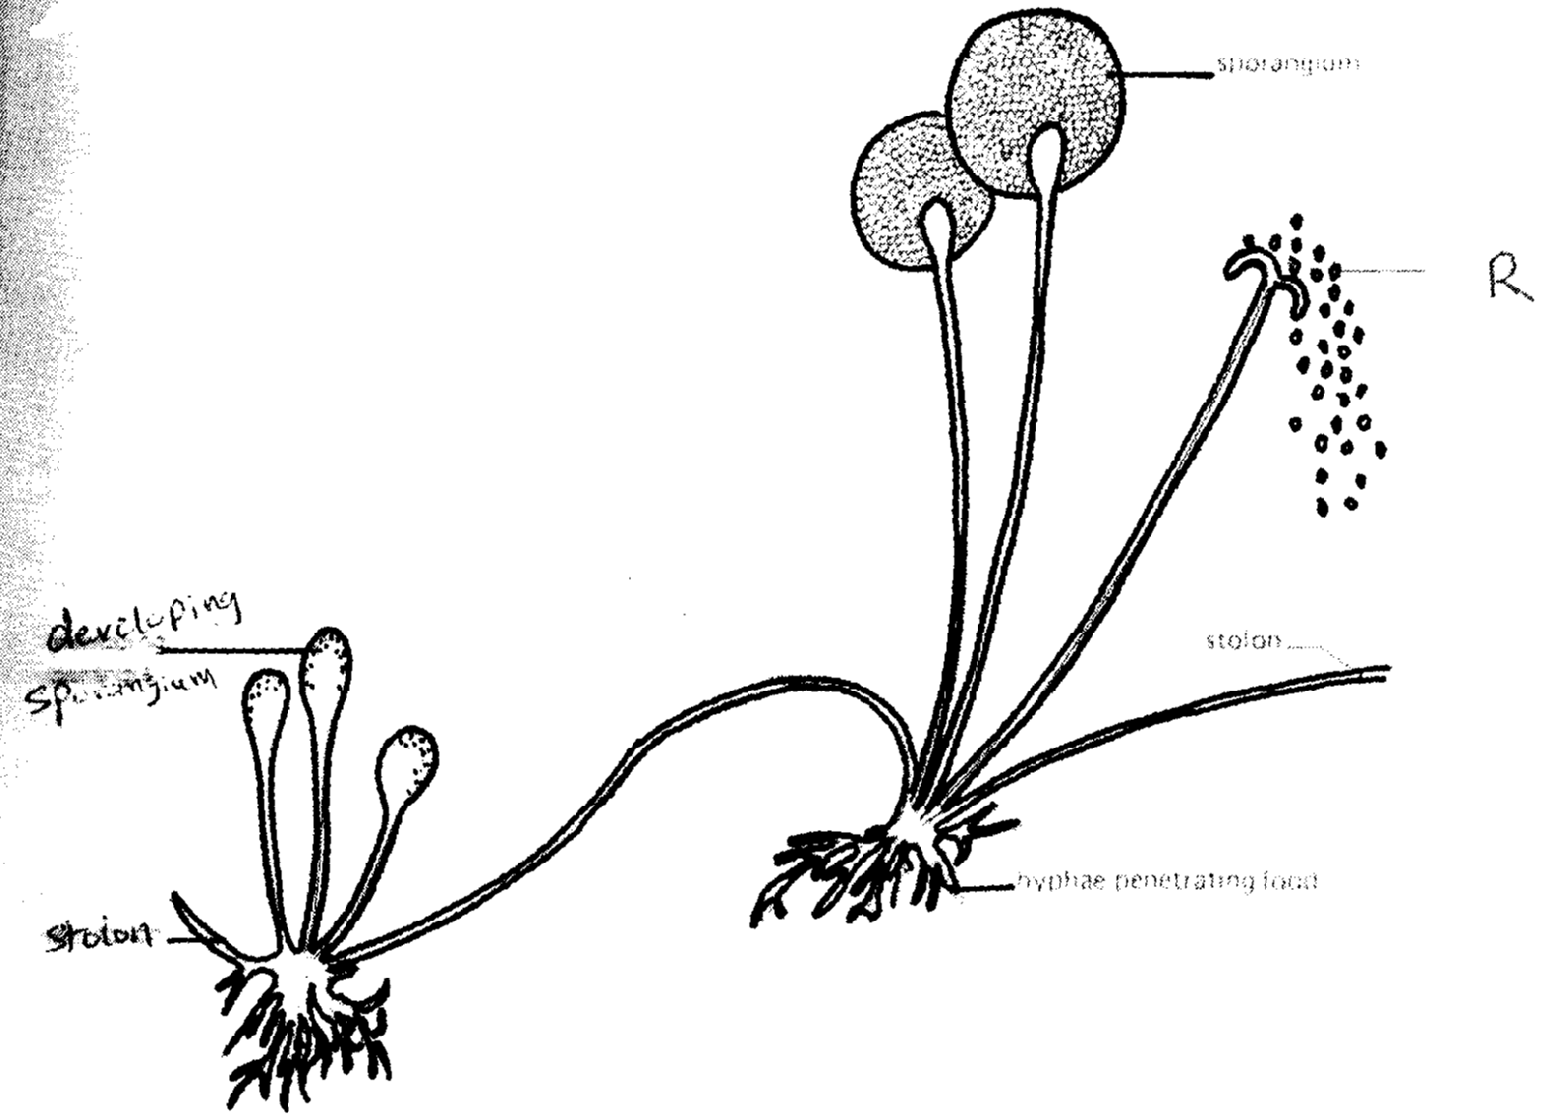
R
Stolon
Sporangum
Stolon
Hyphae penetrating food
Developing sporangium
- The diagram below represents a bread mould.

a) (i) Name the Kingdom to which bread mould belongs. (1 mk)
…………………………………………………………………………………………………………
…………………………………………………………………………………………………………
(ii) Give three distinguishing characteristics of the Kingdom named in (a)(i) above. (3 mks)
…………………………………………………………………………………………………………
…………………………………………………………………………………………………………
…………………………………………………………………………………………………………
b) Give four general characteristics of Class Mammalia (4 mks)
…………………………………………………………………………………………………………
…………………………………………………………………………………………………………
…………………………………………………………………………………………………………
…………………………………………………………………………………………………………
SECTION B
- Two persons X and Y drunk volume of concentrated solutions of glucose. The amount of glucose in their blood was determined at intervals. The results are as shown in the table below.

Time (Min) | Glucose level in blood (mg/100cm³)
 | X | Y
0 | 87 | 84
15 | 112 | 123
30 | 139 | 170
45 | 116 | 188
60 | 100 | 208
90 | 95 | 202
120 | 92 | 144
150 | 88 | 123

- On the grid provided, plot graphs of glucose level in the blood of X and Y against time, on the same axis. (8 mks)
- What was the concentration of glucose in blood of X and Y at 20th minute (2 mks)
X
…………………………………………………………………………………………………………

Y
…………………………………………………………………………………………………………
- Suggest why the glucose level in person X stopped rising after 30 minutes while that of person Y kept on rising (2 mks)
…………………………………………………………………………………………………………..
…………………………………………………………………………………………………………..
…………………………………………………………………………………………………………..

- Account on decrease in glucose level in person X after 30 minutes and Y after 60 minutes. (4 mks)
…………………………………………………………………………………………………………..
…………………………………………………………………………………………………………..
…………………………………………………………………………………………………………..
…………………………………………………………………………………………………………..
…………………………………………………………………………………………………………..

- Name the compound that stores energy released during oxidation of glucose in cells (1 mk)
…………………………………………………………………………………………………………..

- Explain what happens to excess amino acids in man (2 mks)
…………………………………………………………………………………………………………..
…………………………………………………………………………………………………………..
…………………………………………………………………………………………………………..

- State the assimilation of fatty acids and glycerol in man (1 mk)
…………………………………………………………………………………………………………..
…………………………………………………………………………………………………………..

- Describe how the human male reproductive system is adapted to its function (20 mks)
- Describe the process of digestion that takes place when one eats an egg and ugali. (20 mks)

DIGITAL PROVE INVESTMENT CO.
0716052864
END OF PRINTED PAGE

