NAME: ……………………………………..…………………………………….…… DATE: ………………………………
ADM NO: .…………….……….……..…..…….. CANDIDATE’S SIGNATURE: …………..………..
SCHOOL………………………………………………………………………………………………………………………

231/3
BIOLOGY
PAPER 3 (PRACTICAL)
TERM TWO
TIME 1 ¾ HOURS
FORM THREE

INSTRUCTIONS TO CANDIDATES
- Write your name and Admission number in the space provided above.
- Sign and write the date of examination in the space provided above.
- Answer all questions in the spaces provided in this question paper.
- You are supposed to spend the first 15 minutes of the 1 ¾ hours allowed for this paper reading the whole paper carefully before commencing your work.
- Additional pages must not be inserted.
- Candidates should check the question paper to ascertain that all the pages are printed as indicated and no questions are missing.

QUESTIONS | MAXIMUM SCORE | CANDIDATES
1 | 12
2 | 15
3 | 13
TOTAL | 40

DIGITAL PROVE INVESTMENT CO.TEL 01716052864 .-

- You are provided with visking tubing labeled J, a piece of thread and a solution labeled K.
Dip the visking tubing in distilled water to moisten it, open it, and then tie one end tightly with the thread provided.
Half-fill the visking tubing with solution K then tie the open end of the tubing tightly. Ensure solution K does not spill out of the tubing.
Immerse the visking tubing into distilled water in a beaker. Ensure that the visking tubing is completely immersed in the distilled water.
Leave the set-up for 20 minutes. Record your observations after 20 minutes.
(a) (i) Observations (1 mk)
……………………………………………………………………………………………………...

(ii) Explain you observations in a (i) above (2 mks)
……………………………………………………………………………………………………...
……………………………………………………………………………………………………...
……………………………………………………………………………………………………...

(b) Remove the visking tubing carefully. Ensure the contents of the visking tubing do not mix with that of the beaker.Using the reagents provided, test for the food substance present in the visking tubing and the beaker.

I Visking tubing (3 mks)
FOOD TEST | PROCEDURE | OBSERVATIONS | DEDUCTIONS
Starch

Reducing sugars

II Beaker (3 mks)
FOOD TEST | PROCEDURE | OBSERVATIONS | DEDUCTIONS
Starch

Reducing sugars

(c) Explain the observations and deductions in (b) above. (3 mks)
……………………………………………………………………………………………………...
……………………………………………………………………………………………………...
……………………………………………………………………………………………………...
……………………………………………………………………………………………………...

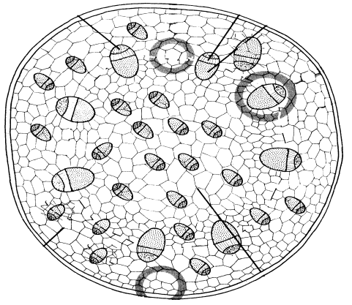
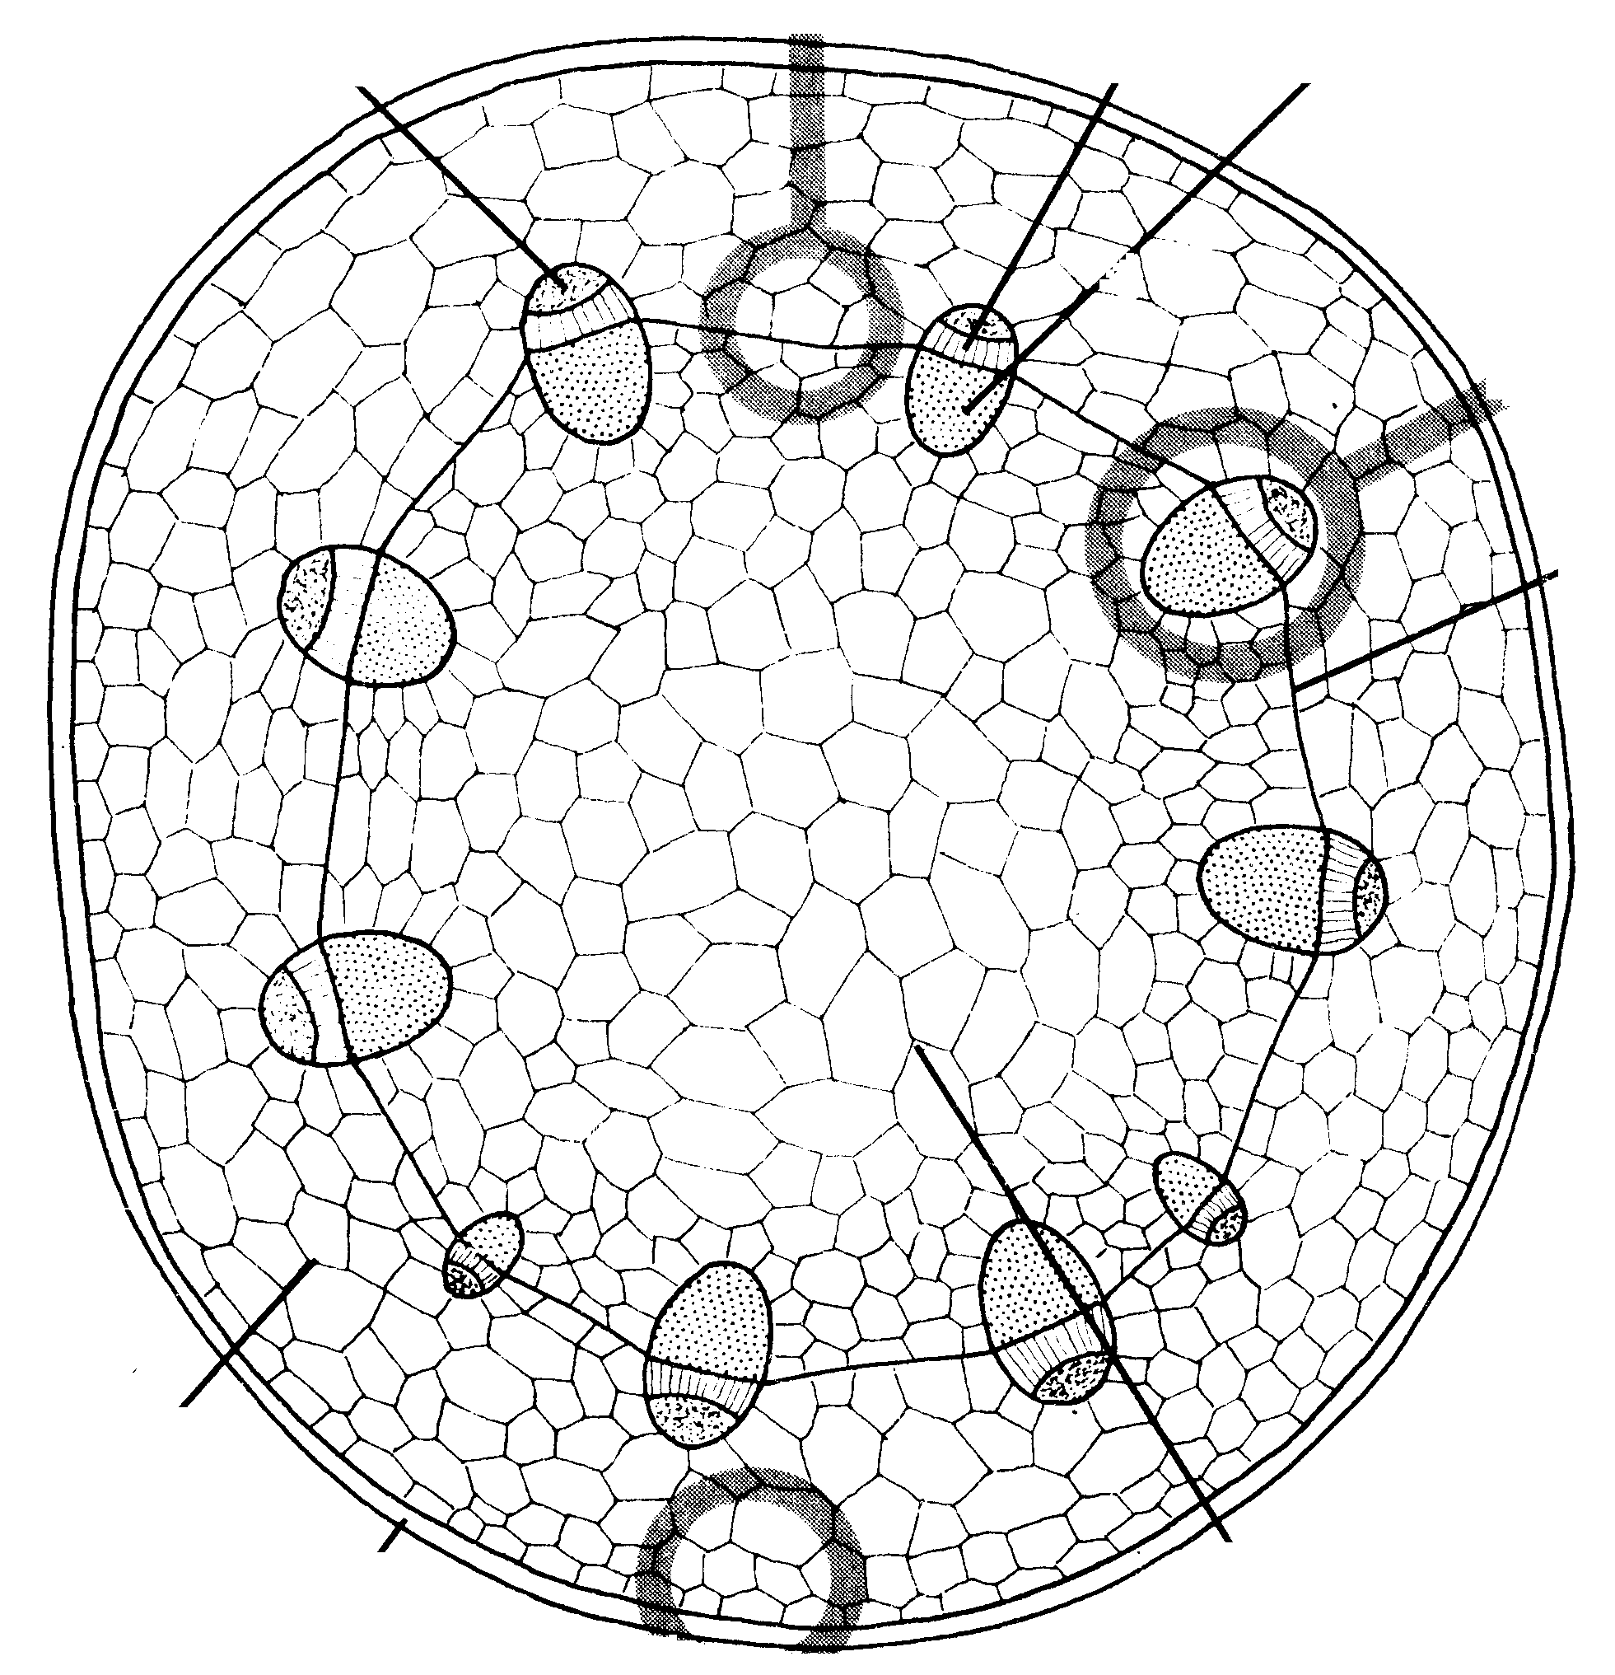
- Below are photographs of cross sections through plant organs. Study them and answer the questions next.
T
S

U

Photograph A
Photograph B

- From Which plant organ were the sections obtained (1 mk)
………………………………………………………………………………………………………..

- Using observable features state the similarities and differences between organs from which the
sections were obtained.
Similarities (2 mks)
…………………………………………………………………………………………………………
…………………………………………………………………………………………………………
…………………………………………………………………………………………………………
Differences
Organ from which section A was obtained Organ from which section B was obtained (3 mks)
…………………………………………………………………………………………………………
…………………………………………………………………………………………………………
…………………………………………………………………………………………………………
…………………………………………………………………………………………………………

- Which of the plants is likely to have a longer life cycle. Explain. (3 mks)
…………………………………………………………………………………………………………
…………………………………………………………………………………………………………
…………………………………………………………………………………………………………
…………………………………………………………………………………………………………
- Name the type of cell labeled U (1 mk)
…………………………………………………………………………………………………………

- Name five parts that make up the plant organ illustrated by the photographs (5 mks)
……………………………………………………………………………………………………………..
……………………………………………………………………………………………………………..
……………………………………………………………………………………………………………..
……………………………………………………………………………………………………………..
- Study the diagrams Q and R carefully and answer the following questions.

(a) (i) Name the phylum to which specimens R and Q belong. (1 mk)
………………………………………………………………………………………………………

(ii) State three reasons for your answer in a (i) above. (3 mks)
………………………………………………………………………………………………………
………………………………………………………………………………………………………
(b) (i) Name the class to which each of R and Q belong (2 mks)
………………………………………………………………………………………………………
………………………………………………………………………………………………………
(ii) State two reasons for your answer in each of (b) (i) above (4 mks)
………………………………………………………………………………………………………
………………………………………………………………………………………………………
(c) (i) Other than (b) i) name other three classes of organisms (3 mks)
………………………………………………………………………………………………………
………………………………………………………………………………………………………
END OF PRINTED PAGE

