TOP EVALUATION EXAMINATION - 2016

Biology Paper 2
FORM 3
JULY/AUGUST

MARKING SCHEME

- (a) Name the mode of feeding in parasites. (1 mark)
Parasitism

(b) Define the following as used in nutrition. (3 marks)
- Ingestion: This is the introduction of the food into the mouth.
- Absorption: Taking into blood the digested products.
- Egestion: This is removal of undigested or indigestible material from the body.

(c) State two adaptions of ileum to absorption. (2 marks)

- It is highly coiled to ensure that food moves along slowly to allow time for its digestion and absorption.

- It is long to provide a large surface area for absorption.

- The epithelium has many finger-like projections called villi (singular villus) which greatly increase the surface area for absorption.

- Villi have microvilli that further increase the surface area for absorption.

- The wall of villi has thin epithelial lining to facilitate fast diffusion of products of digestion.

- Has lacteal vessels; for absorption of fatty acids and glycerol and transport of lipids.
(d) Identify two enzymes contained in pancreatic juice. (2 marks)
- Trypsin
- Amylase
- Lipase which
- (a) State three structural differences between arteries and veins. (3 marks)
Arteries:
1. Carry blood away from the heart always.
2. Have thick muscular walls
3. Have a pulse
4. Deep under the skin
5. Have no valves
6. Arteries branch at their ends, into tiny arterioles those then join capillaries.
Veins:
1. Carry blood to the heart.
2. Have thin walls
3. Do not have a pulse
4. Near surface of the skin
5. Have valves to stop back-flow of blood.
6. Veins branch at their beginnings into tiny venules which join capillaries.
(b) State two functions of the circulatory system to human beings. (2 marks)
- To carry digested food from the small intestine to all areas in the body which need it.
- To carry oxygen from the lungs to the rest of the body.
- To aid in the disposal of all wastes from the body.
- To distribute heat.
- To fight diseases by using white blood cells to fight off infection.
(c) Explain why capillaries are only one cell thick. (1 mark)
So substances (Food or cells) can easily get through them and into the blood or out Heart
(d) Name the part of the heart: (2 marks)
(i) that separates the right and left sides of the heart.
Septum
(ii) connects each atrium to the ventricle below it
Valve
(e) State the function of pericardial fluid in the heart of human being. (1 mark)
to reduce friction when the heart beats.

- The figure below shows a nephron. Use it to answer questions that follow.
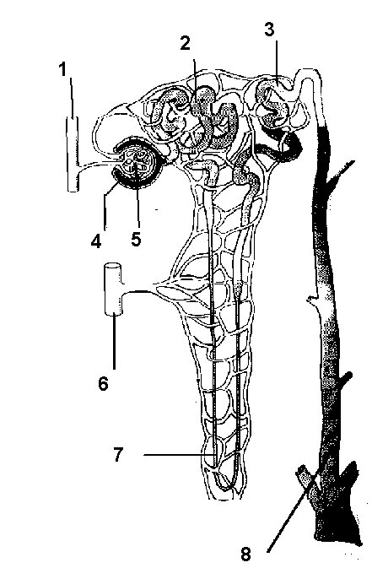

    - Name the parts labeled: (5 marks)
- 2 – Proximal convoluted tubule
(ii) 3 – Distal convoluted tubule
(iii) 4 – Bowman’s capsule
(iv) 6 – venule
(v) 8 – collecting duct

    - Give the function of: (2 marks)
- 1 – brings waste-filled blood from the aorta to the kidney for filtering in the nephron.
(iii) 7 reabsorbs water in tubular fluid, reabsorbs Na+ and Cl-, secretes some H+ ions

    - What happens when the filtration rate in 5 is increased? (1 mark)
decreasing the efferent arteriole diameter and increasing the afferent arteriole diameter
- The epidermis of a leaf is adapted to have the specialized cells known as the guard cell such as shown below.

Guard cell
●

●
X

●

Epidermal cell
●

(a) (i) Name the structure labelled X on the diagram. (1 mark)

Stoma Reject Stomata

(ii) State the factors which affect the opening of the part labeled X. (2 marks)
- water which when low stomata close and when high stomata keeps open
- light as stomata open in bright light and close in darkness
- temperature

(iii) Describe the photosynthetic mechanism of opening and closing of stomata. (4 marks)

During day time. The guard cell traps light for photosynthesis; which results into sugar that is a osmotically active; the sugars draw in water by osmosis; from epidermal cells making it turgid and opening stomata/converse is correct.

(b) State the characteristics of respiratory surfaces in animals. (2 marks)
- moist
- thin walled/thin membrane/thin surface
- Highly/richly vascularised/numerous blood vessels/well supplied with blood vessels.
- Large surface area

- (a) The diagram below is of a certain organism. Use it to answer questions that follow.
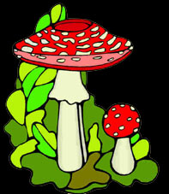
- To which kingdom does this organism belong? (1 mark)
- Mention two observable characteristics of the kingdom in a(i) above. (2 marks)
- have hyphae
- have rhizoids
- have spore forming structures (sporangia)
(b) State the economic benefits of insects. (2 marks)
- food supply
- important in food chains
- pollinators
- biological control of pests and other organisms
- aesthetic value
- contribute to decomposition e.g. litter feeders like beetles
c) Name two classes of chordate. (2 marks)
- Pisces
- Amphibian
- Reptilia
- Aves

SECTION B (40MARKS)

- On the same axes, plot graphs of temperature of water in the tubes against time. (Graph paper provided) (7marks)

6. (a)

Scale – 1mark
Plotting – 2marks
Curves – 1mark
Identity – 1 mark
Axes – 2 marks
Total 7 marks

2
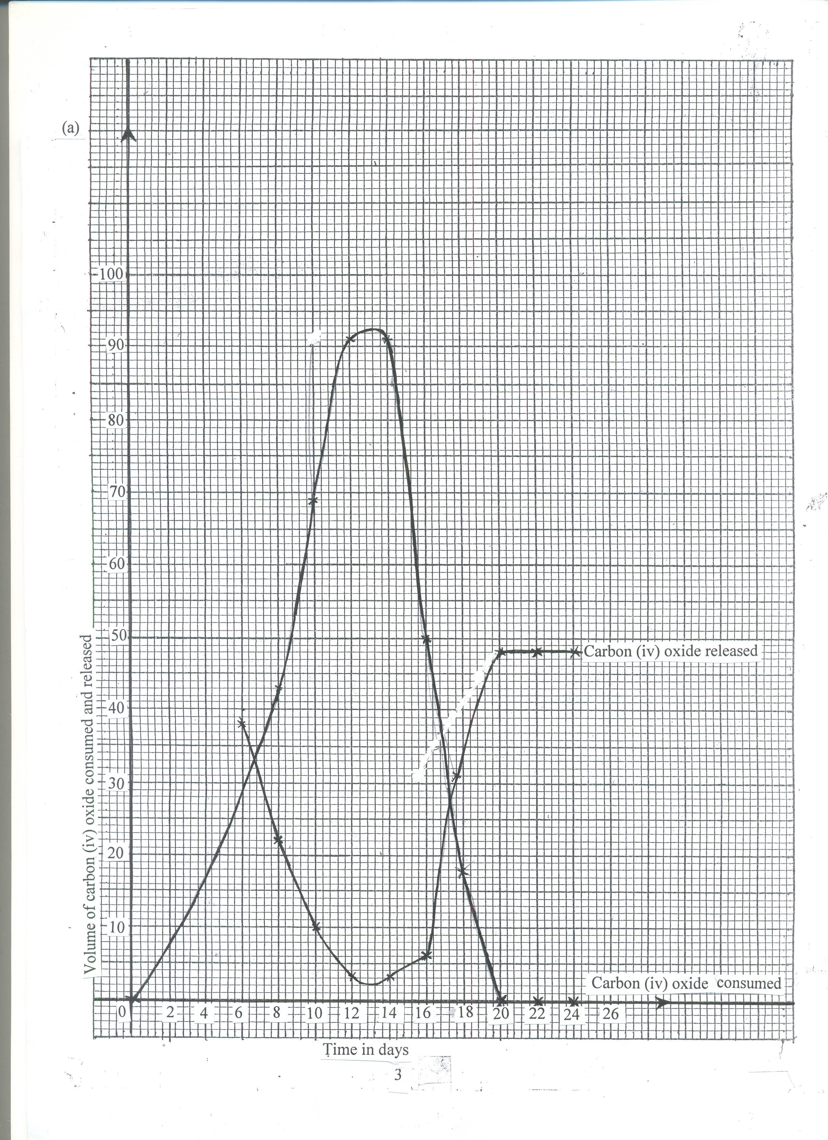

(b) (i) Photosynthesis;
(ii) Respiration;
(c) (i)Rate of CO₂ consumption increases from 6hrs – 12hrs; this is due to increase in light (2mks) intensity; The rate remains the same between 12hrs and 14 hrs which is the period of optimum light intensity; after which it decreases due to increase in light intensity; (3mks)
(ii) Rate of CO₂ released decreased from 6hrs to 12hrs; because some of the CO₂ is used for photosynthesis; from 14hrs to 20 hrs the rate of carbon (iv) oxide released increased; because the rate of photosynthesis is decreasing as light intensity decreases after which the rate remains constant since no photosynthesis is taking place to consume the CO₂ (4mks max 3mks)
- (i) 8 hrs and 18 hours
(ii) Point at which rate of photosynthesis; equals to the rate of respiration/rate of CO₂
consumption equals to the rate of CO₂ released; (2mks)
(e) Increase in temperature increases the rate of CO₂ consumption upto an optimum; because temperature activates enzymes; (2mks)\

- Describe how the following types of plants are adapted to their habitats:
a) Mesophytes
- Trees may grow very tall in forests ecosystem due to competition for light as vegetation is very dense
- Some plants are climbers which support themselves on large tree in an attempt to reach light
- Some plants are epiphytes growing on tree branches to reach light
- Some undergrowth plants have numerous chloroplasts which are sensitive to low light intensity to enable them carry out photosynthesis in low light intensity
- Many plants have leaf mosaic that minimise overlapping and overshadowing and increase exposure of leaves to light
- those in areas with adequate water supply posses broad leaves with thin cuticle and many stomata on both sides of the leaf to increase transpiration
- Those in dryer areas have fewer stomata w3hich are mainly located on the lower surface to reduce transpiration.
- Some which leave in wet areas have shallow roots to absorb less water
- Large tall trees have developed butress roots or prop roots for extra support.
- Those in dryer areas have deep roots to absorb water from water table
- Some have waxy and glossy surface to reflect light to reduce absorption of light hence reduce transpiration also to drip off rain water.
b) Halophytes
- They have roots that concentrate a lot of salts in their cells by active transport; to enable them off set osmotic imbalance and take in water by osmosis
- Some have salt glands that secretes excess salts
- Some have water storage tissues to store water that has been taken in.
- Some like mangrooves have pneumatophores which have lenticels for gaseous exchange
- Some mangrooves have stilt roots for extra anchorage in mudflats.
- Most halophytes are found growing close to the water surface to enable them get sufficient light for photosynthesis
- Those in deeper water have highly sensitive chloroplasts to photosynthesise under low light intensity
- Some e.g. coconut have fruits with large aerenchyma tissue to enable them float.
c) Hydrophytes
- Most emertgent and floating types have broad leaves with many stomata on upper surface to provide a large surface area for gaseous exchange
- Some submerged hydrophytes have leaves which are deeply dissected into thread- like straws to provide a large surface for absorption of maximum light for photosynthesis
- Some submerged hydrophytes have leaves with numerous and sensitive chloroplasts that synthesise under low light intensity
- Many hydrophytes have aerenchyma tissues filled with air to enable them float and store gases for gaseous exchange
- They have poorly developed roots that lack root hairs to reduce absorption of water
- Their flowers are raised above the water level to allow for pollination for submerged and emergent species
8. Describe the movement of water from the soil, through the stems to the leaves of a tall plant.
(20 marks)
- water exists as a thin film in the soil, between soil particles
- the concentration of cell sap of root hair is greater than that of the surrounding solution in the soil, thus drawing the water molecules across the cell wall and cell membrane into the root hair by osmosis
- water drawn into the root hair cell dilutes the cell sap making it less concentrated than that in the adjacent cortex cells of the root
- due to osmotic gradient water moves from the root hair cells into the cortex by osmosis, from cell to cell by osmosis, across the endodermis by active transport into xylem vessels of the root that conduct water into xylem vessels of the stem into xylem vessels of the leaves.
- Once in the stem water moves up the plant aided by the narrowness of the xylem vessels (capillary), root pressure, attraction of water molecules to each other (cohesion). Attraction of water molecules to the walls (adhesion)
- from the stem water enters the xylem of leaves
- water moves in the xylem vessels of the stem in a continuous (uninterrupted) water column up to the tree leaves
- in the leaves ,water moves into the mesophyll cells by osmosis
- as water vaporizes from the spongy mesophyll cells their sap becomes more concentrated than the adjacent cells
- as the result water flows into the cell from other surrounding cells which in turn takes in water from xylem vessels within the leaf veins
- this creates a pull(suction force) called transpiration pull that pulls a stream of water from xylem vessels in the stem and roots
- The transpiration pull maintains a continuous column of water from the roots to the leaves.

