Name:……………………………………………………………… Adm No…………………
Signature …………………………………. Date …………………………
231/2
BIOLOGY
PAPER 2
THEORY
JULY/AUGUST 2014
2 HOURS

TOP EVALUATION EXAMINATIONS – 2016
FORM THREE
INSTRUCTIONS TO STUDENTS
(i) Write your name and admission number in the spaces provided
(ii) This paper consists of section A and B
(iii) Answer ALL the questions in section A in the spaces provided
(iv) In section B, answer question 6 (compulsory) and either question 7 or 8 in the spaces provide.

For examiner’s use only
Section | Question | Maximum score | Candidate score
A | 1 | 8
 | 2 | 8
 | 3 | 8
 | 4 | 9
 | 5 | 7
B | 6 | 20
 | 7 | 20
 | 8 | 20
Total |  | 80

- (a) Name the mode of feeding in parasites. (1 mark)
…………………………………………………………………………………………………………...

(b) Define the following as used in nutrition. (3 marks)
(i) Ingestion
…………………………………………………………………………………………………………………………………………………………………………………………………………….
(ii)Absorption
……………………………………………………………………………………………………………………………………………………………………………………………………………………………..

(iii) Egestion

……………………………………………………………………………………………………………………………………………………………………………………………………………………………..

(c) State two adaptations of ileum to absorption. (2 marks)

………………………………………………………………………………………………………………………………………………………………………………………………………………………………………………………………………………………………………………………………

(d) Identify two enzymes contained in pancreatic juice. (2 marks)
……………………………………………………………………………………………………………………………………………………………………………………………………………………
- (a) State three structural differences between arteries and veins. (3 marks)
………………………………………………………………………………………………………………………………………………………………………………………………………………………………………………………………………………………………………………………………………………………………………………………………………………………………………………………………………………………………………………………………………………………………………………
(b) State two functions of the circulatory system to human beings. (2 marks)
..............................................................................................................................................................................................................................................................................................................................................................................................................................................................................................................................
(c) Explain why capillaries are only one cell thick. (1 mark)
………………………………………………………………………………………………………………………………………………………………………………………………………………………………
(d) Name the part of the heart: (2 marks)
(i) that separates the right and left sides of the heart.
..................................................................................................................................................................... (ii) connects each atrium to the ventricle below it.
………………………………………………………………………………………………………….…
(e) State the function of pericardial fluid in the heart of human being. (1 mark)
....................................................................................................................................................................................................................................................................................................................................................
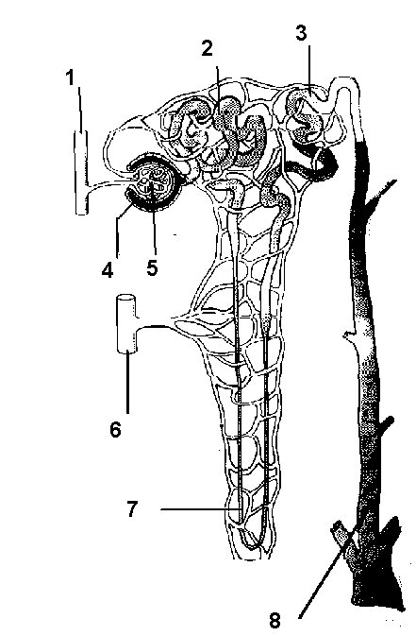
- The figure below shows a nephron. Use it to answer questions that follow.

    - Name the parts labeled: (5 marks)
- 2 – ……………………………………………………………………………………………..
(ii) 3 – ………………………………………………………………………………………………
(iii) 4 – ……………………………………………………………………………………………..
(iv) 6 – …………………………………………………………………………………………….
(v) 8 – ……………………………………………………………………………………………..
    - Give the function of: (2 marks)
- 1 –……………………………………………………………………………………………….
………………………………………………………………………………………………….
(iii) 7 ………………………………………………………………………………………………..
…………………………………………………………………………………………………
    - What happens when the filtration rate in 5 is increased? (1 mark)
…………………………………………………………………………………………………………………………………………………………………………………………………………………….
- The epidermis of a leaf is adapted to have the specialized cells known as the guard cell such as shown below.

Guard cell
●

●
X

●

Epidermal cell
●

(a) (i) Name the structure labeled X on the diagram. (1 mark)
………………………………………………………………………………………………………….......
(ii) State the factors which affect the opening of the part labeled X. (2 marks)
……………………………………………………………………………………………………………………………………………………………………………………………………………………………………………………………………………………………………………………………………………..
(iii) Describe the photosynthetic mechanism of opening and closing of part X. (4 marks)

…………………………………………………………………………………………………………………………………………………………………………………………………………………………………………………………………………………………………………………………………………………………………………………………………………………………………………………………………………………………………………………………………………………………………………..…
(b) State the characteristics of respiratory surfaces in animals. (2 marks)
………………………………………………………………………………………………………………………………………………………………………………………………………………………………..
- (a) The diagram below is of a certain organism. Use it to answer questions that follow.
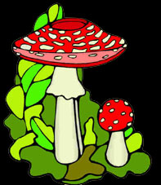
- To which kingdom does this organism belong? (1 mark)
…………………………………………………………………………………………………
- Mention two observable characteristics of the kingdom in a(i) above. (2 marks)
…………………………………………………………………………………………………………………………………………………………………………………………………………………….
(b) State the economic benefits of insects. (2 marks)
………………………………………………………………………………………………………………………………………………………………………………………………………………………………
c) Name two classes of chordate. (2 marks)
……………………………………………………………………………………………………………………………………………………………………………………………………………………………….

SECTION B (40MARKS)
Answer question 6 (compulsory) in the spaces provided and either question 7 or 8 on the spaces provided after question 8.
- In an experiment to investigate a certain process in a given plant species, the rate of carbon(iv) oxide consumption and the rate of carbon (iv) oxide released were measured over a period of time of the day. The results of the investigation are shown in the table below.
Time of day (hrs) | 6 | 8 | 10 | 12 | 14 | 16 | 18 | 20 | 22 | 24
Carbon (iv)oxide consumption mm³/min | 0 | 43 | 69 | 91 | 91 | 50 | 18 | 0 | 0 | 0
Carbon (iv) oxide released mm³/min | 38 | 22 | 10 | 3 | 3 | 6 | 31 | 48 | 48 | 48
(a) On the same axes, draw the graphs of volume of carbon (iv) oxide consumed and released against time (7marks)
(b) Name the biochemical process represented by
(i) Carbon (iv) oxide consumption (1 mark)
……………………………………………………………………………………………………..
(ii) Carbon (iv) oxide release : …………………………………………………………………………….. (1 mark)
(c) Account for the shape of the curve for
(i) carbon (iv) oxide consumption (3marks)
………………………………………………………………………………………………………………………………………………………………………………………………………………………………………………………………………………………………………………………………………………

(ii) Carbon (iv) oxide release. (3marks)
……………………………………………………………………………………………………………………………………………………………………………………………………………………………………………………………………………………………………………………………………………..
(d) (i) From the graph state the time of the day when the plant attains compensation point (1mark)
……………………………………………………………………………………………………………..
(ii) What is made by compensation point? (2marks)
……………………………………………………………………………………………………………………………………………………………………………………………………………………………..
(e) Explain how temperature affects the rate of carbon (iv) oxide consumption in a plant. (2marks)
……………………………………………………………………………………………………………………………………………………………………………………………………………………………………………………………………………………………………………………………………………..

- Describe how the following types of plants are adapted to their habitats:
a) Mesophytes (10marks)
b) Halophytes (5marks)
c) Hydrophytes (5marks)

- Describe the movement of water from the soil, through the stems to the leaves of a tall plant.
(20 marks)

