GATITU DAY MIXED SECONDARY SCHOOL
BIOLOGY FORM 3
END TERM EXAM TIME: 2HRS 70 MKS
SECTION A 50 MKS
1. List any two characteristics shared by reptiles and fish. (2mks)

2. Name the gaseous exchange structures found in the :
i. stem of a mesophyte plant (1mk)

ii. Roots of halophytes. (1mk)

3. State the role of each of the following in photosynthesis: (2mks)
a) Light

b) Water.

4. The diagram below represents a mature breed mould (rhizopus)

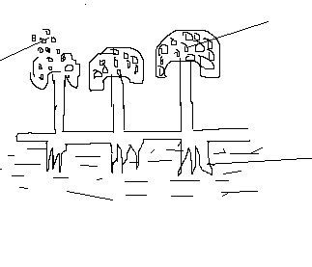

a) Name the kingdom to which breed mould belongs (1mk)

b) Name the structures A,B and C (1mk)

c ) state two roles of the part labeled C (1mk)

5. What is meant by the following terms: (2mks)
a) Carrying capacity

b) Synecology.

6. Explain why plants do not have an elaborate excretory system. (2mks)

7. Differentiate between condensation and hydrolysis. (2mks)

8. Distinguish between interspecific and intraspecific competition. (2mks)

9. The diagram shows external structures of a leaf

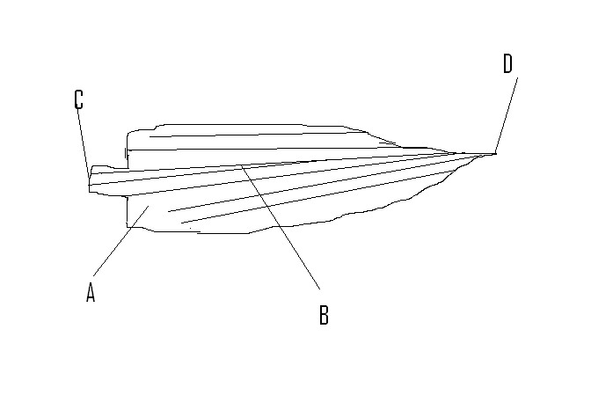

a) Name the parts label led A, B, C and D (2mks)

b) With two, reasons identify the class of the plant from which the leaf was obtained. (3mks)

10. Name two disorders or diseases of the mammalian kidney. (2mks)

11. Would fertilization take place if copulation takes place two days prior to ovulation? Give a reason for your answer. (2mks)

12. The diagram below is a gill of a fish. Study it and use it to answer the questions that follow.
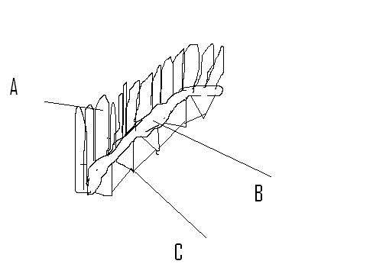

a) Name the parts labeled A and B (1mk)
b) State the function of part labeled C. (1mk)

c ) Explain how structure labeled A is adapted to its function. (2mks)

13. The diagram below shows the structural of the embryo sac.
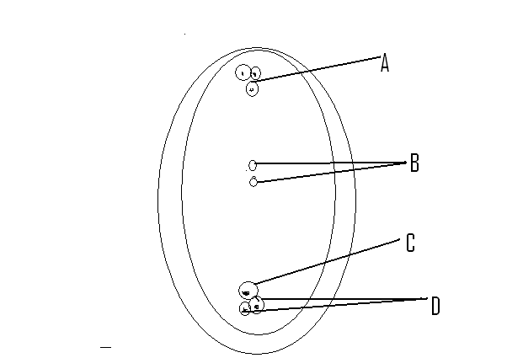

a) Name the structures labeled A, B , C and D. (4mks)
14. Give the biological reason behind each of the following.
a) After fertilization has taken place in a female mammal, another sperm cell cannot penetrate the fertilized egg. (2mks)

b) If the ovaries of a female human being are removed after the third month of pregnancy, pregnancy still persists. (2mks)

15. a) Name the respiratory surfaces in animals of the class Pisces . (1mk)

b) List three characteristics of respiratory surfaces. (3mks)

16. a) State two differences between oil and fats. (2mks)

b) Give the differences between the following structures in wind and insect pollinated flowers. (3mks)

SECTION B 20MKS
. Do either question 17 or 18 each question carries (20mks) . Do not do both.
17. a) Describe the process of the menstrual cycle using the four hormones involved. (10mks)
b) Describe how glucose is regulated in the body using the two hormones involved. (10mks)

or

18. a) Explain how heart is adapted to perform its functions . (10mks)
b) Explain how is the male reproductive organ s adapted to perform its functions. (10mks)

