GATITU MIXED SECONDARY SCHOOL
BIOLOGY FORM 3 MID EXAM TERM 2 2014
- Name the structures used for locomotion in each of the following organisms: 2mks
- Euglena

- paramecium

- Black jack (Bidens pilosa) belongs to the family compositae.What is the plants. 2mks

- Name two metabolic waste products in
- Birds 2mks

- Plants 2mks

- Name two parts in the human body with cilia. 2mks

- The diagram below represents a closed stoma.

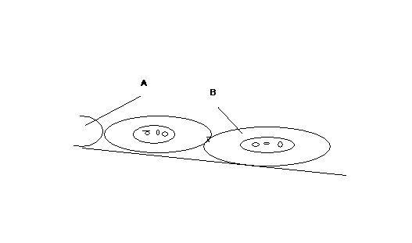
- Identify the cells labeled A and B. 2mks

- Name the substances excreted through the stomata. 1mk

- State on adaptation of the guard cell to its function. 1mk

- The equation below shows what happens in cellular respiration
C₁₈H₃₆ + 26O₂ → 18 CO₂ + 18H₂O + Energy
- Name the type of respiration shown and where it occurs in a cell. 2mks

- Determine the respiratory quotient of the process. 2mks

- What food substance is broken in the respiration? 1mk

- List two features of the small intestine that increase its surface area 2mks

- Explain why food is stored in an insoluble form in the cells of living organisms. 2mks

- State the difference between assimilation and absorption of food nutrients. 2mks

- Differentiate between lactic fermentation and alcoholic fermentation. 4mks

- Water logging can cause death of some plants, explain. 2mks

- Distinguish between plasmolysis and haemolysis. 2mks

- Give three examples of gaseous exchange surface in animals and the animals they are found in. 3mks

- State the significance of photosynthesis. 3mks

- Explain how the mammalian kidney is adapted to its functions. 13mks

