- Name the structure used for locomotion in each of the following organism
- Euglena ( 2 marks)

- Paramecium ( 1 mark)

- Blackjack (bidens pilosa) belongs to the family compositae. What is the plants
(a) Genus (1 mark)

(b) Species (1 mark)

- Name two metabolic waste products in
(a) Birds (2 mark)

(b) Plants (2 marks)

- State three adaptations of flowers to pollination by wind ( 3 marks)

- (a) State two differences between meiosis and mitosis ( 2 marks)

(b) State two processes that takes place during interphase (2 marks)

- Name two parts in the human body with cilia ( 2 marks)

- The diagram below represents a closed stoma
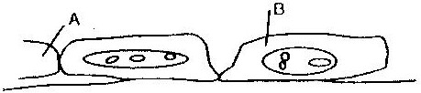

(a) Identify the cells labeled A and B (2 marks)

b. Name the excretory product in plants which is excreted through the stomata ( 1 mark)

(c) State one adaptation of the guard cell to its function ( 1 mark)

- Name two organisms that form the biological environment of a malaria parasite ( 2 marks)

- Name the organs of the mammalian body that are responsible for production of gametes (2 mks)

- The equation below show what happens in cellular respiration
C₁₈ H₃₈+ 26O₂ → 18CO₂ + 18H₂O + Energy
  - Name the type of respiration shown and where it occurs in a cell ( 2 marks)

  - Determine the respiratory quotient of the process ( 2 marks)

  - What food substrate is broken in the respiration? ( 1 mark)

- List two features of the small intestine that increase its surface area
( 2 marks)

- Explain why food is stored in an insoluble form in the cells of living things(2 marks)

- State the differences between assimilation and absorption of food nutrients( 2 marks)

- State three homeostatic function of the liver

- Water logging can cause the death of some plants. Explain ( 2 marks)

- Distinguish between plasmolysis and haemolysis ( 2 marks)

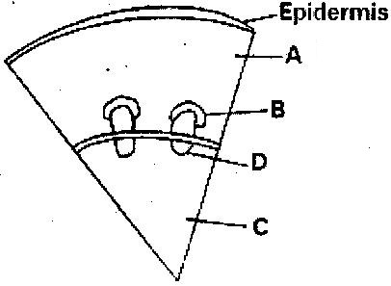
- The diagram below shows a section of a dicotyledonous stem.

Name the tissues labeled A and D and state the function of each.

- Name the organism that causes each of the following diseases
(a) AIDS

(b) Bilhazia

(c) Cholera ( 3 marks)

- List three examples of gaseous exchanges surfaces in animals ( 3 marks)

- state the significance of photosynthesis ( 3 marks)

MARKING SCHEME( 50 mks)
- (a) Flagellum
(b) Cilium
- (a) Genus - Bidens
(b) Species- pilosa
- (a) Carbon (IV) Oxide
- Uric acid
(b) Oxygen, gum, carbon (IV) Oxide
- Tannins, quinine water vapour, latex
- - Small and light to be carried easily by wind
- Have hair- like structures or floss to increase buoyancy in the air
- Develop wing- like structures or floss to increase surface area for increased buoyancy in the air

- (a)
Meiosis | Mitosis
- Takes place in reproductive cells  - Division are double (I and II)  - Daughter cells are identical to prevent cell (Diploid)  - Homologous chromosomes associate  - Four daughter cells formed  - Chiasmata formed and crossing over occur | - takes place in body cells  - division is only one  - daughter cells are not identical to prevent cells (Haploid)  - Homologous do not associate  - Two daughter cells formed  - Chiamata not formed and there is not crossing over

- Oviduct
- Trachea or tracheal epithelium
- (a) A- Epidermal cell
B- Guard cell
(b) Carbon (IV) Oxide
(c) - Thick inner wall and thin outer wall to control the opening and
closing of them.
- Presence of chloroplasts to carry out photosynthesis
- - Human
- Mosquitoes

- (a) Aerobic respiration, mitochondria
(b) R.Q = Carbon (IV) Oxide produced
Oxygen used
= 18 = 0.692 = 0.7
26
(c) Lipid/ fat

- - Has villi and micro villi
- Long length

- It prevents the formation of solutions which would otherwise interfere with osmotic pressure of the tissues

- (a) Cotyledon pushes above the ground
(b) Shoot pushes above the ground but cotyledon remains underground.

- Assimilation is the process by which the body uses up the absorbed products by which the end products of digestion are taken into the epithelial cells of the ileum by diffusion or active transport.

- - Regulation of blood glucose
- Regulation of amino acids
- Excretion of cholesterol and bile
- Production of heat

- Water logging reduces the oxygen concentration in the soil hence plants die due to lack of oxygen for respiration.

- - Plasmolysis occurs when plant cells are placed in hypertonic solution.
They lose water by osmosis and shrink.
- Haemolysis occurs when red blood cells are placed in hypertonic solution. They absorb water by osmosis swell and burst.

- A- Collenchyma- provides support for the stem
B- Sclerenchyma – provide mechanical support for the plant
C- Parenchyma- for support and storage of food
D- Xylem- transports water and minerals salts from the roots to other to parts of the plant, also gives support to the plant

- (a) AIDS- Human immunodeficiency virus
(b) Bilharzia- Schistoma mansoni or Schistoma spp
(c) Cholera- Vibrio cholerae

- Lungs, gills, skin, buccal cavity, book lung or tracheole.

- - Production of food
- Production of oxygen
- Removal of carbon (IV) Oxide from the air.

