END OF TERM TWO EXAM
FORM 3 BIOLOGY P3
231/3 MARKING SCHEME
- You are provided with:-
- Soaked maize grains
- A piece of liver
Using pestle, mortar and sand, grind maize grains into a soft pulp. Add 10ml of distilled water. Mix thoroughly then filter into a test tube and label it A. Repeat the procedure for a piece of liver and put the filtrate into test tube B.
Follow the procedure and complete table 1 below.
a) (i) Table 1 (2 mks)
 | Observation
Add 2ml of hydrogen peroxide into 1ml of filtrate A | in A effervescence;  acc, few bubbles of gas
Add 2ml of hydrogen peroxide into 1ml of filtrate B | In B vigorous effervescence;  acc, many bubbles of gas

(ii) Comment on your results (4 mks)

Presence of catalase enzymes in living tissues; which breakdown toxic hydrogen peroxide into water and carbon (iv) oxide higher concentration of catalase in liver than maize grains; due to high metabolism in the liver;

b) Using the reagents provided, test for the food substance in filtrate A. (6mks)
Food tested | Procedure | Observation | Conclusion
Proteins: | take 2cm³ of the filtrate in aTtest tube  add equal amount of NaoH, followed by Cuso₄;drop wise and shake; | mixture remains green | Proteins absent  Rej absence of reducing sugars
Reducing sugar; | take 2cm³ of the filtrate in a Test tube; add equal amount of Benedict solution and heat gently; | green , yellow, orange, brown, red colouration; | Reducing sugar present  Nb: conclusion tied to colour observed  Rej presence of reducing sugars

State the importance of carbohydrates in the human body (1mk)
Used for energy production (through respiration)

- Study the diagrams of fruits below
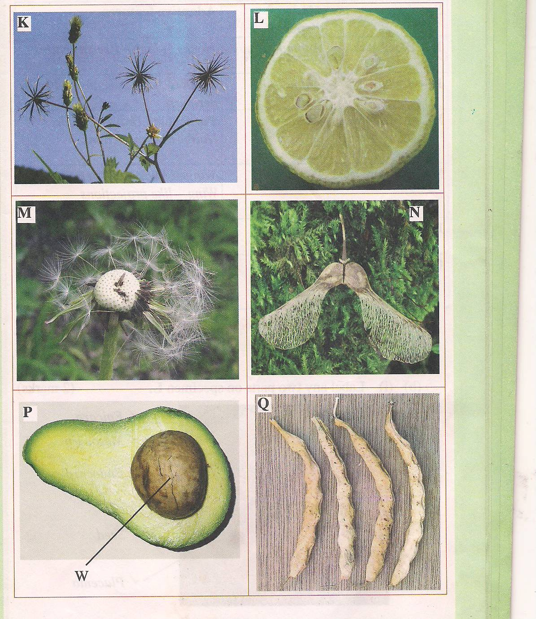

a) Name the type of fruit shown by P and Q (2mks)

P- Succulent acc Drupe rej succulent fruit
Q- Dry Acc Legume rej dry fruit
b) State the type of dispersion used by fruit M, K and N. Give adaptation for each of them (6mks)
M- wind dispersion
K-Animal dispersion
N- Self explosion acc explosive mechanism

d) State the type of placentation shown by diagram Q and L (2mk)
Q- Marginal
L- Axile

e) State the significance of fruit and seed dispersal (1mk)

- Prevents overcrowding which leads to competition of resources
- Ensures that seeds reach new environments which may be more suitable for their growth.
Any of the answer scores a full mark

f) Describe the main differences between entomophilous flowers and anemophilous flowers (3mk)

Entomophilous/insect pollinated | Anemophilous/ wind pollinated
- Large flowers  - Conspicuous with bright petals  - Scented with nectar  - Anthers small and firmly attached tom filament  - Large pollen grains which are sticky  - Stigmas are small sticky and occur inside the flower | Small flowers  Inconspicuous petals  Not scented and lack nectar  Anthers large and loosely attached to a flexible filament  Small pollen grains which are smooth and light  Stigmas are long feathery and hang outside the flower

Any first 3 each to score 1 mark

- 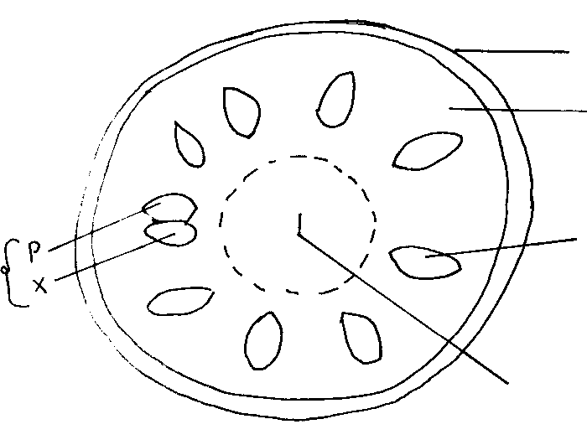The diagram below shows a photomicrograph of a transverse section of a young cowpea stem.
K
Z
M
L
Q

- Name the structures labelled K, L and Q. (3 mks)
K- Epidermis
L- Cortex
Q- Pith
- State the functions of each of the parts labelled Z and M. (2 mks)
Z- Translocation of manufactured food
M- Responsible for secondary growth

- The magnification of the photomicrograph is X50. Determine the actual diameter of the section in micrometers. (Show your working) (3 mks)

Magnification=drawing diameter
Actual length
5cm
50
= 0.1CM
0.1x1000= 100um

- a) State how the functioning of the phloem tissue is affected if the companion cell is destroyed. (1mk)

Translocation will be impaired
b) Give a reason for your answer in iv (a) above. (2mk)

Companion cells have mitochondria; which are involved in energy production, the energy is involved for translocation of manufactured food;

- In what ways is the drooping of leaves observed on hot days advantageous to the plant? (2mks)
It reduces the surface area exposed for respiration; this helps to conserve water in the leaves;

