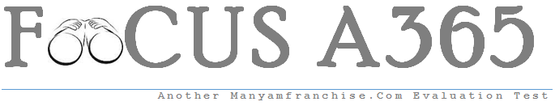GEOGRAPHY PAPER II FORM 3 MARKING SCHEME

SECTION A: 25 MARKS
Answer all the questions
- (a) Name two areas where gold is mined in Tanzania. (2 mks)
- Geita
- Mpanda
- Musonka near Sekenke in central Tanzania.
- Lupa in southern Tanzania. 2 x 1 = 2mks

(b) State three industrial use of copper as a mineral. (3 mks)
- Used in electrical engineering
- Used as an alloy
- Used in metallurgical industries
- Used for manufacture of boilers, radiation pipes and tubes. 3 x 1 = 3mks

(c) Name three methods of alluvial mining (placer mining). (3 mks)
- Panning
- Dredging
- Hydraulic mining 3 x 1 = 3mks

- (a) A photograph is divided into 3 parts. Name them. (3 mks)
- Foreground
- Middle ground
- Background 3 x 1 = 3mks

(b) State three limitations of using photographs. (3 mks)
- Expensive ie require a camera or a photographic device/must travel to where the feature is.
- May not be useful to visually impaired persons.
- Blurred images may not be clear hence can lead to wrong interpretation.
- Black and white photograph of some features may give wrong impression of a different feature eg wheat and oats/grass.
- Requires a skilled person who knows how to capture photographs using devices such as video cameras. 3 x 1 = 3mks

- (a) List three main types of sampling. (3 mks)
- Random
- Systematic
- Stratified 3 x 1 = 3mks

(b) Name the methods that are used to analyse statistical data. (3 mks)
- Calculation of percentages
- Measures of central tendencies
- Measures of dispersion. 3 x 1 = 3mks
- Name two types of questionnaires. (2 mks)
- Personal (interview) questionnaire
- Rigid questionnaire

- Outline three types of field work. (3 mks)
- Field research
- Field excursions
- Field teaching/study 3 x 1 = 3mks

SECTION B:
Answer question 6 and any other two questions from this section.
- Use the table below to answer the questions that follow.
(a) The table below shows the quantity of minerals produced in Kenya in tones in 2010 and 2011.
MINERALS/YEARS | 2010 | 2011
Soda ash | 290,000 | 350,000
Fluorspar | 40,000 | 80,000
Salt | 20,000 | 40,000
Others | 10,000 | 20,000
TOTAL | 360,000 | 490,000
- Draw proportional circles to present the information above. (14 mks)
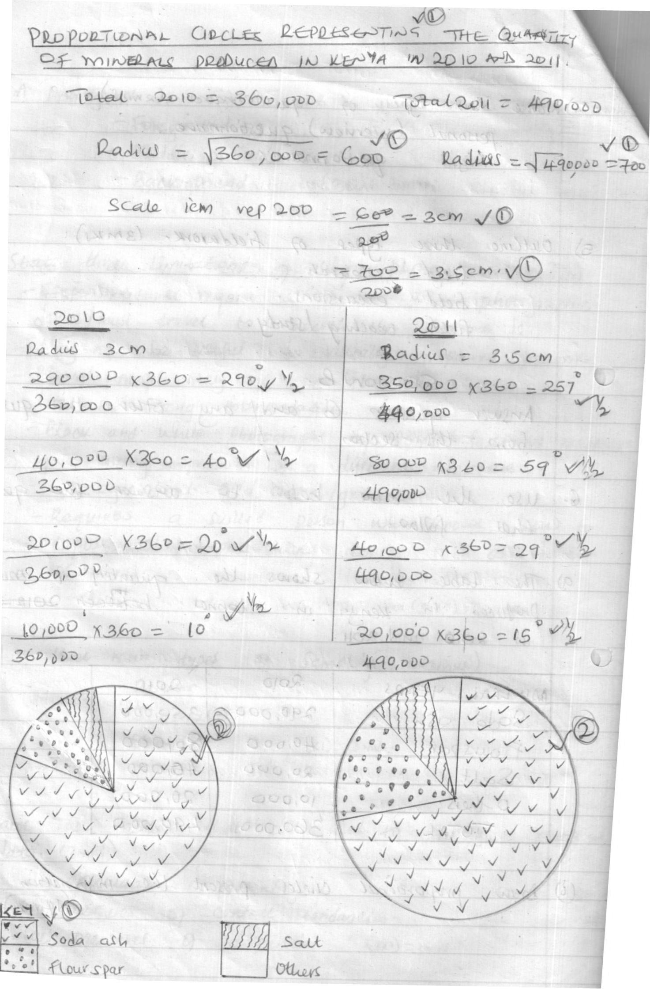

Total 14 mks
- State two advantages of using proportional circles in data representation.(2 mks)
- Can be used to present varying types of data.
- Easy to compare individual segments.
- It gives a clear visual impression since the various quantities in different segments can be clearly seen since they are shaded differently. 2 x 1 = 2mks

(b) (i) Name any two fuel minerals. (2 mks)
- Coal
- Oil
- Natural gas 2 x 1= 2mks

(ii) Name three major oil producers in the Middle East. (3 mks)
- Saudi Arabia
- Iraq
- Iran
- Kuwait
- United Arab Emirates 3 x 1 =3mks

(iii) State four contribution of oil to the economies of the Middle East countries. (4 mks)
- The revenue and royalties earned from oil have enable Arab investments overseas to increase immensely hence increasing their source of wealth.
- The profit has also enabled the Middle East countries to have a high per capita income.
- The countries are able to develop other sectors of the economy eg roads, health services, education etc.
- It has created employment opportunities for the people in the region.
- Industrial linkages have led to the development of other oil related industries eg. Petro-chemical industries. 4 x 1 = 4mks

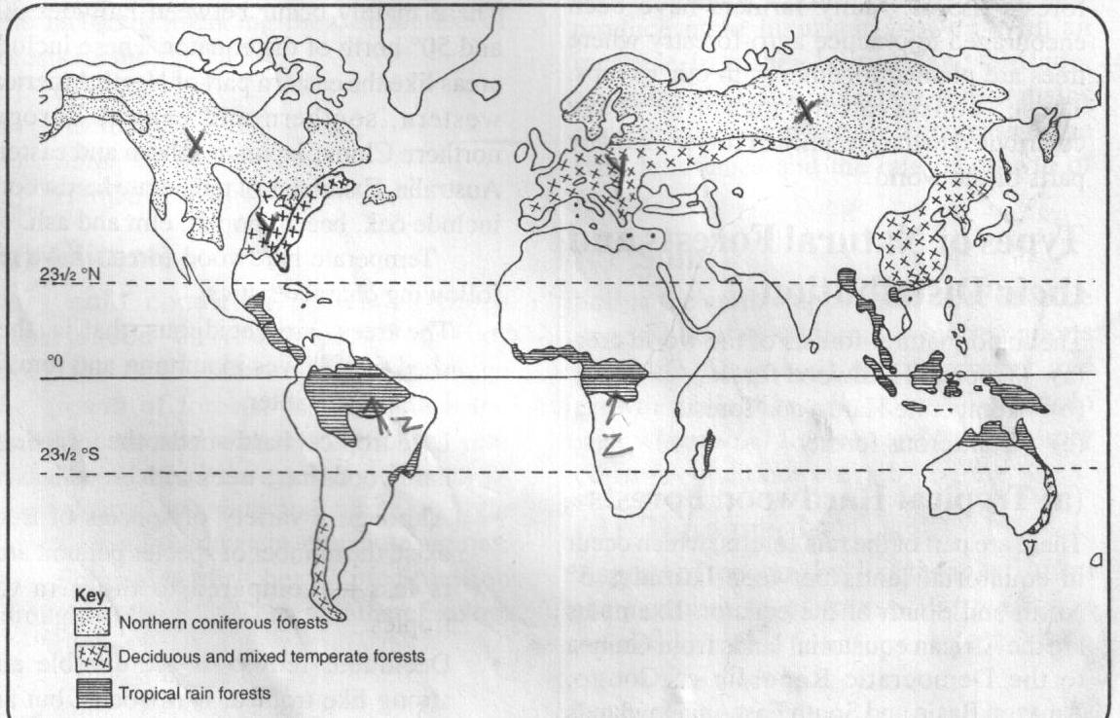
- Study the map below showing the distribution of world’s natural forests.

x
y

z
- Name the types of forests found in the regional marked X, Y and Z. (3 mks)
- X – coniferous forests
- Y - Deciduous and mixed temperature forests
- Z – tropical rain forests 3 x 1 = 3mks

- State three characteristics of temperate hardwood forests. (3 mks)
- The trees are decious.
- They have trees with broad leaves
- Although a variety of species of trees exist, the number of units per unit area is less compared to those in the tropics.
- Deciduous hardwoods are durable and strong. 3 x 1 =3mks

- (i) Differentiate between afforestation and Re-afforestation. (2 mks)
- Afforestation is the process of planting trees where there was none before while reafforestation is the process of deliberate replacement of trees which have been cut.
2 x 1 = 2mk
(ii) Explain four measures the government has taken to realize effective management of the forests. (8 mks)
- Carrying out public campaigns on the value of forests through mass media.
- Carrying out research on suitability of soils and the effects of pests and diseases on forests.
- Establishment of training institutions dealing with forestry eg. Londiani forestry training college and Kenya forestry research institute.
- Infrastructural facilities like roads, machinery, tractors and seedbeds are being provided to improve the management of resources.
- Employment of forest guards and forest officers to guard against destruction of forests.
- Laws have been enacted to govern the management of forests.
- Creation of forest reserves on mountain slopes and river banks to prevent soil erosion and conserve river catchment areas.
- Agro-forestry is being encouraged. 2 x 4 = 8mks

(iii) State five problems facing forests in Kenya. (5 mks)
- Clearing of forests to create land for farming and settlement.
- High demand for timber products causing many people to cut trees.
- Illegal loging.
- Forest fires caused by hunters and honey harvesters.
- Biolgoigal conflicts eg. The number of animals increases in the forests causing animals like elephants to trample and cause a lot of damage to trees.
- Drug growing – some people clear illegally some portions of forests to grow drugs especially bhang.
- Pests and diseases eg. Aphids which affects forests with exotic trees.
- Prolonged drought has resulted to shrinking of forests and retarded the rate of generation of forest cover.
- Degazettement of forests eg in 2002, thousands of hectares were degazzetted causing a reductive of total acreage under forests. 5 x 1 = 5mks

(d) Explain two importance of forest exploitation in Canada. (4 mks)
- It provides employment for those working in the forests eg felling trees, lumberjacks, tree farmers, those employed in timber industry etc hence raising their standards of living.
- The country earns a lot of income from the timber products through taxation hence its able to develop other sectors.
- It has led to the establishment of many pulp and paper factories in Canada.
- It has led to the improvement of infrastructure and hydro-electric power in lumbering areas. 2 x 2 = 4mks

- (a) Name two major types of aerial photographs. (2 mks)
- Vertical aerial photograph
- Oblique aerial photographs. 2 x 1 = 2mks

(b) To describe the major reliefs features in a photograph, some clues are used. Name four of them. (4 mks)

- Hilly landscapes – indicating a hilly area.
- Human activities taking place in the photograph eg. Irrigation suggests gently sloping area.
- The type of drainage in a photograph eg. Swamp indicates a plain.
- Different forms of communication lines eg. A road between two hills indicates the area is characterized by passes.
- Vegetation types shown in a photograph i.e different vegetation grows on different landscapes. 4 x 1 = 4mks

(c) Explain how each of the following features would be indentified in a photograph.
(8 mks)
(i) Settlement
This is shown in photographs by houses. The arrangement of the houses in different ways gives different settlement patterns. 2 x 1 = 2mks

(ii) Planted trees
These are identified by the appearance of the trees. Ie. Their similar heights species and appear in rows. 2 x 1 = 2mks
(iii) Mining
Its indicated by a mine or quarry people undertaking a mining activity or a mineral processing factory. 2 x 1 = 2mks
(iv) Manufacturing
Its indicated by factory buildings with large chimneys of people engaged in processing activity like jua kali artisans. 2 x 1 = 2mks

(d) (i) Name two methods of open cast mining. (2 mks)
  - Stripping
  - Hill-slope boring 2 x 1 = 2mks

(ii) Briefly explain the shaft method of underground mining. (5 mks)
- Its used in cases where the mineral bearing rocks occurs deeply underground.
- Vertical shafts are sunk deep underground.
- From the shaft, horizontal tunnels are driven outwards until the mineral bearing rock is reached.
- The mineral bearing rock is blasted using explosives.
- Its then transported along the tunnel to the shaft by light railway or conveyor belt.
- Its brought to the surface in a type of lift called a cage.
- The cages are also used to transport the miners and their equipment.
- The galleries are supported by timber pit props or steel concrete beams to hold up the roofs. 5 x 1 = 5mks
(NB: The procedure must be systematic)
(iii) Name the areas where the following minerals are mined in Kenya. (4 mks)
- Fluorspar – Kimwarer (Kario valley)
- Diatomite – Kiriandusi (Near Gilgil)
- Gicherio (in the Aberdare ranges)
- Gold – Kakamega Migori District
- Macalder
- Titanium – Kwale District 4 x 1 = 4mks
- (a) What is field work? (2 mks)
This is the scientific study of geography which applies practical techniques and uses the environment as the laboratory and source of information. 2 x 1 = 2mks

(b) Name three types of fieldwork. (3 mks)
- Field study
- Excursion
- Fieldwork research 3 x 1 = 3mks

(c) You plan to carry out a field study of an open air market near your school.
- State four types of information you would collect during the field study. (4 mks)
- The traffic flow
- The layout of the market
- Origin of the good sold in the market
- Types of goods sold in the market.
- Prices of various items sold in the market.
- The history of the market.
- Means of transport used.
- Types of taxes paid to the local authority.
- The special market days.
- The problems faced by the traders.
(Any other relevant point) 4 x 1 = 4mks

- List four methods you would use to collect the data. (4 mks)
- Administer the questionnaire
- Interviewing
- Observation
- Collecting samples
- Taking photographs 4 x 1 = 4mks

- Explain three ways in which the local authority would use your findings to improve the open air market. (6 mks)
- To plan roads connecting the market in the source areas.
- To improve the layout of the market.
- To improve the services in the market.
- To improve revenue collection in the market.
- To plan other markets in the area.
(Each point must be supported by an explanation relating it to the learners research.)
2 x 3 = 6mks
- State two hypothesis for the study. (2 mks)
- Most of the goods sold in the market originate from the surrounding areas.
- The market was established ten years ago.
- Donkey carts are the main means of transport used to deliver goods to the market.
(Any other relevant hypothesis) 2 x 1 = 2mks

- What are the advantages of learning geography through fieldwork. (4 mks)
- It enables students to learn through experience.
- It enables the students to apply the theory learnt in class.
- It enables the students to develop skills such as observation, measuring, evaluating and judging.
- Students learn to cooperate with others.
- It improves the students understanding of geography.
- It breaks the monotony of classroom learning.
- It enables students to familiarize with the environment in which they live.
- It enables the students to identify specific problems that may require geographical investigation. 4 x 1 = 4mks

- (a) The table below represents Kenya’s export crops 2009-2011 in ‘000 tonnes.
COMMODITY | 2009 | 2010 | 2011
Coffee | 230 | 200 | 190
Tea | 210 | 240 | 320
Sisal | 50 | 30 | 40
(a) (i) Using the table above, draw a comparative bar graph to present the data. (7 mks)
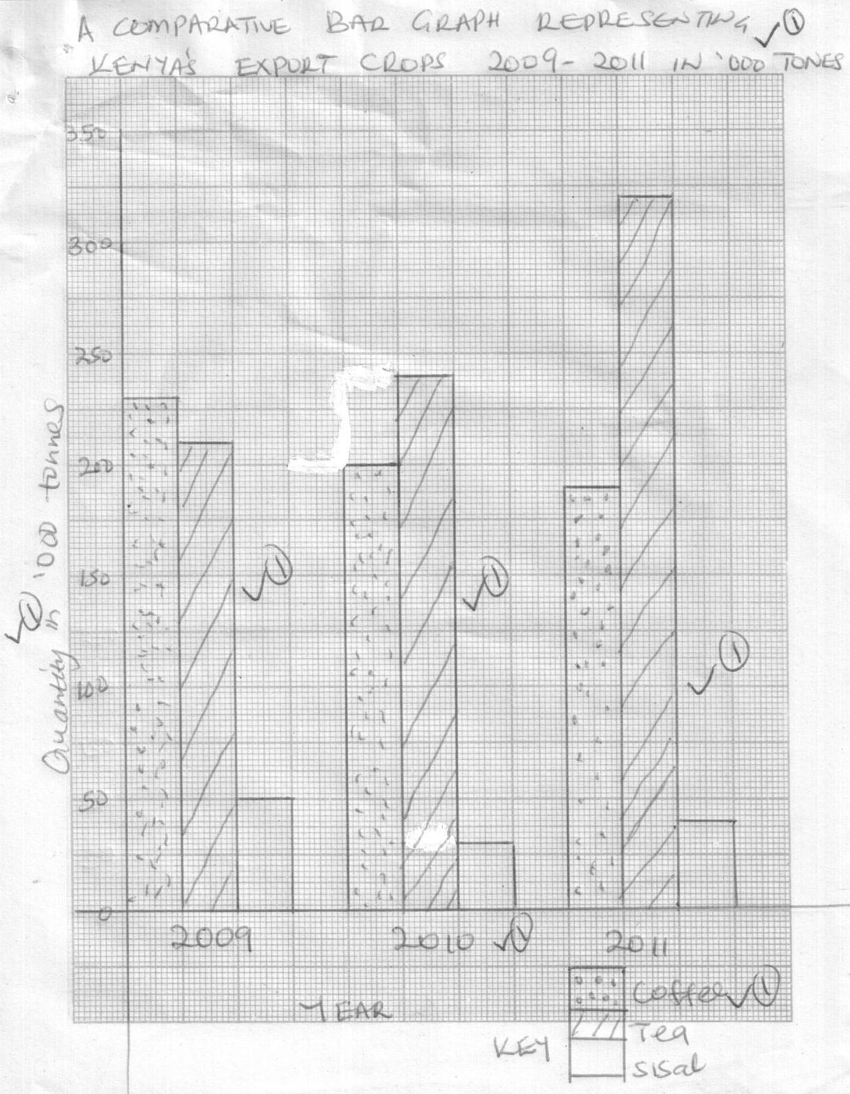

Total 7 mks
(ii) State two advantages of using comparative bar graphs to present data. (2 mks)
- The individual contribution made by variables in each group is easily indentified.
- Values in the same group can be compared easily.
- It gives a good visual impression due to the different shading of the different bars.
2 x 1 = 2mks
(iii) Name three other methods of data presentation that can be used to present the data above. (3 mks)
- Proportional circles.
- Comparative line graphs.
- Compound divided rectangle.
- Cumulative/compound bar graph. 3 x 1 = 3mks

(b) Name two methods used in taking measurement as a way of collecting statistical data. (2 mks)
- Pacing
- Estimating
- Counting
- Using instruments 2 x 1 = 2mks

(c) Name three secondary sources of statistical data. (3 mks)
- Journals
- Periodicals
- Census reports
- Text books
- Maps 3 x 1 = 3mks

(d) Explain four factors you would consider when setting up questions in a questionnaires. (8 mks)
- The questions should be simple and clear and not ambiguous so that they may not solicit (attract) the correct responses.
- The number of questions should not be too many as they may discourage the respondents. The respondent may also not have enough time to fill in the questions.
- The questions should be arranged in a logical order beginning with the simplest to the more difficult ones.
- The questions should be strictly related to the topic under research and those that can assist the researcher obtain the information needed.
- The questions should not annoy the respondents, and should not touch on the respondents privacy or personal life.
- The questions should be free of bias. i.e leading questions that help the respondents decide on the answers should be avoided. 4 x 2 = 8mks

