312/2
GEOGRAPHY
PAPER 1
July/August 2016
2hours

TOP EVALUATION EXAMINATIONS – 2016
Form 3
GEOGRAPHY
Paper 1
2hours

Instructions to Students
- This paper contains two sections: A and B.
- Answer all the questions in section A.
- Answer question 6 and any other two questions from section B.
- All answers must be written in the answer booklet provided.
- This paper consists of 5 printed pages.
- Students should check the question paper to ascertain that all the pages are printed as indicated and that no questions are missing.

- Name two layers of discontinuity that are part of the interior structure of the earth. (2marks)
(b) Identify any three areas covered under human and economic Geography. (3 marks)
- (a) List theories that explain the origin of Fold Mountains. (2 marks)
(b) State three positive significance of folding. (3 marks)
- (a) At town A 40◦E time is 1 pm what is the time at town B 40◦E? (2 marks)
(b) State three characteristics of comets. (3 marks)
- (a) Differentiate between rocks and minerals. (2 marks)
- Give three changes that occur in rocks during metamorphism. (3 marks)
- (a) Identify two types of desert. (2 marks)
(b) State three characteristics Tropical Monsoon Climate. (3 marks)
.
SECTION B (75 MARKS)
Answer question 6 (compulsory)& any other TWO questions from this section.

Use map of Migwani 151/1 provided to answer question 6

- (a)Name two type of natural vegetation found along northing 68. (2marks)

(b)Citing evidence from the map, explain three factors that could have favoured the establishment of Mutitu (Ndooa) Town in the area (6marks)
(c) Measure the approximate distance of all weather loose surface road to the north west of the map.
(2 marks)
(d) Describe the drainage of the area covered by the map. (6 marks)

(e) Giving evidence in each case, identify four social services offered at Mtito Ndoa. (4 marks)
(f) Citing evidence from the map, state three economic activities carried out in area carried by the map (3marks)
(g) List two types of scales shown on the map. (2 marks)

- (a) The picture below shows a type of river erosion. Use it to answer the questions after it.
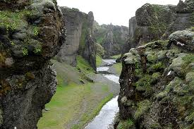
(i) Identify the feature. (1 mark)
(ii) List three characteristics of the feature above. (3 marks)
(iii) Describe three modes of the formation of the feature above. (6 marks)
(b) (i) What is river transportation? (1 mark)
(ii) Explain three ways of river transportation. (6 marks)
(c) List any three types of deltas. (3 marks)
(d) State positive five significance of rivers. (5 marks)

- Your class is planning to go on field work to study organically and chemically formed sedimentary rocks in the neighbouring village.
- Give five ways in which you would prepare for the field work. (5 marks).
- Suggest four ways in which you would classify the rocks under study. (4 marks)
- Since it is a place you do not know well, you have resorted to ask for a map.
- What type of map will you be given? (1 mark)
- Mention three characteristics of the map in c(i). (3 marks)
- State three uses of the map above. (3 marks)
- State five importance of field work to a student. (5 marks)
- Mention four challenges you are likely to face during this field work. (4 marks)

9. (a) What is weathering? (1 mark)
(b) Apart from people, list three other agents of weathering. (3 marks)
(c) Explain three factors that influence weathering. (6 marks)
(d) Identify two human activities that accelerate the rate of weathering. (2 marks)
(e) The picture below shows a type of mechanical weathering. Use it to answer questions that follow.

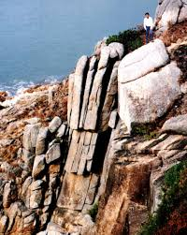
- With a reason, identify the process shown in the picture. (2 marks)
- Why is the process shown effective in arid areas? (1 mark)
- Describe the process above. (4 marks)
(f) Explain three importance of weathering. (6 marks)

10.(a)(i) What is vulcanicity? (1 mark)
(ii) Differentiate between an intrusive volcanic feature and extrusive volcanic feature. (2marks)

(b) Use the diagram below to answer the questions that follow.

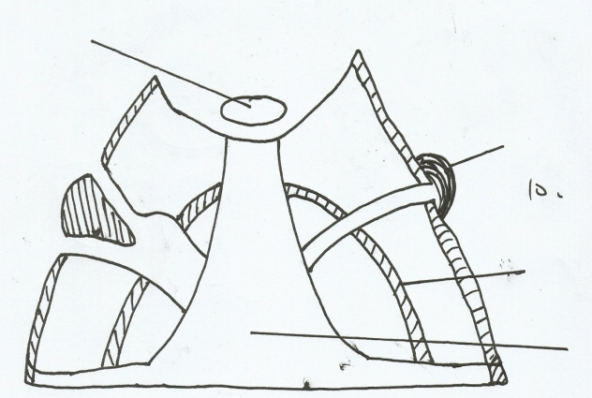
Crater

B

C

Vent

- Identify the type of volcano represented above (1mark)
- Name the parts marked B,C (2marks)
- Mention three features of above volcano above. (3 marks)
- Explain any three features that are formed as a result of intrusive vulcanicity. (6 marks)
(c) List and explain the three life cycles of a volcano. (6marks)
(d) Give two differences between a hot spring and geyser. (2 marks)
(e) State three negative effects of vulcanicity to human environment. (3 marks)

