GEOGRAPHY FORM THREE
GATITU MIXED SECONDARY
MID TERM EXAM
TERM TWO 2014
KENYA CERTIFICATE OF SECONDARY EDUCATION
INSTRUCTIONS TO STUDENTS
- This paper contains two sections
- Answer all the questions in section a
- Answer question six and any other two questions
SECTION A
Answer all the questions in this section
- i). differentiate between SIAL and SIMA (2mks)
ii) Give the characteristics of outer core (2mks)

- i) outline three types of deltas (3mks)
(ii) Highlight three conditions necessary for the formation of deltas (3mks)

- i) highlight four types of drainage pattern (4mks)
ii) Outline four significance of rivers and the resultant features(4mks)

- 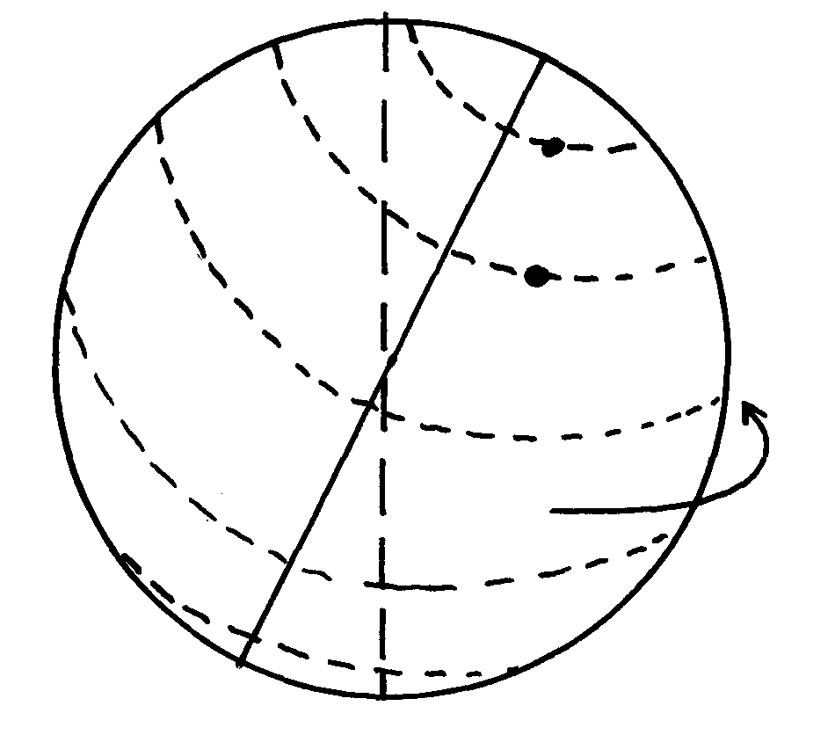The diagram below represents the earth on its axis. Use it to answer question (a)
N
North
G
Rotation of the earth
South
Orbit

a) i) Name the latitude marked G (1mk)
ii) What is the angle of inclination of the earth’s axis from its orbit? (2mks)

- i) define the term landslide (1mk)
ii) State three processes of a landslide (3mks)
SECTION B
Answer questions number six and any other two questions in this section only
6. The table below shows leading import crops by value ( Kshs. Million). Use is to answer questions a – c

 | CROP
Year | Un milled wheat | Maize | Rice | Wheat flour
2000 | 6,989 | 4,664 | 1,968 | 180
2001 | 7,515 | 3,342 | 2,619 | 639
2002 | 5,577 | 229 | 2,104 | 237
2003 | 6,099 | 1,417 | 2,981 | 168
2004 | 6,754 | 4,647 | 3,659 | 200
(a) (i) Using a scale of 1cm represents 100,000 , draw a comparative bar graph to represent the data in the table above (7mks)
(ii) Give three advantages of suing comparative bar graphs (3mks)
(b) Explain three reasons why Kenya is a producer of the commodities shown in the table above yet she imports the same (3mks)
(c) State five methods of representing relief on topographical maps (5mks)
(d) Differentiate between direction and bearing (2mks)
(e) Define aerial photographs. Name two types of aerial photographs (2mks)
(d) Study the photograph given below and answer the questions given

- Name the type of photograph shown in b above (1mk)
- Name two human activities carried out in the photograph given above (2mks)

7. (a) What is a lake? (1mks)
(b) (i) Name two types of lakes formed due to vulcanicity (2mks)
(ii) Explain how
Lake Victoria has influenced the climate of the surrounding area (3mks)
(c) (i) State four main reasons why lakes within the Rift valley are salty (4mks)
(ii) Name any three fresh water lakes in Kenya which are within the rift valley (3mks)
(d) Explain any four economic significance of lakes to Human activities (8mks) (e) Name three features resulting from river rejuvenation (3mks)
(f) State the processes through which a river erodes its channel (2mks)

8. (a) Explain four measures which have been taken to manage forests in Kenya (4mks)
(b) Give the differences between the soft wood forests in Kenya Canada, under the following headings:
(i) Species (2mks)
(ii) Problems (3mks)
(iii) Marketing (2mks)
(iv) Exploitation (2mks)
(c) (i) State three factors that have led to the reduction of the area under forest in Mau forest (3mks)
(ii) Distinguish between forestry and forest (2mks)
(d) Your class intends to carry out a field study on the exotic trees of the Kenya highlands:-
(i) Name two types of tree species they are likely to observe (2mks)
(ii) Identify three methods you will use to record the data in the field (3mks)
(iii) Problems the students are likely to encounter (3mks)

9. (a) State three reasons why wind erosion is predominant in desert areas. (3mks)
(b) Describe three processes by which wind erodes.(3mks)
(c) With aid of well labeled diagrams, describe the formation of the following desert features;
(i) Rock pedestal.(5mks)
(ii) Zeugen. (5mks)
(d) State four ways in which desert land forms influence man’s activities (4mks)
(e) State three features resulting from wind deposition in desert (3mks)
(d) State two factors that facilitate the formation of a sand dune (2mks)

10. The map below shows the climatic regions of Kenya
(a) Use it to answer the question a and b

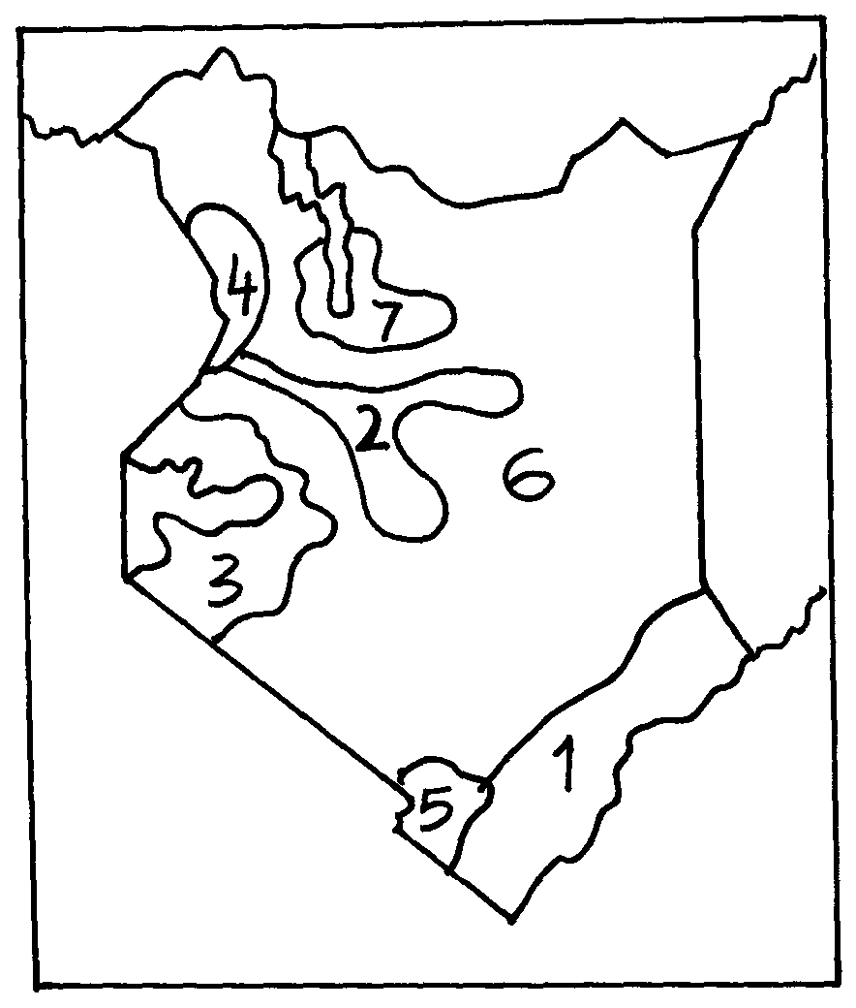

(a) Name the climatic region name 2 and 3 (2 mks)
(b) State four characteristics of climatic region marked 1 (4mks)
(c) State two human causes of climate change (2mks)
(d) Explain three consequences of climate change (3mks)
(e) Four classes intend to visit a weather station near your school to study the instrument for measuring weather element:-
(i) Describe how you would use a rain gauge to measure rainfall (2mks)
(ii) Name four instruments you would find inside a Stevenson screen (2mks)
(f) Differentiate between aridity and desertification (2mks)
(g) (a) Name two types of vegetation (1mks)
(b) The diagram below shows vegetation zones of a S. Africa mountain. Use it to answer the question below:-
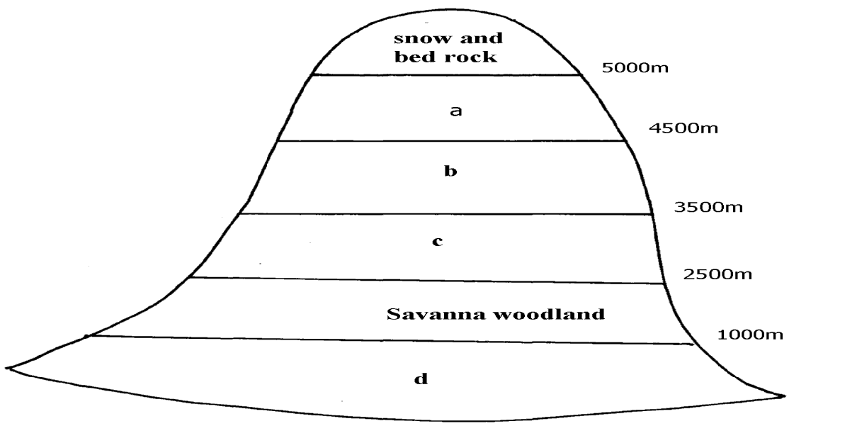

(i) Name the zones a, b, c, d (4 mks)
(ii) Give one reason why there is no vegetation cover on to p of the mountain (1mk)
(c) (i) State the names given to temperate grassland vegetation in:-(2mks)
- North America
- Argentina

