GATITU MIXED SECONDARY SCHOOL
MATHEMATICS FORM 3 END OF TERM 2 2013
- Without using mathematical tables or a calculator evaluate 3mks
1.89 + 0.3 of 1.5
0.2² × (17.8 -7.6) ÷4

- Convert 0.2⁰ 13⁰ to a fraction 3mks

- Solve for y in the equation 3mks
8^{(2y -1)} × 32^{y} =16^{(y +1)}

- Find the integral values that satisfy the inequality below 3mks
x = 21 >15 – 2x > x +12

- Expand ( x +4)⁵ 3mks

- The fig below AB and CD are chords of a circle that intersect externally at Q. if AB =5cm BQ = 6cm and DQ =4cm, calculate the length of chord CD. 3mks

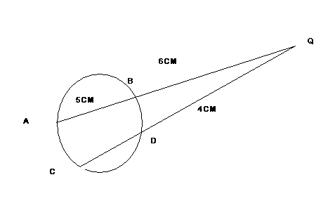
- The line L passes through point (3,1) and is perpendicular to the line 2y =4x +5. Determine the equation of line L. 3mks

- Simplify √5 , leaving the answer in the form a +b √c , where a, b
√5 -2
and c are integers 2mks

- The exchange rate in January 2010 was us$1 =ksh 85.60 and uk £1 = us $ 1.42. a tourist came to Kenya with us$ 5000. She spent kshs 189,000 and changed the balance to uk £. Find the amount she received to the nearest uk £. 3mks

- The sum of the interior angles of an n sided polygon is 720⁰ . find the value of n and hence deduce the name of the polygon. 3mks

- Oruka uses 1/3 of his farm for planting coffee , ¼ for planting tea and 2/5 of remainder for mixed farming. He still had 6 hectares of unused land. Find the size of Oruka’s land. 4mks

- At 10.30 am, a boy starts out from town A and cycles to an average speed of 15 km /hr towards B which is 65km away. Some 20 minutes later a motorist leaves town B and travels towards A at an average speed of 75km/h. at what time did the two meet? 4mks

- Two similar solids gave surface areas 48 cm² and 108 cm² respectively. find the volume of the smaller solid if the bigger one has a volume of 162 cm² 3mks

- In June of a certain year. An employee’s basic salary was ksh. 17,000. The employee was also paid a house allowance of shs.6000 a commuter allowance of kshs.2500 and a medical allowance of kshs. 1800. In July of that year, the employee’s basic salary was raised by 2%
- Calculate the employees:
- Basic salary for July 2mks

- Total taxable income in July of that year. 2mks

- In the year, the income tax rate were as shown in the table below
Monthly taxable income(kshs) | Percentage rate of tax per shilling
Upto 9680 | 10
From 9680 to 18800 | 15
18801 – 27920 | 20
27921 – 37040 | 25
37040 and above | 30
Given that the monthly personal relief was ksh. 1056. Calculate the net tax paid by the employee 6mks

- Find the angle subtended at the centre of a circle by an arc of length 20cm . If the circumference of the circle is 60 cm. 2mks

- The fig shows 2 circles centres O₁ and O₂ touching externally at T. P is a point on their common tangent. Tangents from P touch one of the circles at R and other at s , if PR =8cm , PO₂ =10 cm and PO₁ =17 cm . find 6mks

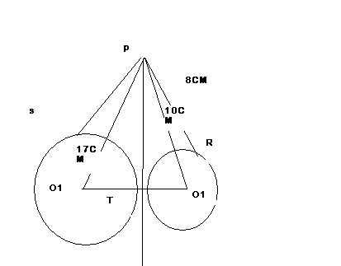

- PT

- PS

- O₁O₂

- Find the value of the angles marked by a and b where o is the centre of the circle. 2mks
