GATITU MIXED SECONDARY SCHOOL
PHYSICS FORM 3 MID TERM EXAM TERM 2 2015
- . State the principle of moments. (1mk)

- (a) Distinguish between density and relative density of a substance (2 mks)

(b) A ship of mass 1300 tonnes floats on sea water:
i) What volume of sea water is displaced (Density of sea water is 1025kg/m³) (3mks)

(ii) Suppose it sails from sea water to fresh water, what cargo must be removed so that the same volume of water is displaced? (Density of fresh water = 1000kg/m³ ⁾ (3mks)

- A bathroom shower has 200 holes each 2.5mm² in area. Water flows from a pipe of cross-section area of 15cm² at 5m/s to the shower. Determine the speed of the spray. (3mks)

- State two factors that would raise the boiling point of a liquid. (2mks)

- The barometric height at sea level is 76cm of mercury while at a point on a highland it is 74cm of mercury. What is the altitude of the point? (Take g = 10m/s² , density of mercury =13600kg/m³ and density of air as 1.25kg/m³) (3mks)

- A small nail may pierce an inflated car tyre and remain there without pressure reduction in the tyre. Explain the observation (2mks)

- State how heat transfer by radiation is reduced in a vacuum flask (2mks)

- Figure 1 shows a beam balance made out of concrete and reinforced with steel
Concrete
Steel

Use a diagram to explain the behaviour of the shape of the beam when heated up (2mks)

- When a drop of olive oil of radius 1.36mm is placed on the surface of water, it spreads out to form a circular film of diameter 40cm. Calculate;
(a) The volume of the olive oil drop in m³ (Take π = ²²/₇) (3mks)

(b) Using the value of (a) above, estimate the thickness of the film. (2mks)

(c) Explain why lycopodium powder is sprinkled on the surface of water before the
oil is dropped on it. (1mk)

(d) State two assumptions made when finding the thickness of the film formed. (2mks)

- Figure 4 shows a uniform wooden plank which weighs 10N. The plank is balanced at 0.8m
from one end by a mass of 2.5kg
2.5kg
0.8m
fig. 4

What is the length of the wooden plank in metres? (3mks)

- State two ways in which stability of a body can be increased. (2mks)

.
- Figure 5 below shows the cross-section of an aerofoil, with the aeroplane moving in the direction
shown by the arrow.

Sketch the streamlines to show how air flows past the wing as the aeroplane moves. (3mks)

- The three springs shown in figure 2 are identical and have negligible weight. The extension
produced on the system of springs is 20cm
20N
20N

fig. 2 (4mks)

Determine the constant of each spring

- a) Distinguish between the terms ‘uniform velocity’ and ‘uniform acceleration’ (2mks)

b) The figure below shows a section of a ticker tape. The dots were made at a frequency of 50Hz.
Determine the acceleration of the trolley pulling the tape (3mks)

- a) State Boyle’s law (1mk)

(b) The volume of a bubble at the base of a container of water is 3cm³. The depth of water is
30cm. The bubble rises up the column until the surface ;
(i) Explain what happens to the bubble as it rises up the water column. (2mks)

ii) Determine the volume of the bubble at a point 5cm below the water surface (3mks)

- A ball of mass 100g is kicked horizontally from the top of a cliff. If the ball takes 4 seconds to hit the ground, determine the height of the cliff. (3mks)

- Sketch a velocity-time graph for a body moving with zero acceleration (3mks)

- A block of mass 20kg slides downward a plane inclined of 6o0 with the horizontal. The coefficient of friction between the plane and the block is 0.4.
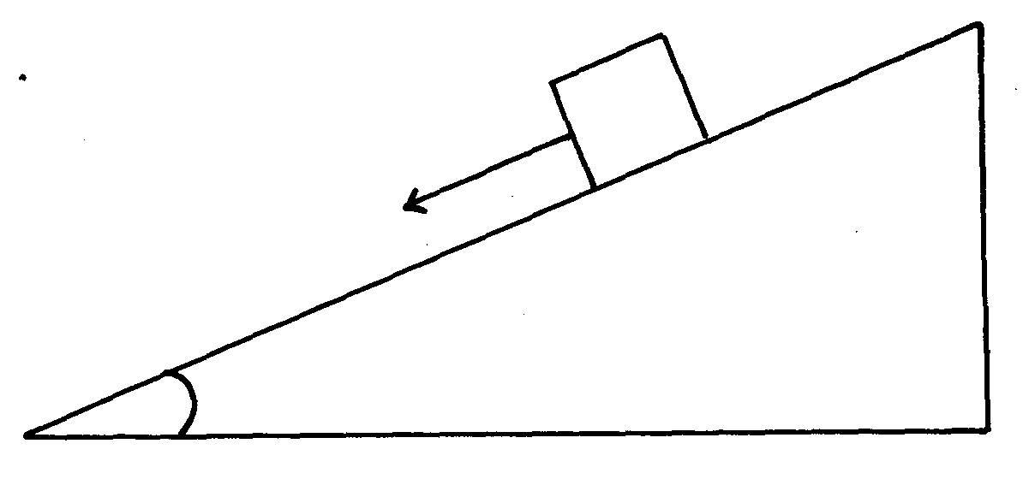
60º
20kg

Calculate the acceleration of the block. (3mks)

- A hydraulic machine is used to raise a load of 100kg at a constant velocity through a height of 2.5m. The radius of the effort piston is 1.4cm while that of the load piston is 7.0cm. Given that the machine is 80% efficient, calculate:-
(i) The effort needed. (3mks)

(ii) The energy wasted in using the machine. (3mks)

- (a) State Newton’s first law of motion. (1mk)

(b) Distinguish between elastic collision and inelastic collision. (2mks)

(c) A minibus of mass 2000kg traveling at a constant velocity of 36km/h collides with a stationary car of mass 1000kg. The impact takes 2 seconds before the two move together at a constant velocity for 20 seconds. Calculate:
(i) The common velocity (2mks)

(ii) The distance moved after impact. (2mks)

(iii) The impulse force.(2mks)

(iv) The change in kinetic energy (2mks)

