DARAJANI BOYS SCHOOL,
P.o Box 20-90129, Ngwata.
Mid-Term 2 Examinations 2015
Form 3.
Physics Paper 1
232/1
Time : 2hrs

Name…………………………………………..Adm.No………class…...
Section I (25mks)

1. The micrometer screw gauge shown has a thimble scale of 50 divisions
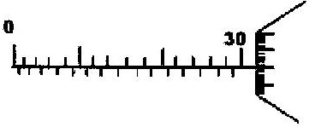
What is the reading shown? (2mks)

- State the principle of moments. (1mk)

- Determine the value of Y in the diagram below(3mks
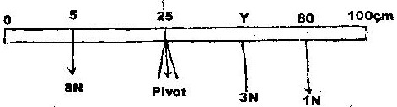

- Figure 2 shows a solid cylinder standing on a horizontal surface. The cylinder is in stable equilibrium.

In the horizontal space provided, sketch the cylinders in neutral equilibrium. (1mk

- State two factors that determine the stability of a vehicle.(2mks

- State the necessary conditions for equilibrium of body which is acted upon by a number of forces.(2mks

- State the modification introduced in the modern buses so as to enhance stability(1mk

- Figure below shows a pulley system being used to raise a load.
If the effort applied is 28N and the load lifted is 100N, determine the efficiency of the system. (3mks)

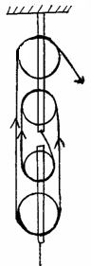
Effort = 28N
Load
100N

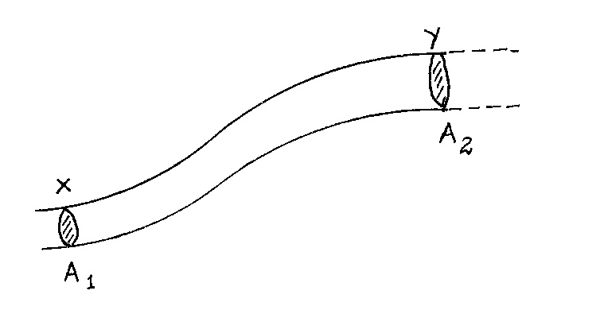
10. Figure below shows a section of a pipe XY. A constant pressure difference maintains a streamline flow of a liquid in the pipe.

If the cross-sectional area A₁ at X is less than A₂ at Y, state how the liquid velocity V₂ at Y compares with V₁ at X. (2mks)

11. Explain the cause of random motion of smoke particles as observed in Brownian motion experiment using a smoke cell. (2mks)

- A bullet is fired horizontally from a storey building 15m high. If the initial speed is 350msˉ¹, determine the maximum horizontal distance covered by the bullet. (3mks)

13. The figure shows a speed-time graph for part of the journey of a motorcar.
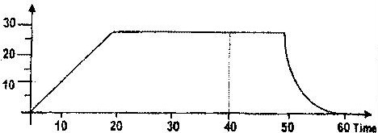

Determine the distance the car travels in the first 40 seconds.(3mks)

Section II (55mks)
14. (a) Name a device that is used to convert sound energy to electrical energy. (1mark)

(b) Define the term efficiency of a machine. (2marks)

(c) A pulley system having a velocity ratio of 4 is used to raise a load 100N through a height of 0.6m at a constant speed using an effort of 20N in a time of 15 seconds.
- Calculate the efficiency of the system. (3marks)

(ii) How far does the effort end move in order to raise the load by 0.6m (3marks)

(d) Figure (10) below shows two pulley arrangements used to lift different loads
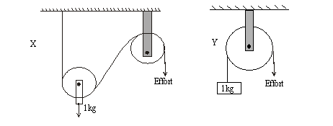
Fig 10
Which of the two systems is more efficient? Give a reason. (2marks)

- The figure below shows an inclined plane, a trolley of mass 30kg is pulled up a slope by a force of 100N, parallel to the slope. The trolley moves so that the centre of mass C travels from points A to B.
•
A
C
100N
B
10m
15º

- What is the work done on the trolley against the gravitational force in moving from A to B.? (3mks)

- Determine the work done by the force in moving the trolley from A to B. (3mks)

- Determine the efficiency of the system. (2mks)

- Determine the work done in overcoming the frictional force. (2mks)

- Determine the mechanical advantage of the system. (2mks)

.

16. a) i) A body is initially in motion. If no external force acts on the body, describe the subsequent motion. (2mks)

ii) A car of mass 800 kg is initially moving at 25 m/s. Calculate the force needed to bring the car to the rest over a distance of 20 m. (3mks)

b) Two trolleys of masses 2 kg and 1.5 kg are traveling towards each other at 0.25m/s and 0.40 m/s respectively. Two trolleys combine on collision.
i) Calculate the velocity of the combined trolleys. (3mks)

ii) In what direction do the trolleys move after collision? (1mk)

(c) A stone is thrown horizontally from a building that is 50 m high above a horizontal ground. The stone hits the ground at a point, which is 65m from the foot of the building. Calculate the initial velocity of the stone. (3mks)

- (a)A rifle of mass 4.0kg fires a bullet of mass 12.0g with a muzzle velocity of 700ms⁻¹. Assuming that the rifle is free to move, find the velocity of recoil. (3mks)

- Figure 10 shows a cross-section of a handle of a screw jack 70cm long. The pitch of the screw is 0.8cm.
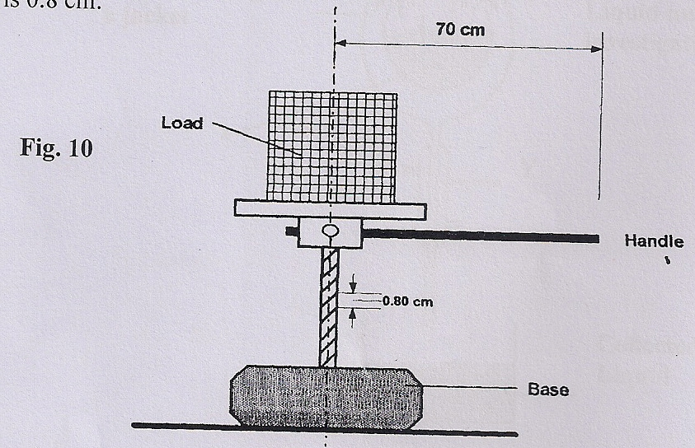

Given that the efficiency is 65%, calculate:-
- The velocity ratio of the system. (2mks)

- The mechanical advantage of the screw jack. (2mks)

    - Draw a single moving pulley with a velocity ratio of 2. (2mks)

- (a) (i) Define Pressure Law. (1mk)

- State one basic assumption of the Kinetic Theory of gases. (1mk)

- Figure 12 shows a set up that may be used to verify Pressure Law.
Figure 12
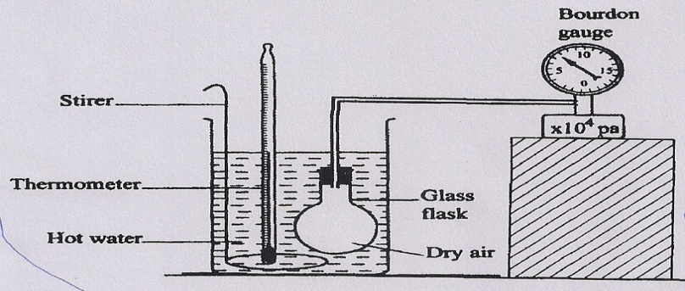
- State the measurements that may be taken in the experiment. (2mks)

- Explain how the measurement in (i) above may be used to verify Pressure Law. (4mks)

- A car tyre is at an air pressure of 4.0 x 10⁵ Pa at a temperature of 27⁰C. While it is running, the temperature rises to 75⁰C. What is the new pressure in the tyre? (Assume the tyre does not expand). (3mks)

