DARAJANI BOYS SCHOOL,
P.o Box 20-90129, Ngwata.
Mid-Term 2 Examinations 2015
Form 3
Physics Paper 2
232/2
Time: 2hrs

Name…………………………………………..Adm.No………class…...
Section I (25mks).

- What measurable quantity is associated with colour of light? (1mk)

- State TWO uses of total internal reflection. (2mks)

- The graph shown below shows, the apparent depth (y-axis) against real depth.
Use it to calculate the refractive index of glass. (3mks)
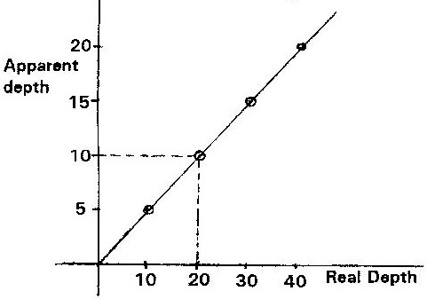

- The refractive index for air-water boundary is ⁴/₃. Calculate the critical angle for water–air interface. (3mks)

5. A positively charged sphere is suspended by an insulating thread. A negatively charged
conductor is suspended near it. The conductor is first attracted, after touching the sphere it is repelled.
Explain this observation. (2mks)

6. Figure 5, shows how the displacement of a point varies with time as a wave passes it.
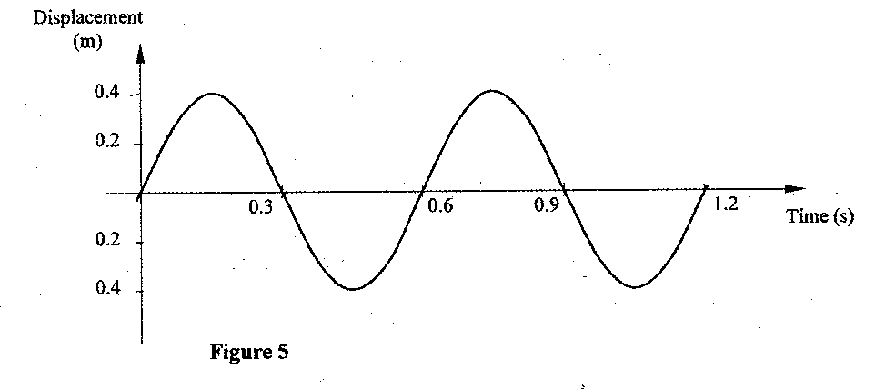
On the same diagram, draw a wave which passes the point with half the amplitude and twice
the frequency of the one shown. (2mks)
.
7. A water wave of wavelength 18 mm is incident on a boundary of shallow water at right
angles. If the wavelength in the shallow end is 14.4 mm, determine the refractive index of
water for a wave moving from the deep to the shallow end. (3mks)

8. Figure 12, shows an electrical circuit including three switches, S₁, S₂, S₃, and three identical lamps L,, L₂, L₃. A constant potential difference is applied across X and Y.
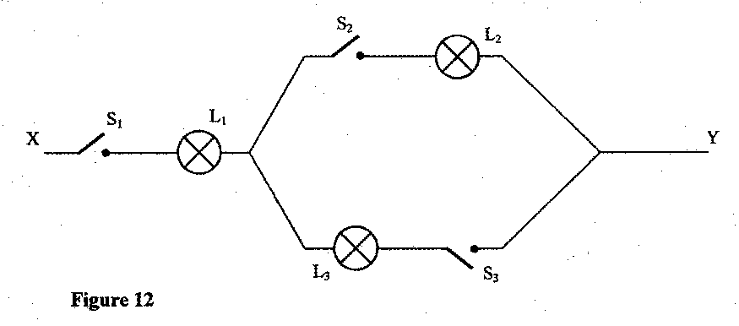
- Other than L₁, state the lamp that will light when S₁ and S₂ are closed. (1mk)

- How does the brightness of L₁ in (i) above compare with its brightness when all the switches are closed? (1mk)

- Explain the observation in part (ii) above.(1mk)

- In a vacuum flask the walls enclosing the vacuum are silvered on the inside. State the reason for this (1 mark)

Figure 4 shows two identical balloons A and B. The balloons were filled with equal amounts of the same type of gas. The balloons are suspended at distances X₁ and X₂ from a metal cube filled with boiling water and placed on an insulating material. Use this information to answers questions 10 and 11.
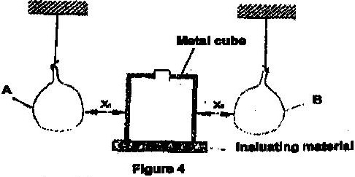

- State the mode by which heat travels from the cube to the balloons. (1 mark)

- The face of the cube towards A is bright and shiny and the face towards B is dull black. State with a reason the adjustments that should be made on the distances X₁ and X₂ so that the rate of change of temperature in both balloons is the same. (2 marks)

- Temperature scale in clinical thermometer ranges from 35⁰c to 43⁰c. Explain. (1mk)

- State one application of expansion in gases. (1mk)

Section II (55mks)
- (a) Why is it that boiling is not used for sterilization of clinical thermometer? (1mk)

- In the space provided below, sketch a labeled diagram to show how a pinhole camera forms an image of a vertical object placed in front of the pinhole. (3 marks)

- A building standing 100m from a pinhole camera produces on the screen of the camera an image 5 cm high 10 cm behind the pinhole. Determine the actual height of the building. ( 3 marks)

- The force of a conductor carrying a current in a magnetic field can be varied by changing among others, the magnitude of the current and the magnetic field strength. Name two other factors that can be changed to vary the force.(2mks)

- The figure below shows a soft iron ring placed between poles of two magnets. Sketch the magnetic field pattern.(2mks)

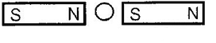

- Four bars of metal A, B, C and D are tested for magnetism. B attracts both A and C but not D. D does not attract A, B or C, A and C sometime attract one another and sometimes repel one another. What conclusion can you draw about?(3mks)
- Bar A

- Bar B

- Bar D

- Figure 8 beside shows an incomplete circuit of an electromagnet. Complete the circuit between X and Y by drawing the windings on the two arms of the core such that A and B are both North poles when the switch S is closed. Indicate the direction of the current on the windings drawn. (2mks)
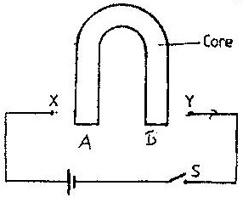

- (a) What is meant by a virtual image? (1mk)

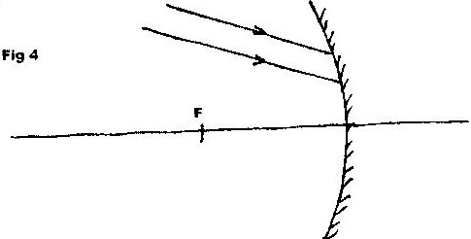
- Fig 4 shows two parallel rays incident on a concave mirror. F is the focal point of the mirror.

On the same diagram sketch the path of the rays after striking the mirror. (2mks)
- State two ways of increasing the strength of an electromagnet.(2mks)

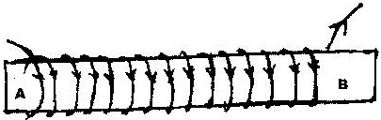
(d) An iron rod XY is placed inside a coil of wire. What type of magnetic pole is induced at the end x when the current flows through the coil? (2mks)

(e). Calculate the refractive index of glass given that the velocity of light in air is 3x 10⁸ ms⁻¹ and velocity of light in glass is 2.4 x 10⁸ms⁻¹.(2mks)

(f). The real thickness of crown glass block of refractive index 1.58 is 10cm is 10cm. Calculate the apparent thickness of the glass.(2mks)

- (a) Fig 1 shows a displacement – time graph of a wave. The velocity of the
wave is 50cm/s.
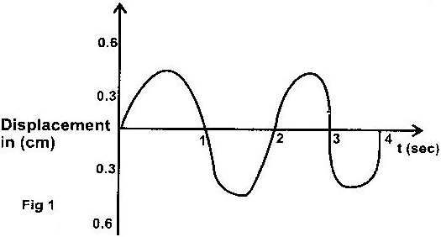

Determine the
- Amplitude. (1mk)

- Period. (2mks)

- Wavelength. (2mks)

- Frequency. (2mks)

(b)
  - What is the difference between longitudinal and transverse waves? (1mk)

  - A mineworker stands between two vertical cliffs 400m from the nearest cliff. The cliffs are distance apart. Every time he strikes the rock once, he hears two echoes the first one comes after 2.5s while the second follows 2s later. From this information calculate:
        - The speed of sound in air. (3mks)

        - The value d. (2mks)

- (a)State Ohm’s law.(2mks)

b) In an experiment to determine the resistance of a resistor x, it is connected in parallel with a 100 Ω resistor. The current through the combination and the p.d across the combination is tabulated as shown below.
Potential difference (v) | 1.5 | 3.0 | 4.5 | 6.0 | 7.5
Current (A) | 0.075 | 0.015 | 0.225 | 0.30 | 0.375
Draw a diagram of the circuit that could have been used. (3mks)

c) i) Plot a graph of current against potential difference. (5mks)
ii) Calculate the gradient of the slope. (3mks)

iii) Calculate the resistance of resistor x. (2mks)

