FORM 3 END TERM EXAM
PHYSIC PP1-2015
Name:.................................................................. Adm No............................ Stream.....................
Answer all the questions in this section in the space provided
1.The water level in a burette is 35 cm³.If 20 drops of water are added;what is the new level if each drop has a volume of 0.15 cm³?(2 mrks)

2.A cylinder of height 25 cm and 7 cm diameter is completely melted and a sphere of the same radius made.Determine the radius of the sphere in metres and expres your answer in standard form.(3 mrks)

3.State two reasons why mercury is prefered as a barometric liquid and not water.(2 mrks)

4.It is not advisable to fix electrical cables tightly during the day.Give reasons for this.(1 mrk)

5.The diagram below shows circuit of a fire alarm.when fire breaks it rings the bell to alert the people that there is fire.Name two properties of mercury that makes it suitable to be used.(2 mrks)
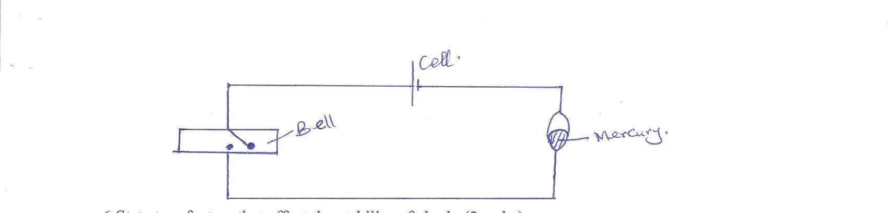

6.State two factors that affect the stability of abody.(2 mrks)

7.Oil accidentally split on ocean and spread into a monolayer film of the area 2.0×10¹² cm².The oil was found to consist the molecules of thickness 5×10⁻¹⁹ m each.Calculate the volume of oil that spilt.(3 mrks)

8.A uniform metre rule is balanced at the 20 cm mark when a load of 1.2 N is hung at the zero mark.calculate the weight and mass of the metre rule.(3 mrks)

9.A bullet of mass 40 g is fired at a velocity of 400m/s from a gun of mass 8 kg.Determine the recoil velocity of the gun(3 mrks)

10.When a thermometre is immersed in ice cold water the mercury thread is observed to rise before dropping steadly in capillary tube.Explain.(2 mrks)

11.In an attempt to prepare a cup of tea, astudent placed boiling water into a glass tumbler.The glass tumbler broke into pieces.Explain this observation.(2 mrks)

SECTION B(55 MARKS)
12. a)State the Law of conservation of momentum(1 mrk)

b)Distinguish between elastic and in elastic collisoin(2 mrks)

c)A bullet of mass 22 g travelling horizontally with a velocity of 300 mls strikes a block of wood of mass 1.978 g which rest on a rough horizontal surface.After impact the bullet and the block move together and came to rest when the block has travelled a distance of 5 m,Calculate
i) The velocity of the bullet and wood after impact. (2 marks)

ii) The force of friction between wood and surface.(2 mrks)

d)A car starts from rest and accelerates uniformly at 2 m/s for 5 seconds.It then travels at constant velocity for next 3 seconds before acelerating again at 2.5 m/s for 2 more seconds.The car is then brought to rest in another 2 seconds.
i) Sketch a velocity-time graph for this motion.(2 mrks)

ii) From the graph,calculate the total distance travelled.(3 mrks)

13. A light beam with support at B and C has loads of 40N,20N and 30N placed on it as shown in the figure below.
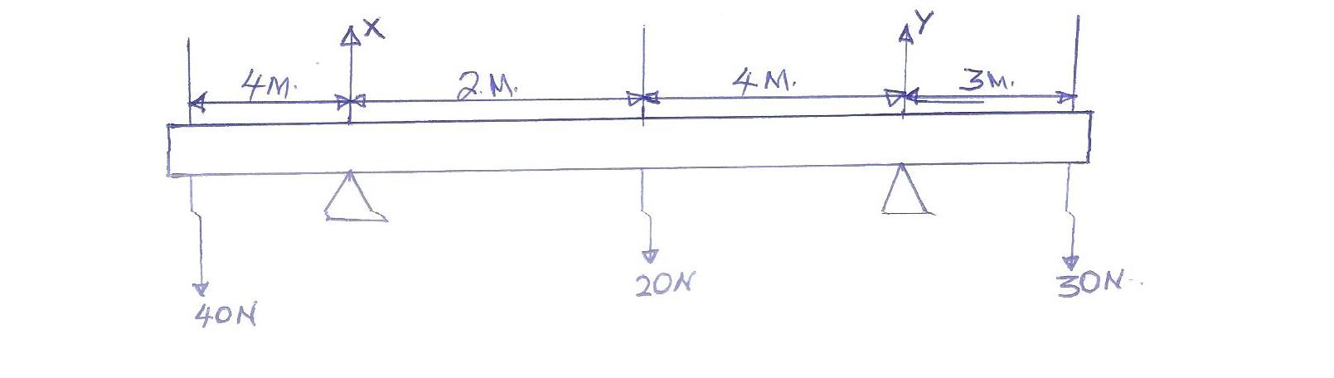

- Calculate the reaction X and Y at the supports.(5 mrks)

- What additional weight at A would make the beam just tilt about B?(3 mrks)

14. a) Using the pulley systems shown a mass of 10Kg is raised 2m by an effort of 80N
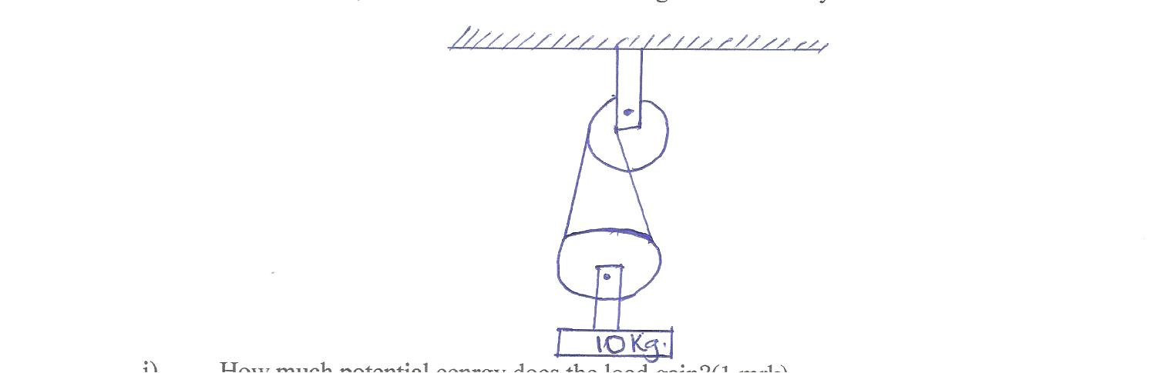

- How much potential energy does the load gain?(1 mrk)

- How far does the effort move in order to raise the laod by 2m? (2 mrks)

- How much work is done by the effort?(2 mrks)

- What is the efficiency of these puleys?(2 mrks)

- If all the wasted energy is used to lift the botom pulley.how much does the pulley weigh?(2 mrks)

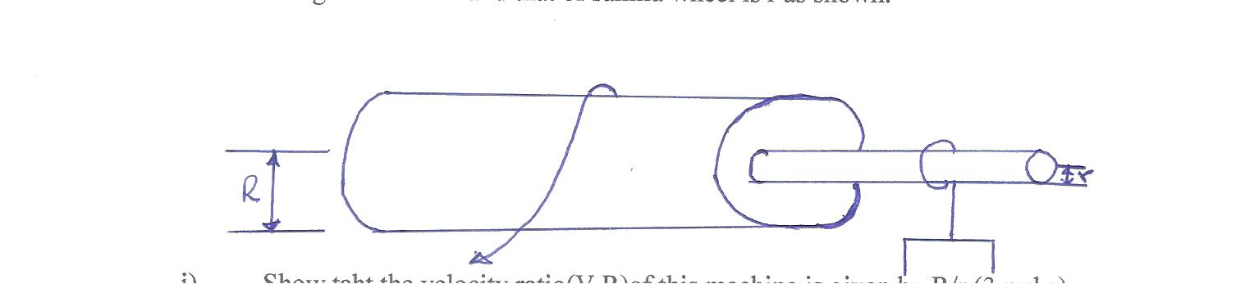
b)The figure below shows a wheel and axle being used to raise a load by applying effort at E.the radius of the large wheel is R and that of simillar wheel is r as shown.

- Show that the velocity ratio(V.R)of this machine is given by R/r.(2 mrks)

- Given that r=5 cm and R=8 cm,determine,the Effort required to raise a load of 20 N if the efficiency of the machine is 80%(3 mrks)

15. a) Define impulse in terms of momentum.(1 mrk)

- For a aparticle of mass M which is initially moving vertically downward with velocity u.obtain an expression for changes in kinetic energy after:
- It has moved freely under gravity for time t (3 mrks)

- It has moved freely under gravity for a vertical distances:(3 mrks)

- A lead ball is placed on the surface of viscous oil and released.
- State three forces acting on the ball as it falls though the oil.(3 mrks)

- State which forces varies during the fall and explain why the variation.(2 mrks)

- What’s meant by the term terminal velocity of the ball.(1 mrk)

- Sketch a graph showing the variation of displacement of the ball with time from when it was released.(1 mrk)

16 a) State Hooke’s Law.(1 mrk)

b)The table shows the extension produced by a spring by various forces.
Extension(cm) | 0 | 0.3 | 0.7 | 1.1 | 1.5 | 1.9 | 2.4
Forces(N) | 0 | 1.0 | 1.9 | 3.0 | 4.1 | 5.0 | 8.0

- Plot a graph of force(y-axis) gainst extension( x-axis) (4 mrks)

- Determine from the graph the spring constant.(2 marks)

