Name: ------------------------------------------------------------------------------------------ADM No: ---------------------

School: ------------------------------------------------Candidate’s Signature: ---------------------------------------------

Date: -------------------------------------------------------------

**FORM THREE**

**PHYSICS PAPER 3**

**PRACTICAL**

**JULY/AUG/2015**

**TIME: 2 ½ HOURS**

**232/3**

**PHYSICS**

**PAPER 3**

**JULY/AUGUST/2015**

**TIME: 2 ½ HOURS**

**INSTRUCTIONS TO CANDIDATES:**

* *Write your* ***name*** *and* ***index number*** *in the spaces provided above.*
* *Sign and write the* ***date*** *of the examination in the spaces provided above.*
* *You are supposed to spend the first 15 minutes of the 2 ½ hours allowed for this paper reading the whole paper carefully.*
* *Marks are given for a clear record of the observation actually made, their suitability, accuracy and the use made of them.*

FOR EXAMINER’S USE ONLY

|  |  |  |  |  |  |
| --- | --- | --- | --- | --- | --- |
| Question1 | (a) | (h) | (i) | (j | (k) |
| Marks score | 01 | 09 | 05 | 03 | 02 |
| Candidate’s score |  |  |  |  |  |

|  |  |  |  |  |  |
| --- | --- | --- | --- | --- | --- |
| Question2 | (a) | (h) | (i) | (j) | (k) |
| Marks score | 01 | 10 | 05 | 03 | 01 |
| Candidate’s score |  |  |  |  |  |

1. You are provided with:

Six identical pieces of glass blocks, a retort clamp, two optical pins, a meter rule and a vernier caliper

1. Using a vernier caliper, measure the thickness of one of the glass blocks given

Thickness of glass block ----------------------------------------------------------cm (1mk)

1. Clamp the optical pin with its pointed end protruding outside as shown in figure 1 below
2. Place the other optical pin on the bench provided
3. Place one glass block on top of the optical pin on the bench so that the block lie with one of its largest surfaces
4. Place the retort clamp on a stool and arrange the whole set up as shown in figure 1 below
5. Adjust the position of the clamped optical pin as you sight the objectpin as shown in the set up below till the two pins appear to coincide at **no parallax position**
6. Measure and record down distances p and q
7. Repeat the experiment in turn using two, three, four and five glass blocks placed on top of the optical pin

RESULTS

|  |  |  |  |  |  |  |
| --- | --- | --- | --- | --- | --- | --- |
| Number of glass blocks used | 1 | 2 | 3 | 4 | 5 | 6 |
| P (cm) |  |  |  |  |  |  |
| Q (cm) |  |  |  |  |  |  |

(9mks)



i) In the grid provided, draw a graph p against q (5mks)

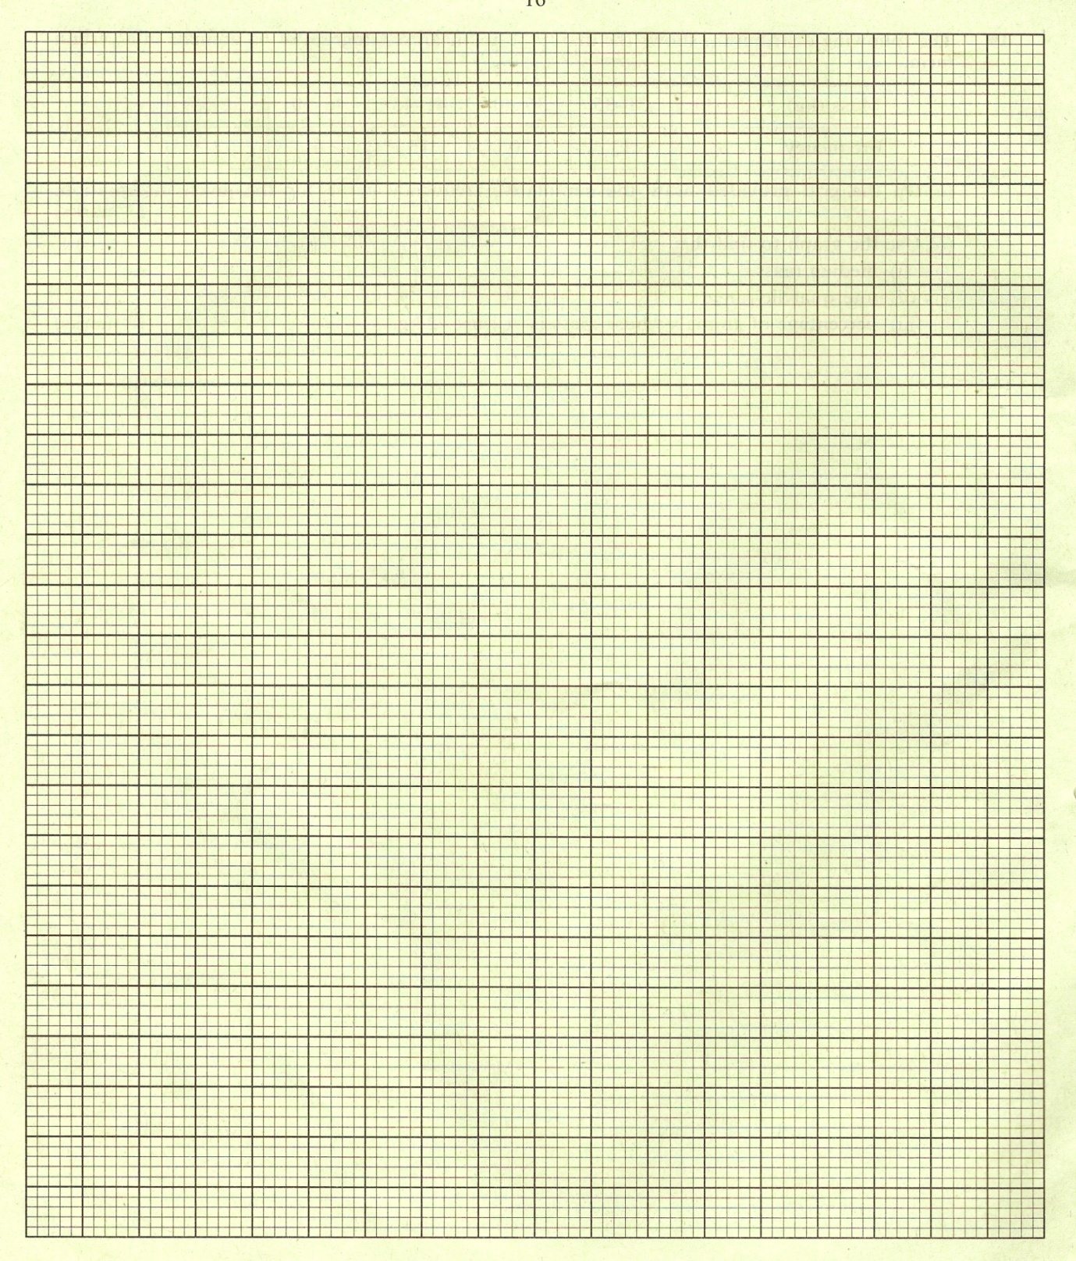

j) Determine the slope of the graph (3mks)

k) State the significant of the value in (j) above (2mks)

1. You are provided with the following pieces of apparatus and materials: A wooden block marked X, a frictionless pulley, a paper bag tied with a piece of twine thread, a beaker of sand, a spatula, one 50g-mass and two 100g-masses, glass slab, a 10cm piece of twine thread , 60cm piece of cotton thread, a spring balance and an heavy object(large piece of stone)



1. Measure the mass of the wooden block X and place the wooden block on the glass slab placed on bench.

Mass of wooden block X = ------------------------------------------------------------------------ (1mk)

1. Tie the pulley on the retort clamp using the 20cm piece of twine thread so that the pulley is firmly held in position but the pulley is free to rotate about its axis
2. Using the 60cm piece of cotton thread, tie the paper bag given to one end of the thread then pass the thread through the grove of the pulley as shown in the figure 2 above then tie the other end to the wooden block x lying on glass slab with the side with fixed paper. **Ensure the thread section connecting the block and the pulley remain perfectly horizontal**
3. Place the heavy object (large piece of stone) on the retort clamp as shown in the diagram to hold the retort firmly
4. Place the wooden block X on the glass slab then place one 50g-mass on the block
5. Using a spatula carefully pour sand in the paper bag till the block just begin to slide on the glass slab
6. Measure and record the weight of the paper bag plus the sand
7. Repeat the experiment using 100g, 150g, 200g and 250g masses

|  |  |
| --- | --- |
| **Weight of wooden block plus the masses on it(W1) in Newtons (N)** | **Weight of paper bag plus sand (W2)**  **in Newtons (N)** |
|  |  |
|  |  |
|  |  |
|  |  |
|  |  |

(10mks)

1. In the grid provided, draw a graph of weight of paper bag plus sand (W2) against weight of wooden block plus the masses place on it(W1) (5mks)

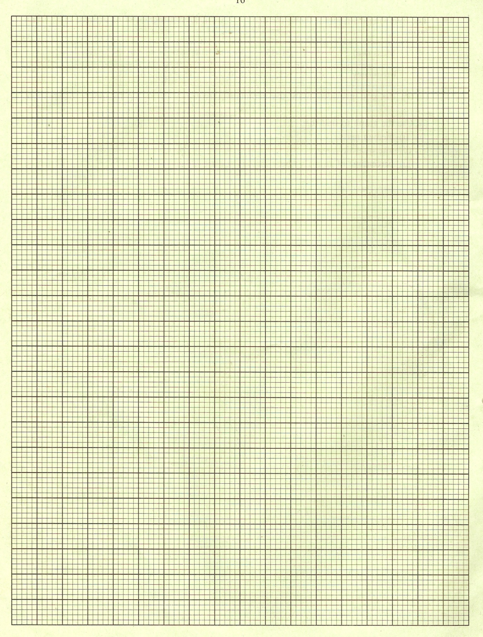

1. Determine the gradient of the graph (3mks)
2. State the significance of the value obtained in (j) above (1mk)