NAME ……………………………………..………………..INDEX NO. …………….……….……..…..…
CANDIDATE’S SIGNATURE …………..…..………..
DATE …………………………………

451/1
COMPUTER STUDIES
PAPER 1
(THEORY)
TIME: 2 ½ hours

PRE KCSE 2016
Kenya certificate of Secondary Education

451/1
COMPUTER STUDIES
PAPER 1
(THEORY)
JULY/AUGUST 2016
TIME: 2 ½ hours

Instructions to Candidates
- Write your name and index number in the spaces provided above.
- This Paper consists of two sections A and B.
- Answer ALL the questions in section A.
- Answer question 16 (compulsory) and any other THREE questions from section B.
- All answers should be written in the spaces provided.
- This paper consists of 12 printed pages. Candidates should check to ensure that all pages are printed as indicated and no questions are missing

FOR EXAMINER’S USE ONLY
Section | Questions | Candidate’s score
A | - 15
B | 16
 | 17
 | 18
 | 19
 | 20
 | TOTAL SCORE

Computer Studies
Paper 1
(Theory)

- Give importance of having the following in computer laboratory;- (3marks)
- Standard furniture in the laboratory
………………………………………………………………………………………………………………………………………………………………………………………………………………………………
- Antiglare screen/ monitor
………………………………………………………………………………………………………………………………………………………………………………………………………………………………
- UPS
………………………………………………………………………………………………………………………………………………………………………………………………………………………………
- Distinguish between ROM and RAM (2marks)
………………………………………………………………………………………………………………………………………………………………………………………………………………………………
- Explain the following computer crimes (2marks)
- Fraud.
………………………………………………………………………………………………………………………………………………………………………………………………………………………………
- Alteration
………………………………………………………………………………………………………………………………………………………………………………………………………………………………
- (a) Define
- Firewalls (1mark)
………………………………………………………………………………………………………………………………………………………………………………………………………………………………
- Data encryption (1mark)
………………………………………………………………………………………………………………………………………………………………………………………………………………………………
- Differentiate between the following terms as used in word processing (3marks)
- Drop Cap and Case
………………………………………………………………………………………………………………………………………………………………………………………………………………………………
- Superscript and subscript
………………………………………………………………………………………………………………………………………………………………………………………………………………………………

- Indent and tab
………………………………………………………………………………………………………………………………………………………………………………………………………………………………
- (a) State and explain any one type of computer processing file (1mark)
………………………………………………………………………………………………………………………………………………………………………………………………………………………………
(b) List any two file organization methods (2marks)
………………………………………………………………………………………………………………………………………………………………………………………………………………………………
- Describe the following terms as used in internet.
(a) Webpage (1mark)
………………………………………………………………………………………………………………………………………………………………………………………………………………………………
(b) Blog (1mark)
………………………………………………………………………………………………………………………………………………………………………………………………………………………………
(c) Hyperlinks (1mark)
………………………………………………………………………………………………………………………………………………………………………………………………………………………………
- Web portal (1mark)
………………………………………………………………………………………………………………………………………………………………………………………………………………………………
- (a) Give four advantages of DTP over a word processor (2marks)
………………………………………………………………………………………………………………………………………………………………………………………………………………………………
(b) Differentiate between the following
(i) Kerning and tracking (2marks)
………………………………………………………………………………………………………………………………………………………………………………………………………………………………
(ii) Margins and column guides (2marks)
………………………………………………………………………………………………………………………………………………………………………………………………………………………………
- Define the term simulation (1mark)
………………………………………………………………………………………………………………………………………………………………………………………………………………………………

- Differentiate between baseband and broadband signal as used in networking (2marks)
- Baseband signal
………………………………………………………………………………………………………………………………………………………………………………………………………………………………
- Broadband signal
………………………………………………………………………………………………………………………………………………………………………………………………………………………………
- Explain how the operating system controls the following resources (3marks)
- Processor
………………………………………………………………………………………………………………………………………………………………………………………………………………………………
- Main memory
………………………………………………………………………………………………………………………………………………………………………………………………………………………………
- Input and output devices
………………………………………………………………………………………………………………………………………………………………………………………………………………………………
- What is deadlock in reference to operating systems (1mark)
………………………………………………………………………………………………………………………………………………………………………………………………………………………………
- (a) The most popular type of electronic data storage currently us magnetic disk storage such as hard disk or Winchester disk. Give reasons as to why they are popular. (2marks)
………………………………………………………………………………………………………………………………………………………………………………………………………………………………………………………………………………………………………………………………………………………………………………………………………………………………………………………………
(b) Outline two advantages of hard disk over floppy disk. (2marks)
………………………………………………………………………………………………………………………………………………………………………………………………………………………………
- Define the following computer crimes
- Piracy (1mark)
………………………………………………………………………………………………………………………………………………………………………………………………………………………………
- Industrial espionage (1mark)
………………………………………………………………………………………………………………………………………………………………………………………………………………………………
- Explain two ways of protecting data and information against unauthorized access (2marks)
………………………………………………………………………………………………………………………………………………………………………………………………………………………………
SECTION B (60MARKS)
Answer question 16 and any other three questions

- (a) list two examples of
- Third generation languages (2marks)
………………………………………………………………………………………………………………………………………………………………………………………………………………………………
- Object oriented languages (2marks)
………………………………………………………………………………………………………………………………………………………………………………………………………………………………
(b) Define (2marks)
- Object code
………………………………………………………………………………………………………………………………………………………………………………………………………………………………
- Source code
………………………………………………………………………………………………………………………………………………………………………………………………………………………………
(c) Differentiate between a compiler and an interpreter (2marks)
………………………………………………………………………………………………………………………………………………………………………………………………………………………………
- A car rental firm leases its cars for Kshs. 2500.00 per day. The manager gives a discount based on the number of days that the car is rented. If the rental period is greater than or equals to 7 days then a 25% discount is given. Write a peudocode to accept a car number and the rental period, and calculate the total amount earned by the company when a car is leased. (7marks)

- (a) Subtract 0111₂ from 1001₂ (2marks)
………………………………………………………………………………………………………………………………………………………………………………………………………………………………………………………………………………………………………………………………………………………………………………………………………………………………………………………………
(b) Using two’s compliment, subtract 7 from 4 and give the answer in binary notation. (4marks)
………………………………………………………………………………………………………………………………………………………………………………………………………………………………………………………………………………………………………………………………………………………………………………………………………………………………………………………………
(c) Convert
- 91C₁₆ to octal (3marks)
………………………………………………………………………………………………………………………………………………………………………………………………………………………………………………………………………………………………………………………………………………………………………………………………………………………………………………………………
- 377₈ to hexadecimal (3marks)
………………………………………………………………………………………………………………………………………………………………………………………………………………………………………………………………………………………………………………………………………………………………………………………………………………………………………………………………
- 9.625₁₀ to binary (3marks)
………………………………………………………………………………………………………………………………………………………………………………………………………………………………………………………………………………………………………………………………………………………………………………………………………………………………………………………………
- A school computer laboratory is scheduled to undergo major renovations. The lab is schedule to receive new computer whose specifications are given below:-
Pentium IV 2.8GHz processor
40GB HDD
3 ½ FDD
256MB RAM
56 x CD ROM
17” SVGA TFT monitor
The computers are going to be networked and will be able to browse the internet.

- Explain what is meant by the terms:- (2marks)
- FDD
………………………………………………………………………………………………………………………………………………………………………………………………………………………………
- HDD
………………………………………………………………………………………………………………………………………………………………………………………………………………………………
- SVGA
………………………………………………………………………………………………………………………………………………………………………………………………………………………………
- TFT
………………………………………………………………………………………………………………………………………………………………………………………………………………………………
- The computer is to be networked, name one extra device that should be fitted on every computer to enable this to happen (1mark)
………………………………………………………………………………………………………………………………………………………………………………………………………………………………
- The computer is to receive internet facilities through the server on a dial; up system. Name and describe the function of a special device that needs to be connected to the server to complete the connection.
(1mark).
………………………………………………………………………………………………………………………………………………………………………………………………………………………………
- (i) The school has to apply star topology to link up the computer. List two advantages of this type of
topology. (1mark)
………………………………………………………………………………………………………………………………………………………………………………………………………………………………
(ii) Name the central device used to connect the computers in this topology. (1mark)
………………………………………………………………………………………………………………………………………………………………………………………………………………………………
- List two other types of topologies that the school could have opted for (1mark)
………………………………………………………………………………………………………………………………………………………………………………………………………………………………
- List four advantages of using a network (2marks)
………………………………………………………………………………………………………………………………………………………………………………………………………………………………

- (i) Data transmission via the internet is done using a mode known as packet switching. Describe this
data transmission mode (1mark)
………………………………………………………………………………………………………………………………………………………………………………………………………………………………
(ii) Name two other modes of transmission (1mark)
………………………………………………………………………………………………………………………………………………………………………………………………………………………………
- (i) The school’s LAN is done using UTR cable. List two advantages of using this type of cable.
(1mark)
………………………………………………………………………………………………………………………………………………………………………………………………………………………………
(ii) List two advantages of using fibre cable in networking (1mark)
………………………………………………………………………………………………………………………………………………………………………………………………………………………………
- Data flows in the school’s LAN in a duplex manner. Discuss two other types of data transmission in network giving examples (2marks)
………………………………………………………………………………………………………………………………………………………………………………………………………………………………

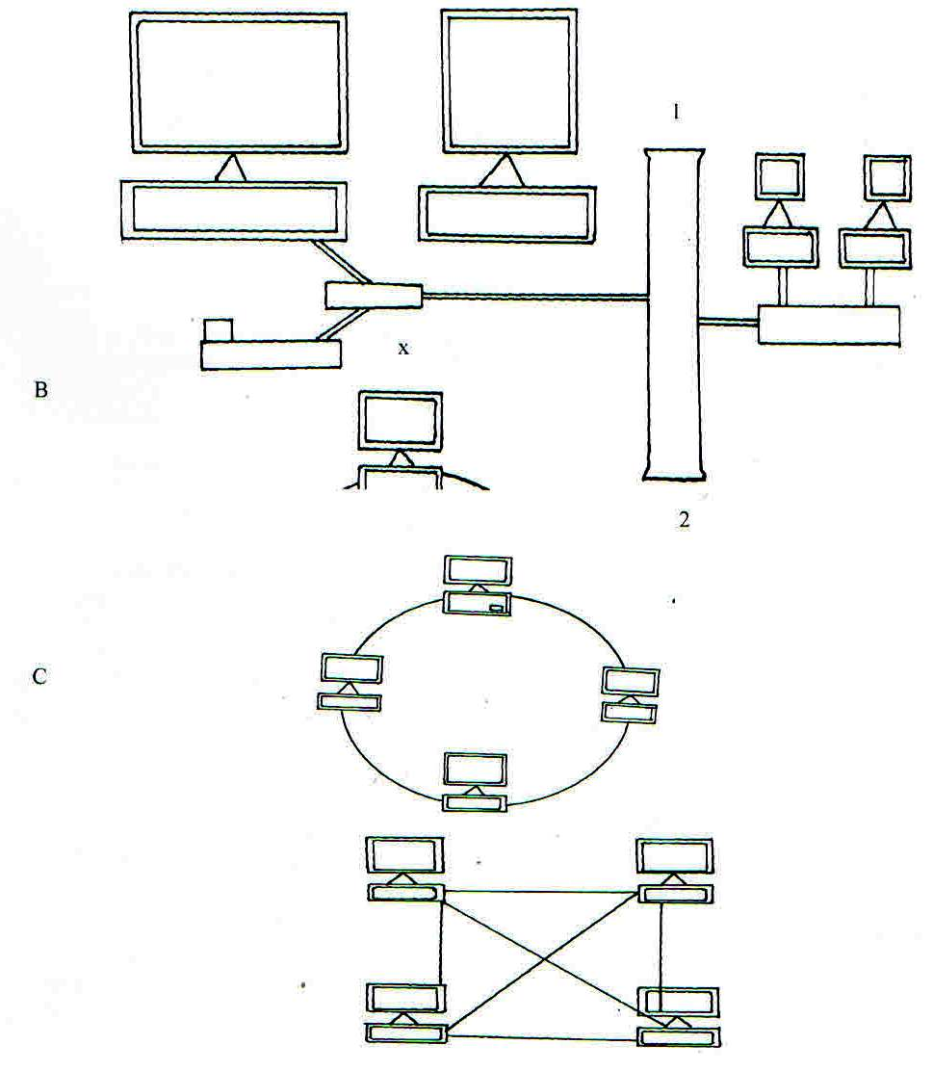
- (a) Consider the topologies demonstrated in the diagram below.

- Identify the network topologies (3marks)
A
………………………………………………………………………………………………………………………………………………………………………………………………………………………………
B
………………………………………………………………………………………………………………………………………………………………………………………………………………………………
C
………………………………………………………………………………………………………………………………………………………………………………………………………………………………
- In topology A, identify the network device that should be at the end point 1 and 2 (1mark)
………………………………………………………………………………………………………………………………………………………………………………………………………………………………
- Which of the above topologies is likely to be used in a wide area network? (1mark)
………………………………………………………………………………………………………………………………………………………………………………………………………………………………
- Highlight three disadvantages of topology B. (3marks)
………………………………………………………………………………………………………………………………………………………………………………………………………………………………
- Identify the device labeled X in topology A (1mark)
………………………………………………………………………………………………………………………………………………………………………………………………………………………………
(b) State two main classes of network software (2marks)

(c) Briefly describe the following as used in networking (4marks)
- Repeaters
………………………………………………………………………………………………………………………………………………………………………………………………………………………………
- Network hub
………………………………………………………………………………………………………………………………………………………………………………………………………………………………
- Fibre optic cables
………………………………………………………………………………………………………………………………………………………………………………………………………………………………
- Network interface card (NIC)
………………………………………………………………………………………………………………………………………………………………………………………………………………………………
- (a) Define the following terms
- Database ( ½mark)
………………………………………………………………………………………………………………………………………………………………………………………………………………………………
- Database management system ( ½ mark)
………………………………………………………………………………………………………………………………………………………………………………………………………………………………
- Hierarchical database (1mark)
………………………………………………………………………………………………………………………………………………………………………………………………………………………………
- Relational database (1mark)
………………………………………………………………………………………………………………………………………………………………………………………………………………………………
- Network database (1mark)
………………………………………………………………………………………………………………………………………………………………………………………………………………………………
(b) List the advantages of using an electronic database system for storage of data over the file approach.
(4marks).
………………………………………………………………………………………………………………………………………………………………………………………………………………………………………………………………………………………………………………………………………………………………………………………………………………………………………………………………
(c ) Study the spreadsheet below and answer the questions that follow
 | A | B |  | C |  | D
1 | WESTERN  COMPBOOK  CENTRE SALES
2 | BOOK TITLE |  | PRICE PER BOOK |  | BOOKS SOLD
3 | DBASE IV |  | 400.00 |  | 145
4 | LOTUS FOR DUMMIES |  | 460.00 |  | 15
5 | OFFICE WORD IN 3 DAYS |  | 300.00 |  | 65
6 | LEARN C++ IN 3 DAYS |  | 700.00 |  | 100
7 | TEACH YOURSELF PASCAL |  | 700.00 |  | 200
8 | COMPUTER STUDIES |  | 500.00 |  | 300
9 | THE CLEVER FOOL  COMUTER |  | 300.00 |  | 10
10

- Write down the formula that can be used to find the price of the most costly book (1mark)
………………………………………………………………………………………………………………………………………………………………………………………………………………………………
- Write down the formula that can be used to determine the total sales for the book titled COMPUTER STUDIES (1mark)
………………………………………………………………………………………………………………………………………………………………………………………………………………………………
- Write down the formula that can be used to determine the average price of the books. (1mark)
………………………………………………………………………………………………………………………………………………………………………………………………………………………………
- Write down the formula in cell D6 that can be used to find the new price per book if they went up by a percentage written in cell B 10 and the formula has to be entered only in cell D3 then be copied to others. (1mark)
………………………………………………………………………………………………………………………………………………………………………………………………………………………………
- Write down the output in D7 if in B6 is 10% (1mark)
………………………………………………………………………………………………………………………………………………………………………………………………………………………………
(d) State any four advantages of using an electronic spreadsheet as compared to a traditional worksheet.
(2mark)
………………………………………………………………………………………………………………………………………………………………………………………………………………………………

