- Put the following letters A to H in the correct places in the periodic table below to fit these descriptions.

(4mks)
ELEMENT | Description
A | An element with 7 protons
B | It belongs to period three and has 4 electrons in the outermost energy level
C | An element with oxidation number +3 and with 13 protons
D | An element that forms its ions by loss of one electron and belongs to period 4.
E | An element that can be placed in group I or VII
F | An element with the highest number of energy levels and belongs to group II
G | An element with electronic configuration of 2.8.7
H | An element with a valency of 3. It gains electrons to form ions and belongs to period 4

b) State the name given to the elements placed in the shaded region. (1mk)
……………………………………………………………………………………………….
c) Draw a dot(.) and cross(x) diagram to show bonding between elements F and G. (2mks)

ii. Compare the atomic radius of elements D and H. Explain. (2mks)
………………………………………………………………………………………………………
………………………………………………………………………………………………………
……………………………………………………………………………………………………….
iii. State two uses of element E. (1mk)
………………………………………………………………………………………………………..
2.)Describe how a mixture of sodium chloride, iodine and sand can be separated to obtain dry sodium chloride
……………………………………………………………………………………………………… (4mks)
…………………………………………………………………………………………………………
…………………………………………………………………………………………………………
…………………………………………………………………………………………………………..
…………………………………………………………………………………………………………..
3). Starting with Lead (II) Oxide, describe how a pure sample of lead(II)sulphate can be prepared in the laboratory. (4mks) ………………………………………………………………………………………………………….
…………………………………………………………………………………………………………..
4). (a) State Boyles law (1mk) ……………………………………………………………………………………………………………
……………………………………………………………………………………………………………
(b) A fixed mass of gas occupies 20cm³at -23 ^{O}C and 725mmHg pressure. Find the pressure of the gas if it
occupies 25cm³ at 27 ^{O}C. (3mks)
……………………………………………………………………………………………………………
……………………………………………………………………………………………………………
5. The electrical conductivity of some substances was investigated and observations recorded as in the
table below.
Substance | Conductivity in solid state | Conductivity in molten/ aqueous state
M | Does not conduct | Conducts
N | Does not conduct | Does not conduct
P | Conduct | Conducts

- i). Identify a substance that is a metal. Give a reason. ( 2mks)
…………………………………………………………………………………………………..
………………………………………………………………………………………………….
ii) Substance M does not conduct electricity in solid state but conducts in molten/ aqueous state.
Explain (2mks)
………………………………………………………………………………………………….
…………………………………………………………………………………………………..
- Lead (II) bromide was electrolyzed using the set-up below.
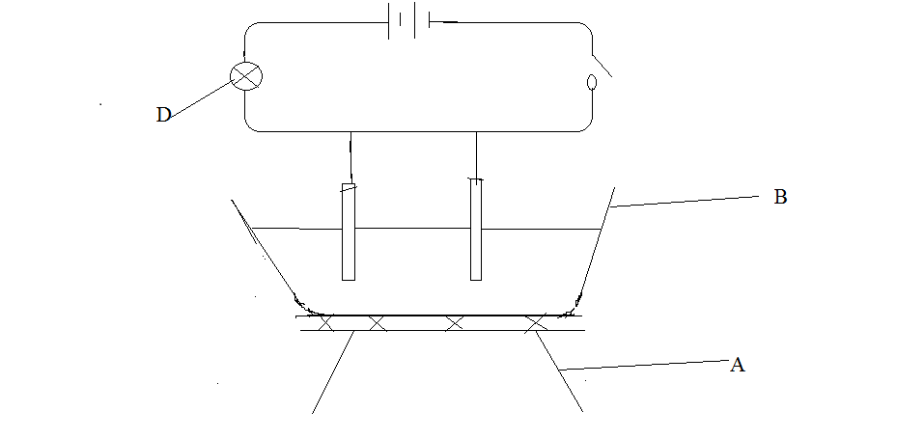
- Identify the missing requirement in the set up above. (1mk)
…………………………………………………………………………………………..
- State the observations made during the electrolysis. (2mk)
…………………………………………………………………………………………..
……………………………………………………………………………………………
- Name the apparatus labeled (2mks)
A…………………………………………………………………………………………
B………………………………………………………………………………………….
- Write the equation for the reaction that occurs at the anode. (1mk)
…………………………………………………………………………………………….

- What is electroplating. (1 mk)
……………………………………………………………………………………………
……………………………………………………………………………………………..
ii. State the purpose of electroplating. (1mk)
……………………………………………………………………………………………

6. The flow chart below shows some steps in manufacture of sodium carbonate by the Solvay process.
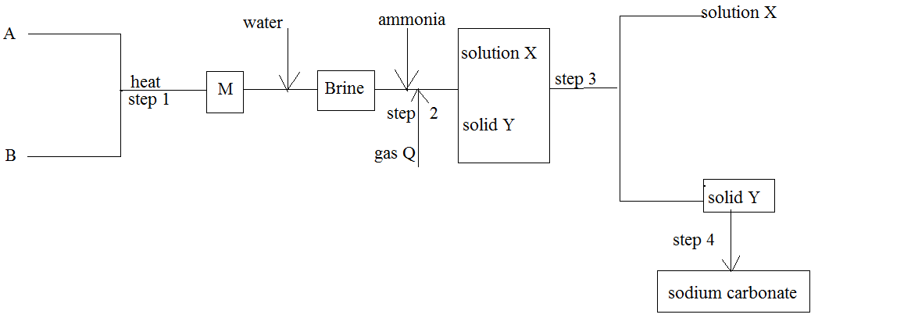

- Identify the process involved in :( 2mks)

Step 3 ……………………………………………………………………………………………..

Step 4 ……………………………………………………………………………………………
- Element A and B were heated to form substance M, what name is given to this process? (1mk)
………………………………………………………………………………………………….
- Write an equation for the reaction which takes place in;
- Step 2 (1mk)
……………………………………………………………………………………………….
- Step 4 (1mk)
…………………………………………………………………………………………………
- State two uses of Sodium Carbonate (2mk)
…………………………………………………………………………………………………………..
………………………………………………………………………………………………………….
- Name two substances that are recycled in the Solvay process. (1mk)
…………………………………………………………………………………………………………
- Explain why the solvay process is termed as an efficient industrial chemical process. (1mk)
……………………………………………………………………………………………………………

- Give one use of the major byproduct of the Solvay process. (1mk)
……………………………………………………………………………………………………………

- Explain why the solvay plant is normally located near a large water supply. (1mk)
…………………………………………………………………………………………………………….

7. When 1.15g of a compound containing carbon, hydrogen and oxygen was burnt in excess air, 2.2g of carbon
dioxide and 1.35g of water were the only products. Find the empirical formula of the compound.
( C =12, H =1, O =16). (4mks)

8. A student used the figure below to investigate the action of dilute sulphuric(VI) acid on some metals. Beaker
I and beaker II contained equal volumes of the sulphuric(VI) acid, to beaker I , a clean iron rod was dipped and to beaker II, a clean rod of copper was dipped.
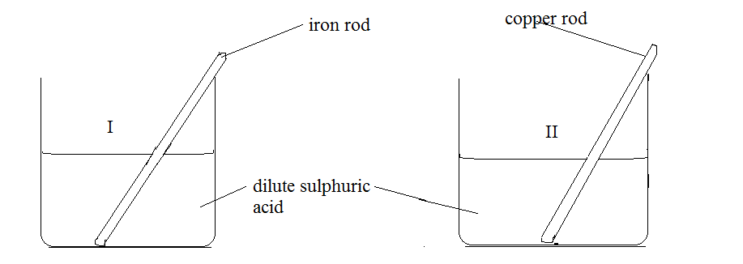
- Why was it necessary to use clean metal rods? (1mk)
……………………………………………………………………………………………………………
………………………………………………………………………………………………………………
- State the observations made in each beaker.
Beaker I; (1mk)
………………………………………………………………………………………………………………
………………………………………………………………………………………………………………
Beaker II (1mk)
……………………………………………………………………………………………………………..
……………………………………………………………………………………………………………..
- Explain the observations made in each beaker in (ii) above.
Beaker I (2mks)
……………………………………………………………………………………………………………..
……………………………………………………………………………………………………………..
Beaker II (2mks)
…………………………………………………………………………………………………………….
……………………………………………………………………………………………………………

9. 50 cm³ of aqueous sodium hydroxide solution of an unknown concentration is diluted by addition of water
to obtain 250 cm³ of 0.1M sodium hydroxide solution. Find the concentration of the original sodium
hydroxide solution in; (Na = 23, O = 16, H = 1)
- Mol/dm⁻³ (2mks)
…………………………………………………………………………………………………………..
…………………………………………………………………………………………………………..
…………………………………………………………………………………………………………..
- g/dm⁻³(2mks)
……………………………………………………………………………………………………………
……………………………………………………………………………………………………………
……………………………………………………………………………………………………………
10. The products formed by the action of heat on nitrates of metals P, Q and R are as shown in the table below.

Nitrate of metal | Products Formed
P | Metal oxide, nitrogen (IV) oxide and Oxygen gas
Q | Metal, nitrogen(IV) oxide and oxygen gas
R | Metal nitrite and oxygen gas

- Arrange the above metals in order of reactivity starting with the least reactive. (1mk)
………………………………………………………………………………………………………….
- Name two metals that could possibly be R. (1mk)
………………………………………………………………………………………………………….

- What is the general name of the metals in (b) above.(1mk)
…………………………………………………………………………………………………………
11. Explain the following.
- Sodium chloride becomes damp when exposed to air. (1mk)
…………………………………………………………………………………………………………
- Many cooking pans are made of aluminiumalthough it is a reactive metal. (1mk)
…………………………………………………………………………………………………………
…………………………………………………………………………………………………………

- Diamond and methane have the same type of bonding yet methane is a gas at room temperature and pressure while diamond is a very hard solid. (1mk)
…………………………………………………………………………………………………………….

12. Use the diagram below to answer the questions that follow.
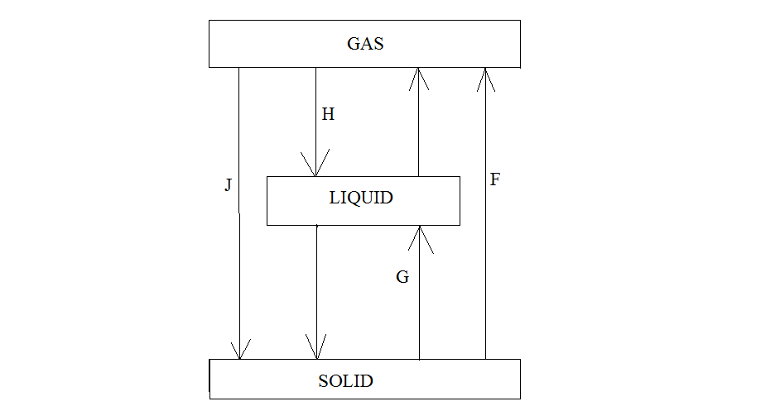
- Identify process; (1mk)
H ………………………………………………………………………………………………….
G ………………………………………………………………………………………………….
- Apart from dry ice identify two compounds that undergo process F. (1mk)
………………………………………………………………………………………………………
13. Metal A reacts with steam to form an oxide B which is yellow when hot and turns white when cold and
liberates gas C.
- Identify (3mks)
A ……………………………………………………………………………………………
B …………………………………………………………………………………………….
C …………………………………………………………………………………………….
- Write the chemical equation of metal A and steam. (1mk)
…………………………………………………………………………………………………..
14. Give the valency of the elements (3mks)
- ₇X ……………………………………………………………………………………………….

- ₁₈M ………………………………………………………………………………………………….

- ₁₁ D ………………………………………………………………………………………………
15. If hydrogen gas diffuses at a rate of 10cm³ per secondfrom a given apparatus under certain conditions.
Calculate the volume of oxygen gas that diffuses in 10 seconds under the same conditions
(H =1, O =16) (3mks
………………………………………………………………………………………………………………….
………………………………………………………………………………………………………………….
16. The figure below shows the apparatus used to burn hydrogen in air. Use it to answer the questions that
follow. 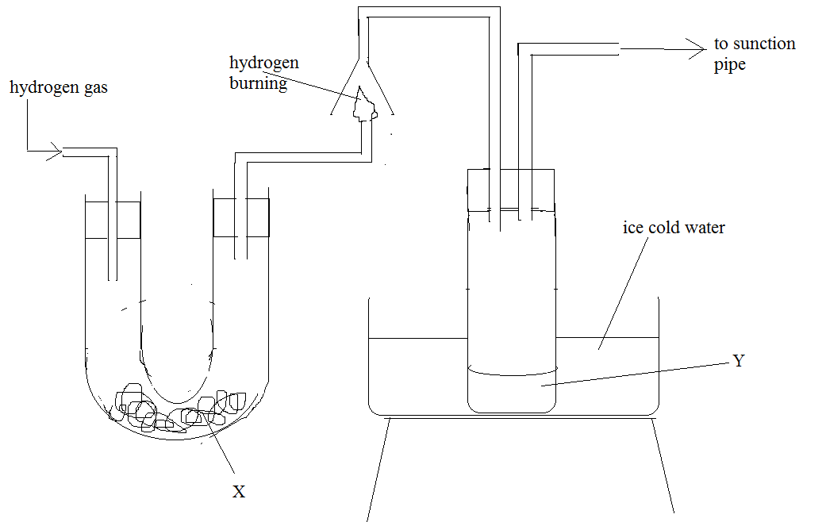
- State the role of substance X. (1mk)
………………………………………………………………………………………………………..

- Give the name of the substance that could be used as X. (1mk)
…………………………………………………………………………………………………………

- State the role of the sunction pipe. (1mk)
…………………………………………………………………………………………………………

- Name the product Y formed. (1mk)
…………………………………………………………………………………………………..........

- Give a simple physical test to prove the identity of Y. (2mks)
………………………………………………………………………………………………………………
………………………………………………………………………………………………………………

- State the difference between ‘dry’ and ‘anhydrous’. (1mk)
……………………………………………………………………………………………………………
…………………………………………………………………………………………………………….

