Name……………………………………………………………………….Index No………………………………………………………
443/2 Candidates Signature……………………………………………
AGRICULTURE Date……………………………………………………………………...
PAPER 2
2 HOURS
MOKASA 2 EXAMINATION 2018
443/2
AGRICULTUE
PAPER 2
( Kenya Certificate of Secondary Education (K.C.S.E)
Instructions to candidates
Write your name and index number in the spaces provided above.
Sign and write the date of the examination in the spaces provided above.
This paper consist of three sections, A,B and C. Answer all questions in sections A and B and any Two questions from section C.
All answers be written in the spaces provided after every question.

For Examiners use only
SECTION | QUESTIONS | MAXIMUM SCORE | CANDIDATES SCORE
A |  | 30
B |  | 20
C |  | 20
 |  | 20
 | TOTAL | 90

SECTION A ( 30 Marks)
Answer all question in this section in the spaces provided.
1 Study the table below fill in the blanks to show the term used to refer to parturition and young ones of the following animals? (2mks)
Type of animal | Act of parturition | Term to refer to the young one
Cattle | Calving | Calf
Goats | ………………………………… | …………………………………..
pig | …………………………………. | …………………………………..

2 Name two tools used to trim overgrown hooves in sheep. (1mk)
………………………………………………………………………………………………………………………………………………………………………………………………………………………………………………………………………………………………………………………………….
3 Name three dual purpose breeds of sheep. ( 1 ½ mks)
…………………………………………………………………………………………………………………………………………………………………………………………………………………………………………………………………………………………………………………………………………………………………………………………………………………………………………………………………………………………………….
4 State four symptoms of mastitis in cattle. (2mks)
…………………………………………………………………………………………………………………………………………………………………………………………………………………………………………………………………………………………………………………………………………………………………………………………………………………………………………………………………………………………………………………………………………………………………………………………………………………………………………………………………………

5 State two functions of the queen bee in a bee colony. (1mk)
…………………………………………………………………………………………………………………………………………………………………………………………………………………………………………………………………………………………………………………………………..
6 State four factors affecting the digestibility of a feed. (2mks)
…………………………………………………………………………………………………………………………………………………………………………………………………………………………………………………………………………………………………………………………………………………………………………………………………………………………………………………………………………………………………………………………………………………………………………………………………………………………………………………….
7 State four harmful effects of ticks. (2mks)
…………………………………………………………………………………………………………………………………………………………………………………………………………………………………………………………………………………………………………………………………………………………………………………………………………………………………………………………………………………………………………………………………………………………………………………………………………………………………………………….
8 State four conditions that may inhibit milk let-down during milking. (2mks)
…………………………………………………………………………………………………………………………………………………………………………………………………………………………………………………………………………………………………………………………………………………………………………………………………………………………………………………………………………………………………………………………………………………………………………………………………………………………………………………….
9 Give three disadvantages of using a plunge –dip for tick control. (1 ½ mks)
………………………………………………………………………………………………………………………………………………………………………………………………………………………………………………………………………………………………………………………………………………………………………………………………………………………………………………………………………………………
10 Name two viral diseases that affect each of the following livestock.
(a) Cattle………………………………………………………………………………………………………………………. (1mk)
(b) Poultry…………………………………………………………………………………………………………………….. (1mk)

11 State four desirable factors to consider when siting a fish pond. (2mks)
…………………………………………………………………………………………………………………………………………………………………………………………………………………………………………………………………………………………………………………………………………………………………………………………………………………………………………………………………………………………………………………………………………………………………………………………………………………………………………………….
12 Give three disadvantages of cross breeding in cattle. ( 1 ½ mks)
………………………………………………………………………………………………………………………………………………………………………………………………………………………………………………………………………………………………………………………………………………………………………………………………………………………………………………………………………………………
13 State four conditions that would encourage hens to eat eggs in poultry production. (2mks)
…………………………………………………………………………………………………………………………………………………………………………………………………………………………………………………………………………………………………………………………………………………………………………………………………………………………………………………………………………………………………………………………………………………………………………………………………………………………………………………….
14 Outline four reasons for maintaining farm tools and equipment in good condition. (2mks)
…………………………………………………………………………………………………………………………………………………………………………………………………………………………………………………………………………………………………………………………………………………………………………………………………………………………………………………………………………………………………………………………………………………………………………………………………………………………………………………….
15 State four nonpathogenic causes of livestock diseases. (2mks)
……………………………………………………………………………………………………………………………………………………………………………………………………………………………………………………………………………………………………………………………………………………………………………………………………………………………………………………………………………………………………………………………………………………………………………………………………………………………………………………………………….

16 In the preparation of artificial colostrum, what is the role of each of the following?
(a) Caster oil ( ½ mk)
……………………………………………………………………………………………………………………………………………………………..
(b) Cod liver oil ( ½ mk)
……………………………………………………………………………………………………………………………………………………………..
17 What is the importance of applying milking salve on teats of a lactating cow? ( ½ mk)
…………………………………………………………………………………………………………………………………………………………
SECTION B (20 Marks)
Answer all questions in this section in the spaces provided
18 Below are illustrations of farm tools labeled A,B,C and D. Study them and answer questions that follow.
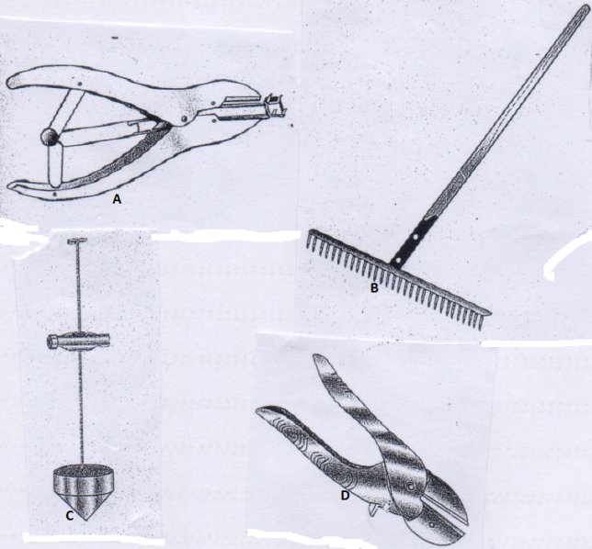
(a) Give the correct name of each of the tools illustrated above. (2mks)
A…………………………………………………………………………………………………………………………………………
B…………………………………………………………………………………………………………………………………………
C………………………………………………………………………………………………………………………………………..
D………………………………………………………………………………………………………………………………………….
(b) How is each of the tools B and D maintained? (1mk)
B…………………………………………………………………………………………………………………………………………….
D…………………………………………………………………………………………………………………………………………….
(c ) State one proper use of each of the tools A and C. (2mks)
A……………………………………………………………………………………………………………………………………………………
C……………………………………………………………………………………………………………………………………………………
19 The diagram below illustrates a method of providing feed stuff to chicken in a chicken house. Study the diagram and answer the questions that follow.
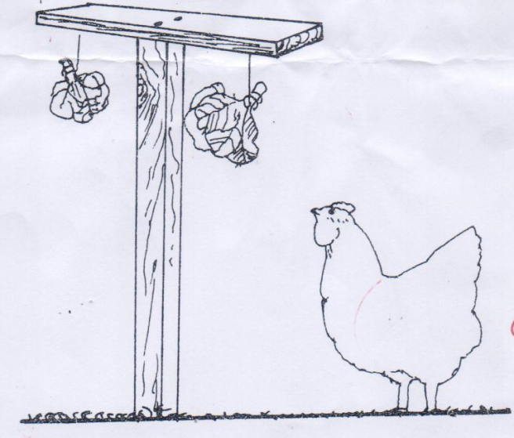
(i) What type of feed stuff is illustrated in the diagram above? (1mk)
…………………………………………………………………………………………………………………………………………………………………
(ii) Give two reasons why the feed stuff should be suspended above the height of the chicken.(2mks)
…………………………………………………………………………………………………………………………………………………………………………………………………………………………………………………………………………………………………………………………………….

(iii) Apart from above practice, name one other practice that can be used in place of practice (ii) above. (1mk)
…………………………………………………………………………………………………………………………………………………………………
(iv) What other advantage of the practice named in (ii) in a deep litter house. (1mk)
…………………………………………………………………………………………………………………………………………………………………
20 The diagrams below illustrate two types of rabbit hutches labeled L and M. Study the diagrams and answer questions that follow.
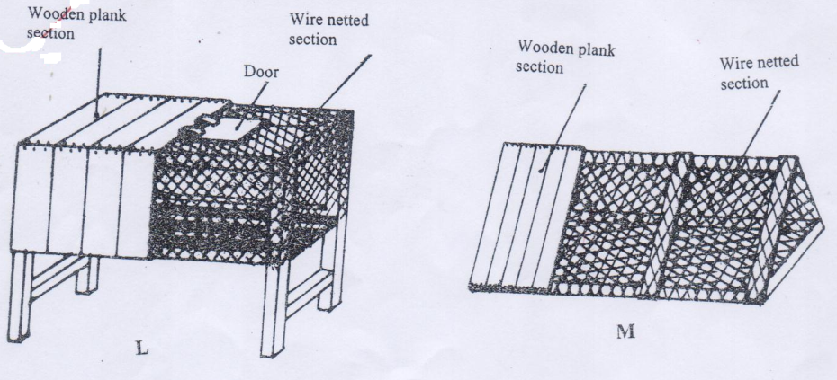
(a) In which section of the hutches should the water and feed troughs be placed? (1mk)
………………………………………………………………………………………………………………………………………………………………….
(b) State one use of the wooden section of the hutch. (1mk)
…………………………………………………………………………………………………………………………………………………………………
(c ) What additional facility should be included inside the hutches for a doe? (1mk)
…………………………………………………………………………………………………………………………………………………………………
(d) Identify the type of floor shown in hutch L above. (1mk)
………………………………………………………………………………………………………………………………………………………………….
(e) Give one advantage of the type of floor illustrated in hutch L above. (1mk)
………………………………………………………………………………………………………………………………………………………………….
21 Below is a diagram of an Ox-plough. Study it and answer questions that follow.
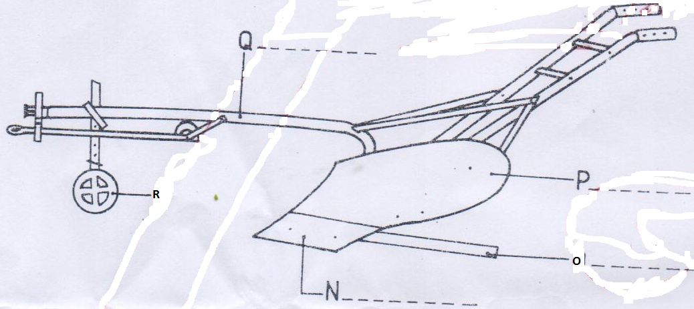
(a) Identify the parts labeled N,O,P and Q on the diagram above. (2mks)
N……………………………………………………………………………………………………………………………………………
O……………………………………………………………………………………………………………………………………………
P…………………………………………………………………………………………………………………………………………….
Q……………………………………………………………………………………………………………………………………………
(b) State one maintenance practice that should be carried out in each of the parts labeled N and R.
N………………………………………………………………………………………………………………………………… … (1mk)
R……………………………………………………………………………………………………………………………………..(1mk)
(c ) What adjustment should be carried out on the implement so as to reduce the depth of ploughing. (1mk)
……………………………………………………………………………………………………………………………………………………………….

SECTION C (40 Marks)
Answer any two questions from this section. The answers be written in the spaces provided after every question.
22 (a) Describe the process of processing honey using heat method. (6mks)
…………………………………………………………………………………………………………………………………………………………………………………………………………………………………………………………………………………………………………………………………………………………………………………………………………………………………………………………………………………………………………………………………………………………………………………………………………………………………………………………………………………………………………………………………………………………………………………………………………………………………………………………………………………………………………………………………………………………………………………………………………………………………………………………………………………………………………………………………………………………………………………………………………………………………………………………………………………………………………………………………………………………………………………………………………………………………………………………………………………………………………………………………………………………………………………………………………………………………………………………………………………………
(b) Describe Foot and Mouth disease under the following sub- headings;
(i) Causal organism. (1mk)
………………………………………………………………………………………………………………………………………………………………..
(ii) Animal attacked (1mk)
……………………………………………………………………………………………………………………………………………………………….
(iii) Five symptoms of attack. (5mks)
……………………………………………………………………………………………………………………………………………………………………………………………………………………………………………………………………………………………………………………………………………………………………………………………………………………………………………………………………………………………………………………………………………………………………………………………………………………………………………………………………………………………………………………………………………………………………………………………………………………………………………

(iv) three control measures. (3mks)
……………………………………………………………………………………………………………………………………………………………………………………………………………………………………………………………………………………………………………………………………………………………………………………………………………………………………………………………………………………………………..
(c ) Outline four ways through which power is made available from a tractor. (4mks)
…………………………………………………………………………………………………………………………………………………………………………………………………………………………………………………………………………………………………………………………………………………………………………………………………………………………………………………………………………………………………………………………………………………………………………………………………………………………………………………………………………
23 (a) Explain six requirements of a good calf pen. (6mks)
…………………………………………………………………………………………………………………………………………………………………………………………………………………………………………………………………………………………………………………………………………………………………………………………………………………………………………………………………………………………………………………………………………………………………………………………………………………………………………………………………………………………………………………………………………………………………………………………………………………………………………… ………………………………………………………………………………………………………………………………………………………………..
(b) (i) Give four reasons for steaming up a dairy cow. (4mks)
…………………………………………………………………………………………………………………………………………………………………………………………………………………………………………………………………………………………………………………………………………………………………………………………………………………………………………………………………………………………………………………………………………………………………………………………………………………………………………………………………………
(ii) Explain the management practices carried out on a dairy calf from birth and immediately after birth. (4mks)
…………………………………………………………………………………………………………………………………………………………………………………………………………………………………………………………………………………………………………………………………………………………………………………………………………………………………………………………………………………………………………………………………………………………………………………………………………………………………………………………………………………………………………………………………………………………………………………………………………………………………………..
(c ) Outline six signs of round worms (Ascaris spp) infestation in cattle. (6mks)
…………………………………………………………………………………………………………………………………………………………………………………………………………………………………………………………………………………………………………………………………………………………………………………………………………………………………………………………………………………………………………………………………………………………………………………………………………………………………………………………………………………………………………………………………………………………………………………………………………………………………………… …………………………………………………………………………………………………………………………………………………………………
24 (a) Describe the process of egg formation in a chicken up to the point of lay. (10mks)
………………………………………………………………………………………………………………………………………………………………………………………………………………………………………………………………………………………………………………………………………………………………………………………………………………………………………………………………………………………………………………………………………………………………………………………………………………………………………………………………………………………………………………………………………………………………………………………………………………………………………………………………………………………………………………………………………………………………………………………………………………………………………………………………………………………………………………………………………………………………………………………………………………………………………………………………………………………………………………………………………………………………………………………………………………………………………………………………………………………………………………………………………………………………………………………………………………………………………………………………………………………… …………………………………………………………………………………………………………………………………………………………………………………………………………………………………………………………………………………………………………………………………………………………………………………………………………………………………………………………………………………………………………………………………………………………………………………………………………………………………………………………………………
(b) State the difference between four stroke cycle and two stroke cycle engine. (4mks)
…………………………………………………………………………………………………………………………………………………………………………………………………………………………………………………………………………………………………………………………………………………………………………………………………………………………………………………………………………………………………………………………………………………………………………………………………………………………………………………………………………

(c ) Describe the process of digestion in the rumen. (4mks)
……………………………………………………………………………………………………………………………………………………………………………………………………………………………………………………………………………………………………………………………………………………………………………………………………………………………………………………………………………………………………………………………………………………………………………………………………………………………………………………………………………………………………………………………………………………………………………………………………………………………………………………………………………………………………………………………………………………………………………………………………………..

