**Name: ……………………………………………... Index no ……..…......................................**

**School: …………………………………………….. Candidate’s sign …………………….......**

**Date: ……………………………………………….. Class…………………………………….**

**443/2**

**AGRICULTURE**

**PAPER 2 (Marking scheme)**

**TIME: 2 HOURS**

**MOI HIGH SCHOOL-KABARAK**

**FORM FOUR MOKASA I MOCK**

***Kenya Certificate of Secondary Education (K.C.S.E.)***

**Agriculture**

**Paper 1**

**INSTRUCTIONS TO CANDIDATES:**

* *Write your* ***name, index number,******school*** *and* ***admission number*** *in the spaces provided.*
* *Sign and write the date in the spaces provided above.*
* *Answer* ***all*** *the questions in section* ***A*** *and* ***B***
* *Answer any* ***two*** *questions in section* ***C.***
* *Answers should be written in the spaces provided in this booklet.*

***For Examiner’s Use Only:***

|  |  |  |  |
| --- | --- | --- | --- |
| **SECTION** | **QUESTIONS** | **MAXIMUM SCORE** | **CANDIDATES SCORE** |
| A | 1-18 | 30 |  |
| B | 19-22 | 20 |  |
| C |  | 20 |  |
|  | 20 |  |
|  | **TOTAL** | **90** |  |

*This paper consists of 13 printed pages. Candidates should check to ascertain that all pages are printed as indicated and that no questions are missing.*

**SECTION A (30MARKS)**

1. State **four** factors that determine the quality of honey. (2mks)

*-The type of plants from which the nectar was obtained.*

*-Maturity stage of honey at thetime of harvesting.*

*-Method of harvesting.*

*-Method of processing honey.*

*-Rate of smoking.*

1. Name **two** types of bacterial diseases in cattle that are controlled by the administration of blanthax vaccine. (1mk)

*-Blackquarter*

*-Anthrax*

1. Name the component on a tractor used for each of the following purposes. (2mks)
2. Checking the level of oil in the sump.

*Dipstick*

1. Connecting and disconnecting the drive shaft to or from the engine.

*Clutch*

1. Regulating the temperature of water in the cooling system.

*Thermostst*

1. Stepping up the battery voltage from 12 volts to about 6000volts

*Ignition coil*

1. State **four** reasons for seasoning timber before using it for construction. (2mks)

-*To prevent warping*

*-To prevent rotting due to fungal attack*

*-To prevent insect attack*

*-To increase strenght*

*-To prevent cracking*

1. State **two** ways in which barbed wire fence may be reinforced in the farm. (1mk)

*-Use of droppers*

*-Use of concrete to fix posts*

*-Use of wire and wooden strainers*

*-Use ofstruts and braces*

1. Name the intermediate host of the following parasites. (1mk)
2. Tapeworm-*Cattle*
3. Liverfluke-*Water/mudsnail*
4. State **three** advantages of using thatch as a roofing material in farm structures. ($1\frac{1}{2}mks)$

*-Has good thermoregulatory capacity.*

*-It is sound proof*

*-They are locally available.*

*-It is cheap*

1. State **four** precautions observed when using workshop tools and equipment. (2mks)

*-Tools should be left in a safe place after use.*

*-Use the correct tool for the correct job.*

*-Tools should be maintained and serviced well.*

*-Tools should be handled correctly when in use.*

*-Use safety devices eg fire extinguishers, goggles.*

1. Name **two** hormones that influence milk let down. (1mk)

-*Oxytocin*

*-Adrenaline*

1. State **four** conditions a farmer would prefer to use an ox-cart instead of a tractor drawn trailer. (2mks)

*-When the farmer has little capital.*

*-When the farmer has little load to carry.*

*-When the land is steep.*

*-When the land is small.*

*-When the farmer has little skill to operate tractor drawn trailer.*

1. Give **two** ways in which proper nutrition helps to control livestock diseases. (1mk)

*-Prevent nutrient defficiency diseases.*

*-Ensures resistance to disease infection.*

1. Give the meaning of the following terms as used in livestock breeding. (2mks)
2. Progeny testing

*A method of selection where the character to be selected is of low heritability and when the charaster is expressed by one sex only.*

1. Heterosis

*This is increased vigour and performance resulting from crossing two unrelated superior breeds*.

1. Name **four** implements that are operated by the tractor P.T.O shaft. (2mks)

*-Mowers*

*-Shellers*

*-Rotavators/rotary tillers*

*-Forage harvesters*

1. State **four** reasons for castration in pig production. (2mks)

*-To control breeding diseases*

*-To prevent uncontrolled mating*

*-For faster growth rates.*

*-To improve the quality of the meat*

*-To make them docile.*

1. State **four** characteristics of roughage livestock feeds. (2mks)

*-They are bulky*

*-They have high fibre content*

*-Have low nutrient content*

*-Have low digestibility*

*-Are mainly of plant origin.*

1. Give **two** reasons why it is necessary to have guard rails in a farrowing pen. (2mks)

*-Prevents the sow from crushing piglets.*

*-Prevents the sow from eating creep feed.*

1. Give **four** advantages of using a disc plough over a mouldboard plough in primary cultivation. (2mks)

*-Discs roll over obstacles*

*-They require less draught power*

*-They require less maintenance costs.*

*-Works better in dry, hard and sticky soils.*

1. State **four** characteristics of a dairy cow. (2mks)

*-Their bodies are wedge to triangular shaped.*

*-They have a straight top line.*

*-They have a well set apart hindquarter to allow room for the big udder.*

*-They have large and well developed udders with large teats that are well spaced.*

*-They have prominent milk veins.*

*-Their lean bodies carry little flesh.This is easily noted if the pinbone is visible.*

*-They have a large stomach capacity that enables the animal to feed heavily for high milk production.*

*-They are docile with mild temperament.*

1. Give **one** reason as to why it is important to understand the life cycle of parasites. $(\frac{1}{2}mk)$

*-Inorder to take the correct control measures.*

**SECTION (20MARKS)**

1. Study the illustration showing a livestock management practice and answer the questions that follow.



1. Identify the livestock management practice illustrated above. (1mk)

*Wool shearing*

1. Name the tool being used in carrying out the practice illustrated above. (1mk)

*Wool shears*

1. Describe the procedure of carrying out the above practice. (3mks)

*-First grab the sheep by the wool on the flanks not by the wool on her back.*

*-Pick her up and sit her down on her rump for ease of handling.*

*-Clip all the wool off her stomach down as far as the udder.Avoid cutting the udder in an ewe or the penis in a ram.*

1. 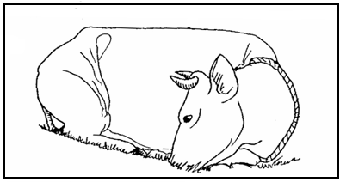The illustration below shows a cow suffering from a disease.Study it and answer the questions that follow.
2. Identify the disease. (1mk)

*Milk fever*

1. State the cause of the disease illustrated above. (1mk)

*-Low levelof calcium in the blood.*

1. Give **three** symptoms of the disease the animal is suffering from. (3mks)

*-Muscle twitching*

*-Staggering*

*-Animal lies with neck twisted backwards and the body stiffens.*

*-Body functions eg urination, defecation and milk secretion stop.*

*-Stomach contents are drawn into the mouth.*

*-Complete anorexia*

*-Sudden death if animal is not treated*

1. The illustration below shows a disc plough.Study it and answer the questions that follow.



1. Name the partslabelled E, F, G and H. (2mks)

E- *Beam*

F-*Furrow wheel*

G-*Disc*

H-*Disc scraper*

1. Give the function of each of the parts labelled F and H. (2mks)

F-*Adjusts the depth of ploughing*

*- Rides over the dead furrow counteracting the thrust created by the discs thereby balancing the whole implement.*

H-*Removes wet soil from the disc during ploughing.*

*-Aid in the turning and inverting of the furrow slice.*

1. State **one** adjustment that can be carried out on the plough to decrease the ploughing depth. (1mk)

*-Adjusting the hydraulic depth control*

*-Increasing the cutting angle of the disc.*

*-Removing weight from the beam if it was added.*

1. Study the illustrations below and answer the questons that follow.

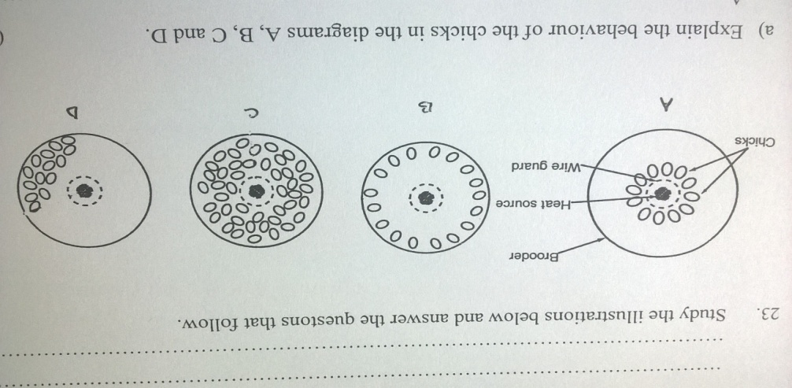

1. Explain the behaviour of the chicks in the diagrams A, B, C and D. (2mks)

A-*Cold/inadequate heat makes the chicks to crowd around theheat source*

B-*High/exess heat makes the chicks to move away from the heat source.*

C-*Appropriate amount ofheat makes the chicks to be evenly distributed within the brooder.*

D-*Presence of draught makes the chicks to crowd on one side of the brooder.*

1. Give **one** reason why dim light is recommended in a brooder. (1mk)

*-To prevent pegging.*

1. State **two** advantages of artificial brooding. (2mks)

*-One can control the temperatures appropriately*

*-A large number ofchicks can be reared.*

**SECTI ON C (40MARKS)**

1. a) State and explain any **five** pre-disposing factors of livestock diseases. (10mks)

***i) The species of the animal-****Swine fever affects pigs only and Newcastle affects poultry only.*

***ii)******The breed of the animal-****Cancer of the eye will affect Hereford breed and solar erythema will affect only the large white breed of pigs.*

***iii) The age of the animal-****Piglet anaemia affects piglets.Lamb dysentery affects lambs.Calf pneumonia affects calves.*

***iv) The sex of the animal****-Orchitis will affectmale animals only because it is a disease of the testes.Vaginitis affect female animals because it is a disease of the vagina.Mastitis affects only lactating female animals.*

***v) The colour of the animal-****Black animals are likely to suffer from heat stress.Animals with light pigmented skins may suffer from photosensitisation when exposed to high light intensity eg large white breed of pigs will suffer from solar erythema when exposed to strong light.*

***Others***

*-Poor/cruel handling. -Poor housing. -Extreme weather conditions.*

b) State **six** differences between digestion in Ruminants and non-ruminants. (6mks)

|  |  |
| --- | --- |
| ***Ruminants*** | ***Non-ruminants*** |
| *Chew the cud* | *Do not chew the cud.* |
| *Have four stomach chambers-thus polygastric.* | *Have one stomach chamber thus monogastric.* |
| *Regurgitate food* | *Cannot regurgitate food once swallowed* |
| *Can digest cellulose ie have micro-organisms in the rumen that digest cellulose.* | *Have no micro-organisms in the stomach hence cannot digest cellulose except those animals with micro-organisms in the caecum.* |
| *Have no amylase in saliva hence no enzymatic digestion in the mouth.* | *Have amylase in saliva hence enzymatic digestion starts in the mouth.* |
| *Most digestion and absorption takes place in the rumen.* | *Most digestion and absorption takes place in the small intestines.* |
| *Have alkaline saliva due to the presence of ammonia.* | *The saliva is neutral in Ph.* |

c) Using the Pearsons square method, compute a 300kg ration with 25% DCP from wheat

which contains 15% DCP and sunflower seedcake containing 30% DCP. (4mks)

*Wheat 15% 5*

*Sunflower s/c 30% 10*

*15*

*Wheat =5x300 =100kg*

*15*

*Sunflower seedcake= 10x300 = 200kg*

*15*

1. a) Describe t*rypanosomiasis* (nagana) under the following sub headings.

i) Animals attacked (2mks)

*Cattle sheep, goats, pigs, dogs and horses (any 2)*

ii) Causal organism and the vector (2mks)

*Trypanosoma spp* transmitted by the *tsetse fly*

iii) Symptoms (4mks)

*-Swoolen lymph nodes.*

*-High temperature/fever*

*-Loss of appetite*

*-General body weakness.*

*-General body weakness.*

*-Lachrimation*

*-Diarrhoea*

*-Rough coat sometimes without hair and may be cracked.*

*-Anaemia*

*-Decrease in milk production.*

iv) Control measures (2mks)

*-Control of tsetseflies*

*-Treat with appropriate drugs.*

*-Confinement of game animals in game parks.*

b) State **six** structural requirements of a calf pen. (6mks)

*-Should have concrete floors-This makes cleaning easy*

*-Should have adequate space.*

*-Single housing-The housing should allow only one calf per pen so as to prevent calves from licking each other which results in hair balls in the stomach and also controls the spread of worms and skin infection.*

*-Proper lighting to allow enough light into the pen for synthesis of vitamin D.*

*-Proper drainage-Poor drainage causes dampness which pre-disposes the calf to infections.*

*-Draught free-Thewindward side should becompletely solid to prevent cold winds which pre-dispose the calf to nfections eg pneumonia.*

*-Leak proof roof-Wetness encourages disease infections eg pneumonia and scours.*

c) State **four** main components of a tractor fuel system and a function for each. (4mks)

|  |  |
| --- | --- |
| *Component* | *Function* |
| *Fuel tank* | *-Stores the fuel and has a filter at its inlet that removes any solid impurities.* |
| *Sediment bowl* | *Used to detect dirt in the fuel.* |
| *Lift pump* | *-Forces the fuel into the injector pump.*  *-Has a priming lever for removing airlock/bleeding* |
| *Fuel filters* | *Removes any dirt from the fuel.* |
| *Injector pump* | *-Forces the fuel(diesel) through the injector nozzles/atomizers* |
| *Injectors/injector nozzles/atomizers* | *-Sprays a fine mist of fuel in the cylinder.* |
| *Fuel return pipe* | *-Carries exess fuel from the injector pump back to the fuel tank.* |
| *Air cleaner* | *-Removes dust from the air before it enters the caburettor or injectors.* |
| *Caburettor* | *(Found in the petrol engine.It replaces the injector pump of the diesel engine)*  *-Vaporises the air*  *-Atomises the petrol*  *-Regulates the ratio of air fuel.* |

1. a) Describe **ten** practices that a dairy farmer must carry out to achieve clean milk production. (10mks)

***Healthy milking herd-****Cows should be tested annually for milk-borne diseases eg tuberculosis and brucellosis which are easily transmitted to man.Affected animals are removed.A mastitis test should be done before each milking.*

***Clean milking cows-****The flanks, underline and the whole udder should be washed and dried thoroughly before each milking.Long hair on the udder should be clipped*

***Healthy milkman-****The milkman should not be suffering from any contagious disease.*

***Clean milkman-****Fingernails should be short and hair covered.Wear white overalls when milking and handling milk.*

***Clean milking shed***

***Clean milking utensils***

***Milk filtration, cooling and storage-****Milk should be filtered and cooled immediately to 5 $0_{c}$ after milking.Cooling slows down bacteria multiplication.*

***Cover the milk to prevent contamination***

***Keep milk in a cool place.***

***Avoid flavours in milk-****Foodstuffs which cause bad flavours eg onions, Mexican marigold should be fed to cows after and not before or during milking.*

b) Outline **six** causes of stress to a flock of layers. (6mks)

*-Any sudden change ie sudden change of feed.*

*-Strangers and predators eg mangoose in the birds house.*

*-Handling of birds eg during vaccination culling or debeaking.*

*-Diseases and parasite infestation.*

*-Lack of food and water.*

c) State **four** disadvantages of inbreeding in livestock. (4mks)

*-Can bring loss of hybrid vigour*

*-May lead to a decline in fertility leading to species extinction.*

*-Brings about reduction in performance.*

*-Leads to high rate of pre-natal mortality.*