GEOGRAPHY
PAPER 2
MARCH / APRIL 2018

POST EVALUATION EXAMINATION

MARKNG SCHEME

SECTION A
Answer all the questions in this section
- The diagram below shows the occurrence of Petroleum in the earth’s crust. Use it to answer questions (a)

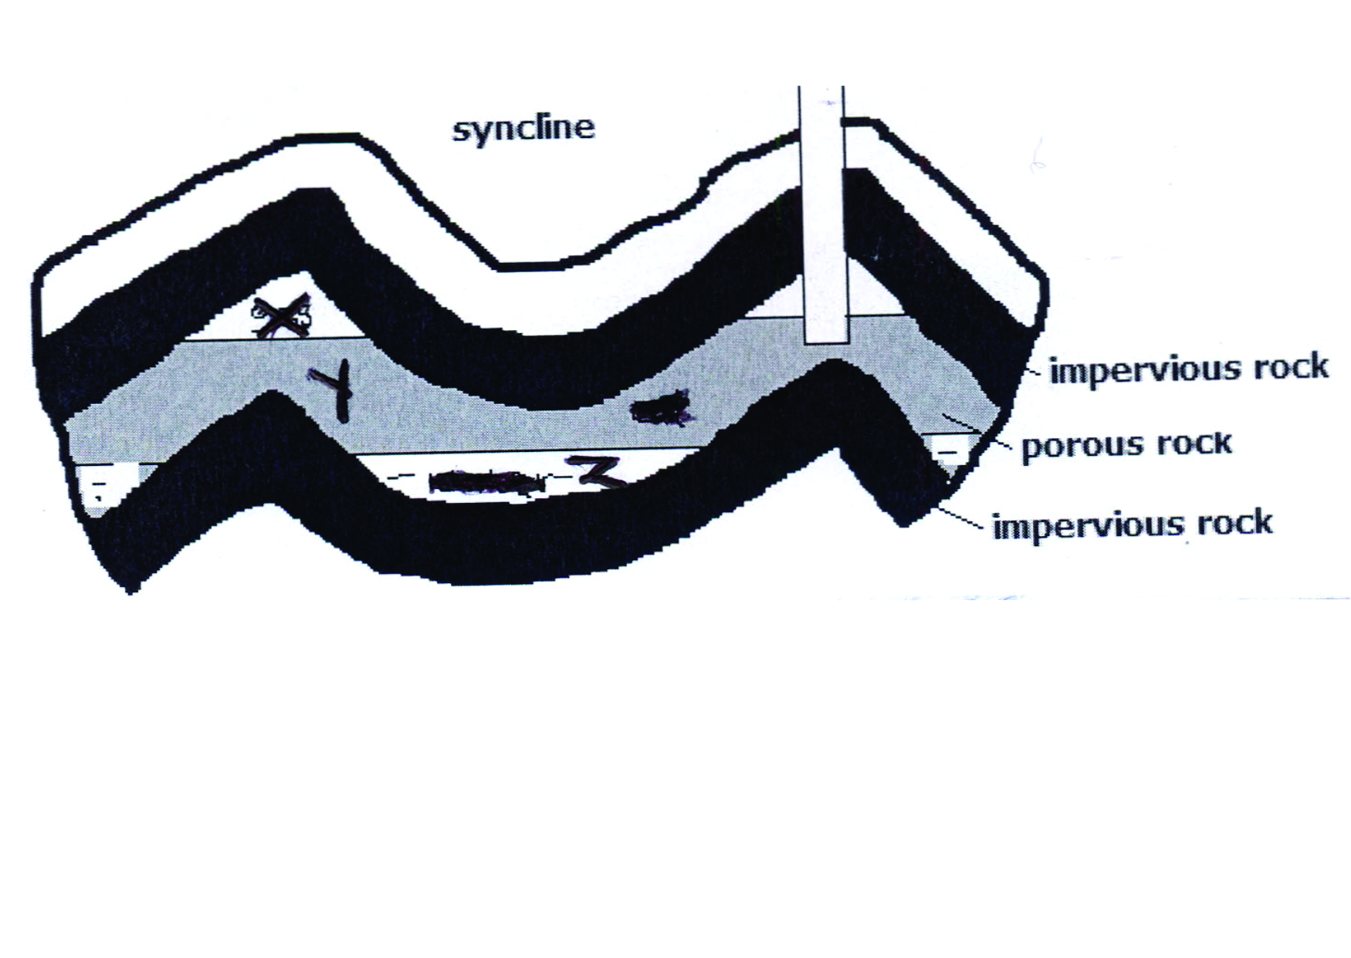

- Name the substances in the areas labelled X, Y and Z. (3 marks)
X – Gas
Y – Oil / Petroleum
Z – Water
- Give two by- products obtained when crude oil is refined (2 marks)
- Wax
- Bitumen / tar /asphalt
- Sulphur
- Lubricants / grease
- Resin / Petrol- chemicals

- (a) What is containerization? (2 marks)
The packing of goods in standardized steel metal boxes designed to transport cargo.

(b) State three problems facing river transport in Africa (3marks)
- Many rivers in Africa have rapids / waterfalls / cataracts which hinder movements of vessels.
- Some rivers have seasonal regime / varying volume making it difficult to use the rivers.
- Some rivers have shallow water / silted river mouths making navigation on them difficult.
- Some rivers have floating vegetation that chokes the engines making it difficult for vessels to move.
- Some rivers have narrow channels which are unsuitable for salting.
- Some rivers are short making navigation difficult.

- (a) Distinguish between horticulture and market gardening. (2 marks)
Horticulture is the intensive cultivation of vegetables fruits and flowers for sale while market gardening is an intensive cultivation of vegetables and fruits for sale in the nearest urban centres.

(b) State three reasons why horticultural farming is more developed in the Netherlands than in Kenya (3 marks)
- Netherland has a higher demand for horticultural products both locally and internationally than Kenya.
- Netherlands has better organized marketing systems for the products than Kenya.
- Netherlands has a more highly skilled labor in horticultural farming than Kenya.
- Transport and communication systems for goods transportation of products are better developed in the Netherlands than in Kenya.

- (a) Give two physical factors that led to the establishment of the seven forks hydroelectric projects along River Tana. ( 2 marks)
- Presence of large volume of water from river Tana / large catchment area for River Tana.
- Regular and constant supply of water from river Tana.
- Presence of a hard basement rocks in the area provided a firm foundation for the dam.
- Presence of rapids and waterfalls that provides massive hydraulic for H.E.P generation.
- Presence of non- porous rocks / impervious rocks.

(b) State three benefits that Kenya would derive from petroleum discovery (3 marks)
- It will reduce the use of wood fuel as cheap oil will be available.
- Increased foreign exchange to a country when oil products are exported.
- Increased industrialization since cheap oil will be available for use in providing power.
- Increase in employment opportunities since they will be engaged in mining oil.
- Lead to reduced prices of goods and services.
- Transport costs will reduce due to low oil prices which increase movement of goods and services.

- (a) Name two crops grown under irrigation at Perkerra irrigation scheme ( 2 marks)
- Seed maize / Maize
- Chilies
- Melons
- Tomatoes
- Pawpaw
- Onions
- Kales
- Butter nuts

( b) Give three problems associated with irrigation farming in Kenya (3 marks)
- Wastage of water through flood irrigation.
- Irrigation water results in leaching of nutrients from the top layer of soil.
- Flood water lead to sheet erosion.
- Improper control of water supply may spoil the plant.
- Stagnant water encourage the spread of water borne diseases.
- Moist and hot conditions cause outbreak of diseases.
- High rates of evaporation leads to salization of soils.

SECTION B
Answer question 6 and any other TWO questions from this sections.

- The graph below shows the value of Kenya’s leading marketed crops between 2008 and 2012. Use it to answer questions ( a) and ( b).

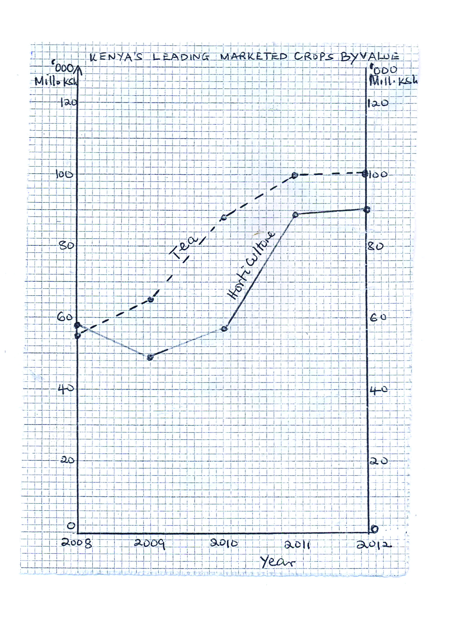
- (i) What was the value of tea marketed in the year 2009? ( 2 marks)
- 62.5
(ii) What was the difference in the value of the horticultural products and tea marketed in 2012? (2 marks)

- (i) Describe the trend of the value of tea marketed from 2008 to 2012. ( 4 marks)
- The value was generally rising over the five years.
- The value was highest in 2012
- The rise between 2011 and 2012 was minimal
- 2009 and 2010 experienced the highest increase
- The value was lowest in 2008

(ii) State three advantages of using simple line graphs to represent data. (3 marks)
- Give clear visual impression
- Easy to contract / Draw
- Easy to interpret / read
- Can be used to represent a wide value of variables
- Are appropriate for comparison.

(c ) State four physical conditions that favour cocoa growing in Ghana ( 4 marks)
- High temperature / 24c - 30c throughout the year.
- High rainfall / 1200 mm – 1500 mm per year.
- Well distributed rainfall throughout the year.
- Deep soils.
- Loamy / volcanic soils
- Undulating lowlands / 0 – 750 m above sea level.
- Well drained soils.
- Shelter for strong direct sunshine.

(ii) Describe the stages followed from harvesting to processing of cocoa (9 marks)

- (a) Distinguish between a forest and forestry ( 2 marks)
A forest is a continuous growth of trees and undergrowth covering a large tract of land while forestry is the science of growing protecting trees and including managing them on the earth’s surface.

(ii) Explain three factors which influence the distribution of softwood forests in Kenya (6 marks)
- Cool climate which enable trees to flourish .
- Heavy rainfall over 1000mm and low evaporation rates which support the growth of forests.
- Some Kenyan highlands are rugged and steep which makes them unsuitable for agriculture leaving forests to thrive.
- High demand / ready market for timber and timber products which encourage tree farming.
- Human activities such as afforestation and reforestation which have led to existence of forests.
(Any 3 well explained * 2= 6 Marks)

(b) State 4 significance of softwood forests products (4 marks)
- Timber form softwood trees is used for making furniture
- The poles from the trees are used for building and construction
- Fruits from some trees species are used for food
- The tannin beans is used for manufacture of tannin used for tanning shoes.
- The cocoa beans are used for the manufacture of cocoa used in making drinking chocolate.
- Some leaves from some trees species are used for medicinal purposes to treat and cure some diseases.
- Some trees leaves and branches are used for thatching houses.

(Any first 4*1 = 4 marks)

- Give five similarities between forestry in Kenya and Canada

- In both countries harvesting of trees is done after maturity.
- In both countries the forests are attacked by pests and diseases.
- In both countries transportation of logs is done using roads.
- In both countries the trees products are used in pulp and paper industries.
- In both trees species grown are similar.
- In both forests are affected by forest flees
- In both forests grow in areas of heavy rainfall such as Kenyan Highlands and Canadian Lowlands.

- Explain 4 measures the Government of Kenya is taking to conserve forests ( 8 marks)
- Creation of forest reserves to protect the indigenous forests from extinction
- Setting of forests guards posts in the forests to protect forest against illegal logging
- Setting Nyayo Teas Zones to act as protective belts to prevent people from trespassing into the forests.
- Afforestation to introduce new trees species and protect original species.
- Reforestation to retain the tree species and introduce new areas under forests.
- Agroforestry protect the soils and improving the mechanism through which forests grow.

- (a) (i) What is fish farming (2 marks)
Rearing of fish in fresh water ponds and reservoirs under controlled conditions.

(ii) Give reasons why the Government is encouraging fish farming (5 marks)
- To meet the demand for food with high protein
- To create employment opportunities for many Kenyans
- Fish farming helps in restocking overfished grounds
- The fish can be exported to earn foreign exchange for the country
- Helps in conservation of rare and endangered fish species from depletion
- Encouraging growth of fish related industries such as canning and net making.
- May facilitate scientific research on general behavior of fish.

( b) Describe drifting method of fishing ( 6 marks)
- Two nets are held vertically in water by floaters to the upper side and weights at the bottom.
- The net is then stretched
- The net is held close to the surface of the water where fish swim in large shoals
- As the fish go past the net they are trapped.
- Once enough fish has been caught the drifters are haul the catch to the shore.
- The fish is removed from the net and taken for processing.
- Then the drift net is cast back into the water for another catch.

- Explain three reasons why marine fishing is underdeveloped in East Africa
(6 marks)
- Warm water which limit the breeding of a large number of fish
- Narrow continental shaft thus limiting the area over which planktons can grow
- Limited market for fish due to low purchasing power, discouraging the fishermen
- Poor transportation network such as roads hindering expansion of markets and delaying delivery of fish to the market
- Inadequate capital for instance finances where fishermen are unable to buy modern fishing equipment
- Poor technology hence fish may go bad before reaching the market
- Shift competition form developed nations hence limiting markets
- Shortage of skillful labuor personnel on fishing technology hence small scale fishing.

- State three methods the government of Kenya has undertaken in order to conserve fishing grounds (6 marks)
- Providing transport routes to enable exploitation of fishing grounds in remote areas
- Encouraging fish farming to complement the fish caught in natural waters
- Encouraging internalized agreements on territorial waters in order to prevent other nations from overexploiting the fishing grounds
- Standardizing nets to ensure only mature fish are caught.
- Increasing fishermen to ensure there is no overfishing
- Restricting fishing to specific seasons to allow maturing of fish
- Restricting disposal of untreated water to ensure water remain clean for fish survival

(Any 6*1 = 6 marks)

- (a) Differentiate between Wildlife Management and Wildlife Conservation
(2 marks)
Wildlife management is the effective planning and control of wildlife while wildlife conservation is the protection of wildlife against interference and destruction by people.

(b) What is green tourism? (2 marks)
The combination of tourism together with the conservation of the environment
People travelling seeking to protect and restore the damaged environment e.g. planting trees.

(c) (i) Explain how the following factors have influenced the distribution of wildlife in East Africa

Rainfall: (2 marks)
Abundant rainfall Attracts variety of wildlife arid areas have limited / few wildlife

Vegetation: (2 marks)
Grassland vegetation Attracts variety herbivorous and carnivorous like Lions and Cheetahs

(ii) Name five tourist attractions in Kenya (5 marks)
- Marine parks
- Historical sites
- Sandy beaches / coral reefs / coastal scenery / Indian Ocean
- Traditional culture
- Warm climate / sunny weather
- Variety of wildlife
- Variety of physical features / mountains. Rift valley / lakes / Rivers

(d) (i) Explain four benefits of wildlife to the economy of Kenya (8 marks)

- Wildlife is natural beauty attracting tourists encouraging tourism industry
- Wildlife conservation employs large number of personnel enabling people to earn income raising their standards of living
- Preservation of forests helps to preserve and protect water catchment areas providing plenty of water for domestic and industrial use.

- What is industrialization? (2 marks)
This is the process through which a country establishes manufacturing industries.

(ii) State five ways in which Kenya has benefited from industrialization (5 marks)
- It has heated employment opportunities hence raising the standards of living of the people / reducing unemployment
- It has led to the acquisition of management / Technical skill.
- It has led to the diversification of the economy
- It has led to the growth / expansion of settlement / urban centre
- It has led to reduction of the importation of some industrial goods.
- It has led to the improvement in the balance of trade
- It has led to the development of transport and communication network
- It has facilitated the establishment of social amenities.
- Kenya exports / taxes industrial goods, thus earning foreign exchange.

(b) (i) Give three characteristics of Jua Kali industries in Kenya ( 3 marks)
- Use simple to advanced equipment
- Use basic / simple skills in craft
- Are wide spread
- Are mostly operated in the open / sheds
- Use local / recycled raw materials
- Require low capital investment
- Are operated by individual / small groups.
- Are pursued as part time / full time occupation
- Goods produced usually find a ready market locally.

(ii) Explain four factors which have favoured the development of car manufacturing industry in Japan. (8 marks)
- Japan has highly skilled / industrious workforce which enhances efficiency in production.
- The country has adequate capital to invest in the industry.
- Advanced technology / research has led to the efficiency methods of production / high quality cars which are competitive in the world market.
- Japan has many sea ports which makes the importation of raw materials / exportation of cars possible.
- The government policy / peace and stability has led to rapid development of the industry.
- Japan has highly developed hydroelectric power projects which provide power needed for the industries.
- The presence of large population / high purchasing power provides a large local market for the cars.
- Japan’s terrain is too rugged unsuitable fo9r the development of agriculture and thus industries / provide an alternative source of income to be used for buying and other requirements.
- The strategic position of Japan in relation to other countries encourages trade thus promoting production of vehicles / Japan is accessible from all directions.

(c) Your class carried out a field work on paper milling industry.

- Name two types of fieldwork they could have used. (2 marks)
- Field study
- Field excursion
- Give two ways in which they prepared themselves for the fieldwork ( 2marks)
- They sought permission from the relevant authority
- They conducted a pre-visit to the area of study
- They held class discussion
- They prepared a working schedule for the administration on the respondents.
- They prepared the questionnaire.
- They prepared objectives and hypothesis after the pre-visit.
- They divided themselves into groups and allocated tasks.

- State three reasons why paper milling industries are located near sources of water supply that they could have found out ( 3 marks)
- The industries use water for cooling machines
- The industries need large amount of water for cleaning.
- The industries dispose off their waste materials through water.
- Water provide cheap means of transport for the logs since they are bulky.
- Some industries use water to debark the logs.

