Name…………………………………… …………………………..………… Index No:………………………….

231/1 Candidate’s Signature …………..……………
BIOLOGY Date: …………………………
PAPER 1
THEORY
JULY/AUGUST- 2016
TIME: 2 HOURS

PRE KCSE 2016
Kenya Certificate of Secondary Education (K.C.S.E.)

231/1
Biology
Paper 1
2 hours

INSTRUCTIONS TO CANDIDATES
- Write your name, Index number and school in the spaces provided above.
- Answer All questions in the spaces provided on the question paper.
- Sign and write the date of examination in the spaces provided above.
- Additional pages must NOT be inserted.

FOR EXAMINER’S USE ONLY
Question | Maximum Score | Candidate’s Score
1-27 | 80
This paper consists of 7 printed pages. Candidates should check to ascertain that all pages are printed as indicated and that no questions are missing.

1. Name the blood vessel that supply:
(a) The heart with nutrients. (1mk)
……………………………………………………………………………………………………………….
(b) The foetus with oxygen (1mk)
……………………………………………………………………………………………………………….
2. Explain why it is important to stain specimen to be observed under a light microscope. (2mks)
…………………………………………………………………………………………………………………….
……………………..………………………………………………………………………………………………
3. What is wilting? (2mks)
…………………………………………………………………………………………………………………….
……………………..………………………………………………………………………………………………
4. State the significance of the following steps while testing for discharge in food sample. (2mks)
(a) Addition of dilute hydrochloric acid
…………………………………………………………………………………………………………………….
(b) Addition of sodium bicarbonate.
…………………………………………………………………………………………………………………….
5. a) (i) Name the fluid produced by sebaceous gland. ( 1mk)
…………………………………………………………………………………………………………………….
(ii) State two function of the fluid name din 5 a) (i) above. ( 2mks)
…………………………………………………………………………………………………………………….
……………………..………………………………………………………………………………………………
b) Explain malpigtian layer of the skin is adapted to perform its function. (1mk)
…………………………………………………………………………………………………………………….
……………………..………………………………………………………………………………………………
6. A certain animal had one cell from its alimentary canal observed under light microscope. A total of 40
chromosomes were seen.
(a) State the number of chromosomes in
(i) The spermatozoon of this animal (1 mk)
…………………………………………………………………………………………………………………….
……………………..………………………………………………………………………………………………
(ii) One of cells in the tongue. (1mk)
…………………………………………………………………………………………………………………….
……………………..………………………………………………………………………………………………
(b) Name a structure in mature plant where meosis takes place. (1mk)
…………………………………………………………………………………………………………………….
……………………..………………………………………………………………………………………………
7. A biological washing detergent contain enzymes which remove stain like mucus and oil from clothes
which are soaked in water with the detergent.

(a) Explain why stain would be removed faster with detergent in water at 35ºC rather than 50ºC (1mk)
…………………………………………………………………………………………………………………….
…………………………………………………………………………………………………………………….

(b) Why is boiling clothes with the detergent less likely to remove stain. (1mk)
…………………………………………………………………………………………………………………….
…………………………………………………………………………………………………………………….
(c) Name an enzyme that catalyses the decomposition of sodium hydrogen carbonate to facilitate
transportation of carbon (IV) Oxide. (1mk)
…………………………………………………………………………………………………………………….
…………………………………………………………………………………………………………………….
8. Form 2 students from samba secondary school set up an experiment as shown below.
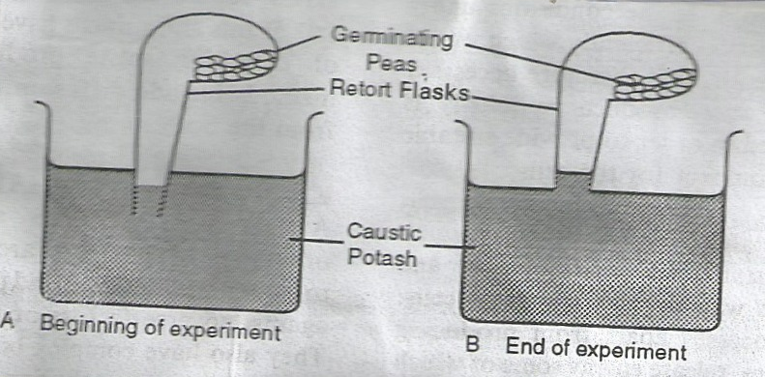

- Explain the change observed at the end of the experiment. (2mks)
…………………………………………………………………………………………………………………….
……………………..………………………………………………………………………………………………
- Explain what would happen if water has been used instead of potassium hydroxide. (2mks)
…………………………………………………………………………………………………………………….
……………………..………………………………………………………………………………………………
9. State two advantages of metamorphosis to the life cycle of insects. (2mks)
…………………………………………………………………………………………………………………….
……………………..………………………………………………………………………………………………

10. The concentration of lactic acid in blood during and after an exercise was determined. The results
are shown in the graph below.

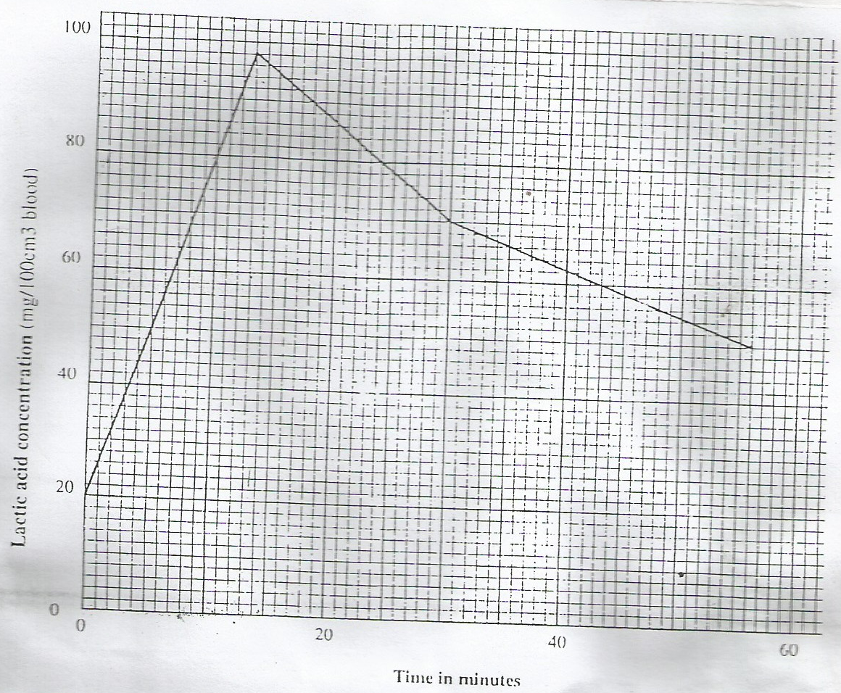

- (i) By how much did the lactin acid increase at the end of 10 minutes? (1mk)
…………………………………………………………………………………………………………………….
…………………………………………………………………………………………………………………….
(ii) After how many minutes was the lactin acid concentration 78mg/100cm³ ( 2mks)
…………………………………………………………………………………………………………………….
…………………………………………………………………………………………………………………….
(iii) What would be the concentration of lactin acid at the 60th minutes. (1mk)
…………………………………………………………………………………………………………………….
…………………………………………………………………………………………………………………….
- Give a reason for the high rate of production of lactic acid during the exercise. (1mk)
…………………………………………………………………………………………………………………….
…………………………………………………………………………………………………………………….
11. Name the part of human brain that perform the following function (2mks)
(a) Controls peristalsis
…………………………………………………………………………………………………………………….
…………………………………………………………………………………………………………………….
(b) Control intelligence
…………………………………………………………………………………………………………………….
…………………………………………………………………………………………………………………….
12. Outline the differences between darwin’s theory and Lamendi’s theory of evolution. (2mks)
…………………………………………………………………………………………………………………….
…………………………………………………………………………………………………………………….
13. Give three functions of cystokinin hormone in plant (3mks)
…………………………………………………………………………………………………………………….
…………………………………………………………………………………………………………………….
…………………………………………………………………………………………………………………….
14. Explain why plants do not require specialized excretory organ. (3mks)
…………………………………………………………………………………………………………………….
…………………………………………………………………………………………………………………….
…………………………………………………………………………………………………………………….
15. The diagram below represents a stage in cell division.\
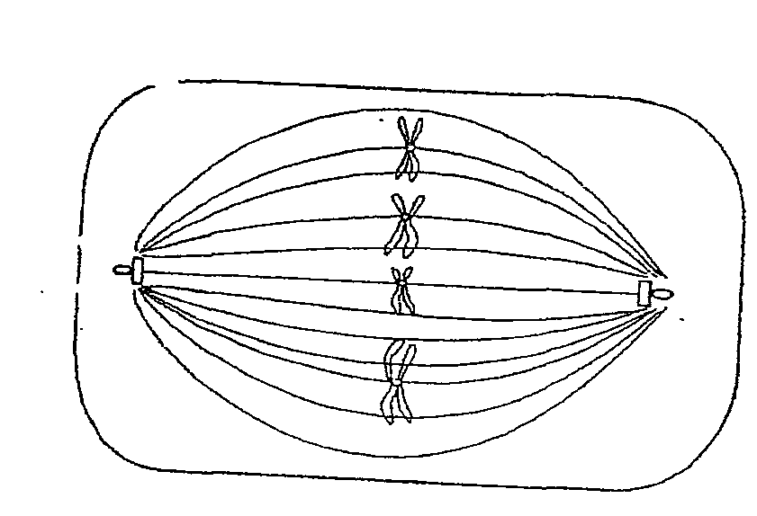

- Identify the stage of cell division (1mk)
…………………………………………………………………………………………………………………….
- Give a reason for your answer (1mk)
…………………………………………………………………………………………………………………….
16. Outline three functions of colon . (3mks)
…………………………………………………………………………………………………………………….
…………………………………………………………………………………………………………………….
…………………………………………………………………………………………………………………….
17. State two advantages of closed circulatory systems in mammal. (2mks)
…………………………………………………………………………………………………………………….
…………………………………………………………………………………………………………………….
18. The diagram below shows a mammalian bone.
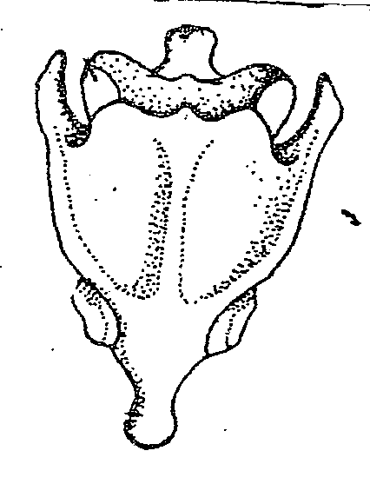

- Identify the bone (1mk)
…………………………………………………………………………………………………………………….
- Give a distinctive reasons for your answer in (a) above. (1mk)
…………………………………………………………………………………………………………………….
- Name the bone that articulate with the bone drawn above at the proximal end. (1mk)
…………………………………………………………………………………………………………………….
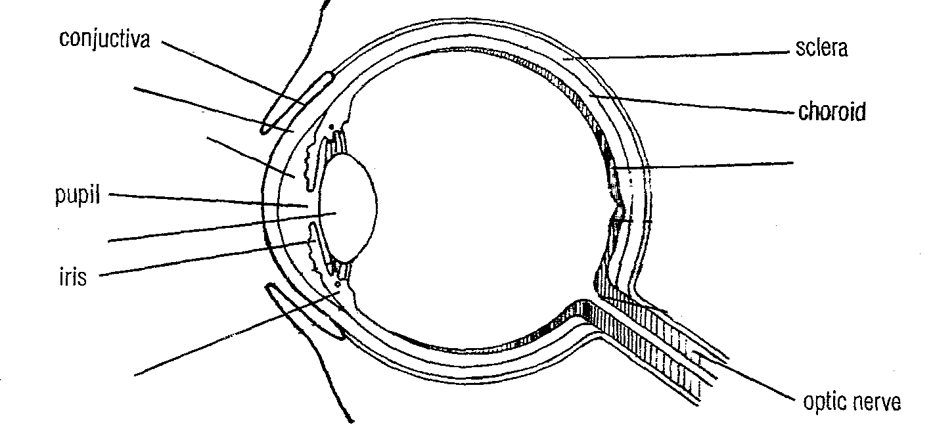
19. The diagram below shows a mammalian eye.
P
L
J
K
N

- Name the parts labeled J,K, and L ( 3mks)
J…………………………………………………………
K…………………………………………………………
L…………………………………………………………
- Explain how the following parts are adapted tot heir function.
(i) N ……………………………………………………………………………………………… (1mk)
(ii) P……………………………….………………………………………………………….…… (1mk)
- Name the eye defect caused by short eyeball and less refractive lens. (1mk)
…………………………………………………………………………………………………………………….
…………………………………………………………………………………………………………………….
20. Explain damsel fertilization as used in flowering plants. (2mks)
…………………………………………………………………………………………………………………….
…………………………………………………………………………………………………………………….
21. The diagram below shows a simplified nitrogen cycle.
Nitrogen in Atmosphere

Ammonia
Animals

Nitriate
H
K
G
Nitrite

- Name the process represented by
P ………………………………………………………
K ………………………………………………………
H ………………………………………………………
- Name the organisms involved in process J (1mk)
…………………………………………………………………………………………………………………….
- Name organisms represented by G (1mk)
…………………………………………………………………………………………………………………….
22. (a) Explain how mammalian trachea is adapted to its function ( 2mks)
…………………………………………………………………………………………………………………….
…………………………………………………………………………………………………………………….
(b) Name the gases exchange site in bony fish. (1mk)
…………………………………………………………………………………………………………………….
…………………………………………………………………………………………………………………….
23. Explain the role of the following hormone in homeostain
(a) insulin ( 3mks)
…………………………………………………………………………………………………………………….
…………………………………………………………………………………………………………………….
(b) Antidimetic hormone (ADH) when there is less water in blood stream. (2mks)
…………………………………………………………………………………………………………………….
…………………………………………………………………………………………………………………….
24. Outline three difference between plant divisions bryophyte and Pteridophyta (3mks)
…………………………………………………………………………………………………………………….
…………………………………………………………………………………………………………………….
…………………………………………………………………………………………………………………….
…………………………………………………………………………………………………………………….
25. Name two products of light stage of photosynthesis that are useful in dark stage. (2mks)
…………………………………………………………………………………………………………………….
…………………………………………………………………………………………………………………….
26. State two functions of xylem tissue. ( 2mks)
…………………………………………………………………………………………………………………….
…………………………………………………………………………………………………………………….
27. State two function of golgi apparatus ( 2mks)
…………………………………………………………………………………………………………………….
…………………………………………………………………………………………………………………….

