1. Use the flow chart below to answer the questions that follow.
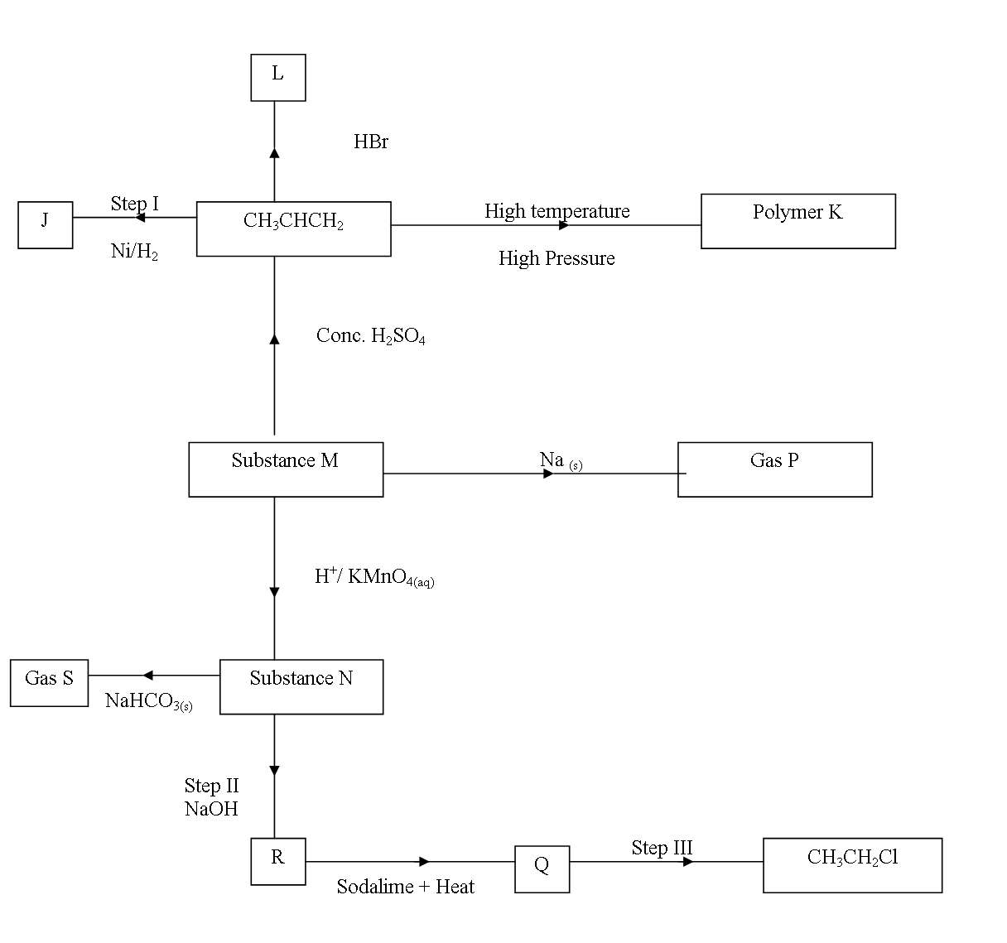
(a) Name the following
(i) Gas S (1 mk)
(ii) Gas p (1 mk)
(iii) J (1 mk)
(b) Name process in
(i) Step I (1 mk)
(ii) Step II (1 mk)
(iii) Step III (1 mk)
(c) Draw two structural Isomers of compound L. (2 mks)
(d) Write a chemical equation for the complete combustion of Substance M. (1 mk)
(e) Name the reagent and condition in step III.
(i) Reagent. (1 mk)
(ii) Condition
(f) Calculate the mass of salt R that would be formed by using 21.9 tonnes of N when it reacts with excess Sodium hydroxide. (C=12.0, H=1.0, Na=23.0, O=16.0) (2 mks)
2 (b) The scheme below shows some reactions starting with Propanol. Study it and answer
the questions that follow.
S
CH₃CH₂COONa
CH₃CH₂CH₂OH
B
CH₃CH₃
CH₃CH=CH₂
T
CH₃CH₂CH₃
CH₃CH₂COOH
NaOH_{(aq)}

Step II
K_{(S)}
CH₃COOH
Limited Cl₂ and uv light.
Drops of Conc.H₂SO₄ Heat

Step I

Step III
Step IV
H H
C C
CH H n

i) Write down the formula of compounds S and T.
S____________________________________________________________________(1mk)
T____________________________________________________________________(1mk)
ii) Draw the structural formula of compound B. (2mks)

iii) Name the type of reaction, reagent and conditions in the reactions in step I and step IV.

Step | Type of reaction | Reagent | Condition
I

IV

(3mks)
iv) Name two chemical tests that can be used to differentiate propanol from
propanoic acid.
Propanol | Propanoic acid
i)

ii)

3. a) A and B shown below represent cleansing agents.
i) State one advantage of using A as a cleansing agent. (1mk)
ii) Explain how an aqueous solution of cleansing agent B removes oil from utensils during washing. (2mks)
b) Study the scheme below and answer the questions that follow.
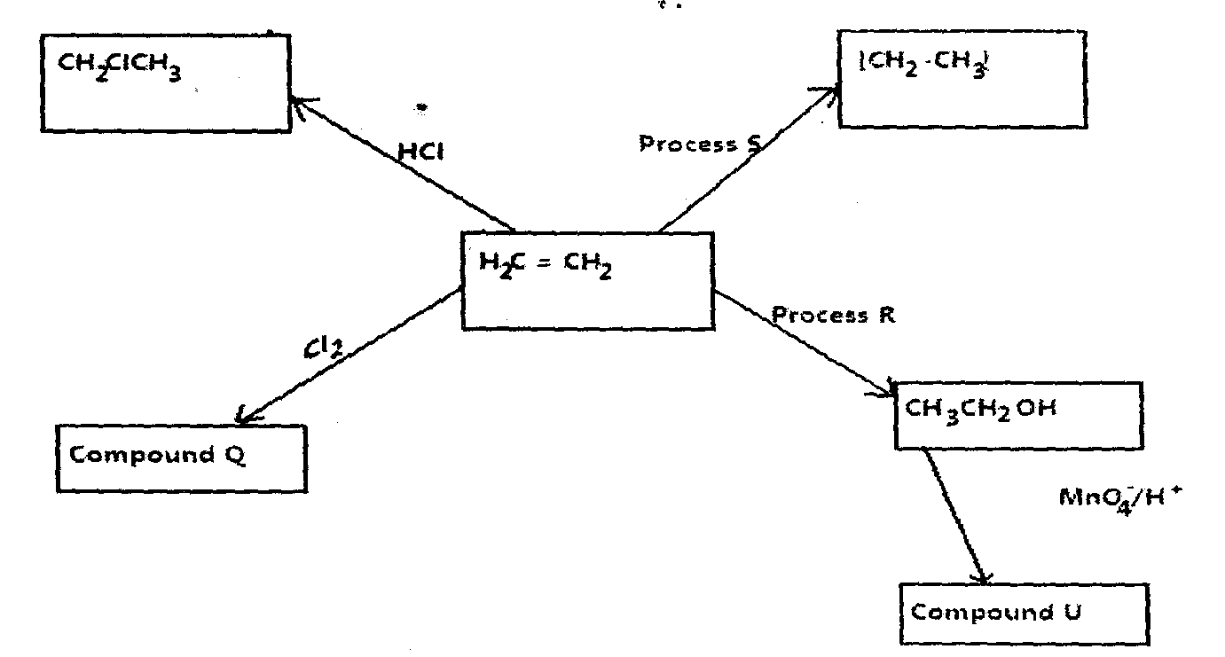
i) State the:
i) Conditions for process R

ii) Type of reaction representation by process S. (1mk)
iv) Name of compound U. (1mk)
ii) Write an equation for the formation of compound Q (1mk)
iii) Draw and name the structural formulae of compound CHClCH. (1mk)

4. The list below shows the formulae of some organic compounds. Use letters T1 to T6 to answer the questions that follow.
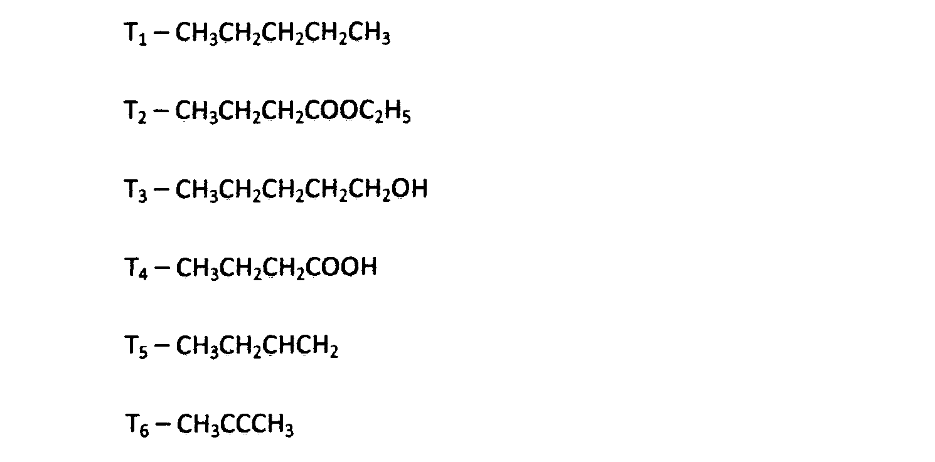
a) Select two compounds which:
i) Are not hydrocarbons (lmk)
ii) Would decolourise both bromine water and acidified potassium manganate( VII). (lmk)
iii) Would produce hydrogen gas when reacted with potassium metal. (lmk)
b) Select a compound which would produce bubbles of a gas when reacted with sodium carbonate. (lmk)
c) i) Identify the compound that is likely to undergo polymerization. Give a reason
for your answer. Using two molecules show how polymerization occurs.
I. Compound (lmk)
II. Reasons (lmk)
III. Polymerization (lmk)
ii) Name the process by which compound T₂ is formed and identify the compounds
that were used to form it.
I. Process (lmk)
II. Compounds
i) ……………………………………………………………. (lmk)
ii). ……………………………………………………………...
c) Compound T₃ can be converted to T₄ as shown by the equation below:
Given the following information:
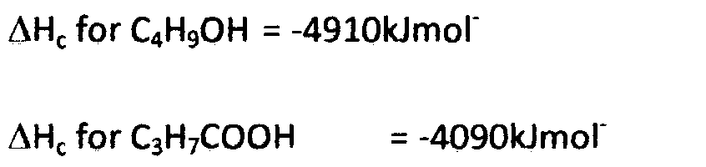
Determine the heat change for the reaction above. (3mks)

5. The scheme below shows some reactions starting with but-1-yne. Study it and answer the questions that follow.
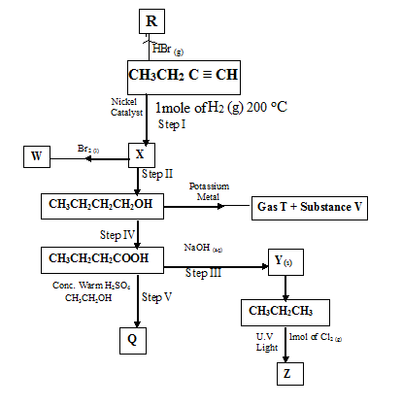
- Name substances (2marks)
W_________________________________________
X__________________________________________
Y____________________________________________
V__________________________________________
b) Name the type of reaction(s) taking place in; (3marks)
Step I__________________________________________
Step III _______________________________________________
Step IV________________________________________________
- State the reagents and conditions required for the formation of the following substances. (3marks)
- CH₃CH₂CH₂CH₂OH
Reagent; _______________________
Condition; _____________________
ii) CH₃CH₂CH₃
Reagent; _______________________
Condition; _____________________
iii) CH₃CH₂CH₂COOH.
Reagent; _______________________
Condition; _____________________
d) Write equations for the reactions that took place during the formation of;
i) R
- W
- Z
(3marks)
e) i) State a chemical test to differentiate between substance X and
CH₃CH₂CH₃ (1mark)
ii) Ethanol (C₂H₅OH) dissolves readily in water yet dimethyl ether CH₃OCH₃, which has the same number and kind of atoms does not. Explain this observation. (2marks)
6.The scheme below shows several reactions starting with propanol. Study the scheme and answer the questions which follow.
Propane
Q
CH₂BrCHBrCH₃
S
CH₃CH₂CH₂OH
Gas R
CH₃CH₂ COOCH₂ CH₃
Bromine water
Excess
H⁺/K₂Cr₂O₇
Na
Conc. H₂SO₄

a) Name gas R. (1mk)
b) Name and draw the structural formula of compound Q. (2mks)
c) What conditions and reagents are necessary to convert S to CH₃CH₂COOCH₂CH₃ (2mks)
Reagents;
Conditions;
d) Write an equation for the reaction that takes place when equal volumes of chlorine gas react with propane. (1mk)
e) The table below shows some properties of organic compounds U, V, and W. use the information
to answer the questions that follow.
 | W | V | U
Reaction with liquid bromine. | Decolourise bromine very fast | No reaction | Decolourises bromine liquid slowly
Combustion | Burns with yellow smoky flame | Burns with a blue flame leaving no residue | Burns with a yellow sooty flame
Reaction with conc. H₂SO₄ | No reaction | It is dehydrated to form compound U. | Reacts to form V.

To which homologous series do the following compounds belong? (3mks)
U…………………………………………………………….
V…………………………………………………………….
W……………………………………………………………
f) CH₂ CH – CH₃ when heated under high temperatures and pressures forms a solid with large
molecular mass.
i) Write the equation for the reaction which involves the formation of the solid. (1mk)
ii) Name the solid and give one use of the solid
Name (1mk)
Use (1mk)
g) State two uses of cracking. (2mks)
- (a) Give the IUPAC names of the following compounds. (1mk)
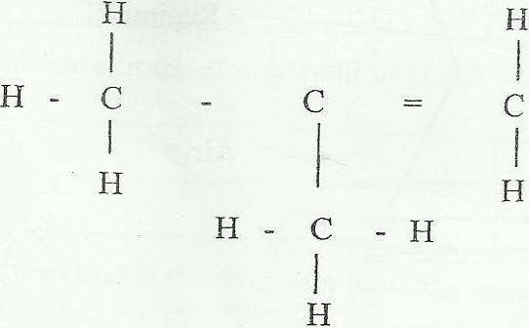
i)

ii) CH₃ CH₂COO CH₂ CH₃ (1mk)
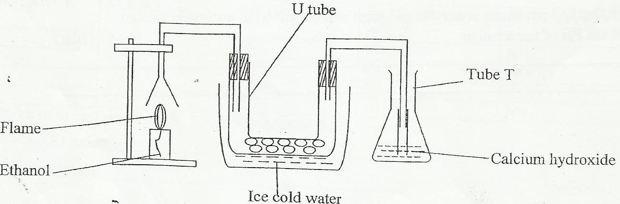
(b) A lamp containing ethanol was burnt in air and the product collected as shown in the diagram.

State the observation made in the
- U-tube (1mk)
- Tube T (1mk)
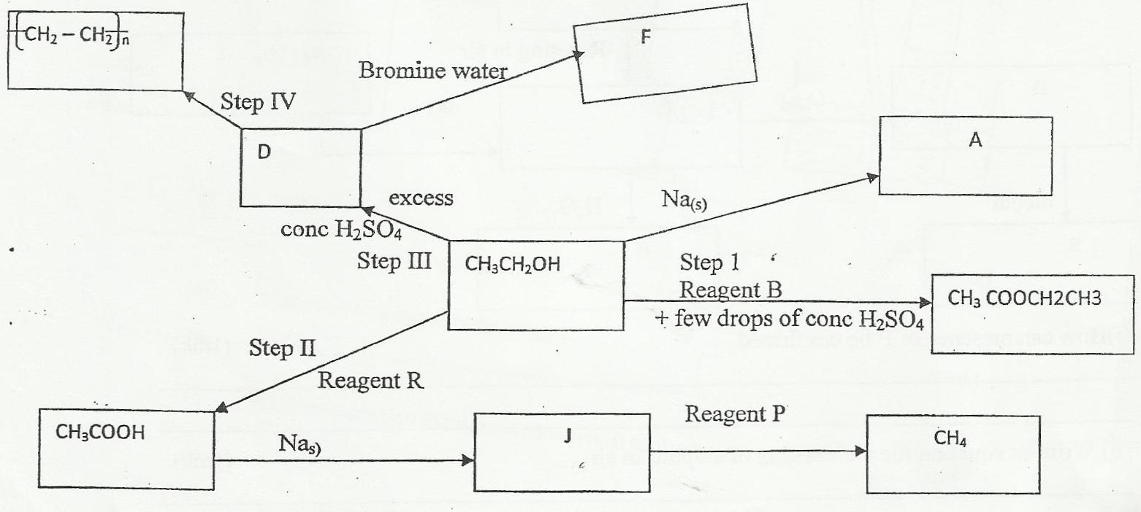
(c) Study the reactions given in the diagram carefully and then answer the questions that follow.

- Identify the following
I. Reagent B………………………………………………………… (1/2mk)
II. Reagent P…………………………………………………………. (1/2mk)
III. Reagent R ……………………………………………………… (1/2mk)
IV. Substance A…………………………………………………….. (1/2mk)
V. Substance F…………………………………………………….. (1/2mk)
VI. Substance D……………………………………………………….. (1/2mk)
ii. Write an equation to show formation of J. (1mk)
iii. Explain one disadvantage of the continued use of items made from compounds formed in step (IV)(1mk)
iv. What observation would be made when D is bubbled through bromine water? (1mk)
v. The compound D reacts with hydrogen in the presence of a catalyst G to form a compound H. Name:
I. Compound H…………………………………………………………………
II. Catalyst G……………………………………………………..……………….

