232/3
PHYSICS
PAPER 3
MARKING SCHEME
QUESTION 1
- N=831
- D=0.0116M(4d.p)$\begin{matrix}+ \\ -\end{matrix}0.00021$
- d=6.3$x{10}^{-4}m$1
- N$=\frac{0.4D}{dm}$¹/₂
M=$\frac{0.4D}{dN}=\frac{0.4x0.0116}{6.3x{10}^{-4}x83}1=0.08871/2(4d.p)$
- Lo=50.0

1mk | W(N) | 0 | 0.01 | 0.02 | 0.03 | 0.04 | 0.05 | 0.6 | 0.7 | 0.8 | 0.9 | 1N
1mk | L(cm) | 50 | 51.2 | 52.4 | 53.6 | 54.8 | 56.0 | 57.2 | 58.4 | 59.6 | 60.8 | 62.0
2mk | e(CM) | 0 | 1.2 | 2.4 | 3.6 | 4.8 | 6.0 | 7.2 | 8.4 | 9.6 | 10.8 | 12.0
2mk | $$\frac{1}{e}{cm}^{-1}$$ | 0 | 0.8333 | 0.4166 | 0.2777 | 0.2083 | 0.1666 | 0.1389 | 0.1190 | 0.1042 | 0.0926 | 0.0833

- Axes=¹/₂mk well labelled unit a must.
Scale=¹/₂mk appropriate scale
Plots=2mks 8-11 plots correctly plotted
4-7 correctly plotted 1mk
Less than 4 - 0mks
Smooth curve -1mk
- Slope=$\frac{5.5}{2.2}-\frac{3.5}{1.4}=\frac{2.0}{0.8}=2.5NCM$
T=$\frac{mx({5+60)}^{2}}{-255}$
=$\frac{0.0887x({2.5+60)}^{2}}{-255}$
T=1.3588N²CM²

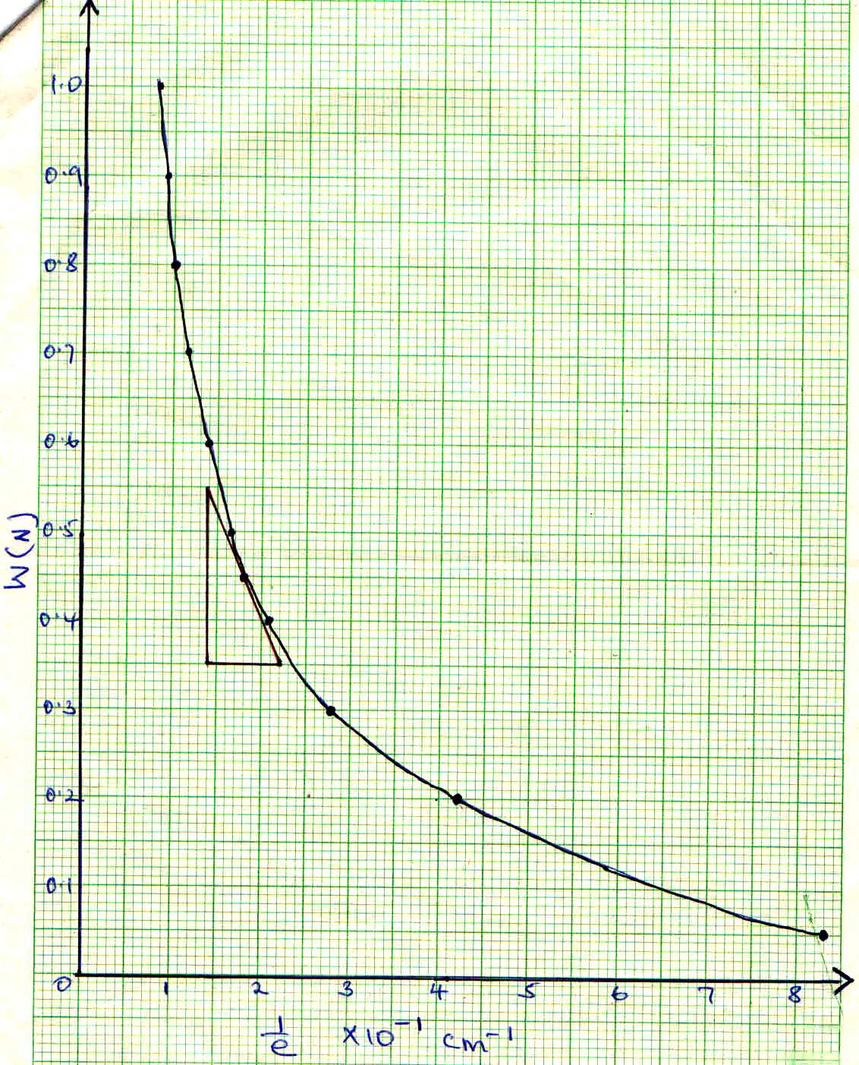

QUESTION 2
b)
- EP=10.0cm$\begin{matrix}+ \\ -\end{matrix}$0.21
- EI=5.2$\begin{matrix}- \\ +\end{matrix}0.2$
- N=$\frac{EP0}{EI}=\frac{10}{5.2}=1.923$
- Refractive index

20 | 30 | 40 | 50 | 60 | 70
46 | 48 | 50 | 45 | 45 | 41

- Axes-1mk-well labelled
Scale-1mk-appropiate scale
Plots-5-6 plots-2mks
3-4plots-1mk
0-2 -0mk
Two extrapolated lines-straight lines-1mk
- Hmax=50.95cm
- R=$\frac{\cos{40}}{\sin^{2}(16+\frac{Hmax}{3}}$¹/₂
=$\frac{0.7660}{\sin^{2}(16+\frac{50.95}{3})}1=\frac{0.7660}{\sin^{2}(32.98)}1/2$
=$\frac{0.7660}{0.29629}1/2=2.5853(at least 4d.p)$¹/₂
