232/1
PHYSICS
PAPER 1
MARKING SCHEME
- Diameter of wire $\frac{20}{15}$ = 1.33
Radius of wire 1.33÷21=0.67cm1
- To increase the time take to come to a stop which reduces the rate of change of momentum or reducing the impulsive force producing a small reaction on him by floor1
- Clean water has a high surface tension addition of detergent lowers the surface tension 1
- Ml_{f}+mcΔT1=$\frac{50}{1000}x3360001+\frac{50}{1000}x2100x10$
=16800+1050
=17850J1
- A₁V₁=A₂V₂₁
π$\frac{7}{2}x\frac{7}{2}x5$=πx20x$\frac{0.7}{2}x\frac{0.7}{2}xV2$1
V₂=$\frac{7x7x5}{20x0.7x0.7}=2.5m/s$1

- Pressure is developed at the point of application of the force. 1Since the liquid is incompressible, pressure is uniformly transmitted and force is generated.1
- Hydraulic machines (brakes, press)1
- F=$\frac{mv^{2}}{r}+mg1=9.5=\frac{150}{1000}x\frac{v^{2}}{{30}/{100}1}+\frac{150}{1000}x10$
$v^{2}=\frac{8.0x1000x30}{150x100}=16$
V=4.00m/s1
- E=4.25-4.00=0.25m
F=Ke= >75=0.25k1
K=300N/M1
- The level of water in the tube first drops and then rises. 1Due to expansion of the glass boiling tube.1
- The c.o.g is raised when the carrier is at the top lowering the stability.1
- Copper a good conductor of heat conducts the heat away hence paper does not char.1
- Wx5=4x20√
W=$\frac{80}{5}=16N$√
√1

- The temperature at which the volume pressure/K.E of a gas is assumed to be zero.1
- Halving the volume doubles the number of collisions per unit time.1Therefore the rate of change of momentum will also double.2

- I -Serves as a pointer to the volume on scale
-A drying agent for the gas1
II -To make the temperature of the bath uniform.1
- Heat the bath and record the temperature and height at suitable temperature interval.1 plot a graph of volume against temperature.1 The graph is a straight line indicating proportional change in volume and temperature.
- See sketch on grid.
- P₁V₁=P₂V₂₁
$$\left(76+6\right)\left(20\right)=\left(76-6\right)x$$
X=$\frac{82x20}{70}=23.429cm$1

- Introduce the oil drop on the water surface.1The surface tension of water reduces and the net force1 of the surrounding water pulls oil molecules outwards hence spreading.1

- Ah=volume1
2
π$x\left( \frac{{21}^{}}{2}\right)h=$π$x\frac{4}{3}{(0.028)}^{3}$1
h=$\frac{2.92693}{110.25}=2.655x{10}^{-7}m$2
- Oil patch is a perfect circle, a monolayer1
Oil drop is perfect sphere1
- To make boundary of oil patch visible1
- Trapping oil in a loop of wire and holding it against a mm scale.1View the oil drop under a magnifying lens (glass) to enable correctly measure diameter.1

- $t=\frac{1}{50}=0.02seconds$
u = $\frac{s}{ t}=\frac{1}{0.02}1=50cm/s1$
- v$=\frac{5}{0.04}1=125cm/s1$
- a$=\frac{v-u}{t}=\frac{125-50}{0.02x4}1=93.75cm/s^{2}or9.375ms^{2}1$
- i) h$=\frac{1}{2}gt^{2}$1
45=$\frac{1}{2}x10t^{2}$ 1 or u=$\sqrt{2gs} =\sqrt{2x10x45}$
T=3sec 1 = 30m/s1
V = u-gt1
O = 30-10t, 1t=3sec1
- T =2t s = vt
=2(3) = 50x6√1
=6sec1 = 300m√1
- a )
- V.R$=\frac{Effort distance}{load distance}$1
=$\frac{AB}{BC}$
But sinθ=$\frac{BC}{AB}1$=V.R=$\frac{1}{\sin{30}}$1
- η=$\frac{MA}{VR}x100$1
65=$\frac{MA}{\frac{1}{\sin{{30}^{0}}}}$ x 100 √1
65=$\frac{MA}{2}x100$
MA=1.31
- Energy is lost as friction force on the inclined surface1

- V.R=4
- M.A increases as the load increases
- P.E K.E heat+sound
- a)
This is the quantity of heat required to raise the temperature of unit mass of substance by one kelvin.1

- Some of the heat is used to warm the insulating cover and surrounding area.1
- The heater was still hot (at a higher temperature than the block/continues heating cooling.1
- Power supplied= IV=10x22=220W1
Slope=$\frac{}{t}=\frac{52-30}{(5-2)(60)1}=\frac{22}{180} {0c}/s$
Pt=McΔθ
M=2kg
C=$\frac{p}{m}x\frac{t}{}=\frac{220}{2}x\frac{180}{22}=900j/{kgk1}$
- Heat lost to the surrounding,1 heat used to warm up the insulating cover and thermometer1 or heat is lost to warm insulating cover and thermometer.
100⁰
50⁰
0⁰
240⁰
X⁰
40⁰
$\frac{100-0}{240-40}$= $\frac{50-0}{X-40}$√1

$\frac{100}{200}$ = $\frac{50}{X-40}$√1
= 140⁰√1

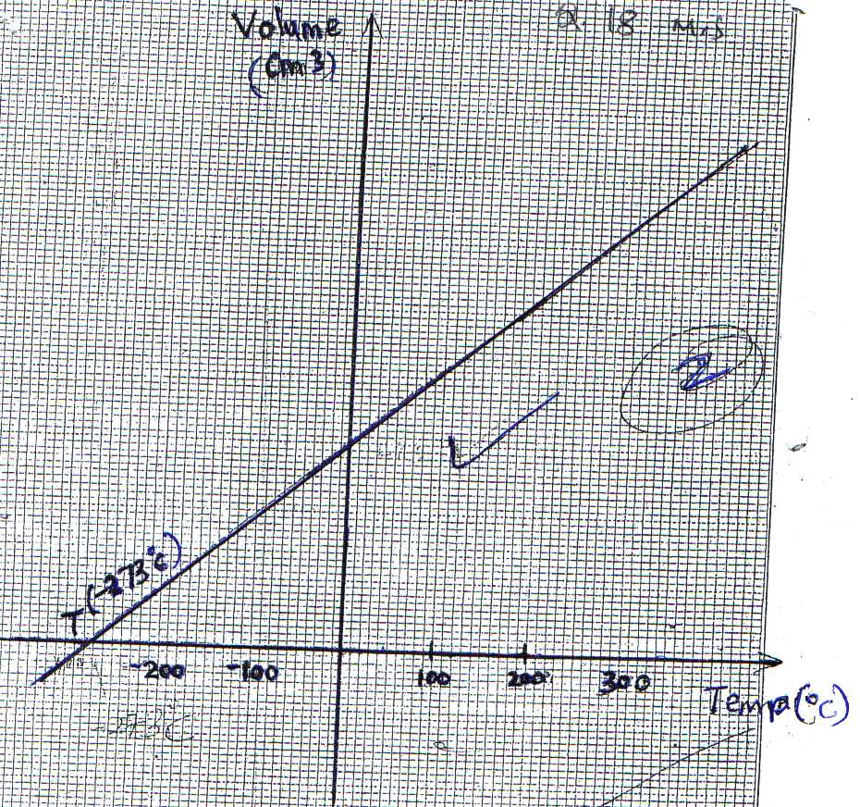
18.C

