MARKING SCHEME p1

SECTION A ( 25 MARKS)
Attempt all the questions in this section in the spaces provided
- Give the reading ,L,on the micrometer screw gauge if it has negative zero error of 0.02mm

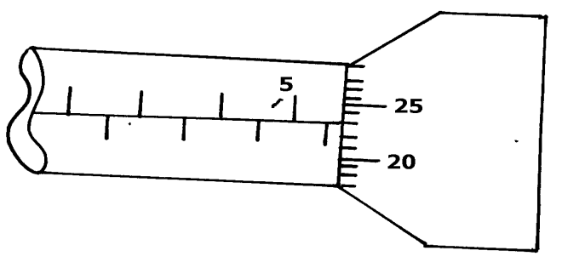

L = 5 . 5
0 . 23
5 . 73;
0 . 02
5 . 75mm; (2mks)
- Differentiate between cohesive and adhesive forces (2 marks)

Cohesive force-˃force of attraction between molecules

Of same kind; but adhesive forces are forces of attraction between
Molecues of different kind;

3. The figure below shows a uniform metre rule in equilibrium under the forces shown.

400g
100cm
40cm
20cm
200g
Frictionless pulley

Determine the weight of the metre rule (3 marks)
Sum of clockwise moments=sum of anticlockwise moments;

(10 x w) + (60 x 2)= 4 x 40 ;
10w + 120=160
10w= 40
w=4N;

4. A fluid flows through a pipe of radius r at a velocity of v. determine the velocity of the fluid if the radius is reduced to r/4. (3 marks)
A₁V₁=A₂V₂ ; V₂=r₂V x 16
IIr²V₁=II(r/ ₄ ) ² V₂
R²V= r ⁴ V₂ ; V₂=16V ;
16 r²

5. State two factors that affect the boiling point of water. (2 marks)
i) Pressure ii) impurities

6. In the figure below, a tennis ball T is resting on an inverted watch glass W.

State with a reason, the state of equilibrium illustrated in the diagram above. (2 marks)
Unstable; A slight displacement causes the tennis ball to fall;

7. Water of density 1200kg/m3 has a mass of 8400g. Determine the volume of the water in SI units giving your answer in standard form. (3marks)

V=m/_{d} =0.007m ³ ;
= 8400 ;
1.2
= 7000cm³ = 7.0 x 10 ⁻³m ³. ;
8. State the mode of heat transfer through which the vacuum in a thermos flask reduces heat loss (1 mark)
Conduction and convection ;(both must be mentioned)
9. Give the first equation of linear motion . (1mark)

V= u + at ;

10. The figure below shows a velocity –time graph of a ball bouncing vertically upward from
the ground. The upward velocity is taken positive.

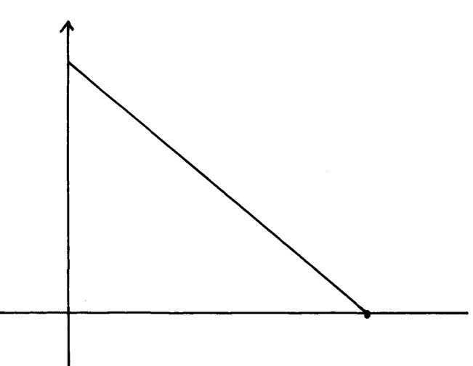
Velocity
(m/s)
1.6
Time(s)

Determine the maximum height the ball rises from the ground. (3 marks)

T=16,V=0;a= 10m/s ² S=16 x 1.6 – ½ x 10 x 1.6 ²
V= u +at = 25.6 - 12.8
0=u-10 x 1.6 12.8m ;
u= 16m/s ;
S=ut- ½ at ²;

11.An elephant weighs 5000kg. Determine the pressure it exerts on the ground if its area of contact with the ground is 0.00025m³. (2 marks)

P= F/A
P=50000 ;
0.00025
P= 2.0 x108pa ;
12. State Hooke’s law. (1 mark)

For a helical spring, extension is directly proportional to extension provided elastic limit is not exceeded ;

SECTION B (55 MARKS)
Attempt all the questions in this section in the spaces provided
13. a) Define matter . (1mark)

Anything that occupy space and has weight/mass;

b) Smoke particles in air when strongly illuminated were observed to describe continuous, random haphazard movements. State and explain what would be observed when the air temperature is decreased. (2marks)

The speed of the particles decreases; this is due to reduced kinetic energy;

c) The figure below shows an arrangement to demonstrate diffusion through solids:-
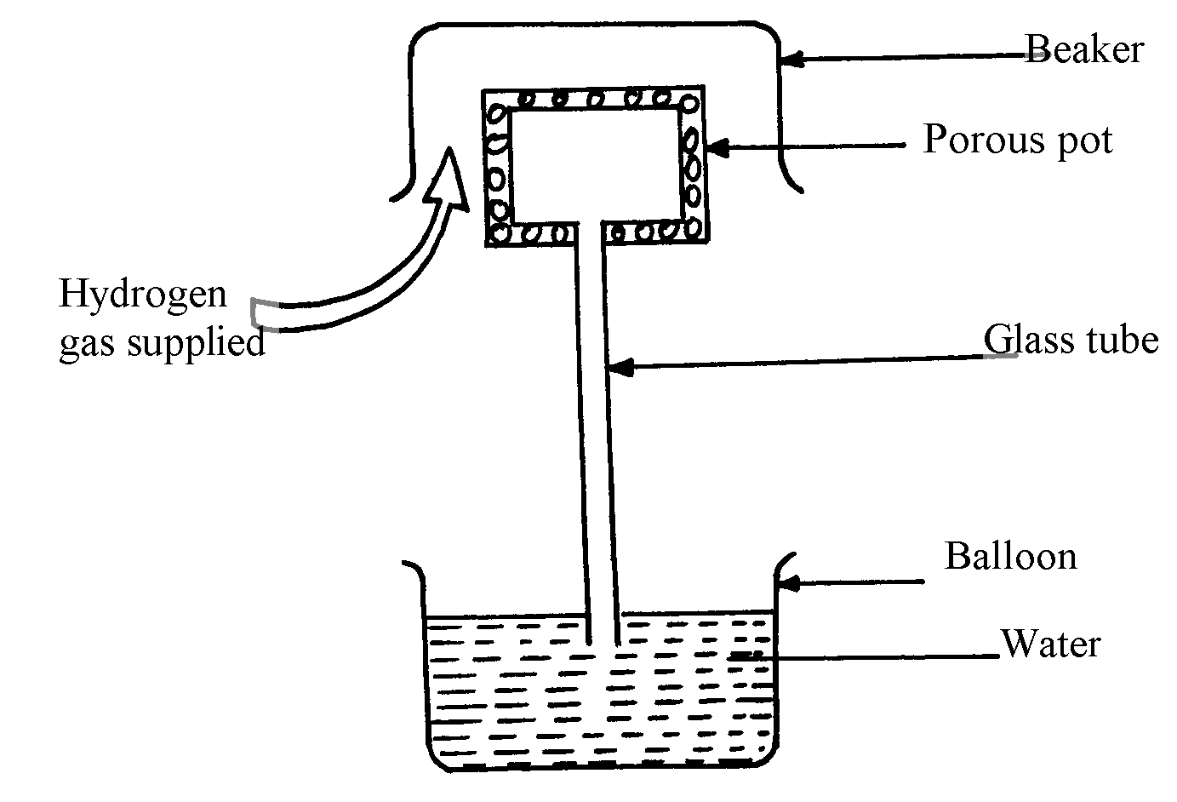

Beaker

The hydrogen gas is supplied for sometimes then stopped. State and explain what is likely
to be observed when the hydrogen gas supply is;
- turned on (2 marks)
Gas bubbles are observed; hydrogen gas diffuses into the porous pot driving air out through glass tube;

- turned off . (2 marks)
Water rises up the glass tube; Partial vacuum is created as hydrogen gas diffuses out faster than the diffusion of the air into the porous pot.;

d) ) An oil drop of average diameter 0.21mm spreads out into a circular patch of diameter 84cm on
the surface of water in a ripple tank.
(i) Determine the thickness of one molecule of oil. 3mks) t=4r ³ ; t= 8.8 x 10⁻¹⁰cm
3R ²
=4/₃ (0.021) ³ t= 8.5 x 10 ⁻¹²m ;
84

= 4(0.0105) ³;
3 x 42 ²

- State one assumptions made in (i) above. (1 mark)
The patch is one molecule thick ;

14.a) State the pressure law. ( 1mark)
Pressure of a fixed mass of a gas is directly proportional to absolute temperature provided volume is kept constant;

- The figure below shows a simple set up for pressure law apparatus.

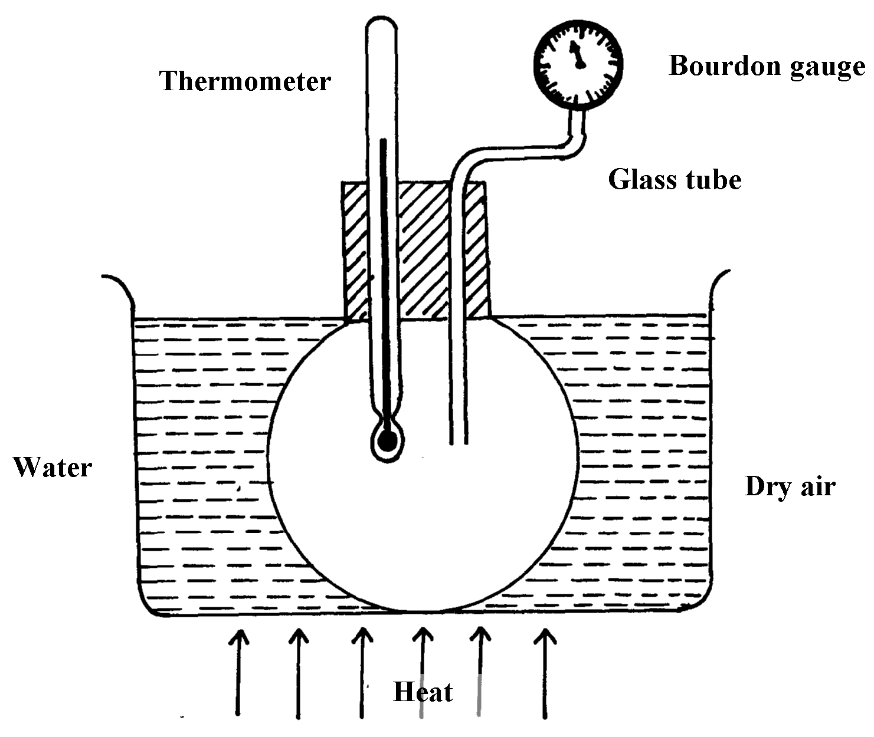

i) Briefly describe how the apparatus may be used to verify pressure law . (4 marks)

-Record temperatures and corresponding pressure readings; as you heat the water bath gently; keeping volume constant.
-Plot a graph of pressure against absolute temperature;
-The graph is a straight line showing that pressure is directly proportional to obsolute temperature.;

ii) The graph in the figure below shows the relationship between the pressure and temperature
for a fixed mass of an ideal gas at constant volume

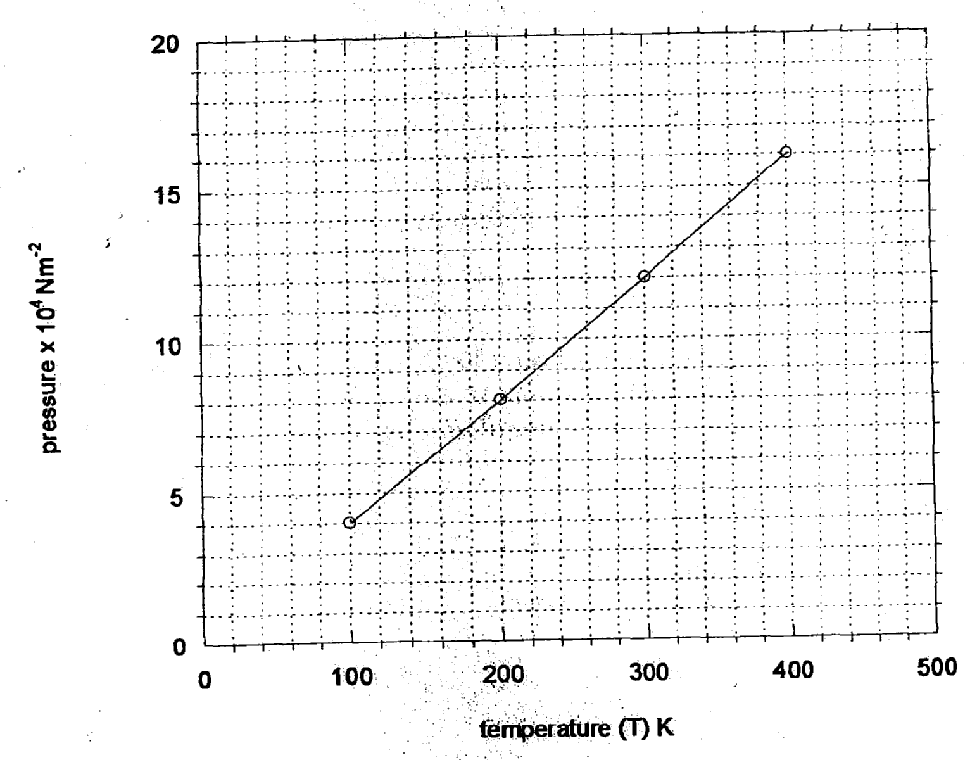

Given that the relationship between pressure, P and temperature, T in Kelvin is of the form
P = MT + N determine :
- The value of M. (2 marks)
= (12 – 4) x 10 ⁴ ;
300 - 100

= 0.04 x 10 ¹⁶ = 400 ;

II) The value of N. (1 mark)

OK ;
c) A gas is put into a container of fixed volume at a pressure of 1.75 x 10⁵ Nm⁻² and temperature 22°C. The gas is then heated to a temperature of 487°C. Determine the
new pressure (3marks)

P₁ = P₂ ; P₂=1.75 x 10 5 x 760
T₁ T₂ 295

1.75 X 10 ⁵ = P₂ ;
295 760 = 4.508 X 105 N/m²;

15. a) A small rectangular block of mass 120g measures 2cm by 3cm by 4cm.
- Calculate the least pressure it exerts on a bench. (3marks)

P = F ; P= 1000 Pa ;
max A
= 1.2
0.0012 ;

- A body of mass M is placed on top of the block. If the pressure on the smallest base is increased to 3kPa, find the value of M. (3mks)
P=F/A Weight M= (1.8 – 1.2)N
3000=F/0.0006 ; = 0.6N
= 60g;
F= 1.8N ;
- The barometric height at the base of a mountain is 75cmHg. If the barometer reads 60cmHg at the top of the mountain, what is the height of the mountain if density of air and mercury is 1.25Kg/m³ and 13600kg/m³ respectively? (3mks)

h ₁e ₁ g ₁ = h₂ e₂ g₂ ;
15 x 13600= h x 1.25 ;

h= 1632m.;
16. a) State the principle of transmission of pressure. (1mark)
Pressure exerted in an enclosed liquid is transmitted equally to all parts of the
Enclosed liquid;

b) The figure below demonstrates the principle of hydraulic jack.
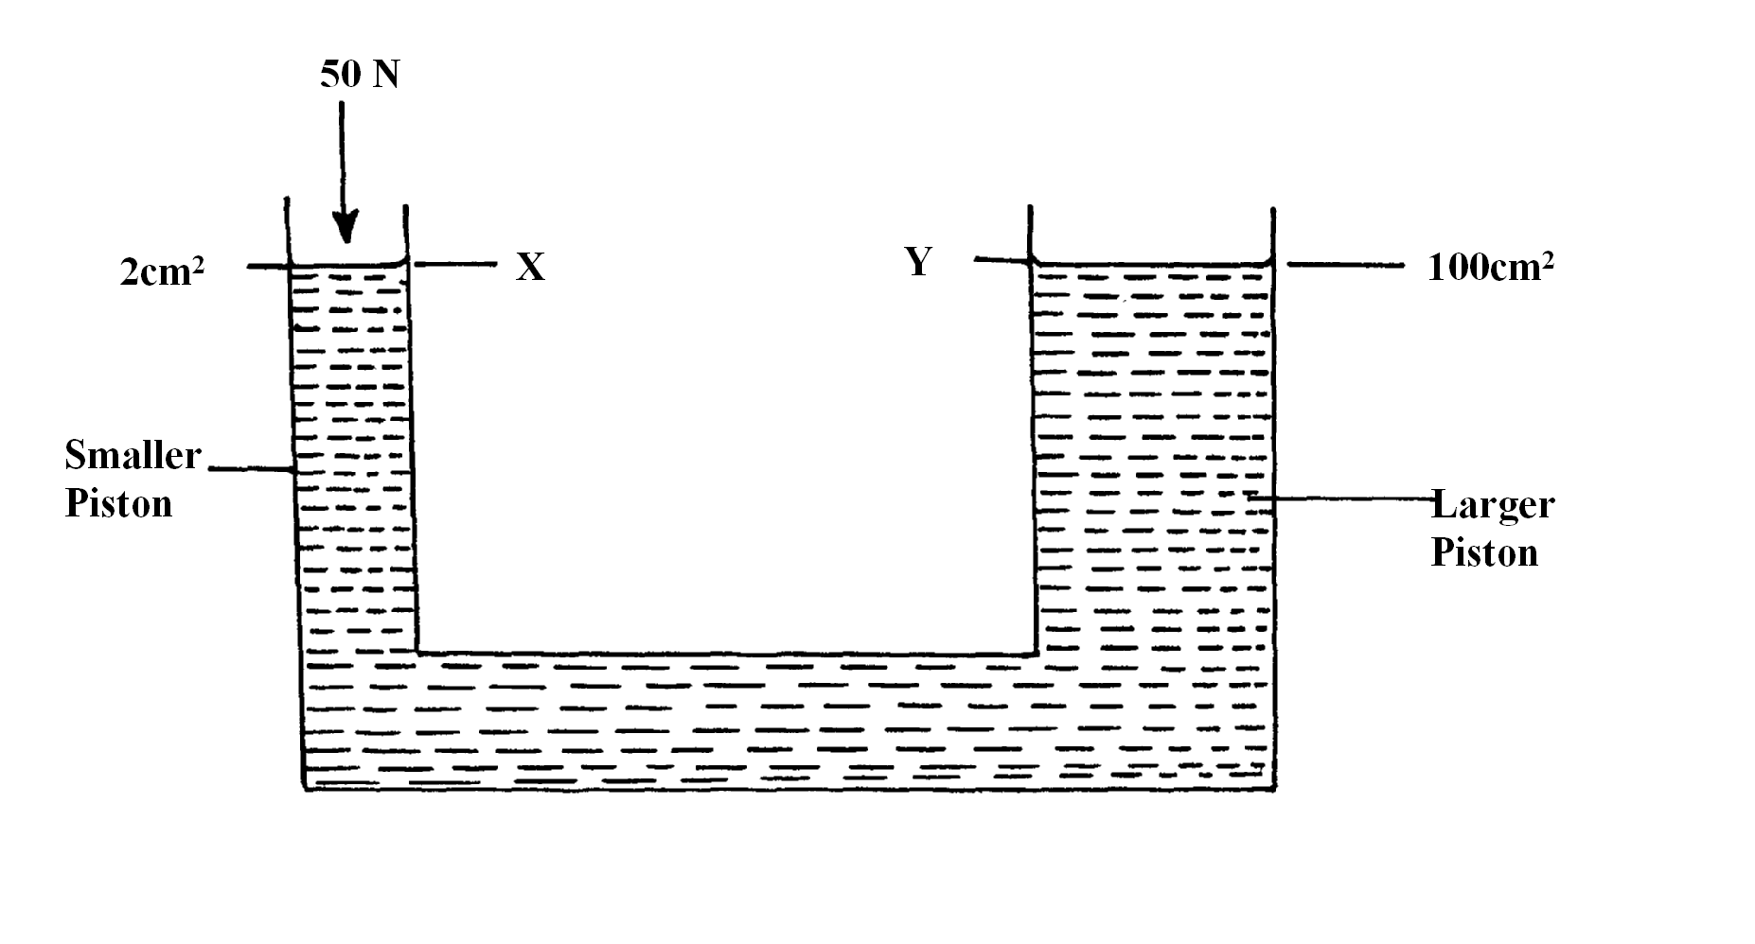
i)A force of 50N is applied on the smaller piston X. Calculate the pressure at Y. (3marks)
Pressure At X = Pressure at Y ;
F₁/A₁ = F₂
A₂
50M = F₂ ; F₂ = 2500N;
2 x 10-4m² 1.0 x 10 ⁻²
ii) Show that the velocity ratio is given by V.R = (² ( 2marks)
V.R= effort distance (d_{e} )
load Distance (d_{l})
volume displaced by effort = volume displaced on load
II r ²d_{e} = IIR²d_{l} ;
d_{e} = R ² ; Where R is radii of load piston
d_{l} r ² r is radii of effort piston

iii) Hence calculate the velocity ratio of the hydraulic jack. ( 2marks)

VR= 100cm ²;
2cm² = 50 ;

D (i) Define the term machine. (1 mark)
Is a device that enables work to be done more easily or conveniently It make work easier.;
The figure below shows a set-up used to find the mechanical advantage of a pulley system.
Use the figure to answer questions (i) and (ii) below.
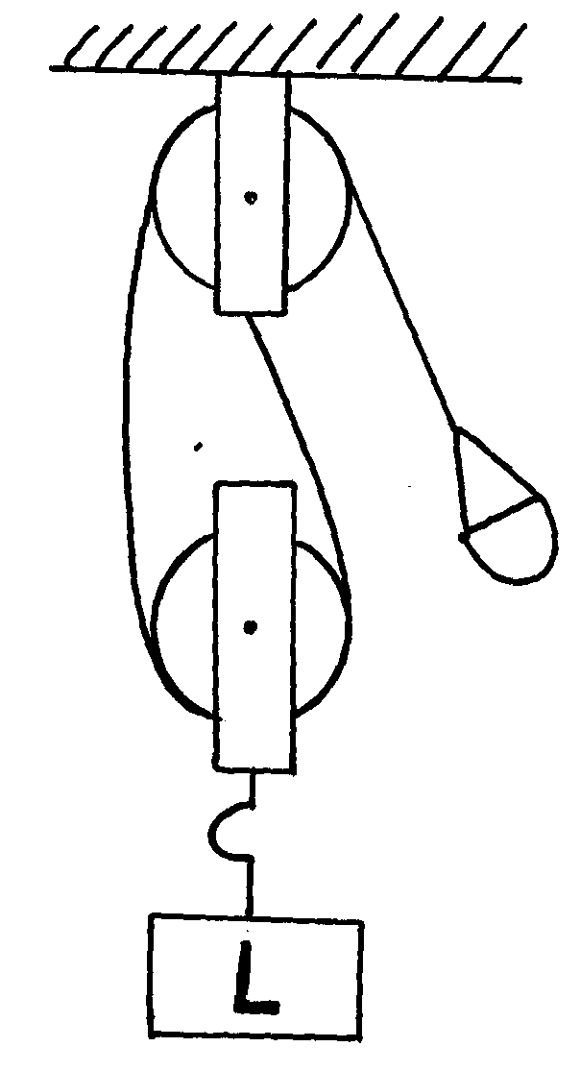

E

ii) Determine the VR of the pulley system. (1 mark)

VR= 2 ;
iii) On the axes provided sketch a graph of mechanical advantage (M.A) against load (L). (2 marks)

Mechanical Advantage
Load (N)
0
1
2
3

17. (a)Explain why water is a good coolant liquid in a car’s engine cooling system. (2marks)

It have high specific heat capacity; hence it absorbs a lot of heat;

(b) Water of mass 5kg initially at 18⁰C is heated in an electric kettle rated 2.5kw. The water is heated until it boils at 98⁰C. Taking specific heat capacity of water to be 4200Jkg⁻¹ K⁻¹, heat capacity of kettle = 438J/kg, specific latent heat of vaporization of water = 2.28MJ/kg
calculate;
(i)The heat absorbed by the water. (3marks)
Qw = MwCw T ;
= 5 x 4200 x (98 - 18;
= 1680000 Joule ;
(ii)Heat absorbed by the electric kettle. (2marks)
Qw = Vit ;
= 2.5 x 1000 x t
= 2500t ;
(iii) The time taken for the water to boil. (3marks)
Heat supplied= Heat gained ;
2500t = 1680000 ;
t = 672 seconds ;
(iv) How much longer it will take to boil away all the water into vapour. (2marks)
2500t = 5 x 2.28 x 10 ⁶;
T= 4560 second more ;

