Name………………………………………………….. Adm no…………………Class……… ….

 Candidates Signature …………………………….

Date……………………………..

232/2

**PHYSICS PAPER 2**

*(****THEORY)***

March April 2017

2 Hours

**Kenya Certificate of Secondary Education 2017**

**Form four evaluation examination**

232/2

**PHYSICS PAPER 2**

*(****THEORY)***

March April 2017

2 Hours

***INSTRUCTIONS TO CANDIDATES***

1. *Write your name and index number in the space provided at the top of this page.*
2. *This paper has two sections* ***A*** *and section* ***B****.*
3. *Answer* ***all*** *the questions in the* ***two*** *sections.*
4. *Working of numerical questions must be clearly shown.*
5. *Marks may be awarded for correct working even if the answer is wrong*
6. *Mathematical tables and/ or non programmable calculators may be used.*

**FOR OFFICIAL USE ONLY**

|  |  |  |  |
| --- | --- | --- | --- |
| **SECTION** | **QUESTION** | **MAX SCORE** | **STUDENT’S SCORE** |
| **A** | 1 – 14 | 25 |  |
| **B** | 15 | 11 |  |
| 16 | 12 |  |
| 17 | 10 |  |
| 18 | 09 |  |
| 19 | 13 |  |
| **GRAND TOTAL** | | **80** |  |

*This paper consists of 12 printed pages****.***



**SECTIONtiotion A (25 MARKS)**

***Answer all the questions in the spaces provided***

1. Differentiate between a vector and a scalar quantity (1mark)

………………………………………………………………………………………………………

……………………………………………………………………………………………………...

2. The figure below shows a circuit consisting of a battery of 2 of cells ,a 1.5Afuse F, a switch S and two identical lamps L1 and L2. A current of 1.5A flows through lamp L2 when the switch is open.

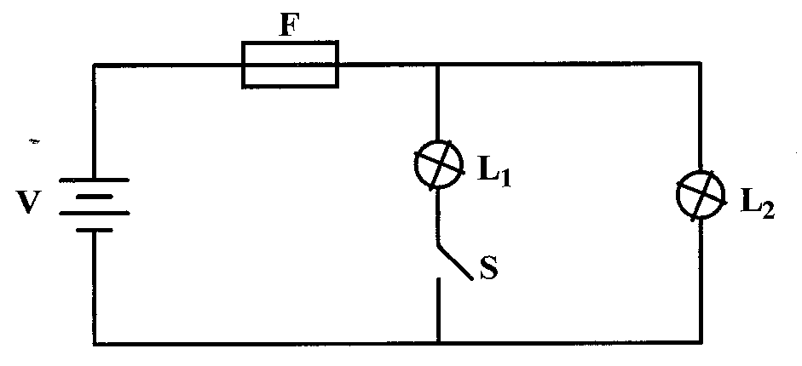

Explain why the fuse may blow when the switch,L1 is closed..

………………………………………………………………………………………………………

……………………………………………………………………………………………………...

…………………………………………………………………………………………………….

3. When a highly negatively charged rod is brought near the cap of a positively charged leaf electroscope, the leaf first falls and then rises .. Explain this observation. (2marks)

………………………………………………………………………………………………………

……………………………………………………………………………………………………...

…………………………………………………………………………………………………….

4. The figure below shows two plane mirrors inclined at an angle of 400 to one another. A ray of

light strikes the bottom mirror at an angle of 500 to the horizontal as shown on the diagram.

**400**

**500**

On the same figure, sketch the path followed by the ray. (2 marks)

1. A charge of 90 coulombs flows through a circuit for one minute. Determine the amount of current

that flows through the circuit. (3marks)

.............................................................................................................................................................

.............................................................................................................................................................

.............................................................................................................................................................

..........................................................................................................................................................

1. State two methods of charging an electroscope. (2marks)

............................................................................................................................................

..............................................................................................................................................

...............................................................................................................................................

....................................................................................................................................

1. The figure below shows two bar magnets placed close to each other.

**N**

**S**

**N**

**S**

Sketch the magnetic field pattern around the two magnets. (2 marks)

1. An electric heater is rated 5000W, 250V. Determine its resistance. (3marks)

.............................................................................................................................................................

.............................................................................................................................................................

……………………………………………………………………………………………………….

1. The figure below shows the magnetic field pattern round a current-carrying conductor. Indicate

on the conductor the direction of the current. (1mark)

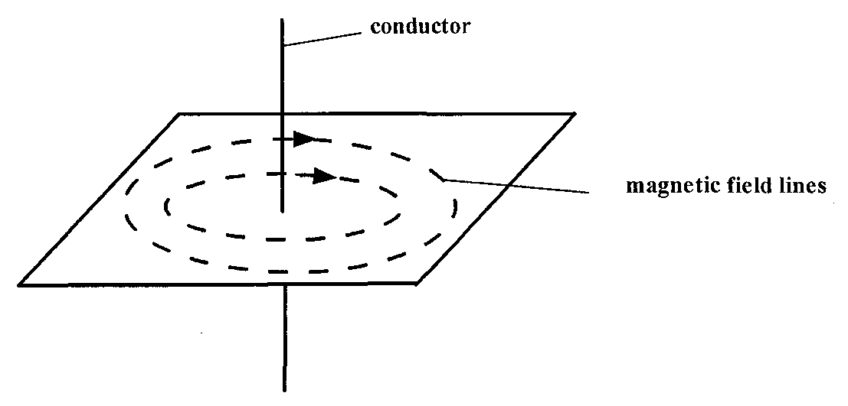

1. Explain how polarization of a cell increases the cell’s internal resistance. (2mks)

.............................................................................................................................................................

.............................................................................................................................................................

1. **Figure 5** shows a ray of light incident on an air bubble which is inside water,

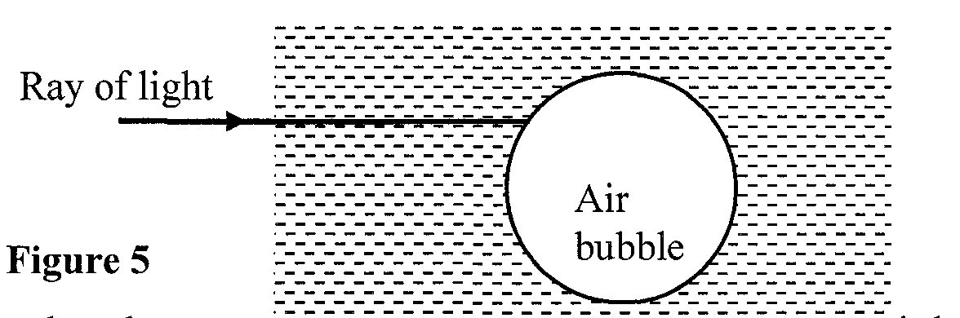

Complete the ray to show the path it follows through the air bubble. (1mk)

1. A battery is rated 40Ah. Determine the time in hours it would work steadily supplying a current of 2A. (2marks)

.............................................................................................................................................................

.............................................................................................................................................................

………………………………………………………………………………………………………

1. The figurebelow is that of a dry cell. Name parts labeled **A** and **B**

B

A

A……………………………………………........... (1mark)

B……………………………………………………. (1mark)

**SECTIION B (55MARKS)**

***Answer all the questions in the spaces provided***

1. a) Define frequency . (1mark)

.............................................................................................................................................................

.............................................................................................................................................................

………………………………………………………………………………………………………

b) The figure below represents a displacement time graph wave.

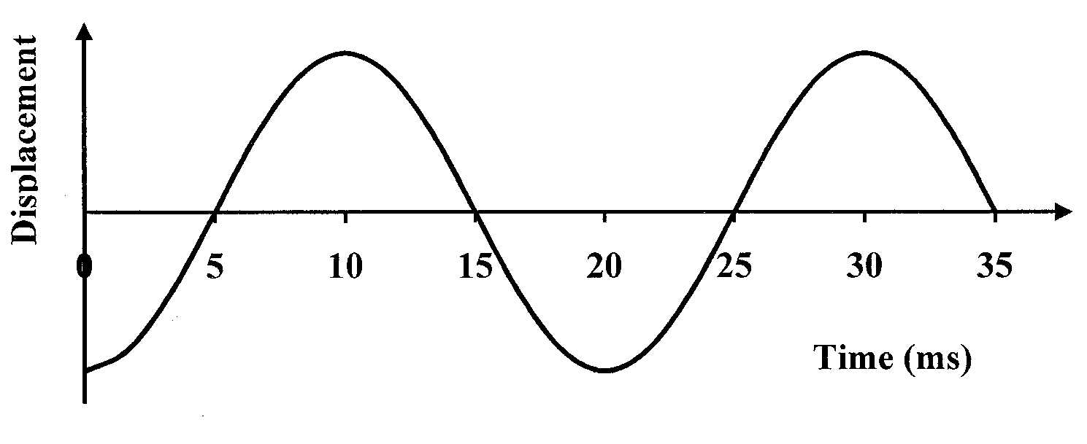

1. On the graph draw a line marking the amplitude of the wave . (1mark)
2. Determine the period of the wave. ( 1mark)

.............................................................................................................................................................

.............................................................................................................................................................

………………………………………………………………………………………………………

1. Calculate the frequency of the wave. (3marks)

.............................................................................................................................................................

.............................................................................................................................................................

……………………………………………………………………………………………………..

1. Given that the wavelength of the wave is 0.2m, find the speed of the wave. (3marks)

.............................................................................................................................................................

.............................................................................................................................................................

………………………………………………………………………………………………………

c) On the same axes in (b) above, sketch another wave with double the frequency and half the

amplitude. (2marks)

1. a) State Ohm's law. (1 mark)

……………………………………………………………………………………………………..

……………………………………………………………………………………………………...

b) Differentiate between Pd and EMF . (2marks)

……………………………………………………………………………………………………..

……………………………………………………………………………………………………...

The figure shows a graph drawn from data obtained in an experiment to verify Ohm's law.

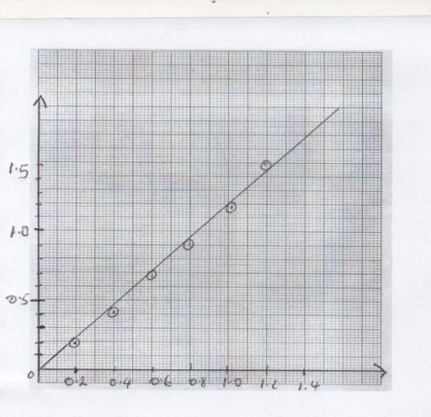

Voltage(v)

Current(A)

c) Draw an electric circuit diagram that can be used to verify Ohm's law . (1mark)

d) Use the graph to determine the resistance of the conductor used in the circuit . (3 marks)

……………………………………………………………………………………………………..

……………………………………………………………………………………………………..

………………………………………………………………………………………………………

e) The figure belowshows resistors connected in a circuit diagram.

 



 

 

10V

* + 1. Calculate the effective resistance in the circuit . (2 marks)

…………………………………………………………………………………………..

……………………………………………………………………………………………

* + 1. Determine the current through the 6Ω resistor. ( 3marks)

………………………………………………………………………………………………..

…………………………………………………………………………………………………

………………………………………………………………………………………………..

1. a) Define capacitance of a capacitor (1mk)

……………………………………………………………………………………………………

…………………………………………………………………………………………………

b)In fig below, a sharp pin is fixed on a cap of a leaf of the electroscope. The electroscope is

highly charged and then left for sometime.

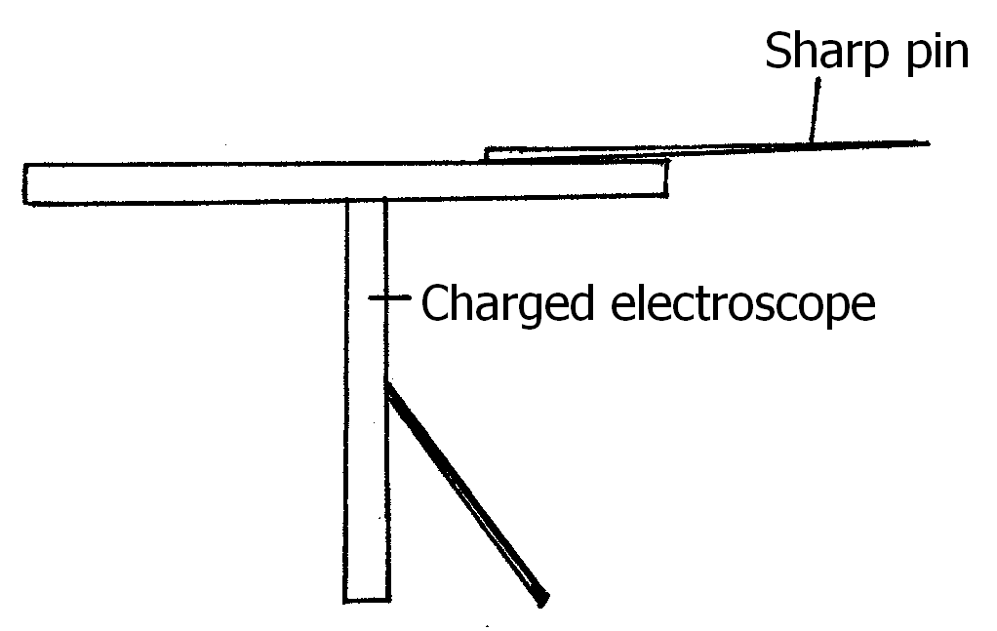

State and explain the observation made after sometime. (3marks)

……………………………………………………………………………………………………

……………………………………………………………………………………………………

……………………………………………………………………………………………………

c)Figure below shows a circuit where a battery of e.m.f. 4.5 V, switches A and B, two

capacitors C1 = 0.6F and C2 = 1.0 F and a voltmeter are connected.

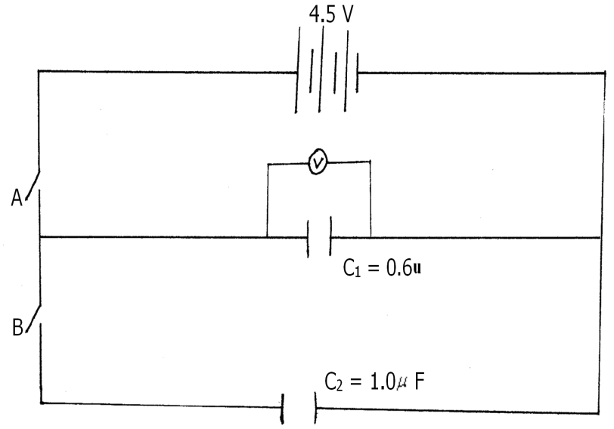

i) Determine the charge on C1 when switch A is closed and switch B is open.(2marks) …………………………………………………………………………………………………..

……………………………………………………………………………………………………

……………………………………………………………………………………………………

ii) State and explain what is observed on the voltmeter when switch A is closed and switch B is

open. (2marks)

…………………………………………………………………………………………………..

……………………………………………………………………………………………………

……………………………………………………………………………………………………

d) The Figure bellow shows a pair of parallel plates of capacitors connected to a battery. The upper plate

is displaced slightly to the left.

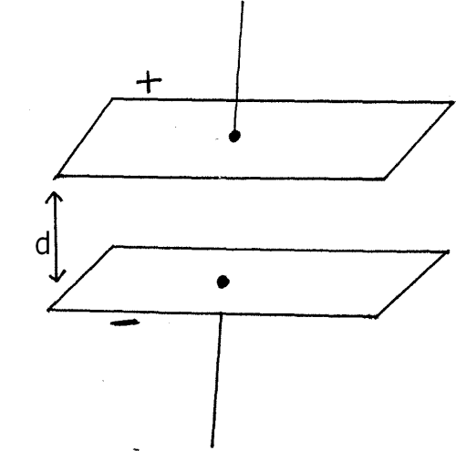

Suggest two adjustments that can be made to so as to reduce the effective capacitance.(2marks)

…………………………………………………………………………………………………..

……………………………………………………………………………………………………

……………………………………………………………………………………………………

1. (a) State two differences between light and sound waves (2mark)

…………………………………………………………………………………………………..

……………………………………………………………………………………………………

……………………………………………………………………………………………………..

(b) A boy standing in front of a cliff blows a whistle and hears the echo after 0.5s. He then moves

17 meters away from the cliff and blows the whistle again. He now hears the echo after 0.6s.

Determine the speed of the sound in air. (3 marks)

…………………………………………………………………………………………..

…………………………………………………………………………………………….

……………………………………………………………………………………………

…………………………………………………………………………………………….

…………………………………………………………………………………………….

( c) Thunder is heard long after lightning has been seen. Explain. (2marks)

…………………………………………………………………………………………..

…………………………………………………………………………………………….

……………………………………………………………………………………………

…………………………………………………………………………………………….

……………………………………………………………………………………………..

(d) Briefly describe an experiment you would set up to illustrate that light travels in a straight

line. ( 2marks)

…………………………………………………………………………………………..

…………………………………………………………………………………………….

……………………………………………………………………………………………

…………………………………………………………………………………………….

…………………………………………………………………………………………….

…………………………………………………………………………………………….

1. a) State Snell’s law (1mark

………………………………………………………………………………………………………………………………………………………………………………………………………………

………………………………………………………………………………………………………

(b)A coin is placed beneath a transparent block of thickness 10cm and refractive index

1.56 .Calculate the vertical displacement of the coin. (3marks)

……………………………………………………………………………………………………………………………………………………………………………………………………………………………….

……………………………………………………………………………………………………………….

……………………………………………………………………………………………………………….

……………………………………………………………………………………………………………….

……………………………………………………………………………………………………………….

(c)The speed of green light in a prism is 1.94×108m/s

(i)Determine the refractive index of the Prism material (speed of light in air = 3 x 108 m/s). (3marks) ……………………………………………………………………………………………………………………………………………………………………………………………………………………………….

……………………………………………………………………………………………………………….

……………………………………………………………………………………………………………….

……………………………………………………………………………………………………………….

……………………………………………………………………………………………………………….

(ii) Determine the critical angle of the prism material (3marks)

……………………………………………………………………………………………………………………………………………………………………………………………………………………………….

……………………………………………………………………………………………………………….

………………………………………………………………………………………………………………

……………………………………………………………………………………………………………….

………………………………………………………………………………………………………………

(e) The refractive indices of glass and water are 3/2 and 4/3 respectively. Find the value of angle Ф in

the figure below. (3marks)

**water**

420

Ф

glass

…………………………………………………………………………………………………

…………………………………………………………………………………………………

…………………………………………………………………………………………………

…………………………………………………………………………………………………