***Name****……………………………………………………….****Adm No****:. ………….****Class****………..*

**

***Student’s Signature****: ……………………..*

***Date****……………………….*

**PHYSICS PRACTICAL**

***PAPER 3***

March april 2017

2 ½ Hours

**Kenya Certificate of Secondary Education 2017**

**Form four evaluation examination**

**PHYSICS PRACTICAL**

***PAPER 3***

March april 2017

2 ½ Hours

***Instructions to Candidates***

*(a) Write your name and Adm number in the spaces provided above.*

*(b) Sign and write the date of examination in the spaces provided above.*

*(c) Answer* ***ALL*** *the questions in the spaces provided in the question paper.*

*(d) You are supposed to spend the first* ***15 minutes*** *of the 2 ½ hours allowed for this paper reading the whole paper carefully before commencing your work.*

*(e) Marks are given for a clear record of the observations actually made, their suitability, accuracy and the use made of them.*

*(f) Candidates are advised to record their observations as soon as they are made.*

*(g) Non-programmable silent electronic calculators may be used.*

*(h)* ***This paper consists of 8 printed pages.***

*(i)* ***Candidates should check the question paper to ascertain that all the pages***

***are printed as indicated and that no questions are missing.***

*(j)*  ***Candidates should answer the questions in English.***

**For Examiner's Use Only**

|  |  |  |  |  |
| --- | --- | --- | --- | --- |
| ***QUESTION*** 1 | b | c | d | e |
| **Maximum score** | 9 | 5 | 3 | 3 |
| **Candidate’s score** |  |  |  |  |

|  |
| --- |
|  |

**Total**

**Total**

|  |
| --- |
|  |

|  |  |  |  |  |  |  |  |
| --- | --- | --- | --- | --- | --- | --- | --- |
| ***QUESTION 2*** | a | c | d | g | h | i | j |
| **Maximum score** | 5 | 1/2 | 1/2 | 5 | 4 | 3 | 2 |
| **Candidate’s score** |  |  |  |  |  |  | **GRAND TOTAL** |

|  |
| --- |
|  |

**QUESTION 1.**

*You are provided with the following;*

* *A pendulum bob*
* *Two pieces of wood*
* *A retort stand*
* *A boss*
* *A clamp*
* *A ctop watch*
* *A metre rule/or half metre rule*
* *A piece of thread*

**Proceed as follows;**

a) Suspend a pendulum bob on a retort stand as shown below.

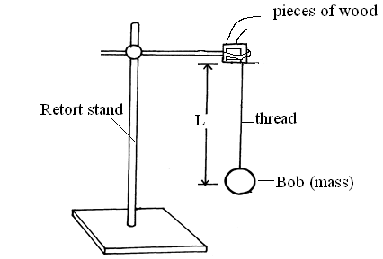

b) Displace the bob for a small angle. As it is oscillating time ten oscillations for every length of the string shown in the table below

|  |  |  |  |  |  |  |
| --- | --- | --- | --- | --- | --- | --- |
| ***Length, l(m)*** | 0.4 | 0.6 | 0.8 | 1.0 | 1.2 | 1.4 |
| **Time ,t, for 10 oscillations(s)** |  |  |  |  |  |  |
| **Periodic time, T(s)** |  |  |  |  |  |  |
| **F=(Hz)** |  |  |  |  |  |  |
| **F2(Hz2)** |  |  |  |  |  |  |
| **(m-1)** |  |  |  |  |  |  |

C) Plot a graph of F2 against 1/L. (5 marks)

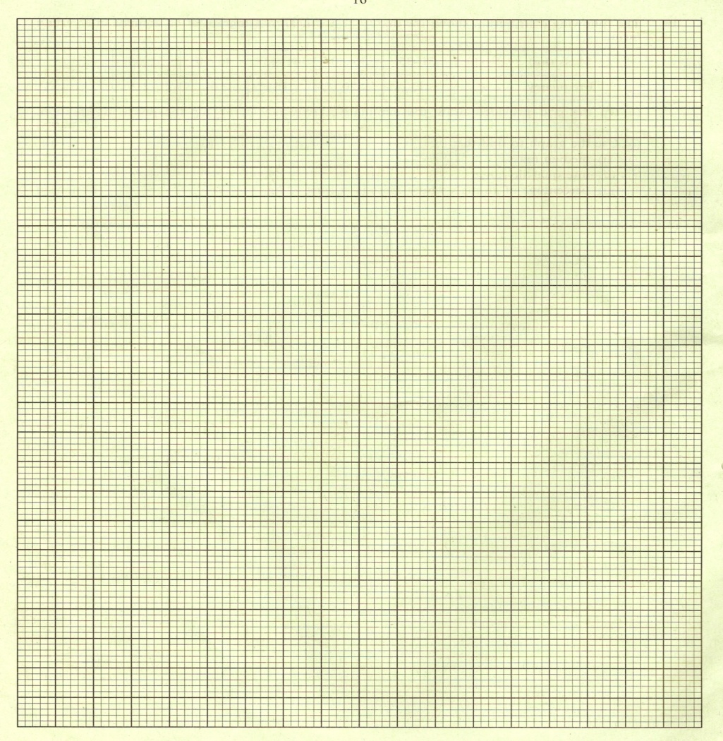

d) Determine the slope ,**S**, of the graph. (3 marks)

………………………………………………………………………………………………………………………………………………...

……………………………………………………………………………………………………………………………………………….

e) Given that the relationship between **F** and **L** is given by *,* ***F2 =***  ,use the graph to determine the value of **g** giving its units . ( 3marks)

………………………………………………………………………………………………………………...

……………………………………………………………………………………………………………….

……………………………………………………………………………………………………...............

**QUESTION 2**

*PART A*

**You are provided with the following apparatus:**

* *A voltmeter (0 – 3 V)*
* *An ammeter (0 – 1A)*
* *A 10Ω carbon resistor*
* *A switch.*
* *One dry cell and a cell holder*
* *Six connecting wires ( 4 with crocodile clips)*

(a) (i) Connect the above apparatus as shown in the circuit diagram **below** with

the switch open.

A

10Ω

V

1. With the switch open record E. the voltmeter reading.

E = ……………………………………………….(1 mark)

1. Close the switch and record V, the voltmeter reading and I, the ammeter

reading.

V = ……………………………………………….(1 mark)

I = …………………………………………………(1 mark)

1. Given that E = Ir + V , determine r. (1mark)

…………………………………………………………………………………………………………………………….

……………………………………………………………………………………………………………………………..

**PART B**

b) ***You are provided with the following:***

* *A complete retort stand*
* *An optical pin*
* *A concave mirror and a mirror holder*
* *A cork*
* *A candle*
* *A white screen*
* *A metre rule*

You are required to estimate the focal length of the concave mirror. Arrange the apparatus as shown in the figure below:

Eye

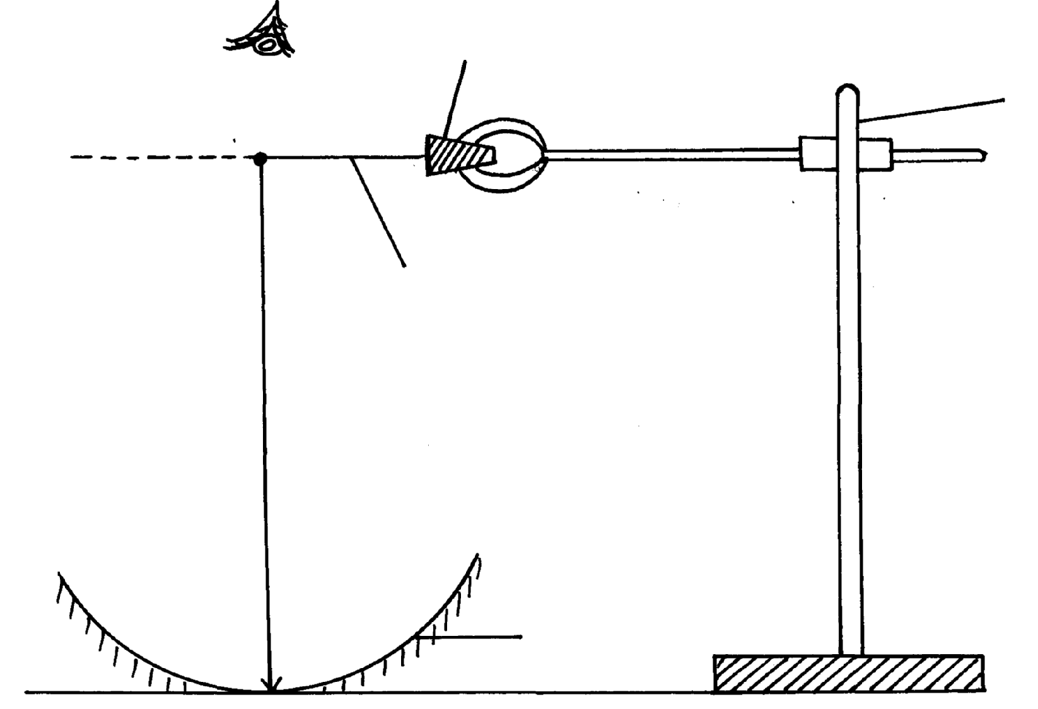

Stand

Cork

Image

Object pin

h

Mirror

1. By adjusting the clamp on the stand, move the object pin up and down until the inverted image and the pin itself appear to coincide (use – no- parallax method). Measure the distance, h .

h = ………………………………… cm ( 1mark)

1. Calculate the value ***f*** given that ; f= $\frac{h}{2}$

***f=*** ……………………………………………………………cm *(1*mark*)*

1. Arrange the apparatus as shown in figure 2 below

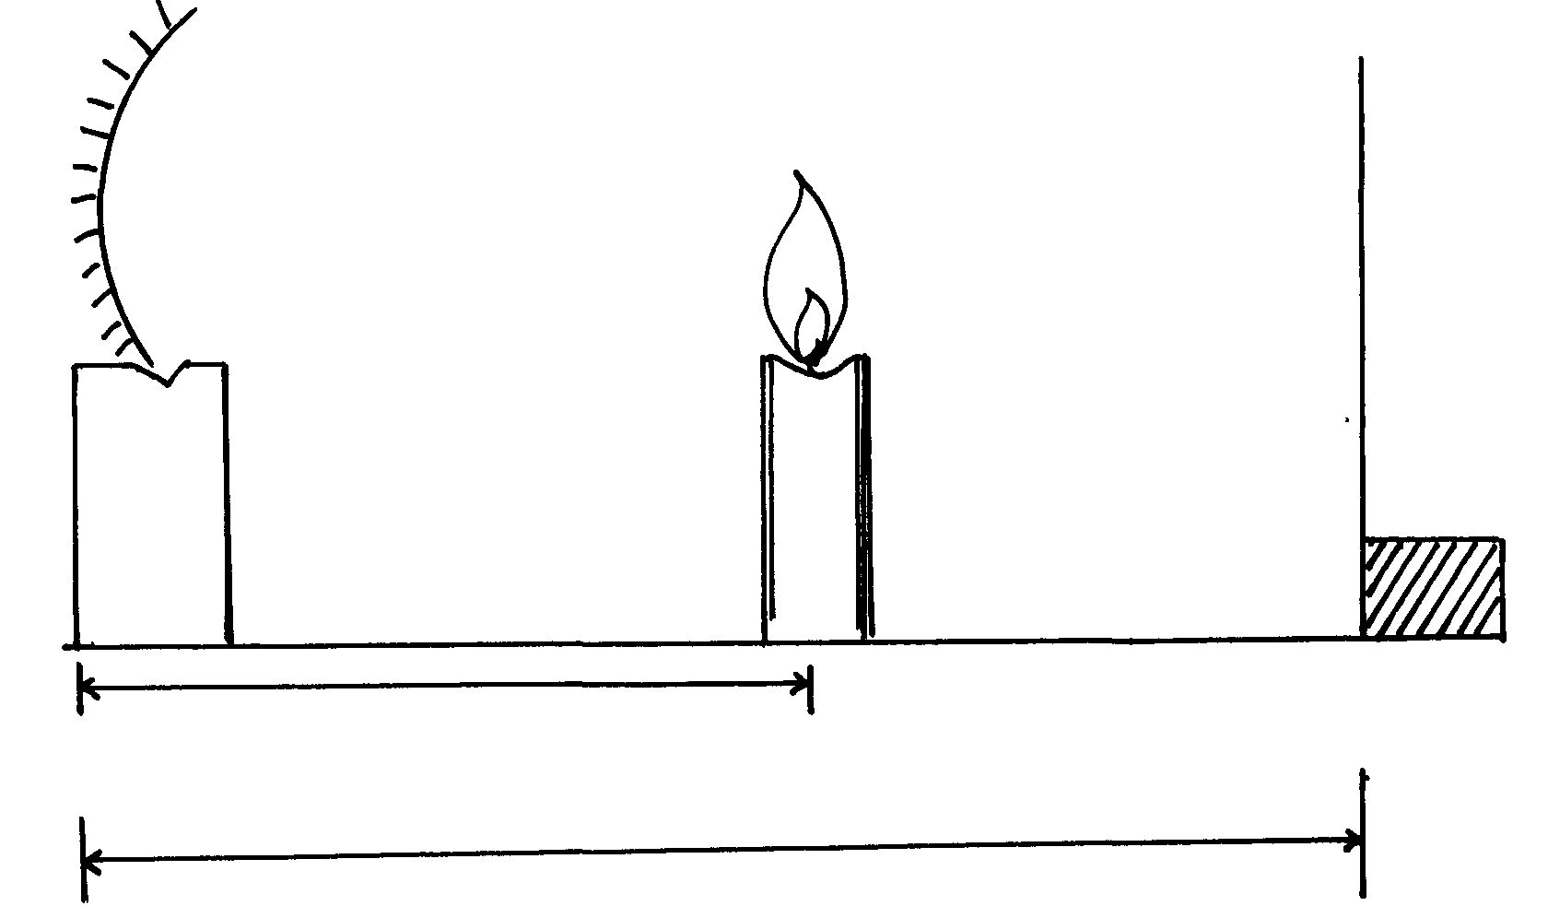 Figure 2

Screen

Candle

mirror

u

V

1. Place the candle at a distance u = 28cm from the mirror. Move the screen along the ruler

until a sharp image is focused on the screen. Measure and record the image distance V .

1. Repeat the procedure for values of u = 30cm, 32cm, 34cm and 36cm. Record your values

in the table below hence complete the column for values of M. ( 5marks)

|  |  |  |
| --- | --- | --- |
| **Object distance u (cm)** | **Image distance V (cm)** | **Magnification M= v/u** |
| 28.0 |  |  |
| 30.0 |  |  |
| 32.0 |  |  |
| 34.0 |  |  |
| 36.0 |  |  |

1. Plot a graph of magnification, M against image distance, v. (4 marks)



1. Determine , S ,the slope of the graph. (3marks)

…………………………………………………………………………………………………………………………………………………………….

…………………………………………………………………………………………………………………………………………………………….

……………………………………………………………………………………………………………………………………………………………..

1. Given that  **M = $\frac{v}{f }$**  - 1 , Determine, ***f,*** the focal length of the mirror. (2 marks)

………………………………………………………………………………………………………………………………………………………….

…………………………………………………………………………………………………………………………………………………………

…………………………………………………………………………………………………………………………………………………………

***THIS IS THE LAST PRINTED PAGE***