3KNT ALLIANCE
END TERM I EXAM 2017
FORM FOUR CHEMISTRY
PAPER 1 (THEORY)
233/1
TIME : 2 HOURS
NAME…………………………………INDEX NO…………………….
Instructions to candidate
Answer all the question in the spaces provided
Mathematical tables and non programmable electronic calculator may be used
All working must be shown where necessary

FOR EXAMINERS USE ONLY
MAXIMUM SCORE | 80 MARKS
STUDENTS’ SCORE

1a. starting from solid magnesium oxide, describe a solid sample of magnesium hydroxide can be prepared (2mks)

b.Give one use of magnesium hydroxide (1mk)

2. The electron affinity for 3 elements A,B and C are as shown in the table below
Element | A | B | C
Electron affinity (KJ/mole) | -324 | -349 | -295
- What is meant by electron affinity (1mk)

- Which element is the strongest oxidizing agent?
Give a reason (2mks)

3. The structure below represents a polymer. Study it and answer the questions that follow
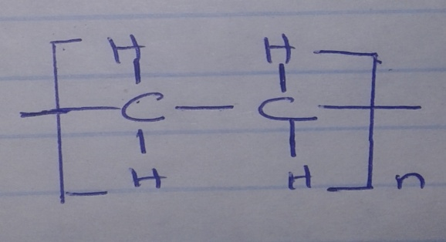

- Name the polymer above (1mk)

- Determine the value of n in the giant molecule had relative molecular mass of 4956
C=12, H=1.0 (2mks)

4. Student in form four placed a thermometer in molten naphthalene at 850C and record the temperature and time until the naphthalene solidified. From the values obtained the figure below was drawn.

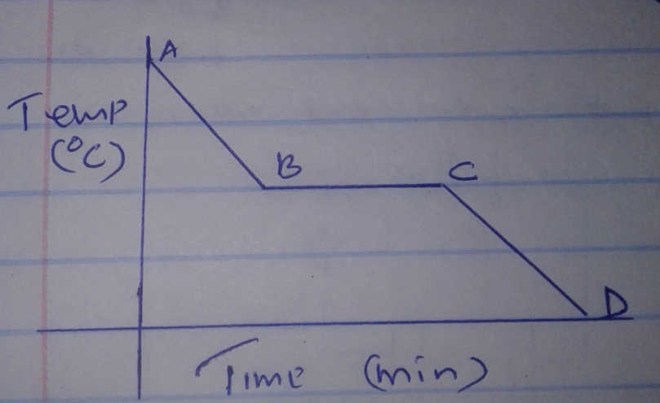

- What name is given to such a figure (1mk)

- Which part of the figure represent the change of state of naphthalene (1mk)

- In terms of kinetic theory explain what happens to molecules along AB (1mk)

5. A label on a bottle containing Ammonia solution has the following information
- Density 0.880gcm3
- Percentage purity 35%
- Relative formula mass 17
Calculate the concentration of Ammonia solution in moles per litre (3mks)

6. The diagram below shows an experiment for investigating electrical conductivity of lead (II) iodide. Study it and answer the questions that follows.
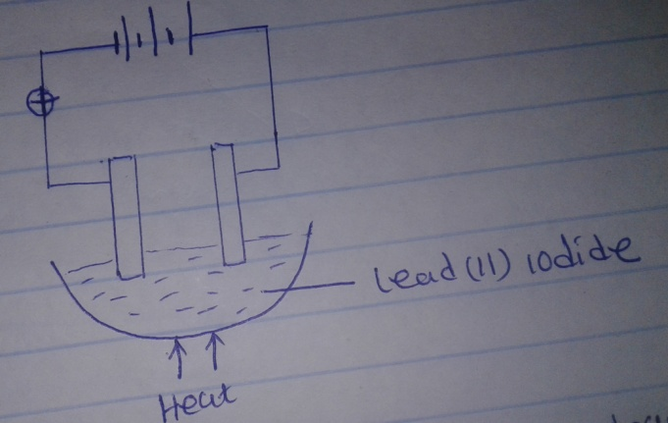
- In the diagram
- Label the cathode (1mk)

- Show the direction of movement of electrons (1mk)

- Write the equation for the reaction that takes place at the anode(1mk)

7a. State Bole’s law (1mk)

- The volume of a gas at 30⁰C and 780mmHg is 400cm³.what will be its volume at 50⁰C at 600mmHg (2mks)

8a.What is meant by molar heat of formation (1mk)

b.Calculate the molar enthalpy of formation of ethyne (C₂H₂) given the following (2mks)
C₂H_{2(g)} + ⁵/₂O_{2(g)}_____________2CO_{2(g)} + H₂O(l) ∆H=-1300KJ/Mol

C(s) + O2(g) _______________CO_{2(g)} ∆H=-394KJ/Mol

H_{2(g)} + ¹/₂O_{2(g)} _____________H₂O_{(l)} ∆H=-286 KJ/Mol

9.The apparatus shown below were set up to prepare and collect hydrogen sulphide gas
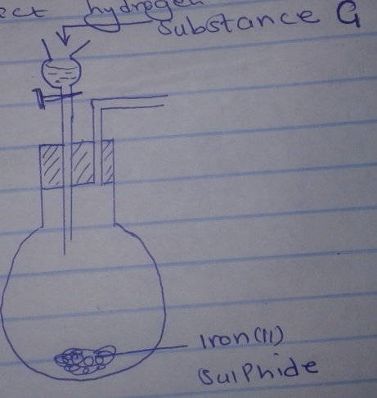

- Name the substance G (1mk)

- Complete the set up to show how dry hydrogen sulphide gas is collected (2mks)

- 6.95g of hydrated iron (II) sulphide FeSO4.nH2O was dissolved in 250cm³ solution resulting into a 0.1M solution
Determine the value of n
(Fe=56, S=32, O=16, H=1) (3mks)

- The electron configuration of ion X²⁺ is 2.8 while that of ion Y- is 2.8.8
- Write down the electron arrangement of the atom of x and y (1mk)

- Compare the atomic radii of the two elements (1mk)

- Give the name of the chemical family to which element x belongs (1mk)

- The diagram below shows a common charcoal burner. Assume the burning takes place in a room with sufficient supply of air.
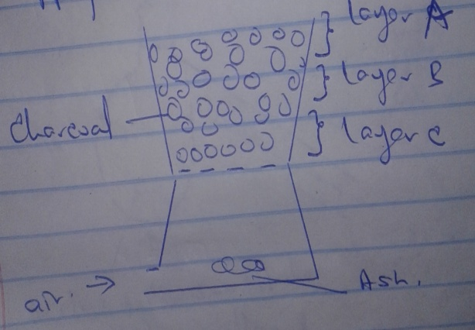
- With the help of a chemical equation explain what happens around layer A (1mk)

- State and explain what would happen if the burner is put in a enclosed room. (2mks)

- 0.318g of an oxide of metal M was completely reduced by hydrogen gas to 0.254g of metal. Calculate the empirical formula of the metal oxide (M=63.5 O=16)(3mks)

- The diagram below shows the set up used to prepare and collect a sample of nitric (V) acid
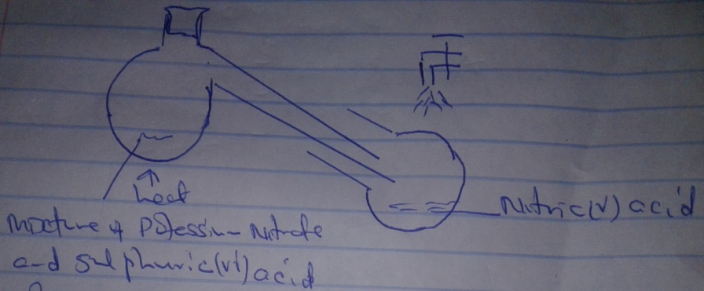
- Give a reason why it is possible to separate nitric (V) acid from su lphuric (VI) acid in the set up (1mk)

- Name another substance that can be used instead of potassium nitrate (1mk)

- Give one use of nitric (V) acid (1mk)

- When excess chlorine is bubbled through dilute sodium hydroxide solution the resulting solution is a bleaching agent.
- Write the equation for the reaction that took place (1mk)

- Name the bleaching agent produced and show how it bleaches using an equation (2mks)

16a.State the causes of temporary hardness in water (1mk)

b.How does distillation removes hardness in water (2mks)

c.State one advantage of drinking hard water rather than soft water (1mk)

17.The table below shows the elements in the halogen family of the periodic table. Study it and answer the questions that follows
Elements | Atomic number | Melting points ⁰C
Fluorine | 9 | -218
Chlorine | 17 | -101
Bromine | 35 | -7
Iodine | 53 | 114

- Name the element that is likely to be a solid at room temperature. Explain (1mk)

- Explain why the melting point increase from fluorine to iodine (2mks)

18a.State the conditions necessary for rusting to occur (1mk)

b.State two reasons why the coating is used in food cans (2mks)

19.State one use of each of the following apparatus in the laboratory
- Dessicator

- Crucible

- Deflagrating spoon. (3mks)

20a.The diagram below illustrates how magnesium reacts with steam. Study it and answer the questions that follows
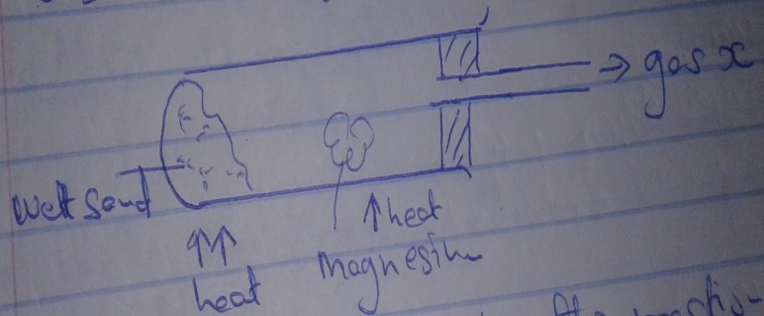

- Write the equation for the reaction that takes place (1mk)

- Explain why this experiment cannot be carried out with potassium in the same way as shown. (2mks)

21a.State the Graham’s law of diffusion (1mk)

b.Two gases a and B have relative densities of 1.98 and 2.90 respectively they diffuse under the same conditions
- Compare their rate of diffusion (1mk)

- Determine the relative molecular mass of gas A given that the relative molecular mass of B is 64 (2mks)

22.Study the flow chart and answer the questions that follow

ProcessT HCL_{(g)}
Ethene
Alcohol R
Compound S
Conc.H₂SO₄

a.Write the formula of
- Alcohol R

- Compound S

b.Name the process T (3mks)

23.Study the information on the table below and answer the questions that follows
 | Solubility g/100g of water
Salts | 50⁰C | 80⁰C
G | 43 | 58
Y | 82 | 138
A mixture containing 40g of salt G and 120g of salt Y in 100g of water cooled from 80⁰C to 50⁰C
- Which salt crystallized out? Give a reason (2mks)

- Calculate the mass of the salt that crystallized out (1mk)

24.A form four student in an attempt to prevent rusting put copper and zinc in contact with iron as shown below
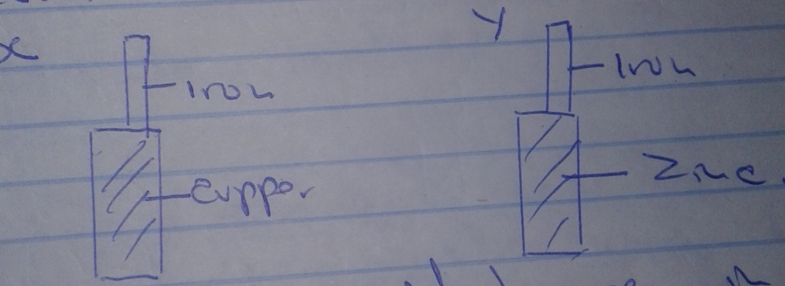

- State what would happen in set up x and y after one week (2mks)

- Explain your answer in Y (1mk)

25.The diagram below shows spots of a pure substance A, B and C, on the chromatography paper. Spot D is that of a mixture. After development A, B and C were found to have moved 8mm, 3mm and 6mm respectively D has separated into two spots which had moved 6mm and 8mm
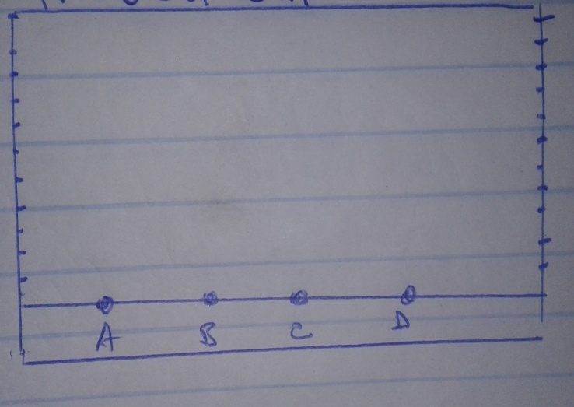
On the diagram
- Label the baseline (¹/₂mk)

- Show the position of all the spots after development (2mks)

- Identify the substance present in the mixture (¹/₂mk)

26. 50cm³ of 5.0m H₂SO₄ was diluted up to a concentration of 0.1M H₂SO₄.Calculate the volume of distilled water added (3mks)

