3KNT
END TERM I EXAM 2017
FORM FOUR CHEMISTRY
PAPER 2 (THEORY)
233/2
TIME : 2 HOURS

NAME:…………………………………….INDEX NO:………………………..
Instructions to candidate
Answer all the question in the spaces provided
Mathematical tables and non programmable electronic calculators may be used
All working must be shown where necessary

FOR EXAMINERS USE ONLY
questions | Maximum score | Student score
1 | 12
1 | 13
3 | 13
4 | 12
5 | 11
6 | 11
7 | 8
Total | 80

- The grid below represents part of the periodic table. Study it an answer the questions that follow. The letters are not the actual symbols of the element
B |  |  |  | G |  | H | E
 | J |  | I | l |  |  |  | C
D |  |  |  |  |  |  | M
Y
- What name is given the family of element a and C (1mk)

- Write the chemical formula of sulphate of D (1mk)

- Which latter represent the most reactive
- Metal (1mk)

- Non-metal (1mk)

- Name the bond formed when B and H reacts (1mks)
Explain your answer

- Select one element that belong to period 4 (1mk)

- Ionic radius of element E is bigger than the atomic radius. Explain (2mks)

- The electronic configuration of a divalent anion of element N is 2.8.8, induce the position of element N on the periodic table below (1mk)

- The oxide of G has a lower melting point than the oxide of l. Explain (1mk)

- How do the atomic radii of I and C compare. Explain (2mks)

- Explain the trend in the 1st ionization energies of the elements J.I and L (1mk)

2a. Draw the structures of the following compounds
- 2-methyl but-2-ene (1mk)

- Heptanes (1mk)

b. Draw two isomers of pentane and name the structures (2mks)

c. Study the flow chart below and answer the questions that follows

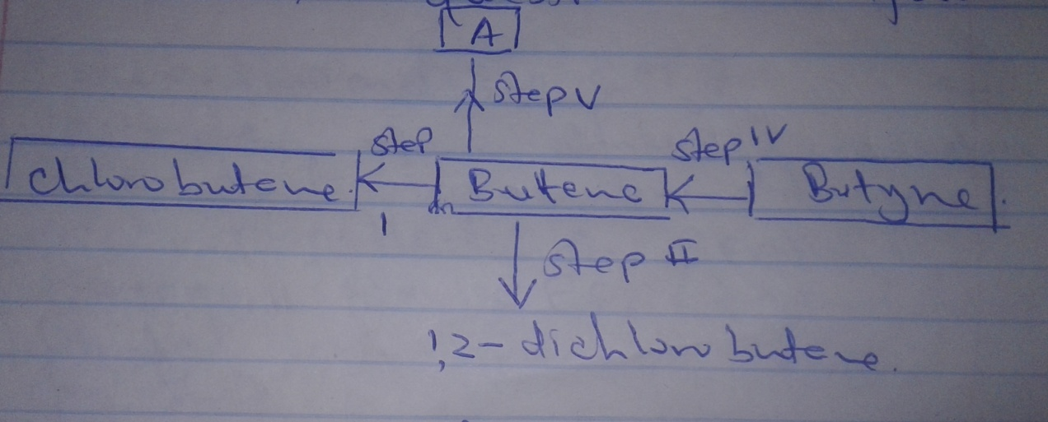
- Write the molecular formula of substance A (1mk)

- Describe one chemical test to differentiate compound a from butyne (1mk)

- Write down the chemical equation for the reaction taking place in step (1) (1mk)

- State one large scale Application of step V (1mk)

- State the reagent and conditions necessary on step (IV)
- Reagent

- Condition
d. Dichlorofluorine CCl₂F₂ is an example of a chlorofluorocarbon. CFC that was commonly used as a propellant in aerosols.
- Nowadays the CFSS (freons) have limited use, give a reason for this

- Draw a dot (.) cross(x) diagram to show a molecule of CCl₂F₂ (1mk)

3. At 25⁰C 50g of potassium nitrate were added to water to make a saturated solution.
- What is meant by a saturated solution (1mk)

- The table below gives the solubility of potassium nitrate at different temperatures
Temp ⁰C | 12 | 20 | 28 | 36 | 44 | 52
Solubility g/100g of water | 22 | 31 | 42 | 55 | 70 | 90
- Plot a graph of solubility of potassium nitrate against temperatures (4mnks)

- Using the graph
- were added to Determine the solubility of potassium nitrate at 15⁰C (1mk)

- Determine the mass of potassium that will remain undissolved given that 80g of potassium nitrate 100cm³ of water and warmed to 40⁰C (2mks)

c. Determine the molar concentration of potassium nitrate at 50⁰C (assume there is no change in density of water at this temperature) K=39 N=14 O=16 (2mks)

d. Starting with alluminium sulphate describe how a solid sample of aluminium hydroxide could be prepared (3mks)

4. The flow chart below shows the large scale manufacture of ammonia by Haber process
Study it and answer the questions that follow.
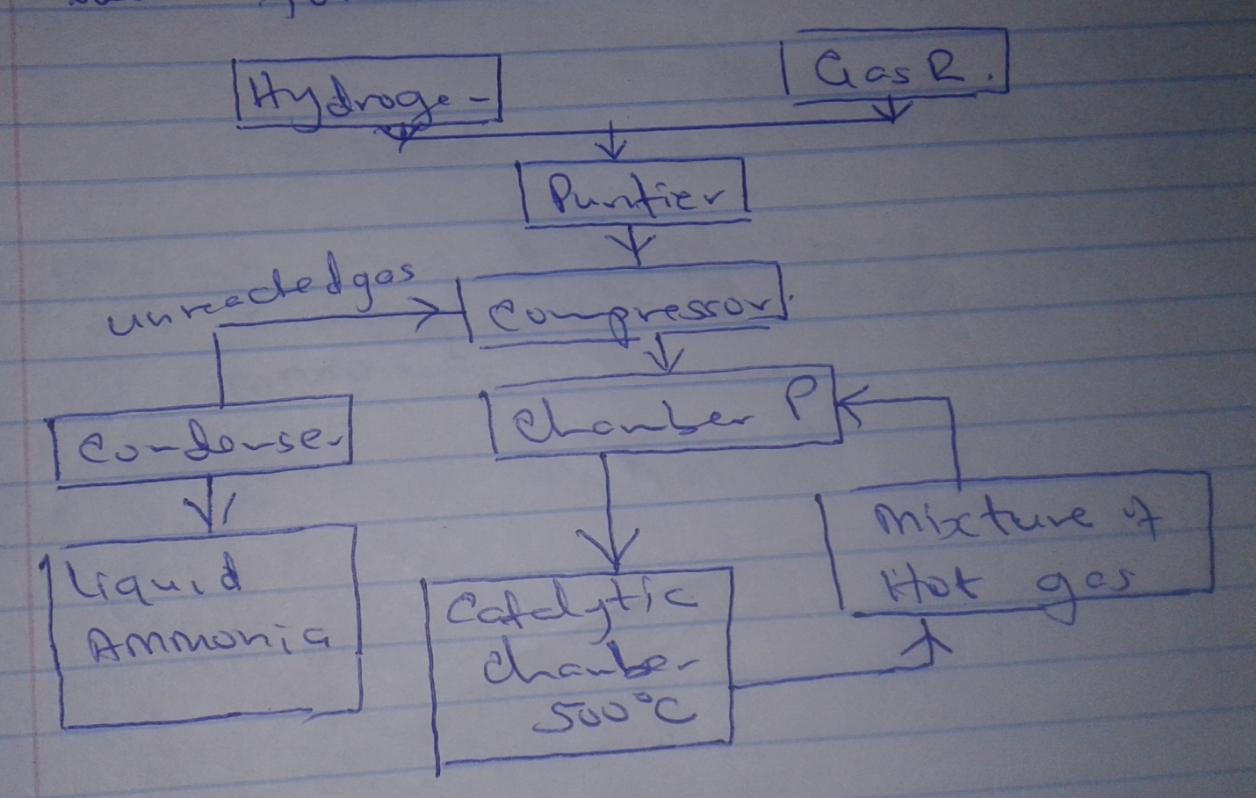

a.Identify gas R

bi.Name two sources of hydrogen gas used in this process (2m,ks)

ii. Explain the reason why the mixture of hydrogen gas and gas R are passed through the purifier (2mks)

iii.Name the suitable catalyst5 in the catalytic chamber (1mk)

ci. Identify chamber P (1mk)

ii. Explain why mixture of hot gas is passed through chamber P (1mk)

d. Explain why hot platinum wire glows on coming into contact with fumes of ammonia (2mks)

e.State two industrial uses of ammonia (2mks)

5a. Define allotropy (1mk)

b. Graphite is an allotrope of carbon which conducts electricity although carbon is non conductor. Explain (1mk)

c.Carbon react with hot concentrated sulphuric (VI) acid
- Write equation for the reaction that occur (1mk)

- What property of carbon is shown in this reaction (1mk)

d. Sodium carbonate can be obtained from Trona, a double salt. Whose formula is Na₂CO₃.NaHCO₃.2H₂O
What is meant by double salt (1mk)

e. Sulphur is extracted from underground deposit by the process shown below

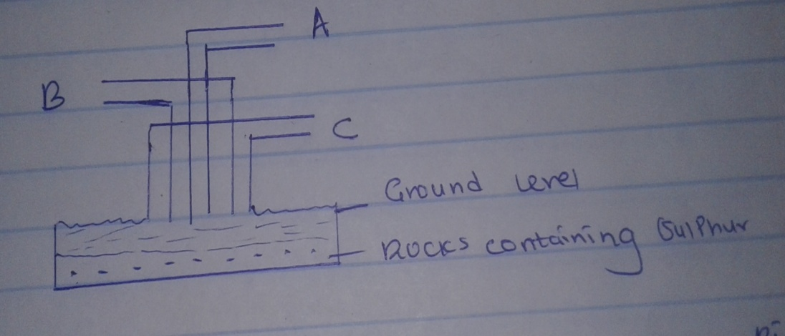
- Water at 170⁰C is pumped down the outer pipe. Explain how it is possible to obtain water with temperature of 170⁰C (1mk)

- Name the substance passed through
- Pipe a (1mk)

- Pipe B (1mk)

f. When excess chlorine is bubbled through dilute sodium hydroxide. The resulting solution bleaches flower petals
- Write an equation between chlorine and dilute sodium hydroxide (1mk)

- Explain how the resulting solution bleaches flower petals (2mks)
6. Below is a brief outline of a method used in preparing lead chloride. Lead carbonate is added to warm dilute HNO₃. When the carbonate has reacted with the warm acid, more carbonate is added until the carbonate is in excess. The mixture filtered. Some sodium chloride solution is added to the filtrate.
ai.What observations are made when lead carbonate is added to the warm HNO₃ (1mk)

ii.What happens when sodium chloride is added to the filtrate (1mk)

b.Write an equation for the reaction between
- The carbonate and the acid (1¹/2mk)

- The filtrate and sodium chloride (1¹/2mk)

c.Write an ionic equation for the reaction in b(ii) (1mk)

d.Name the reaction that takes place between the filtrate and sodium chloride (1mk)

e.Study the scheme below and answer the questions that follow

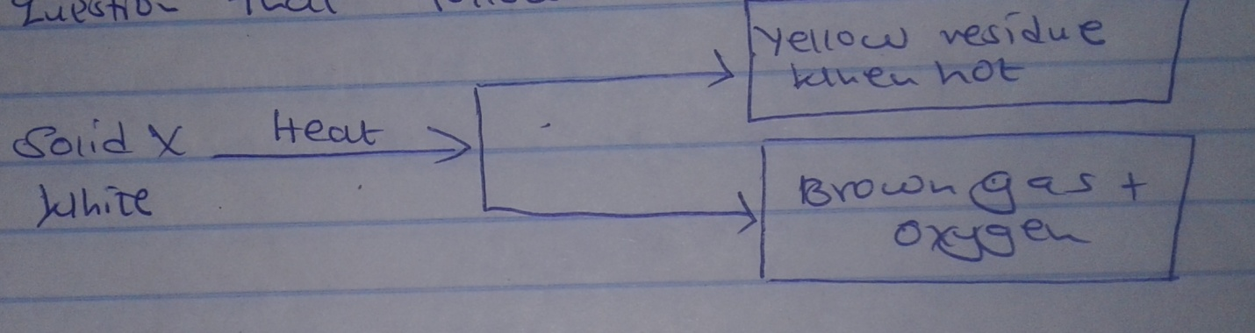
Name
- Solid x (1mk)

- The yellow residue (1mk)

- Write an equation for the thermal decomposition of solid x (2mks)

7.The figure below is used to investigate the effect of carbon (II) oxide on copper (II) oxide. Study it and answer the questions that follows.

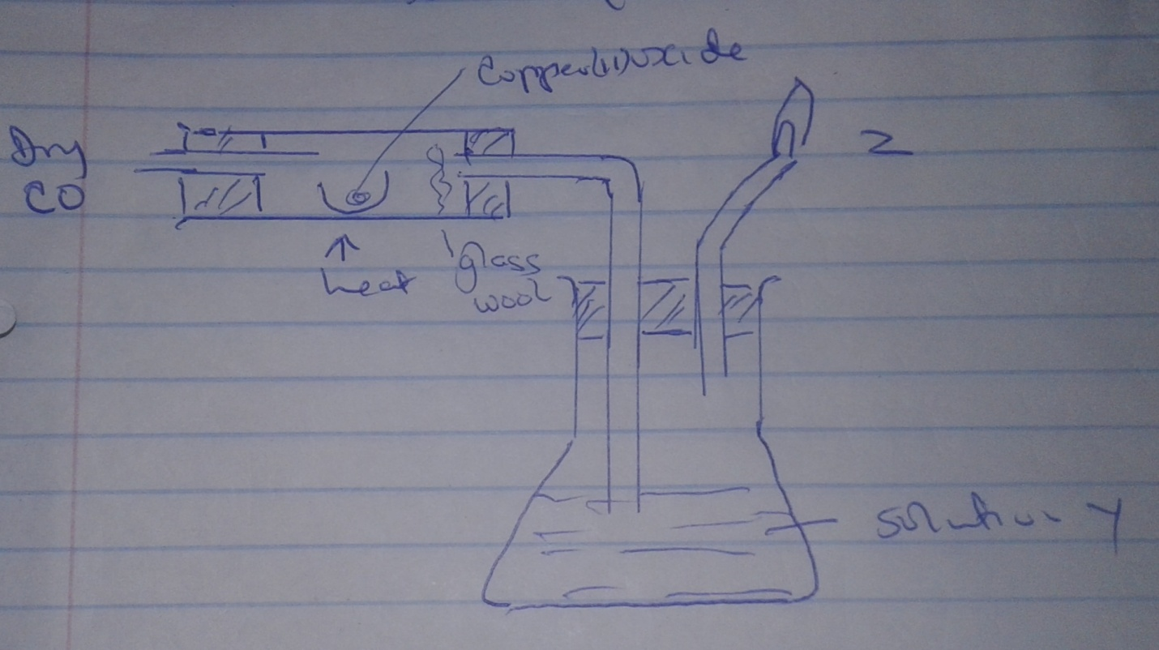
- What will be observed in the combustion tube at the end of the experiment (1mk)

- Identify y and give its use (2mks)

- Why is it necessary to burn the excess gas at Z (1mk)

- Write the equation for the reaction taking place at Z (1mk)

- What is the use of glass wool (1mk)

- Give two uses of carbon (II) oxide (2mks)

