NAME…………………………………………………………………………………………………..ADM.NO……………..CLASS…………….
121/1
MATHEMATICS
PAPER 1
MARCH/APRIL 2017
TIME: 2 ½ HOURS
3KNT JOINT EXAM 2017
INSTRUCTIONS TO CANDIDATES
- Write your name and admission number in the spaces provided above.
- The paper contains TWO sections: Section 1 and section ll
- Answer all the questions in section 1 and only five questions from section 11 Show all the steps in your calculations, giving your answers at each stage in the spaces below each question.
- All answers and working must be written on the question paper in the spaces provided below each question
- Non programmable silent electronic calculators and KNEC Mathematical tables may be used except where stated otherwise.
For examiners use only
Section 1
1 | 2 | 3 | 4 | 5 | 6 | 7 | 8 | 9 | 10 | 11 | 12 | 13 | 14 | 15 | 16 | TOTAL

Section 1
17 | 18 | 19 | 20 | 21 | 22 | 23 | 24 | TOTAL

GRAND TOTAL

SECTION A (50 MKS)
- Simplify 22 - -4 - 4² x -6 – 12
6x – 2 72 ÷ -8 x 3

- A cylindrical pipe 2.5m long has nan internal radius of 10.5mm and external radius of 17.5mm. The density of the material that makes the pipe is 1250kg/m³. Calculate the mass of the pipe in kilogram π =22
7 (4mks)

- a) Find the difference between the G.C.D and the L.C.M of 36 and 54. (2mks)

b) If three numbers 36, 54 and X have a G.C.D of 6 and L.C.M 216. Find the least value of X. (2mks)

- Given that Sin θ = $\frac{√3}{2}$ determine without using tables the values of Cos θ and tan θ (3mks)

- Njoroge spent ¼ of his slary opn school feeds ¼ of the remainder on electricity and water bills and spent 1/9 of what was left on transport. Finally he had sh 3400. Calculate his January salary.

- The figure below show a hemisphere bowl of thickness 1.5cm. Given that the external surface area is 509cm² . Find the volume of the bowl. Take π=3.142

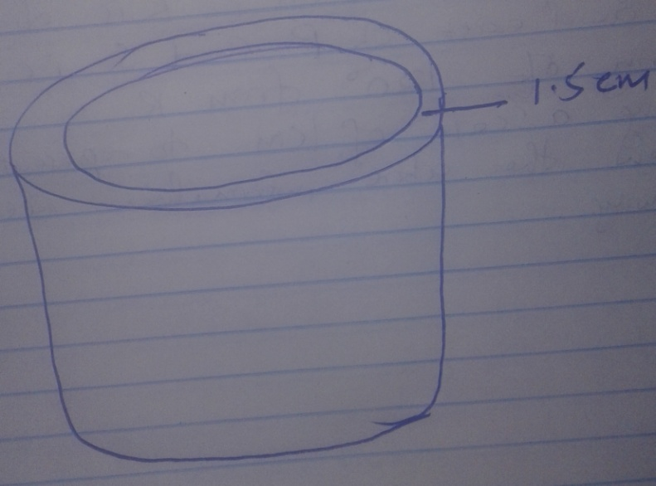

- Factorize completely 3x² – 2xy – y² (3mks)

- Using a ruler and a pair of compasses only
- Construct a parallelogram PQRS in which PQ =6cm QR= 4cm and angle =75⁰ (3mks)

- Determine the perpendicular distance between PQ and SR (1mk)

- The production of milk in litres of 14 cows on a certain day was recorded as follows
22 26 15 19 20 16 27 15
19 22 21 20 22 and 28
Determine
- The mode (1mk)

- Median (2mks)

- Kinuthia made a profit of 20% by selling a fridge for 36,000/=. In a trade exhibition he sold the fridge for ksh 33,600/=. Calculate the percentage profit on the sale during the exhibition. (3mks)

- Write down the inequalities that satisfy. The unshaded region in the figure below (3mks)
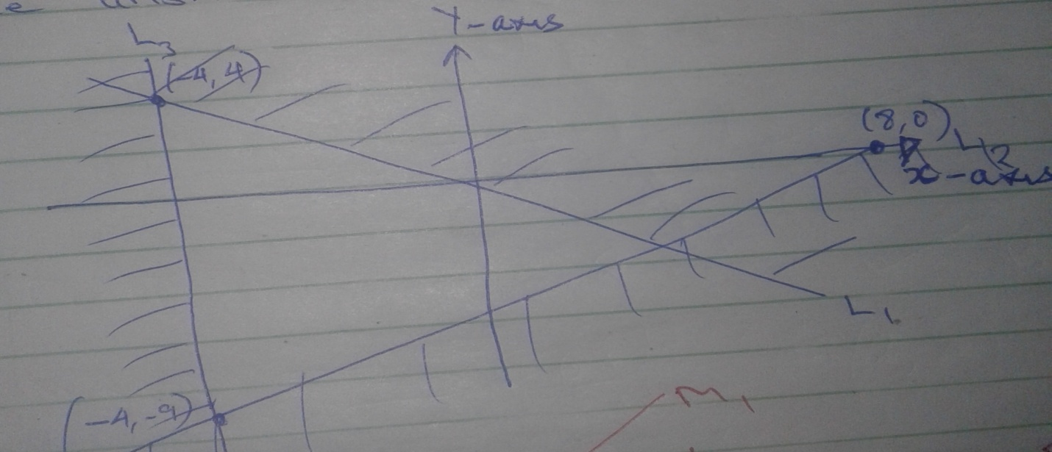

- Simplify completely. 3x² - 1 – (x+7) (2x+1)
X² + 1 (3mks)

13 a)Express 360 in term of its prime factor (1mk)

b)Determine the smallest positive integer K such that 360K is a perfect square. (2mks)

14. Given that log₄= 0.6021 and log₆ 0.7782 without using mathematical tables and calculator evaluate log 0.096 (3mks)

15. The cost of buying a certain car outside Kenya is US$4800. You intend to buy one such car through an agent who deals in Japanese Yen. The agent charges 15% commission on the price of the car and a further 72220 Japanese Yen for shipment. How much money is Kenya shillings will you need to send the agent to obtain the car.
1 US $ = 117.20 Japanese Yen
1 US $ = ksh 103.34

16. Expand and simplify (a + 2b)² – (2b –a)²

SECTION B (50 MKS)
17. Three partners Mutua Muthoka and Mwikali contributed sh 600,000 sh 400,000 and 800,000 respectively to start a business of a matatu plying Mbumbuni – Machoka’s route. The matatu carries 14 passengers with each paying sh 250. The matatus makes tweo round trips each day and ever full. Each day sh 6000is used to cover running cost and wages.
a) Calculate their net profit per day. (2mks)

b) The matatu works for 25 days per month and is serviced every month at a cost of ksh 10,000. Calculate their monthly profit in June (1mk)

c) Three –partners agreed to solve 40% of the profit 24% to be shared in their ratio of their contribution. Calculate Muthoka’s share in that month of June.

d)The matatu developed mechanical problem and they decided to sell it through an agent who charged a commission 5% on selling price . Each partner received ksh 475,000 from the agent after he had taken his commission. Determine the price at which the agent sold the matatu. (3mks)

18. Maralal and Nairobi are 350km apart. Two buses A and B started from Nairobi at the same time travelling towards Marala. Bus B travelling of an average speed of 12km/hr more than bus A reaches Maralal 15 hrs earlier.
a) Find the average speed of A (6mks)

b) How far was A from Nairobi when B was 20 minutes to reach Maralal (4mks)

19. The figure below represents a frustrum of solid cone of base radius 48cm and radius 16cm . The height of the frustrum is 21cm π=22
7

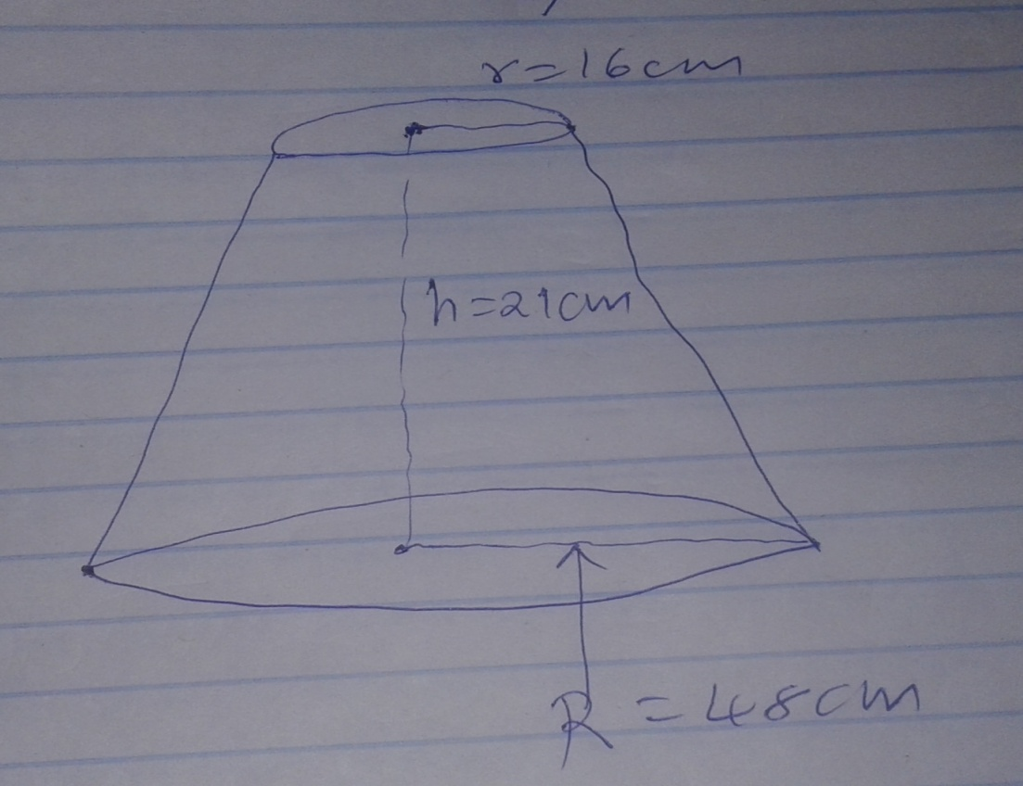
Calculate
- The height of the solid cone (3mks)

- The volume of the solid frustrum (2mks)

- The total surface area of frustrum (5mks)

20. a)Write the inverse of $\left(\begin{matrix}4 & 3 \\ 3 & 2\end{matrix}\right)$ and determine the value of a, b, c and d such that $\left(\begin{matrix}4 & 3 \\ 3 & 2\end{matrix}\right)\left(\begin{matrix}a & b \\ c & d\end{matrix}\right)$=$\left(\begin{matrix}1 & 2 \\ 3 & 4\end{matrix}\right)$

b) Solve the following simultaneous equation using matrix (3mks)
2x + y = 10
2x +2y=14

c)Find the inverse of $\left(\begin{matrix}1 & 1 \\ 3 & 1\end{matrix}\right)$ Hence determine the point of intersection of line x+y = 7 and 3x + y = 15 (3mks)

21. The diagram below shows two circles centre A and B which intersect at P and Q. Angle PAQ =70⁰ and PBQ = 40º PA=AQ =8cm.

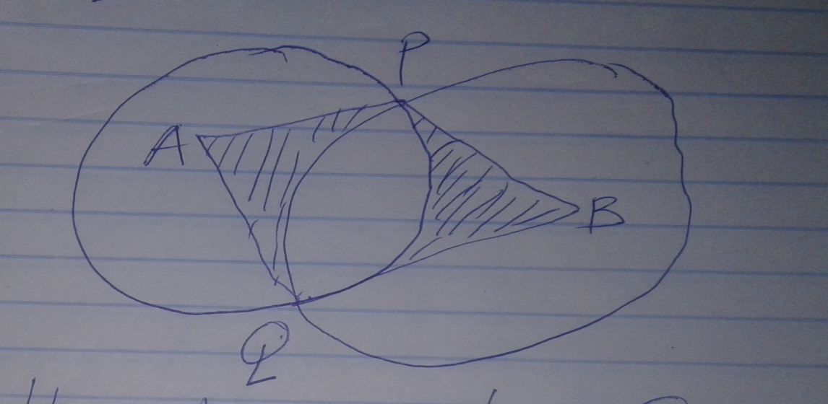

- Use the diagram to calculate the length PB to 2 decimal places (3mks)

- Calculate the common area of the two circles use π = 22 (4mks)
7

- Calculate the area of the shaded region.

22. In the figure below O is the centre of the circle and NOP is the diameter. MO=ON=OP, /__MPN=50^{O} PQ is parallel to MN.

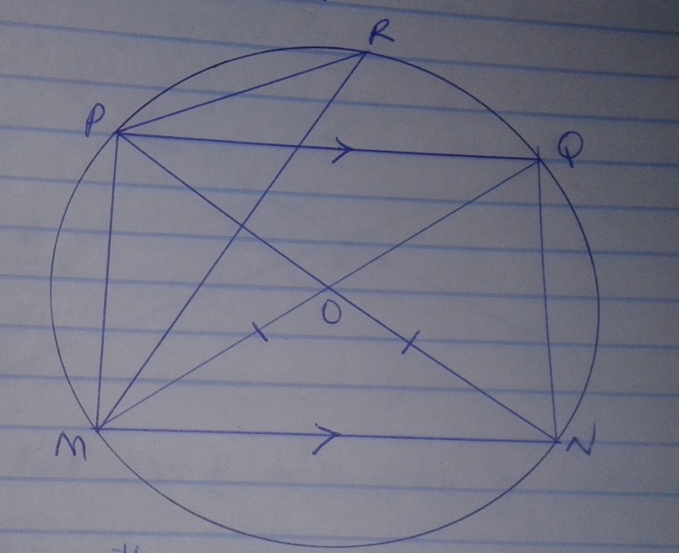

Calculate with reasons, the size of
- LNPQ (2mks)

- Reflex LMON (2mks)

- LPMQ (2mks)

- LRPQ (2mks)

23. In the figure below OABC is a trapezium. AB is parallel to OC and OC=5AB
D is a point on OC such that OD:DC=3.2

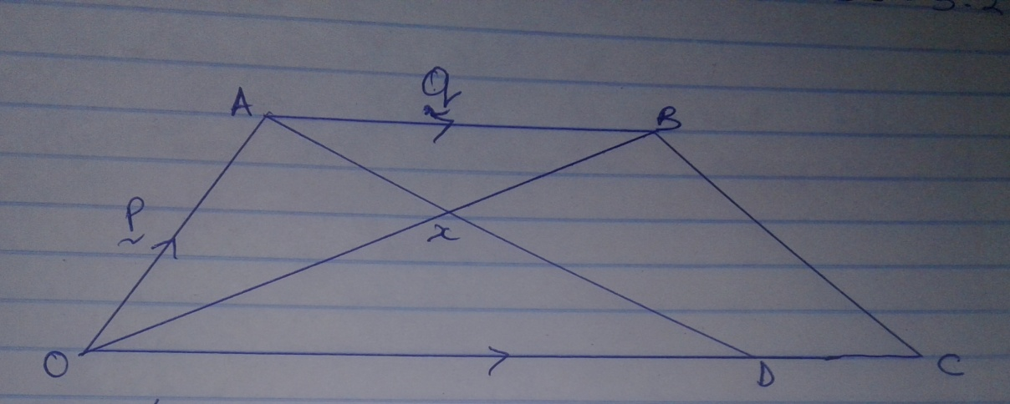

a) Given that OA=P and AB=q. Express in terms of p and q
i)OB (1mk)

ii)AD (2mks)

iii)CB (2mks)

b) Line OB and AB intersect at point X such that AX=kAD and OX=rOB where k and r are scalars. Determine the value of k and r. (5mks)

24. The boundaries PQ,QR and SP of a rauch are straight lines such that Q is 16km and a of bearing of 040º from P. R is directly South of Q and east of P and S is 12km on a bearing of 120º from R.
a) Using a scale of 1cm to represent 2km show the above information using a scale drawing.

b)From the scale drawing determine
i) the distance of P from S (2mks)

ii) Compass bearing of S from P (2mks)

iii) Calculate the area of the ranch in km² (2mks)

