3KNT FRATERNITY EXAMINATION
NAME …………………………………………………………………………………………………….. ADM NO ……………………………………………
SCHOOL …………………………………………………………………………………………………. INDEX NO …………………………………………..
TERM ONE 2017
AGRICULTURE
443/1
2 HOURS

INSTRUCTIONS
1. Write your name and index number in the space provided above.
2. This paper consists of three sections A, B and C.
3. Answer ALL the questions in section A and B.
4. Answer ANY TWO questions in section C.
5. All answers SHOULD be written in spaces provided.

FOR EXAMINERS USE ONLY
SECTION | QUESTION | MAXIMUM SCORE | CANDIDATE SCORE
A | 1 -19 | 30
B | 20-23 | 20
C | 24- 26 | 40
TOTAL |  | 90

SECTION A (30MKS)
ANSWER ALL THE QUESTIONS IN THIS SECTION
- Differentiate between olericulture and pomoculture as used in crop production. (1mk)

2. List 4 physical weathering agents in soil formation process. (2mks)

3. State 2 positive effects of wind on agriculture. (1mk)

4. Give 4 methods of farming. (2mks)

5. State the importance of sub-soiling. (1mk)

6. State 3 benefits of minimum tillage. (1 ½ mks)

7. Name any 3 types of water pumps that can be used to lift water form its source for the farm. (1 ½ mks)

8. Give 4 factors considered when selecting irrigation method. (2mks)

9. Outline 3 indicators of a well rotten compost manure. (1 ½ mks)

10. Define the term opportunity cost. (1mk)

11. Give 4 benefits of processing a land title deed to a farmer. (2mks)

12. Name 4 basis under which inorganic fertilizers are classified. (2mks)

13. State any 2 ways of breaking seed dormancy during the preparation of planting materials .(1mk)

14. Give 4 factors that increase seed rate. (2mks)

15. Give 4 disadvantages of mulching in crop production. (2mks)

16. Give 4 advantages of crop rotation. (2mks)

17. State 4 types of micro-catchments. (2mks)

18. State 2 factors that should be considered when classifying crop pests . (1mk)

SECTION B : (20MKS)
ANSWER ALL THE QUESTIONS
20The diagram below shows a common weed
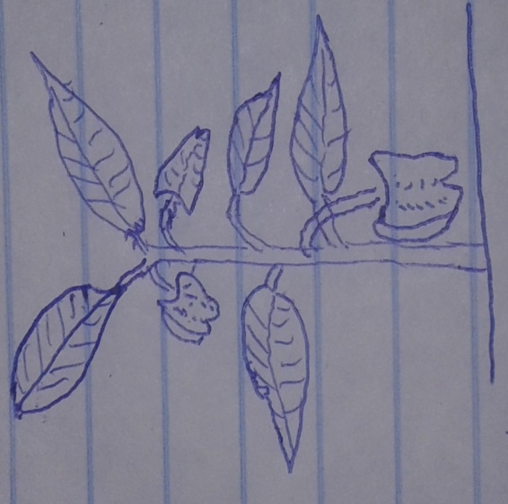

- Identify the above weed. (1mk)

- State 2 economic importance of the above weed. (2ks)

- Under which classification of plant morphology does the above weed belong? (1mk)

- Give one mechanical weed control method that can be used to control the above weed. (1mk)

21. The diagram below shows a method used in preparation of organic Manure.
X |  | Y |  | Z

Farm

- Identify the method illustrated. (1mk)

- Using arrows indicate the direction of the material movement. (1mk)

- State 3 characteristics of crops used for making green manure. (3mks)

22. The diagram below shows a method of forage preservation.
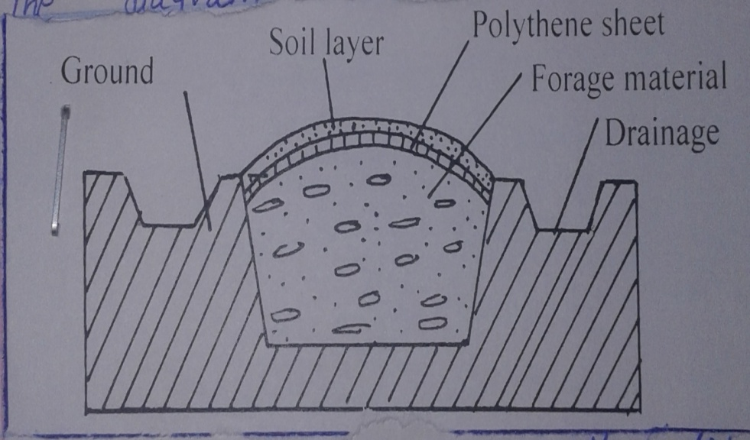

i) State the structure illustrated above. (1mk)

ii) State the form in which forage is preserved as illustrated above. (1mk)

iii) Give the role of the following in the structure ` (2mks)
- Polythene sheet

- Drainage

iv) Name one other method of forage preservation. (1mk)

23. The diagrams below illustrate a disease and a pest of tomato crop.
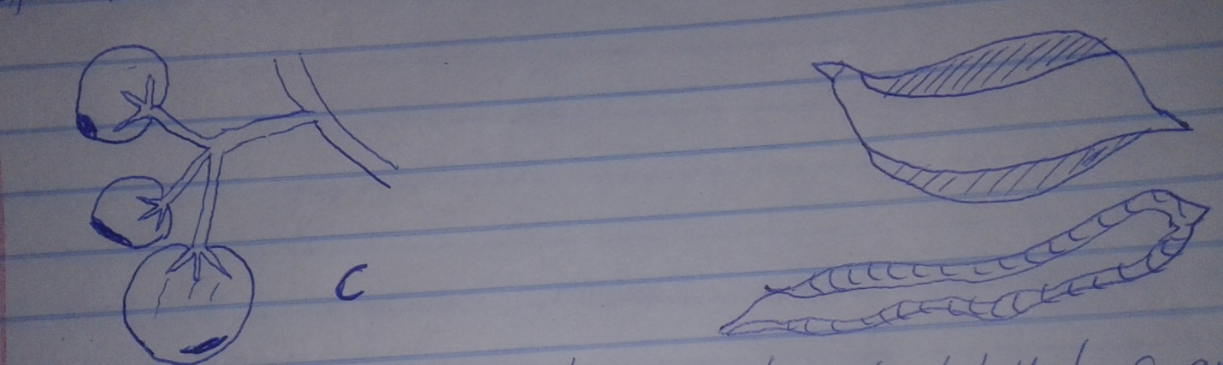
C
D
- Identify the tomato disease and pest labeled C and D respectively. (1mk)

- State two causes of the disease identified in 2a) above. (2mks)

- Give two control measures of pest identified in 23 a) above. (2mks)

SECTION C (40MKS)
ANSWER ANY TWO QUESTIONS IN THIS SECTION
24a).Explain 5 cultural disease control measures in a field of crops. (10mks)
- Explain 5 management practices carried out in a nursery bed. (10mks)
25a) Explain farming practices that help to conserve soil. (12mks)
b) Describe maize production under :
i) Seed bed preparation (4mks)
ii) Field practices (6mks)
26a) Outline the role of phosphorous in plants. (5mks)
b) Describe the policies used by he government to regulate the amount of imported agricultural goods in Kenya.(5mks)
c) Describe uses of farm records in the farm. (10mks)

