3KNT FRATERNITY EXAMINATION
NAME …………………………………………………………………………………………………….. ADM NO ……………………………………………
SCHOOL …………………………………………………………………………………………………. INDEX NO …………………………………………..
TERM ONE 2017
AGRICULTURE
443/2
2 HOURS

INSTRUCTIONS
1. Write your name and index number in the space provided above.
2. This paper consists of three sections A, B and C.
3. Answer ALL the questions in section A and B.
4. Answer ANY TWO questions in section C.
5. All answers SHOULD be written in spaces provided.

FOR EXAMINERS USE ONLY
SECTION | QUESTION | MAXIMUM SCORE | CANDIDATE SCORE
A | 1 -18 | 30
B | 19-22 | 20
C | 23- 25 | 20
 |  | 20
TOTAL |  | 90

SECTION A (30 MKS)
ANSWER ALL THE QUESTIONS IN THIS SECTION
1. Write 2 tools appropriate for cutting mature horns in a bull. (1mk)

2. Give 3 methods used in selection of a breeding stock. (1 ½ mks)

3. Write 2 factors that inhibit milk let down process in dairy cattle. (1mk)

4. Give 4 major routes of administering vaccine in a day old chick. (2mks)

5. Give 4 general characteristics of a dairy cattle. (2mks)

6. Name 3 examples of temperate dairy goats. (1 ½ mks)

7. State any 4 pre-disposing factors to livestock diseases. (2mks)

8. Name 4 larval stages of a liver fluke. (2mks)

9. Give 3 ways in which infectious diseases ca be spread from one livestock to another within the farm. (1 ½ mks)

10. Give 3 diseases in poultry that are caused by virus. (1 ½ mks)

11. State 4 factors at influence the dairy water intake in an animal. (2mks)

12. State 4 importance of flushing in animals. (2mks)

13. State 4 disadvantages of a hedge fence. (2mks)

14. Write 4 construction features necessary in a fish pond. (2mks)

15. Name 4 structures which are used in the control of livestock parasites on a fam. (2mks)

16. Name 2 types of tractor engine cooling system. (1mk)

17. State 4 reasons why piglets should be weighed immediately after birth and weaning. (2mks)

18. Name 2 notifiable diseases in cattle. (1mk)

SECTION B (20MKS)
ANSWER ALL THE QUESTIONS IN THE SPACES PROVIDED
19. The diagram below shows behaviors of chicks in a broader in response to heat. Study the diagram and answer the question that follows.
a) Explain the behavior of chicks in each case. (3mks)

b) Explain why the brooder should be round. (1mk)

c) Draw a diagram to show the behavior of the chicks if the temperature in the brooder is optimum. (1mk)

20. Study the diagram of the fence shown below and answer the question that follows.
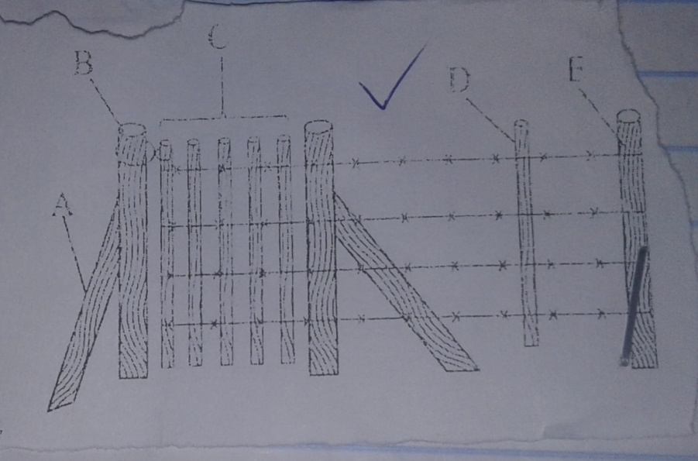
a) Name the type of fence. (1/2 mk)

b)Name the parts labeled A,B,D and E. (4mks)

- Give the function of part labeled D. (1/2 mk)

21. Below is a diagram of two stroke engine cylinder.
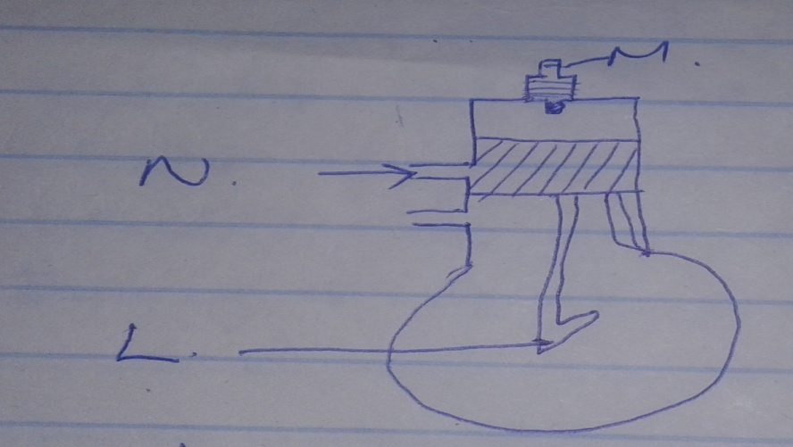
a) Label the parts N and L. (2mks)

b) Name three farm machine where the above engine is used. (3mks)

22. The diagram below shows a method of identification in livestock. Use the diagram to answer the questions that follows.
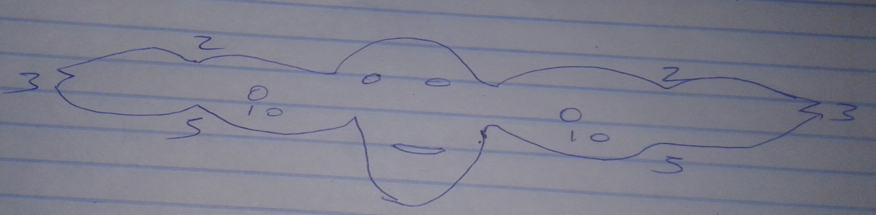
a) Identify the type of identification illustrated above. (1mk)

b)Give the identification number of the animal illustrated in the diagram above. (1mk)

c)Give any other 3 methods of identification. (3mks)

SECTION C (40MKS)
ANSWER ANY TWO QUESTIONS IN THIS SECTION
23a) Describe the management practices that should be carried out on a sow during the furrowing. (12mks)
b) Explain 5 reasons why a breeding boar may be culled. (5mks)
c) State 3 maintenance practices of fork jembe. (3mks)
24a) Discuss Gumboro disease under the following sub headings.
i)Animal affected (1mk)
ii) Causal organism (1mk)
iii) Symptoms (6mks)
iv)Control measures (2mks)
b)Explain 5 essentials of clean milk production . (10mks)
25a) Describe life –cycle of two –host tick. (7mks)
b) Explain general measures used to control livestock diseases. (8mks)
c) Write advantages of using a donkey fro farm work. (5mks)

