NAME :……………………………………………………………AD.NO:…………….CLASS:…………………………..

3KNT EXAMINATIOBS
BIOLOGY
PAPER 3 (PRACTICAL)
TIME: 1³/₄HOUR

FOR EXAMINER’S USE ONLY
QUESTIONS | MAXIMUM SCORE | CANDIDATE SCORE
1 | 15
2 | 11
3 | 14
 | 40

ANSWER ALL QUESTIONS IN THE SPACES PROVIDED

- You are provided with a piece of plant material specimen D. Using a scapel, cut a slit through the middle of each piece. One piece is placed in solution labeled S₁ and the other in solution labeled S₂. The set – up is allowed to stand for 30 minutes.
- After 30 minutes, remove the pieces and press gently between fingers.
- Record the observation made in
piece in solution S₁(1mk)

piece in solution S₂ (1mk)

- Explain the observations in (a) (i) above(6mk)

- (i)On careful examination of the pieces, what other observations beside those made in (a)(i) above can be made.(3mks)

(ii)Explain the observation in b (i) above.(4mks)

- Use the photographs of the two skulls provided to answer the questions below.
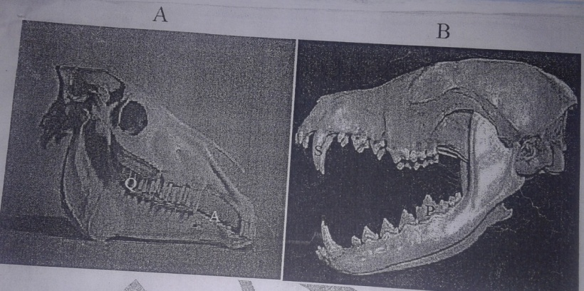
- Identify the diet of A and B
A (1mk)

Reason (1mk)

B (1mk)

Reason (1mk)

- Identify the following parts and state their functions.
- A (1mk)

Function (1mk)

- Q (1mk)
Function (1mk)

- S (1mk)

Function (1mk)

- What is the mode of nutrition of the animal with skull B(1mk)

- You are provided with specimen C.
- Cut a transverse section through specimen C
- Draw and label one of the cut surfaces.(5mks)

- State the type of placentation on specimen C.(1mk)

- Explain how internal features adapt specimen C for dispersal.(2mks)

- Squeeze the juice in specimen C into three test tubes labeled 1,2 and 3.carry out the experiment below using the procedure provided.
Record your observations and conclusions in the table.(6mks)
Test tube | Procedure | Observations | Conclusions
 | Put 2cm³ of DCPIP in a test tube. Add the juice drop by drop shaking after adding each drop.
 | Put cm3 of the juice in a test tube. Add 1cm³ of sodium hydroxide followed by three drops of copper sulphate solution.
 | Put another portion of juice in a test tube. Add Benedict’s solution and heat to boil.

