NAME :……………………………………………………………AD.NO:…………….CLASS:…………………………..

3KNT EXAMINATIOBS
BIOLOGY
PAPER 2
TIME: 2HOUR

FOR EXAMINER’S USE ONLY
SECTION | QUESTIONS NUMBER | MAXIMUM SCORE | CANDIDATES SCORE
A | 1 | 8
 | 2 | 8
 | 3 | 8
 | 4 | 8
 | 5 | 8
B | 6 | 20
 | 7 | 20
 | 8 | 20
TOTAL SCORE |  | 80

SECTION A (40MKS)
ANSWER ALL THE QUESTIONS IN THE SPACES PRIVIDED
- The diagrams below represent a set up to investigate the conditions necessary for seed germination.
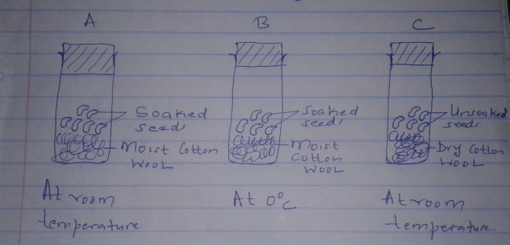
The set up was left for 7 days .
- What conditions were being investigated in the experiment.(2mks)

- State three reasons for soaking seeds in set up A and B.(3mks)

- What were the expected results after seven days.(3mks)

- (a) Distinguish between disaccharide and polysaccharide(2mks)

(b) Name two common polysaccharides.(2mks)

(c)Study the equation below and then use it to answer the questions that follow.

Sucrose Enzyme A Glucose +Fructose
Process B

- Name process A (1mk)

- Name process B (1mk)

- Name the reagent used in process B in the laboratory.(1mk)

- Why is it necessary to add sodium hydrogen carbonate (NaHCO₃) in the above reaction.(1mk)

- The diagram below shows the structure of an open stomata. Study it and answer the questions that follow.
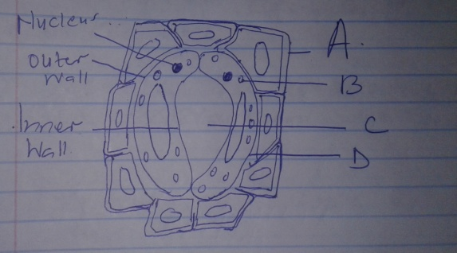

- Name the parts labeled A,B,C and D.(4mks)

A------------------------------------------

B-------------------------------------------

C-------------------------------------------

D-------------------------------------------
- State two functions of the structure above.(2mks)

- State two theories that explain the mechanism of opening and closing of the stomata.(2mks)

- In an experiment to calculate the respiratory quotient , a mouse was observed to have taken 80cm³ of oxygen and produced 72.9cm³ of carbon iv oxide in 12 minutes.
- Calculate the respiratory quotient in the experiment above.(2mks)

- Identify the type of food broken down.(1mk)

- What is the importance of respiratory quotient value.(1mk)

(d) Suppose the same mouse was exposed to insufficient supply of oxygen for a few minutes.

- Name the type of respiration that would have take place.(1mk)

- Name the product of the type of respiration named in (i) above.(1mk)

(e)If the mouse mentioned above requires 2736 kj per gram of body weight while an elephant requires 216 kj per gram of body weight. Explain the difference.(2mks)

- In maize the gene for purple colour is dominant to the gene for white colour. A pure breeding maize with purple grains was crossed with a heterozygous plant.
- (i) Using letter G to represent the gene for purple colour, work out the genotypic ratio of the offspring.(5mks)

(ii)State the phenotype of the offspring.(1mk)

- (i)Name the type used when two alleles in heterozygous state are fully expressed phenotypically in an organism.(1mk)

(ii)Give an example of trait in human beings where the condition whose term is named in b(i) above expresses itself.(1mk)

SECTION B(40MKS)
ANSWER QUESTION 6 (COMPULSORY) AND EITHER QUESTION 7 OR 8 IN THE SPACES PROVIDED.
- An experiment was carried out to investigate transpiration and absorption of water in sunflower plants in their natural environment with adequate supply of water. The amount of water was determined in two hours intervals. The results are as shown below.
TIME OF DAY | AMOUNT OF WATER IN GRAMMS
 | Transpiration | Absorption
1100 - 1300 | 33 | 20
1300 - 1500 | 45 | 30
1500 – 1700 | 52 | 42
1700 – 1900 | 46 | 46
1900 - 2100 | 25 | 32
2100 - 2300 | 16 | 20
2300 - 0100 | 08 | 15
0100 - 0300 | 04 | 11

- Using the same axis plot graph to show transpiration and absorption of water in grams against time of the day.(7mks)
- At what time of the day was the amount of water the same for transpiration and absorption.(1mk)

- Account for the shape of the graph of (3mks)

- Transpiration

- Absorption

- What would happen to transpiration and absorption of water if the experiment was continued until 0500hours.

- Explain how the following contribute to the movement of water up the xylem vessels.
- Cohesion

- Adhesion

- Explain how xerophytes are adapted to their habitats.(20mks)

- (a) Describe the process of fertilization in a flowering plant.(14mks)

(b)State the changes that take place in a flower after fertilization.(6mks)

