FORM FOUR BUSINESS STUDIES
PAPER 1
561/1
MARCH /APRIL 2017
TIME : 2 HOURS
Instructions: answer all questions on the spaces provided
- Outline four reasons for the popularity of hypermarket to shoppers in Kenya today (4mks)

- Highlight four ways through which ban entrepreneur can improve the internal environment of his/her business (4mks)

- Mention four circumstances under which a business would use personal selling as a method of product promotion (4mks)

- Identify four economies of scale experienced by a firm operating on large scale (4mks)

- State four roles of warehousing in promotion of trade (4mks)

- The following information was extracted from the books of Karurumo traders for the month of September 2010.
September 1: | Balance b/d cash 50,000  Bank 60,000 (cr
4: | Paid Wanja by cheque shs 19,500 in full settlement of her account of sh 20,000
15: | Received a cheque for shs 84,600 from Munene stores after deducting 6% cash discount
20: | Took all the money to the bank leaving only shs 5000
Required: prepare a three column cash bank duly balance (5mks)

- The following information was obtained from Ngoire traders
Capital 1 January 2015 shs 900,000
Capital 31 December 2015 shs 450,000
Net loss for the year shs 150,000
Additional investments shs 60,000
Calculate the drawings made during the year (4mks)

- Identify the source document that can be used in recording each of the following transaction (4mks)
Transaction | Source document
To correct an undercharge in an invoice

To pay casual workers in an organization

To show that a credit transaction has taken place

To show that a cash transaction has taken place

- Complete the table below by indicating the account to be debited and account to be credited (4mks)

Transaction | Dr | Cr
- Started business with shs 120,000 in cash

- Bought stock with shs 80,000 on credit from shah limited

- Returned goods to shah limited worth shs 6000

- Withdrew shs 9000 cash for personal use

- Using the accounting equation fill in the missing figures in the table below (3mks)
Liabilities | Assets | capital
45820 |  | 28,700
43,737 | 211,00
 | 148,390 | 108,930
- Enumerate four circumstances under which a firm may acquire monopoly power (4mks)

- State four benefits of indirect production to a country (4mks)

- List the type of human want one would be satisfying in each of the following activities (4mks)
Activity Type of want
- Tourist going to Hawai
- Feeding street children
- Designing suits for the president
- Getting involved in athletics marathon
- Outline four ways in which commercial attaches promote trade in Kenya (4mks)

- The graph below show the rate of population growth of given country

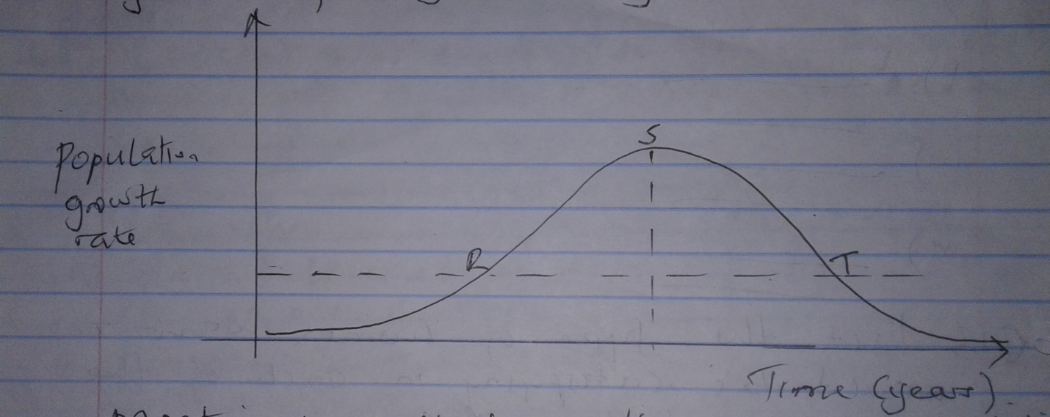

Mention four effects of the trend of population growth between S and T (4mks)

- State four advantages of operating a partnership business (4mks)

- The following diagram shows a shift in demand curve
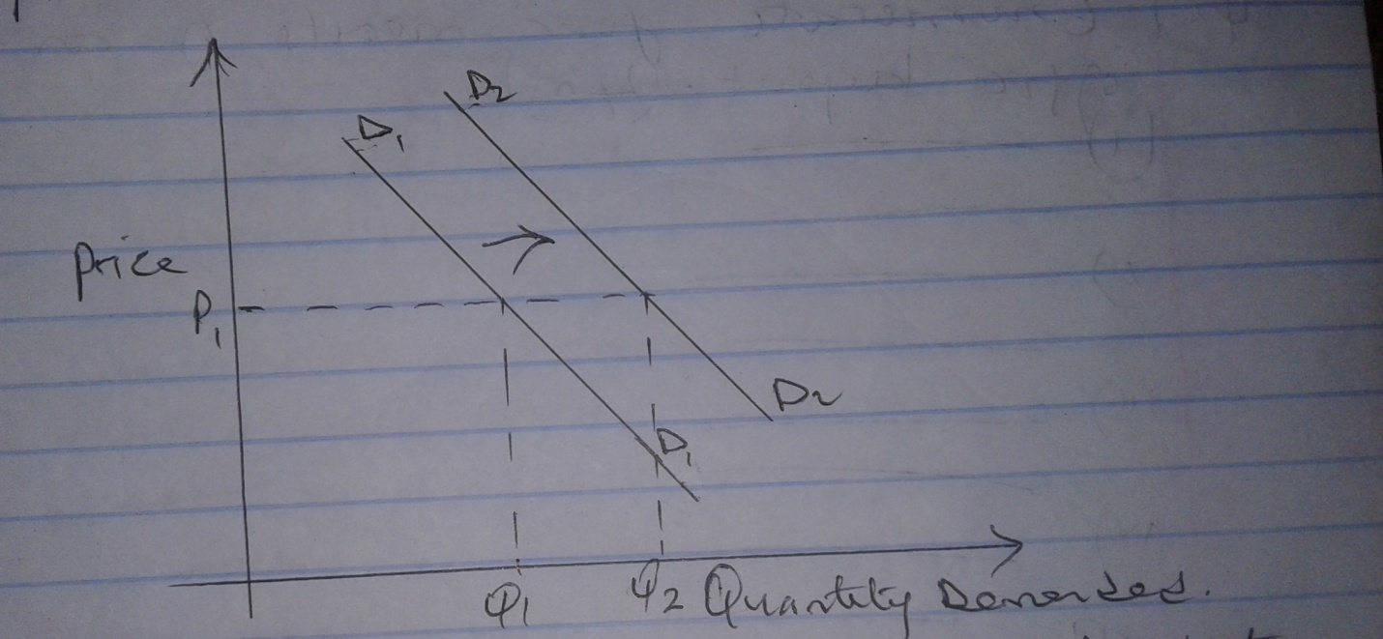

Identify four factors that will lead to the above shift from D₁D₁ to D₂D₂(4mks)

- Mention four circumstances under which an insurance contract can be terminated (4mks)

- Enumerate four merits of an open plan office layout (4mk)

- The table below gives description of area of study in business studies. Identify the area of study that best matches each of the description given below (4mks)
Description | Area of study
- Making the best use of the scarce resources
- Deals with trade and aids to trade
- Maintaining proper business financial records
- Activities involved in the process of identifying a viable business activity
- Highlight four reasons why a business should observe ethical practices while conducting its activity (4mks)

- Outline four disadvantages of a long chain of distribution to a buyer (4mks)

- In calculation of natural income one of the methods uses the formulae Y=C+1+G+(X-M)
- Identify the method used (1mk)

- Write the following abbreviations in full (3mks)
- C
- G
- (X-M)
- The following information was obtained from the books of Kasu traders on 31/12/2015
Item | Amount (shs)
Cash | 560,000
Stock | 700,000
Bank overdraft | 80,000
Creditors | 200,000
10 years bank loan | 500,000
Debtors | 440,000
8 years HFCK loan | 400,000
Required: calculate
- Working capital (2mks)

- Borrowed capital (2mks)

25. Mary sold 10 bags of maize at shs 3000 each to Peter, Peter was allowed a trade discount of 10% and cash discount of 31% if payment was made within a month.
Calculate the total money Peter paid if payment was made within a week. (4mks)

