NAME:……………………………………………………………….AD.NO:…………………CLASS:………………
CANDIDATE SIGN:…………………………………DATE:……………..

101/2
ENGLISH
PAPER 2
(COMPREHENSION LITERARY APPRECIATION AND GRAMMAR )
MARCH/ APRIL 2017
TIME: 2¹/₂HOURS

3KNT COMMON EVALUATION
KENYA CERTIFICATE OF SECONDARY EDUCATION.
INSTRUCTION S TO CANDIDATES:
- WRITE YOUR NAME AND ADMISSION NUMBER IN THE SPACES PROVIDED
- SIGN AND WRITE THE DATE OF EXAMINATION IN THE SPACES PROVIDED ABOVE
- ANSWER ALL THE QUESTIONS IN THIS QUESTION PAPER.
- CANDIDATES MUST ANSWER THE QUESTIONS IN ENGLISH

- READ THE PASSAGE BELOW AND ANSWER THE QUESTIONS THAT FOLLOW.(20MARKS)
When Google hosted a boot camp in California this month for its Android operating system, there were some new faces in the room auto manufacturers. They made the trip to learn about Android Auto, a new dashboard system meant to let a smartphone power a car’s center screen. Tasks as varied as navigation , communication and music apps, all constantly talking to the cloud. And to the driver. A similar scene is playing out just a few miles down the road at Apple, where a ----------system , Carplay, has been developed for iPhone users.
After years of being treated as an interesting side business, autos have become the latest obsession for silicon valley , with Apple assigning about 200 engineers to work on electric vehicle technology and Google saying it envisions the public using driverless cars within five years. But nowhere is that obsession playing out more immediately than in the battle to develop the next generation of cars’ dashboard systems.
In the coming weeks and months, dealership around the country will begin selling vehicles capable of running Android Auto ,Apple Carplay, or both. The systems go far beyond currently available Bluetooth pairing for playing out music or making a hands free call, and allow for Google ‘s or Apple ‘s operating system to essentially take place over the center screen and certain buttons within the car. “ consumers have spoken “ said John Maddox, assistant director of the university of Michigan’s Mobility Transformation Center.
“ They expect to have coordination between their phone and their vehicles” Here at Google’s headquarters, Android Auto is about to make its debut in American’s cars after two yearsin development. Plug in a smartphone with a USB cord and the system powers up on a car’s screen. The phone’s screen, meanwhile, goes dark , not to be touched while driving. Apple ‘s Carplay works similarly, with bubbly icons for phone calls, music,maps, messaging and other apps appearing on the car’s center screen.(Apple declined to comment for this article.)
While the idea of constantly connected drivers zipping along roads raises concerns about distracted driving , both companies say their systems are designed with the opposite goal: to make cellphone – toting drivers safer” we looked at what people do with their phones in the car, and it was scary.” Said Andrew Brenner, who heads Google ‘s Android Auto team. ‘’You want to say to them,” Yikes, no, don’t do that”.
Brenner said his team tried to figure out how to minimize distraction during tasks people frequently do while driving, while also deciding what should be prevented in the car altogether. Google even built its own driver – distraction lab, to test different variations.
Android Auto, for example, has no “back” button like the smartphone version. No “recents” button either. Google Maps has been adjusted to make fronts bigger and streets less detailed, for easier reading while driving. No action should take more than two seconds – consistet with the TranspotationDepartment’s voluntary guidelines.” Things that we don’t show are just as important as what we do show,” Brenner said. Music is most definitely in. Streaming videos? Most definitely not.

Most social media will also be blocked, and texts can be sent only with voice commands. Apps on the screen are optimized for speed: glance,touch and eyes back to the road. “It’s theselittle glances at the screen that people do in car”,he said.
We want something that’s very glanceable , that can be seen and done quickly .” when the Android Auto project began, it included a core group of automakers like General Motors, Audi Honda and Hyundai. Now , as it prepares for its debut, roughly two dozen car brands have signed on to offer it soon apple has teamed up with roughly the same number of brands, many of which will offer both systems . Most automakers are staying mum on their exact start dates, but Hyundai is expected to act shortly, and Volkswagen has indicated availability for its next Golf.GM has said the same about its Spark subcompact. One of the most widespread adopters will be Ford, which this year will begin offering both Android Auto and Carplay in conjuction with the revamping of the automaker’s much - criticized Sync system.
By the end of 2016, they will be available on all Ford sold in the United States. We don’t want people to have to make a vehicle choice based on which mobile phone they have,” said Don Butler,Ford ‘s executive director for connected vehicles and services. “We want to accommodate all customers and their devices”.
Fiat Chrysler, considered to have one of the better infotainment platforms on the market, has signed on to support Google ‘s and Apple ‘s systems. But a bit of lament is evident.” We’re confident that our systems deliver a good experience for our customers,” said Eric Mayne, a spokesman at Chrysler.” But we’re not standing still either.”

- Why did Auto manufacturing companies make the trip to California?(2mks)

- What according to the passage shows the seriousness that companies have autos have attached to autos? (2mks)

- What does the expression “ consumers have spoken” imply? (2m

- Briefly explain how the system works? (2mks)

- Why in your opinion do social have to be blocked?(3mks)

- In point form, summarize how developers have tried to minimize distractions that may arise out of the new developments.(5mks)

- Rewrite the following in reported speech.(1mk)
“We’re confident that our systems deliver a good experience for our customers,’ said Eric Mayne , a spokesman at Chrysler.

- What do the following words means as used in the passage?
- Debut…………………………………………………………………………………………………………………………..
- Mum ………………………………………………………………………………………………………………………….
- Infotainment……………………………………………………………………………………………………………….

- Questions :
Read the exact below and answer the questions that follows
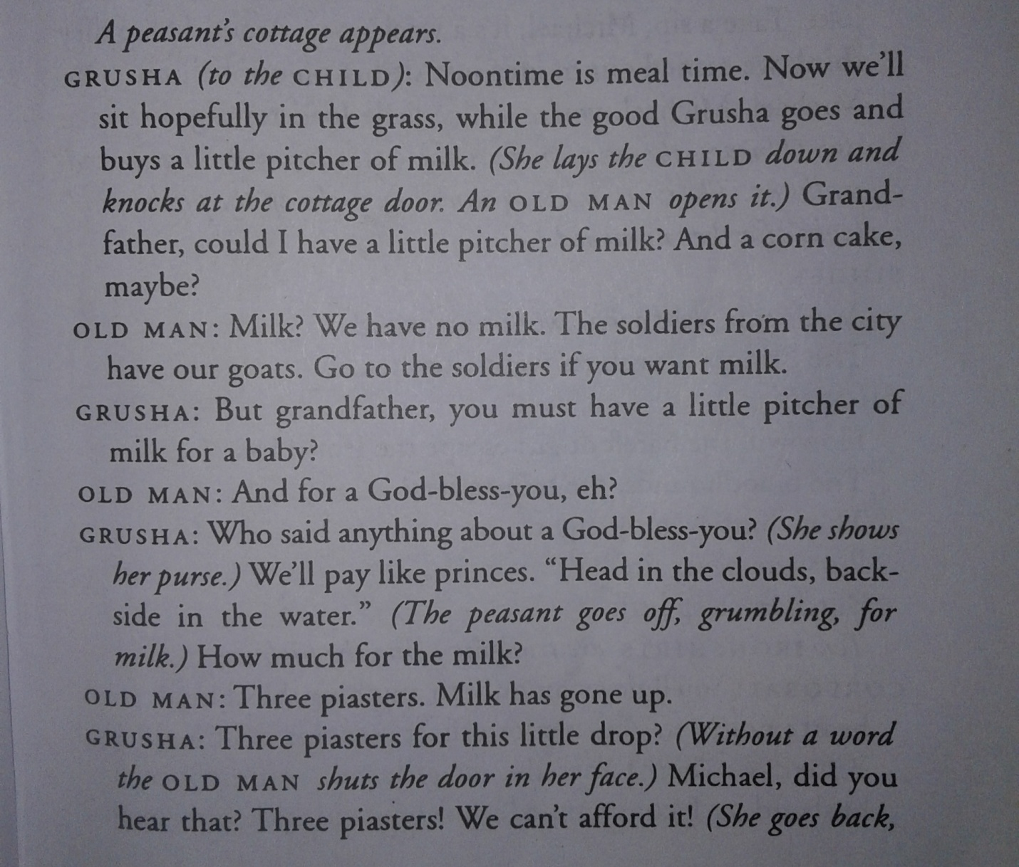

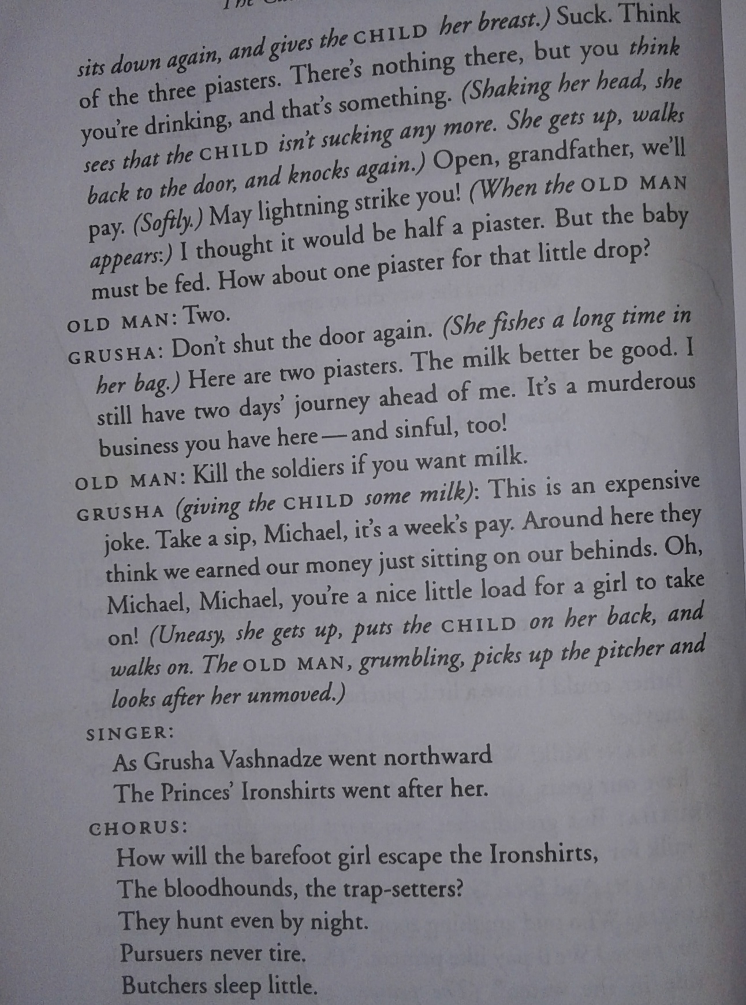

- (i) Why does Grusha rescue the child? (2mks)

(ii) Why is this child being pursued.(2mks)

- To whom does” The blood hounds, the trap settlers” refer? (1mk)

- Explain what happens immediately before this excerpt? (3mks)

- From the above extract, what are the effects of war.(3mks)

- Identify and explain any two character traits of Grusha and the old man as brought out in this excerpt.(4mks)

- Identify and explain any two figures of speech used in this excerpt.(4mks)

- What does Grusha mean by saying “ it’s a murderous business you have here and it is sinful too”(2mks)

- What happens just after this extract.(2mks)

- Read the following narrative then answer the questions that follow.(20marks)

Once upon atime hare and hyena were very good friends. They visited each other every day and herded their cows together.
There came a time when the cows starteddying one after the other. The two friends wanted to find out why the cows were dying.Haresaid, let us go and kill our mothers and take out their livers. We shall then cook and taste these livers. The bitter liver will show whose mother was making the cows die
At once hyena went and killed his mother. He took out the liver and cooked it. Hare went and hid his mother in the garden in a bushy banana plants. He then went and killed an antelope, took out its liver and cooked it.
The two friends met to eat their livers.” My liver is very bitter”, said the hyena” mine is very sweet, said Hare,” so it was your mother who was making the cows die.” Hyena kept quiet and went home feeling sad. He moved from the old house to a smaller one because now he had no mother. Hare did the same.

After a short time, there was great famine in the land. The two friends decided that each of them was to look for food on alternative days sharing on an equal basis what was available.When it was hyena’s turn, he went and found only honeycombs without any honey. When hyena brought these, hare refused this because he had secretly gone to his mother who had given him some bananas. This went on for many days, and hyena grew thinner and thinner .then he started wondering “ how does my friend remain fat and he doesn’t eat anything. I will find out.

One day he followed hare. Hare went to his mother as usual.’ mother, mother I have come’ and the mother dropped some bananas which hare ate quickly. He then looked for some honeycombs and took them to the friend. This is all I could find my friend.” The hyena kept quiet. The next day he went to the banana plant and called. His voice however was very deep and no bananas were dropped for him.
There was an old hyena whowas staying at the end of the forest and used to give advice to people. So Hare ‘s friend went to her and told her his problem. “ Go and put your tongue on the path of black ants,” he was told,” let them bite your tongue until it hurts. That’s how your voice will be soft”
Hyena went and did as he was told.When he went to hare’s mother his tongue was as soft as hare’s. Mother, mother I have come come.” And hare’s mother dropped bananas for him. Then he told her to come and greet him. When she came down and saw hyena she screamed but there was nobody near to help. Hyena killed her immediately.
Hyena went and met hare as usual saying nothing about hare’s mother. The following day it was hare’s turn.He went to his usual place.Mother he called again. He climbed up. There was no body. Having seen some blood on the ground, hare knew what had happened to his mother

When hare got back to hyena’s house he said nothing. At night, hare took all cows including hyenas and went away to live in another part of the country. That ended the Hare and Hyena’s friendship. And that is the end of my story to you.

- Classify the above narrative.(2mks)

- Identify three features in this story that are characteristics of oral narratives.(3mks)

- Briefly explain the character traits of the following.(4mks)
- Hare

- Hyena

- What moral lesson do you learn from this story.(2mks)

- Identify two socioeconomic activities from the community in which the narrative is taken from.(2mks)

- You have been selected for a field work research to collect the above item:
- Briefly explain two ways in which you will collect the information on the item.(2mks)

- Identify two problems and their solutions that you might encounter during the field work.(2mks)

- Who is the most appropriate audience for this story.(1mk)

- Describe the irony in the fifth paragraph.(2mks)

GRAMMAR(15MARKS)

- Explain the difference in meaning between the following pairs of sentences.?(4mks)
- He stopped to smoke a pipe
He stopped smoking a pipe.

- They were treated like common criminals.
They were treated as common criminals

- Complete the following sentences with the correct form of the word in brackets(3mks)
- The --------------------------------------------Tsunami claimed a lot of lives in Asia(disaster)
- To him they are --------------------------------creatures (loath)
- It never was his-------------------------------to start a fight.(intend)

- Rewrite the following sentences according to the instructions. Do not change the meaning.(3mks)
- John shows hardly any understanding of the problem.(begin: little….)

- She is rich but she still leads a simple life.(rewrite beginning : Rich…….)

- The boss will withdraw the negative review if you apologize. (Start: Should…….)

- Fill in the blanks with a phrasal verb from the verb given in brackets.(2mks)
- His suspicious behavior -------------------------------to the police (give)
- I could not -------------------------------------such nasty talk much longer.(put)

- Provide a suitable preposition to fill the blanks in the following sentences.(3marks)

- The butterfly came and settled ---------------------------------her shoulder
- She is hoping to complete -------------------------------the London Marathon.
- The manager is bossy, he likes ordering people-------------------

