3KNT FRETARNITY EXAMINATION
NAME ……………………………………………………………………………………………. ADM NO……………………………………..
SCHOOL ………………………………………………………………………………………….. INDEX NO …………………………………
TIME: 2 ¾ HOURS
MARCH/APRIL 2017
GEOGRAPHY
GEO 312 /1

INSTRUCTIONS TO CANDIDATES
- WRITE YOUR NAME AND INDEX NUMBER IN THE SPACES PROVIDED ABOVE.
- ANSWER ALL THE QUESTIONS IN SECTION A.
- ANSWER QUESTION 6 AND ANY OTHER QUESTION FROM SECTION B.
- ALL ANSWERS SHOULD BE WRITTEN IN THE ANSWER BOKLET PROVIDED.

SECTION A : (25 MKS)
ANSWER ALL THE QUESTONS IN THIS SECTION
1.a) What is a latitude ? (2mks)
b)What is the time of Hola on 400 E when the time at Tema o 00 longitude is 12 noon. (3mks)
2a)State 2 conditions which may influence the occurrence of land slides. (2mks)
b)The diagram below shows mass movement on a slope
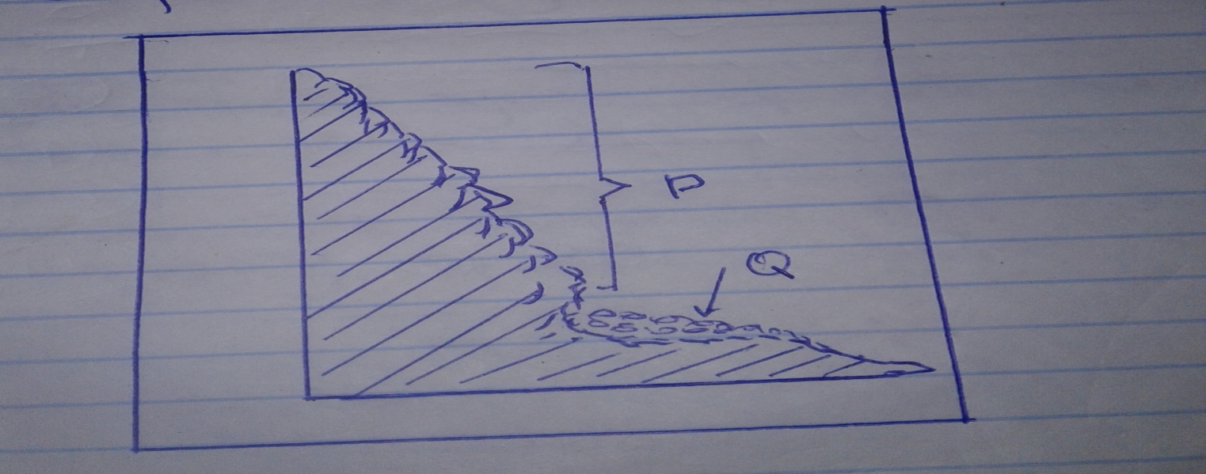
Name the :
i)type of mass movement shown. (1mk)
ii) Feature marked P and Q. (2mks)
3a) State 3 conditions necessary for the development of Karst scenery. (3mks)
b) Give 2 reasons why there are few settlement in Karst land scapes. (2mks)
4a) Give 2 features of deposition that results from action of water in arid areas. (2mks)
b) State 3 positive effects of desert features to human beings. (3mks)
5a) Name three types of soils according to texture. (3mks)
b) Name 2 ways in which humus improves the quality of soil. (2mks)

SECTION B (75 MKS)
ANSWER QUESTION 6 AND ANY OTHER TWO QUESTIONS FROM THIS SECTION.
6.Study the map of Kitale 1:50, 000 (sheet 75/3) provided and answer the questions that follows.
Ai)Identify the two human made features found in the grid square 2320. (2mks)
ii)What is the altitude of the highest point in the area covered by the map. (3mks)
bi)What is the bearing of the Air Photo Princiapl Point at grid square 3426 from the Air Photo Principal point at grid square 2931? (2mks)
ii)Measure the distance of the dry weather road(c 640) from the junction at point M (345142) to the junction at point N (416201) . give your answer in kilometers.(2mks)
ci)Draw a square to measure 10cm by 10cm to represent the area covered by easting 45 and 50 and northing 11 and 16. (2mks)
on the square mark and name the following features :
- Dam
- All weather road loose surface
- Swamp
- Suwerwa river
- Air photo principal
ii) Name two methods when to show relief on the map. (2mks)
iii) Citing evidence from the map, identify five social services offered in kitale municipality. (5mks)
7. The table below represents rainfall and temperature of station X and Y. use them to answer the questions a and b.
Station X
Months | J | F | M | A | M | J | J | A | S | O | N | D
Temp in ºC | 30 | 31 | 31 | 31 | 30 | 29 | 28 | 28 | 29 | 29 | 29 | 30
Rainfall in mm | 250 | 250 | 325 | 300 | 213 | 25 | 25 | 25 | 100 | 275 | 380 | 200
Station Y
Months | J | F | M | A | M | J | J | A | S | O | N | D
Temp in ⁰C | 21 | 20 | 20 | 17 | 15 | 13 | 12 | 13 | 15 | 16 | 18 | 20
Rainfall in mm | 12 | 12 | 15 | 50 | 90 | 110 | 87 | 87 | 50 | 35 | 20 | 15
a)For each of the station, calculate the mean annual range of temperature. (2mks)
bi)Calculate the annual rainfall for station Y. (2mks)
ii)On the graph paper provided, draw a bar graph to represent the rainfall for station X. use a vertical scale of 1cm to represent 50 mm. (5mks)
c) Describe the climate characteristics of station Y. (6mks)
di)Describe how convectional rainfall is formed. (6mks)
ii) Explain two problems associated with convectional rainfall in the lake region of Kenya. (4mks)
8ai)What is a mineral? (2mks)
ii)Describe the following characteristics of minerals :
- Luster (2mks)
- Colour (2mks)
- Density (2mks)
Bi) Name two examples of extrusive igneous rocks. (2mks)
ii) Describe three ways in while sedimentary rocks are formed. (9mks)
c) Explain the significance of rocks to the economy of Kenya under the following subheadings:
i)Tourism
ii) Energy
iii)Water
9. The diagram below represents zones of natural vegetation on a mountain in Africa. Use it to answer the question that follows.
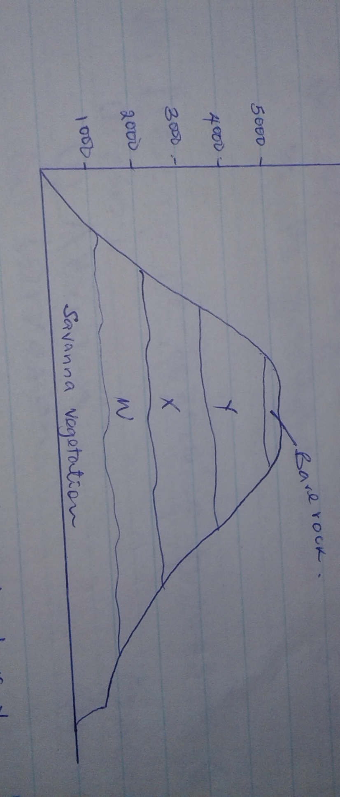
Ai) Name the vegetation zones marked W,X Y (3mks)
ii) Describe six characteristics of savannah vegetation. (6mks)
iii) Name the temperate grasslands found in the following countries (3mks)
- Canada
- Russia
- Australia
b) Explain 3 causes of the decline of the areas under forests in Kenya. (6mks)
c) You are supposed to carry out a field study on the uses of vegetation in the area around your school
i) State 3 reasons why it would be necessary to visit the area before the study. (3mks)
ii) Give 4 uses of vegetation you are likely to identify during the study. (4mks)
10ai) Outline 2 factors that influence the development of drainage pattern. (2mks)
ii) Outline 5 characteristics of a river in its youthful stage. (5mks)
b) Describe the following processes of river erosion:
i) Attrition (2mks)
ii)Corrosion (4mks)
c) Explain 3 negative effects of rivers to the human environment. (6mks)
d) Your class is planning to carry out a field study of a river in its old stage
i) State three reasons why it would be necessary to pre-visit the area of study. (3mks)
ii) State 3 activities you would carry out to determine why deposition occurs at this stage. (3mks)

